TRUSCULPT ID | BODY SCULPTING AND SKIN TIGHTENING IN MEDFORD & GRANTS PASS, OR
TruSculpt iD is a revolutionary treatment for sculpting and shaping the body without surgery. Treatments use powerful monopolar radiofrequency energy to target stubborn fat in areas like the stomach, love handles, back, and thighs. The technology of TruSculpt iD is proven to achieve an impressive 24% reduction in a subcutaneous fat cell within the target area. TruSculpt iD targets multiple areas in a simple 15-minute treatment. In addition, patients receive a personal body sculpting experience that is entirely hands-free.
If you are tired of dealing with stubborn fat deposits or lax skin, TruSculpt iD can help. Learn more about the innovative treatment and how to secure lasting body sculpting results by contacting Admire Aesthetics. We are the leading provider of TruSculpt iD in Medford and Grants Pass, OR. Call us at 541-210-8806 or reach out to us online to schedule a consultation and learn how treatments improve your physique in just 15-minutes.

BENEFITS OF TRUSCULPT ID
TruSculpt Flex features innovative technology that makes it possible to build, strengthen, and sculpt the body without a large amount of time performing manual exercise. In addition, this new treatment is the perfect way to work your muscles and achieve your dream physique without surgery or a lengthy recovery.
- Reduces stubborn fat cells
- Tightens skin
- Provides long-lasting fat reduction
- Monopolar RF body sculpting
- Personalized treatments
- Convenient 15-minute sessions
- Hands-free treatments
- Non-invasive
- No downtime needed

TRUSCULPT ID BEFORE AND AFTER*
The TruSculpt iD before and after images show how this innovative treatment reduces stubborn fat and tightens skin. As with any body sculpting method, results will vary per person.* However, each person shown below achieves noticeable improvements to their physiques, such as a firmer, more toned body.
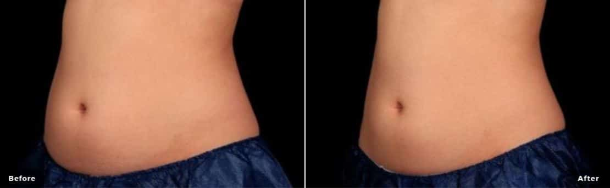
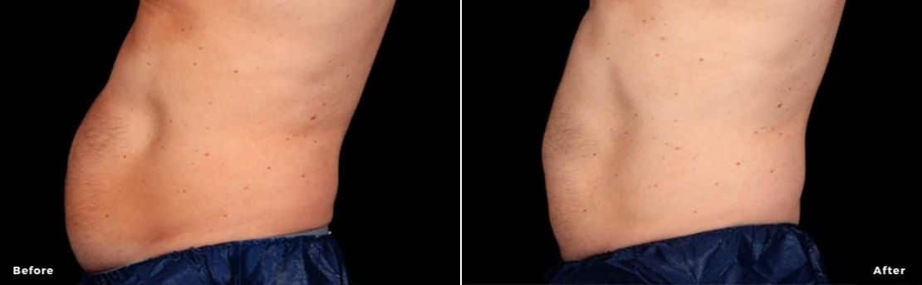
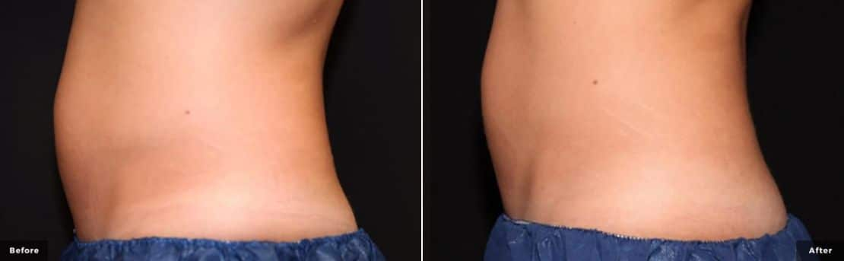

TRUSCULPT ID TREATMENTS
TruSculpt iD uses radiofrequency energy. The energy passes through the skin, targeting fat cells underneath safely. The treatment tackles stubborn fat buildup, inducing cell death. After your treatment, the body naturally collects the dead fat cells and removes them from the body. Best of all, the fat reduction after TruSculpt iD lasts.
In addition to the impressive fat reduction, treatments provide skin tightening. After someone loses fat, they tend to worry about loose or sagging skin. TruSculpt iD addresses this issue. Treatments reduce fat and tighten the skin in addition to the incredible 24% fat reduction.

TRUSCULPT ID TREATMENT APPLICATIONS
TruSculpt iD is FDA-cleared to treat:
- Stomach or abdomen
- Flanks or love handles
- Back
- Upper arms
- Submental fat
- Submandibular fat
- Inner and outer thighs
- Under the buttocks or banana roll
- Bra bulge
With 6 versatile handpieces, TruSculpt iD treats any area on the body in just 15-minutes. Dual-body sculpting is also possible with innovative handpieces. Treatments can reduce fat in multiple areas at the same time.

TRUSCULPT ID IS DIFFERENT FROM OTHER BODY SCULPTING METHODS
Customizable: TruSculpt iD is fully customizable. The technicians can target virtually any area of the body. Other body sculpting technology tends to only target areas with pinchable fat. The unique TruSculpt iD devices lay on the skin of the treatment area, perfectly targeting the fat cells underneath.
Effective Technology: TruSculpt iD’s radiofrequency technology reduces fat and tightens the skin. This technology is the ideal modality for tightening the skin, so patients avoid loose or sagging skin after fat reduction.
No Downtime: This method of body sculpting requires no downtime after. Most people come in for a quick, convenient 15-minute session on their lunch break and then return to normal daily activities. This is a big reason so many people prefer TruSculpt iD.

TREATMENT CANDIDACY
TruSculpt iD is not for everyone. It is a fat reduction method. It does not treat someone who needs to lose a significant amount of weight or is obese. TruSculpt iD body sculpting is perfect for healthy adults struggling with diet and exercise-resistant fat buildup.
If you question your candidacy, contact Admire Aesthetics. During your consultation, you can discuss your TruSculpt iD treatment candidacy with an expert specialist. You undergo a physical evaluation to determine if TruSculpt iD suits your body and goals.

TRUSCULPT ID COST
The cost of TruSculpt iD varies. Each treatment is created to fit the unique needs of each person. Therefore, prices are different per person. During a consultation, you can discuss specific body goals with your specialist. If this body sculpting treatment suits you, they create a plan that achieves optimal results at the most affordable rate.

TRUSCULPT ID in Medford and grants pass
If you want to learn more about TruSculpt iD and how it reduces fat while tightening skin, contact Admire Aesthetics. We are the leading provider of this safe body sculpting option in both Medford, OR, and Grants Pass, OR. Call us at 541-210-8806 to schedule your consultation and learn more.

TRUSCULPT ID FAQS

H2: When will I see my Trusculpt iD results?*
TruSculpt iD results appear gradually over time. You may notice less fat or more firm skin in the treatment area in about 6 weeks. The full results take up to 12 weeks to appear. As with all body sculpting treatments, results will vary per person.*

H2: How many Trusculpt iD treatments do I need?*

Some people notice results after just one TruSculpt iD treatment. However, additional sessions may be needed to achieve optimal aesthetic results. During a consultation with Admire Aesthetics, you can discuss your goals and how best to achieve them. Then, our expert team creates a plan capable of achieving optimal fat reduction and skin tightening.

H2: Does Trusculpt iD hurt?

TruSculpt iD procedures are painless. Most people describe treatments as feeling warm, similar to a hot stone massage. During the session, the skin temperature rises but remains comfortable.

H2: Are truSculpt iD results permanent?

Trusculpt iD results are permanent. The device uses the heat emitted by soundwave energy to melt and eliminate unwanted fat cells. The human body stops producing new fat cells in adulthood. Therefore, once those fat cells are removed from the body, they can never grow back. It is important to note that if you gain weight, you could obscure your Trusculpt iD results. To continue your results, observe a healthy diet and exercise routine to avoid excessive weight gain.

H2: Is truSculpt better than CoolSculpting?

truSculpt, on average, provides a 24% fat reduction. CoolSculpting often achieves 20-25% fat reduction. It is important to note that these are the average fat reduction per treatment. Admire Aesthetics offers both truSculpt iD and CoolSculpting treatments. Speak with our professionals to determine which fat reduction method best suits your body and aesthetic goals.

H2: Where does the fat go after TruSculpt?

The fat cells targeted during a truSculpt iD treatment are eliminated with heat. Once the heat “melts” the fat cell, the body recognizes it as dead and removes it from the body as a form of waste via the lymphatic system.

H2: Does truSculpt tighten skin?

TruSculpt iD targets stubborn areas resistant to fat loss through exercise and diet. TruSculpt iD uses focused and localized 15-minute treatments that kill fat cells and tighten loose skin.

H2: Is truSculpt better than lipo?

truSculpt iD achieves fat reduction much like lipo but with less invasive means. Also, truSculpt iD’s fat loss is not as sudden and dramatic as lipo.

