TRUSCULPT FLEX | MUSCLE BUILDING IN MEDFORD AND GRANTS PASS, OR
TruSculpt Flex treatments provide an innovative way to build impressive muscle mass. This treatment targets the abs, thighs, and buttocks using multi-directional stimulation with electrical pulses. Each target area comprises a smaller muscle group with special functions. The TruSculpt Flex hits all those muscles, achieving the deepest muscle contractions possible with non-invasive body shaping.
If you are tired of wasting hours working out and seeing no improvements to your muscle mass or definition, TruSculpt Flex may help. This unique muscle stimulation provides a more intense workout than anything you can accomplish manually. Learn how you can achieve a 30% increase in muscle mass with TruSculpt Flex. Contact Admire Aesthetics today by calling 541-210-8806. We are the premier provider of this new muscle-building technology in Medford, OR, and Grants Pass, OR. Call us to schedule your consultation and discover how to achieve a more muscular, defined physique.

BENEFITS OF TRUSCULPT FLEX
TruSculpt Flex features innovative technology that makes it possible to build, strengthen, and sculpt the body without a large amount of time performing manual exercise. In addition, this new treatment is the perfect way to work your muscles and achieve your dream physique without surgery or a lengthy recovery.
- Intense muscle stimulation
- Firm, tone, and strengthen muscles
- Treats popular areas like the abdomen, thighs, and buttocks
- Non-invasive body treatment
- Fully customizable
- Easy and convenient
- No downtime needed

TRUSCULPT FLEX BEFORE AND AFTER*
The TruSculpt Flex before and after images feature the impressive muscle sculpting and building possible with treatments. As with all aesthetic body treatments, results will vary per person depending on their specific body.* However, when you receive TruSculpt Flex sessions from a professional provider like Admire Aesthetics, you can expect similar results as those seen in the before and afters.
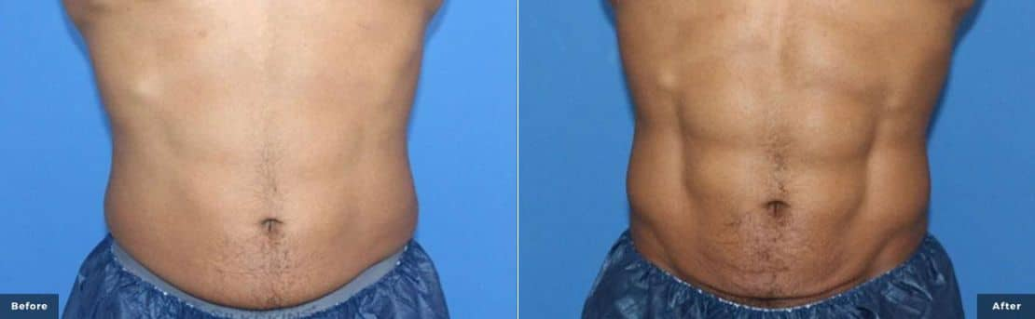
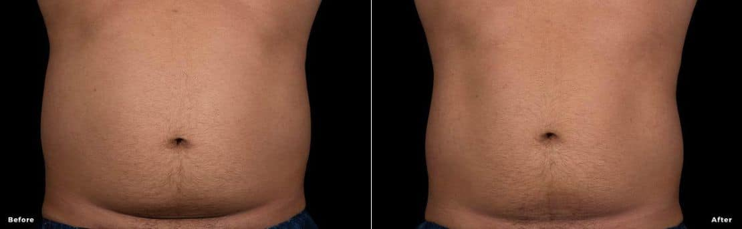
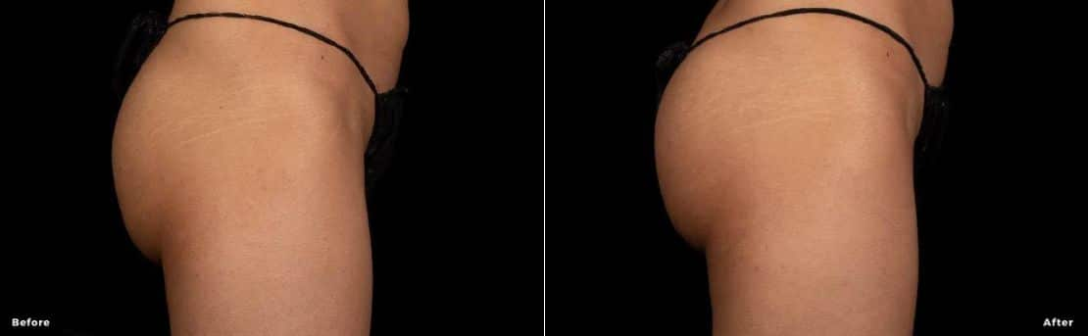

TRUSCULPT FLEX TREATMENT EXPERIENCE
TruSculpt Flex treatments are entirely customizable to fit each patient’s unique needs. The treatments are divided into three modes: Prep Mode, Tone Mode, and Sculpt Mode.
Prep Mode: Like pre-workout stretches, Prep Mode prepares the muscles for work. During this mode, you experience a twisting motion designed to warm up and stretch the muscles. It also allows the body to build up a tolerance to muscle contractions in a gradual manner.
Tone Mode: The Tone Mode is similar to exercise for increasing and strengthening the muscles while building endurance. You experience muscle contractions to the point of exhaustion and then release them to increase muscle strength.
Sculpt Mode: On par with an intense exercise that breaks down muscle fibers, the Sculpt Mode provides fast, deep, sequential muscle contractions. The action of this mode builds impressive muscle mass—attributing to the average 30% improvement in muscle mass patients experience after a TruSculpt Flex treatment plan.

TRUSCULPT FLEX TREATMENT REQUIREMENTS
The initial TruSculpt Flex plan consists of four to six treatments. The frequency and rest intervals between the sessions are different for everyone. This depends mostly on your fitness level, body shape, and your aesthetic body goals. Rest is a very important part of this treatment. The muscles need to rest to recover after each treatment. Most professionals recommend that you wait about two to five days between treatments for optimal results.
You undergo a physical evaluation when you schedule a consultation with Admire Aesthetics. Once your specialists listen to your aesthetic goals and evaluate your unique body needs, they determine the best course of action to achieve optimal TruSculpt Flex results.

TRUSCULPT FLEX IS DIFFERENT FROM OTHER BODY SCULPTING TREATMENTS
TruSculpt Flex is different from other treatments in the industry. Many advantages suggest that TruSculpt Flex is the best way to achieve optimal muscle strengthening, toning, and firming.
Here are a few ways TruSculpt Flex is superior to other treatments:
- Safer Muscle Contouring: The TruControl technology allows a safe treatment with consistent results by targeting, selecting, and customizing the delivery with less energy.
- Faster: TruSculpt Flex treats up to eight areas of the body in each 45-minute session.
- Superior Muscle Thickness: Clinical studies prove that the new TruSculpt Flex achieves an average 30% increase in muscle mass.
- No Downtime: TruSculpt Flex is non-invasive, so patients need no downtime.
- Customizable: This treatment is completely tailored to fit the needs of each patient. All sessions are based on the patient’s fitness levels, body shape, and aesthetic goals.

TRUSCULPT FLEX COST
The TruSculpt Flex cost varies per person. Since treatments are versatile and can be tailored to meet each person’s unique needs, prices will be different for everyone. When you schedule a complimentary consultation with Admire Aesthetics, you can discuss the price in depth with a specialist. If they determine TruSculpt Flex’s superior muscle strengthening, building, and toning is perfect for your body and needs, they custom a plan that fits your financial budget.

TRUSCULPT FLEX MEDFORD AND GRANTS PASS, OR
If you are tired of working out and seeing no visible results, TruSculpt Flex can help you achieve the muscles and definition you desire. Contact Admire Aesthetics today for a consultation and discover how this new treatment can improve and enhance your physique without surgery or downtime. Call us at 541-210-8806 or reach out to us online.

TRUSCULPT FLEX FAQS

How does Trusculpt FLEX work?

TruSculpt Flex uses Cutera’s proprietary multi-directional stimulation (MDS). The MDS energy provides three treatment options by replicating intense squats, crunches, and twisting actions. In addition, it covers the most extensive treatment area in the body sculpting industry, setting it apart from all other treatments.

Does Trusculpt FLEX hurt?*

At the beginning of the TruSculpt Flex session, patients may experience gentle contractions. As the intensity increases, the muscle contractions gradually get more intense. Each treatment session induces an impressive 54,000 contractions per session. Some patients may experience mild muscle soreness afterward. This is on par with what one would experience after an intense gym workout. As with all treatments, results will vary per person.*

When will I see Trusculpt FLEX results?*

The maximum TruSculpt Flex results are typically visible within 8-12 weeks after the plan is complete. As with all body shaping treatments, results vary.*

H2: How long do truSculpt Flex results last?

TruSculpt FLEX uses radiofrequency energy to target fat cells. The cells die as a result of the heat. They are then processed out of the body-usually in roughly 3 months. Once gone, the fat cells can never return or regrow, leading to sustainable fat loss.

H2: What is truSculpt Flex equivalent to?

truSculpt FLEX provides a workout similar to 54,000 abdominal crunches with each 45-minute treatment.

H2: Where does the fat go after truSculpt FLEX?

The fat cells are removed through the lymphatic system as a form of waste. Once removed, those fat cells can never return or regrow. So they are gone for good.

H2: What are the risks of truSculpt?

Each truSculpt treatment is designed to be safe and comfortable for each patient.
Typically, there is no downtime afterward. However, patients may experience some mild discomfort, including redness, sweating, and mild tenderness in the treated areas. Usually, these effects are mild and resolve on their own.

H2: Who is a good candidate for truSculpt?

The best candidate for treatment is someone who is overweight or with a BMI of 30 or greater.

H2: How can I speed up my truSculpt results?

It is recommended to drink lots of water, get at least 5 hours of moderate exercise weekly, and eat a nutritious diet after your trusculpt treatment. This will help enhance your results significantly.

