Hello Always Beautiful Team,

How are you?

We wanted to give you an update on the progress of your SEO campaign. Our team implemented numerous initiatives to improve your SEO ranking. We’ve also added your site to several SEO Marketing sites. We used their tools and ours - combined with our expertise - to review, audit, manage & boost your online presence and SEO score. We have outlined your improvement & progress in more detail below.

It would be easiest for us to jump on a call and discuss how to look at these reports, but we provide some content below.

In order to improve your rankings on our end, we focus on creating relevant content, building links, improving your onsite SEO and updating and adding your business to local directories.

Content Creation & Blog Posts November
https://www.alwaysbeautiful.net/blog/aesthetic-services/how-to-get-rid-of-belly-fat/
https://www.alwaysbeautiful.net/blog/aesthetic-services/does-coolsculpting-tighten-skin/

Content Creation & Blog Posts August
https://www.alwaysbeautiful.net/blog/aesthetic-services/body-contouring-near-me/
https://www.alwaysbeautiful.net/blog/aesthetic-services/cooltone-abs/

Content Creation & Blog Posts Views, Clicks – From 10/13/21 to 12/25/21 *
https://www.alwaysbeautiful.net/blog/articles-by-date/ever-wonder-bruise-easily/ | (clicks) 471 | (Impressions) 12,267
https://www.alwaysbeautiful.net/blog/aesthetic-services/cooltone-vs-emsculpt/ | 445 | 9,470
https://www.alwaysbeautiful.net/blog/coolsculpting/yes-there-is-something-coolsculpting-cannot-do/ | 336 | 23,766
https://www.alwaysbeautiful.net/ | 289 | 32,943
https://www.alwaysbeautiful.net/blog/aesthetic-services/coolsculpting-elite-vs-coolsculpting/ | 249 | 7,730
https://www.alwaysbeautiful.net/blog/cooltone/cooltone-cost/ | 229 | 29,782

Top Queries – From 10/13/21 to 12/25/21 *
cooltone vs emsculpt
always beautiful
emsculpt vs cooltone
coolsculpting elite vs coolsculpting
always beautiful medspa
skin classic machine
cooltone cost

* See full stats on attached Excel sheet report.

Online link building
Press releases we published for you were picked up by 100+ outlets. Although Google doesn't count these links multiple times, it still benefits you.

We also had some bloggers which own sites with substantial domain authority link to your CoolSculpting page. This produces what is called “Link Juice” which Google and other search engines love.

Landing page - https://www.alwaysbeautiful.net/coolsculpting-aurora/
Keyword targeted: Coolsculpting before and after
Post title - Tired Of Stubborn Body Fat? Try These Fat Busting Methods
Post link - https://candywashington.com/mind-body/tired-of-stubborn-body-fat-try-these-fat-busting-methods

Google My Business SEO Work
Added and updated information on Google My Business profile and shared posts. Also responded to reviews left by clients to help with engagement & for SEO purposes. Tweaked settings, followed up on insights, managed profile.

Your Onsite SEO Score
You are currently scored at 99 out of a 100 which is excellent. We made many adjustments to your site, pages & other properties to help you obtain this score. The report is attached.

* See full stats on attached PDF report.

Reputation Management:
- Average Star rating: 4.67
- Number of Reviews: 326

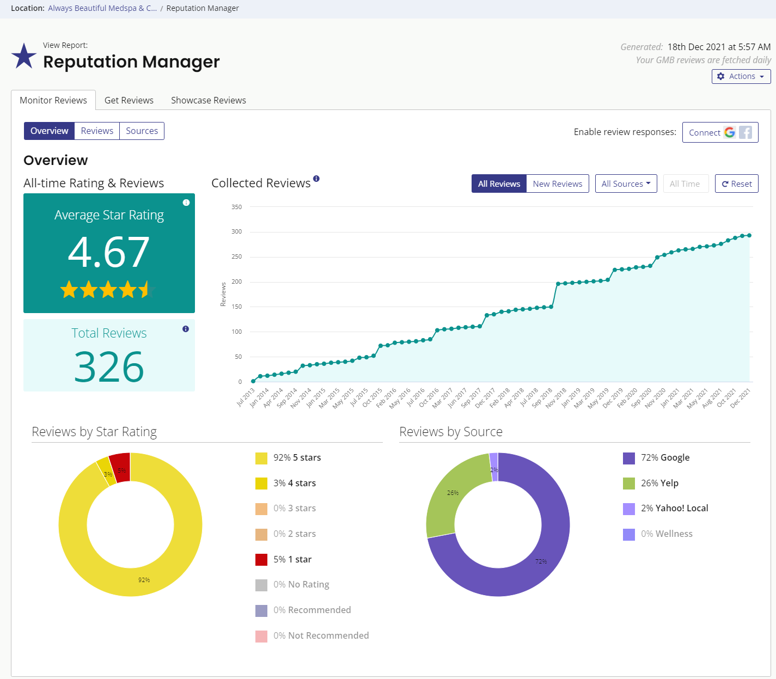

Your Citation Tracker, Builder reports (Bright Local)
Your site is added to over 25 of the most popular and powerful directories on the web. Automated distribution to local data aggregators. This helps boost your local rankings. Some of these are:

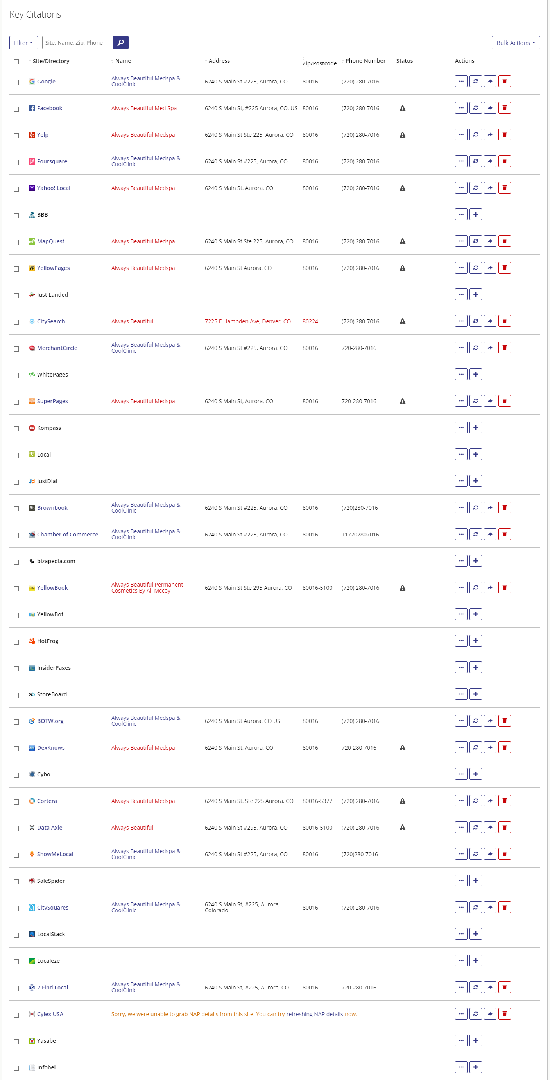

Your Keyword ranking reports (Bright Local)
Your current keyword report shows your ranking positions as well as the rankings table. You can see which pages and keywords you are presently ranking in first place for.
Keyword: Coolsculpting – Rank B – local , 2 - organic
Keyword: Coolsculpting Aurora, CO – Rank A – Local, 1 - organic
Keyword: Cool Sculpting – Rank – Organic – 5,
Keyword: Cool Sculpting Near Me – Rank – Organic – #1, B local

Keyword: Cool sculpt – Rank – B local, 2nd organic

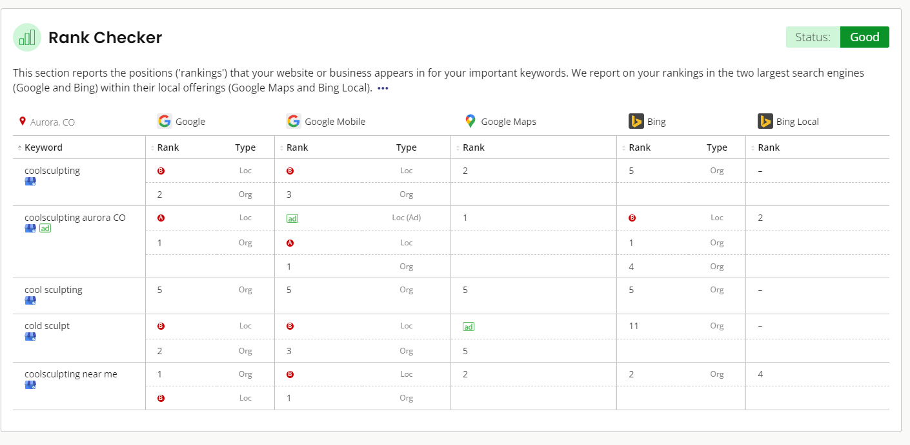

* See full stats on attached PDF report.

Please let us know if you have any questions about your SEO report. We are also attaching it in Word format for your convenience.

