March Specials!


Filler with Haleh
Buy 1, Get 1 half off
-or-
Buy 2, Get 1 Free
Treatments include Cheeks,
Jawline, and Chin!

Call 720.280.7016 to book now!


CoolSculpting
BUY 4, GET 4
Plus, book treatment during your FREE Consultation and receive the Alastin Body TransFORM FREE! TransFORM is clinically proven to tighten skin and accelerate CoolSculpting results by 30%!

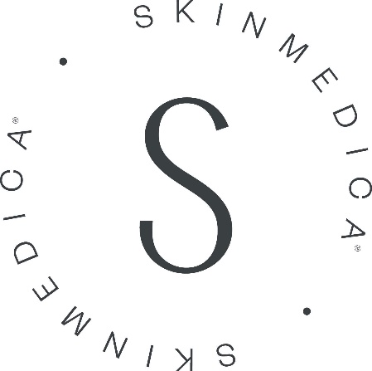
Buy TNS Advanced+ Serum, Receive for FREE:
SkinMedica Neck Correct Cream ($135)
Address visible signs of neck aging
--or--
HA5 Rejuvenating Hydrator 1oz ($120)
Provides instant hydration

