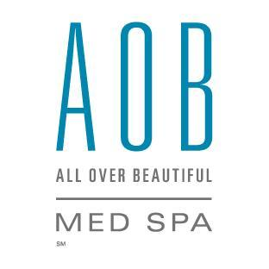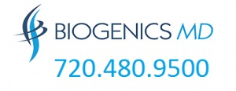
To patients of AOB Med Spa and Biogenics MD,

Re: Covid 19

As our number one concern is always the health and safety of our patients and staff, we are completely committed to best practices at this time. Our office will see only pre-scheduled patients, one at a time for each provider, separated by additional 15 minutes, to ensure that we have ample time to disinfect the office in between each patient. We scrub all common areas (doors, surfaces, etc.) with a Virucidal, we glove and mask and change all linens and protective coverings.

Also, as an added precaution for all, you will be asked to wear a mask and gloves that we will provide, and we will check
your temperature prior to your appt. Please do not bring any additional friends or family with you to your appointment.

We will ask you the following questions before you enter our office:
Please answer YES or NO to each one. If you answer YES to any of the questions below, please re-schedule your appointment.
Feel free to scan and email this to us prior to your appointment. or bring this completed with you to your office.

______Have you been travelling in the last 14 days? Where?_______________________ Was it a Hot Spot? ________________

______Have you been exposed to anyone that has been tested positive for Covid19 in 20-30 days?

______Have you had any fever in the past 2 weeks?

______Have you had a cold or flu-like symptoms in the past 2 weeks?

______Have you had unusual coughing or sneezing in the past 2 weeks?

______Have you had a decrease in you sense of smell or taste?

______Have you had the Covid19 virus test? When?___________Where?___________________________Result____________

______I understand that this business, Dennis Kotelko, M.D. and it’s members cannot be held liable
for any unintentional exposure to the virus, and I waive my right to any legal action again them.

By signing below, I agree to each above statement I understand and agree that I waive all rights to bring any claims against, and further, release the following parties from all liabilities associated with exposure to Covid19: AOB Med Spa, Dennis M Kotelko, M.D., Biogenics MD and all employees of either or both.

AOB Med Spa, Dennis M Kotelko, M.D., Biogenics MD and all employees of this facility agree that they abide by these same
standards and affirm the same. We also affirm that we have improved and expanded our sanitation/disinfection protocols
to more thoroughly fight the spread of COVID-19 and other communicable conditions.

___________________________________________ Date:__________________
Your Signature
___________________________________________ ____________________________________ Date______________
Print Name Witness

