500 Word Update to Azul Medspa Botox Page.KA

Link to page: https://azul-medspa.com/botox-cosmetic/

Changes are made in red

BOTOX | DYSPORT | ANTI-AGING TREATMENTS IN EL PASO
Botox, and similar neuromodulator Dysport, dominate the cosmetic industry. Millions of people turn to these powerful injectables to improve noticeable signs of aging and revitalize how they look. Anti-aging injections are a popular way for people to smooth wrinkles around the brows, eyes, and forehead. They are also FDA-approved as safe, painless, and require no downtime. When a skilled injection specialist performs this treatment, results look natural, preserve your facial expression, and provide lasting results.
Aging gracefully is possible with anti-aging injections. Learn how by contacting the leading provider of Botox and Dysport in El Paso, Azul Medspa. We proudly offer our clients the #1 rated cosmetic injectables. We have two locations to serve our area better, Medspa East 915-317-5212 and Medspa West 915-584-2985. Call us now to schedule a consultation to learn more.
$50 OFF*
NEW CLIENT SPECIAL

Preferred office location:West LocationEast Location

By submitting this form you agree to be contacted via phone/text/email.*
Cannot be combined with other offers**

BENEFITS OF
BOTOX AND DYSPORT
- Most popular cosmetic injectable
- Extensive clinical studies and trials prove safety and efficacy
- FDA approved to reduce crow’s feet and frown lines
- Look more youthful instantly
- Perfect anti-aging treatment for anyone over the age of 20
- Now the perfect preventative treatment for young adults

BOTOX AND DYSPORT
BEFORE AND AFTER RESULTS*
The Botox and Dysport before and after images show the anti-aging results possible with a neuromodulator. As with any cosmetic injectable, results will vary.* However, each transformation shows an actual patient achieving typical results of a Botox or Dysport injection.
It is important to note that Botox and Dysport are technique-sensitive injections. To receive safe, natural-looking results, you should select the most reputable provider in your area. People living in El Paso, Texas, choose Azul Medspa for their Botox and Dysport needs.
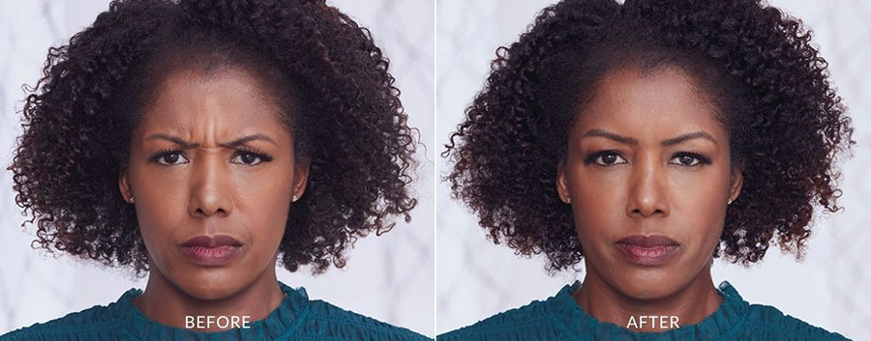
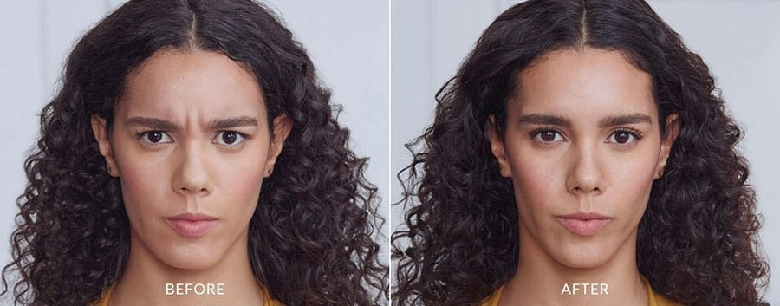
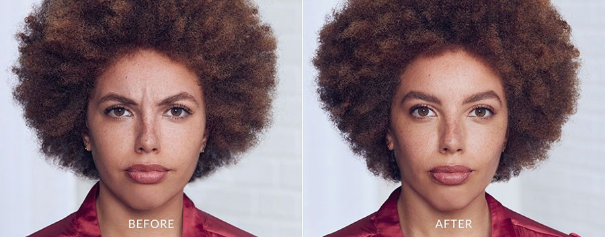
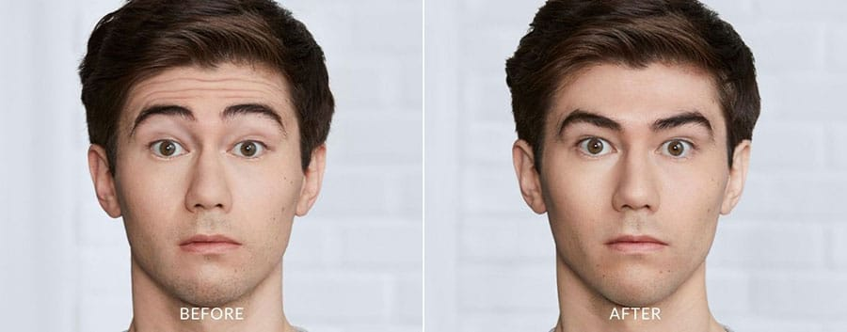
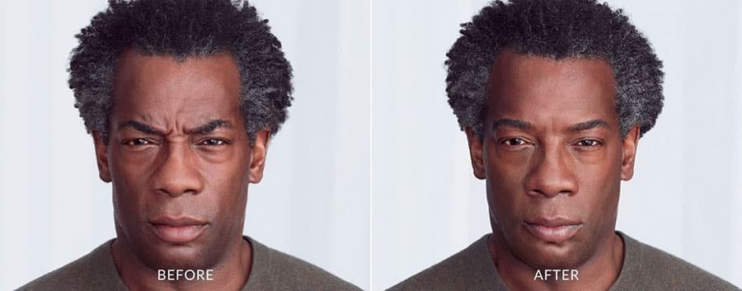
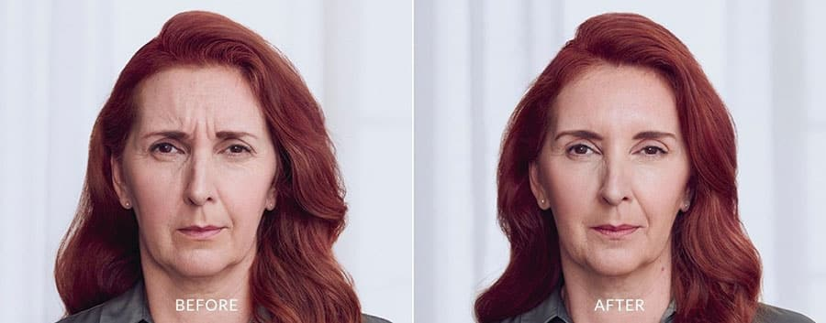
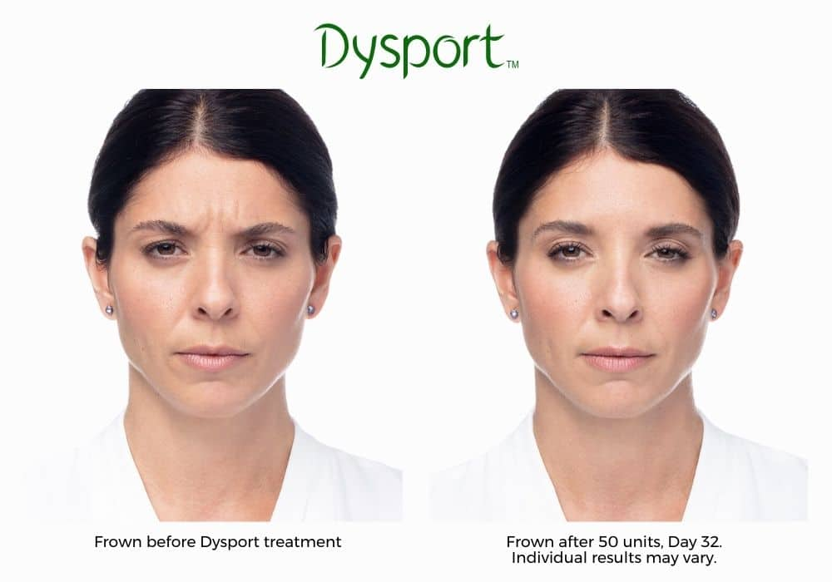
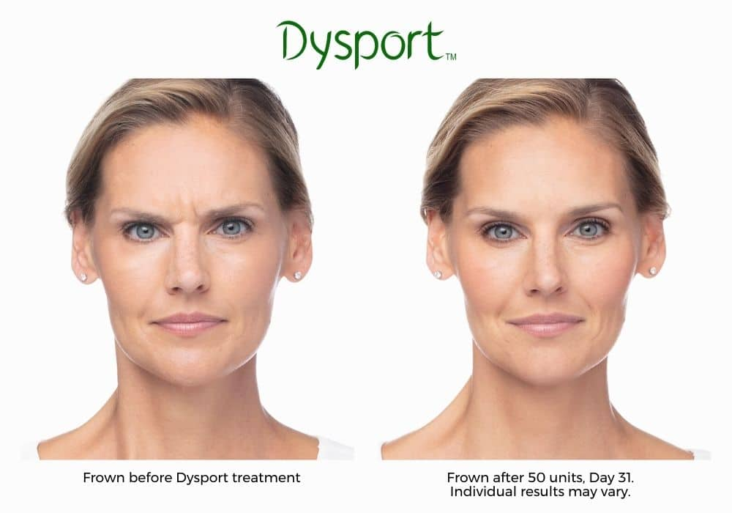
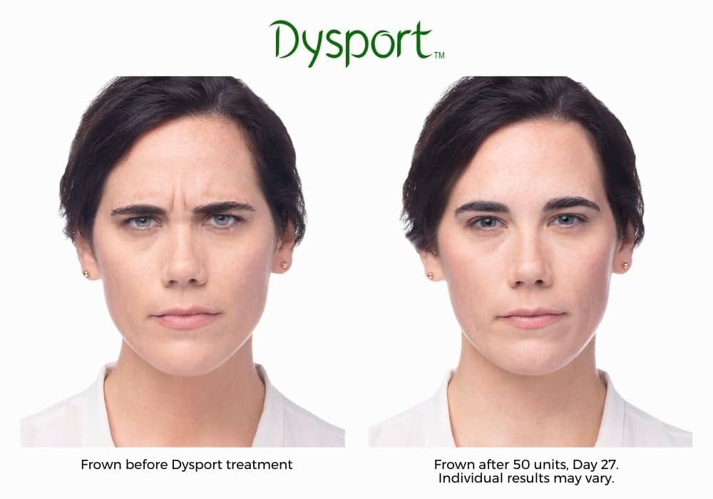
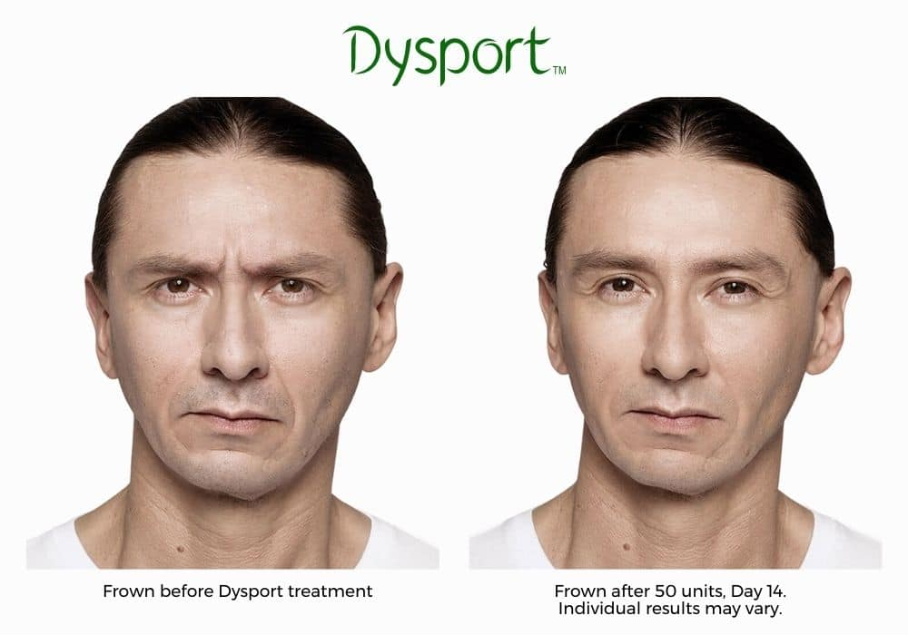

HOW DO NEUROMODULATORS WORK?
Understanding how Botox and similar neuromodulators work starts with understanding what dynamic wrinkles are. These types of wrinkles are known as expression lines. They are grooves in the skin caused by repetitive facial muscle movements. For example, every time we make animated facial expressions like squinting, frowning, smiling, laughing, or even scowling, we cause dynamic wrinkles. The grooves become more evident as we age, in the most expressive areas like the eyes, brows, and forehead.
Botox, and Dysport, are made of Botulinum Toxin Type A. It works by blocking the signal that tells a muscle to contract. When you receive a Botox injection, it temporarily blocks the signal responsible for telling a muscle to contract. When this occurs, it allows the muscles to relax and lengthen. The new elongated muscle allows the overlying expression line to smooth out, diminishing signs of aging.
Neuromodulators also dramatically soften crow’s feet, frown lines, and forehead wrinkles. In addition, they help you look more youthful and rejuvenated instantly.
H2 NEUROMODULATOR TREATMENT AREAS

Botox and Dysport are FDA-approved to treat some of the most problematic areas or areas that are known for becoming wrinkled with age. The most popular treatment areas include:

- Forehead lines – known as glabellar lines- are the area on the forehead between the eyebrows. It is one of the most common areas to accumulate wrinkles because of how reliant our expressions are on using the eyebrows.
- Frown lines – frown lines tend to show up directly between the eyebrows. They are usually vertical on either side of the face, creating a drastic outline above the nose, which is very noticeable.
- Crow’s feet – the wrinkles that form directly on the sides of the eyes.
- Lip lines – also known as smoker’s lines or lipstick lines- form directly above and below the bottom lip. They tend to be small and most noticeable when pursing your lips together.
- Chin dimpling – these wrinkles are caused by the deterioration of the skin near the chin, creating an appearance resembling cellulite in the legs.
- Smile lines – also known as marionette lines or nasolabial folds- these wrinkles form on the lower half of the face. Smile lines come down from the nose's corners to the mouth's side.
- Neck bands – Neuromodulators can smooth over neck bands and lines along the neck. This helps give your skin and neck a more youthful appearance.

INCLUDE ANY GRAPHICS WE HAVE THAT POINT TO THESE AREAS

BOTOX AND DYSPORT COST
The cost of Botox or Dysport in El Paso varies. Cosmetic injectables are tailored to fit the unique needs of each person. Therefore, the cost is different for everyone. Certain factors like the number of injections, number of treatment areas, or if they are used with other Dermal Fillers like Juvéderm or Restylane affect the price.
You speak in person to an expert injector during a consultation with Azul Medspa. They evaluate your skin and listen to your aesthetic goals. They help determine which injectable is best for you, your skin, and your goals. Best of all, you receive a treatment plan that achieves optimal results at the most affordable rates in the area.


HOW LONG DO THE ANTI-AGING EFFECTS LAST?
Most people see results within 24 to 72 hours after their treatment. They also enjoy the anti-aging benefits for 3 to 5 months afterward. It is important to note that individual experiences will be different for each person.*
In addition to managing fine lines and wrinkles, studies suggest Botox works as a preventative treatment. When people receive Botox in their early 20s before expression lines form, they can avoid the creation of these grooves altogether.

IS BOTOX SAFE?
Botox is backed by an extensive number of studies and research. With such a high success rate, and FDA approval, Botox distinguishes itself as one of the safest and most effective anti-aging injections available today.

IS DYSPORT SAFE?
Much like Botox, Dysport is considered a safe neuromodulator. It has FDA approval and an impressive safety profile.

RISKS AND SIDE EFFECTS
Botox risks and side effects are rare. In addition, any risk or side effect of a neuromodulator is rare. When your injections are performed by a reputable professional, you receive safe and optimized results. During a consultation with Azul Medspa, you can discuss risks or side effects with your injection specialist.

BOTOX EL PASO | DYSPORT EL PASO
Reclaim your youth with Botox and Dysport. Contact Azul Medspa today to schedule a consultation and discover how neuromodulators can alter and enhance your look. We are proud to be the leading provider of Botox and Dysport in El Paso, Texas. When you schedule a consultation with our knowledgeable specialists, you get the best El Paso offers. Call us at 915-317-5212 for Medspa East or 915-584-2985 for Medspa West. Call to schedule your appointment now or reach out to us online.

H2 BOTOX FAQS
H3 IS BOTOX SAFE?
An extensive number of studies and research back Botox. With such a high success rate and FDA approval, Botox is among the safest and most effective anti-aging injections available today.

H3 WHO IS THE BEST CANDIDATE FOR BOTOX IN EL PASO?
Botox is a reliable anti-aging injection for everyone. However, if you question your candidacy for this neurotoxin, schedule a consultation with El Paso’s premier Botox provider, Azul Medpsa, and discover if this popular cosmetic injectable suit your skin and aesthetic goals.

H3 DOES BOTOX MAKE YOU LOOK OLDER AFTER IT WEARS OFF?
No. There is a misconception that Botox makes you look older when the anti-aging effects wear off. On the contrary, regular neurotoxin treatments with Botox or Dysport make you look younger even after the toxins wear off.

H3 IS 50 TOO OLD FOR BOTOX?
There is no age limit for people who want to experience the effects of Botox or Dysport. In fact, many women enjoy refreshing their appearance with Botox or similar cosmetic injections well into their 60s or older.

H3 WHAT HAPPENS IF YOU DON'T KEEP UP WITH BOTOX?
If you stop receiving Botox or Dysport injections after years of regular treatments, the only effect you will experience is the return of the dynamic wrinkles. They will return much more slowly than if you had not been using neuromodulators, but they will become prominent again after you stop your anti-aging injections.

H2 DYSPORT FAQS

H3 IS DYSPORT SAFE?
Much like Botox, Dysport is considered a safe neuromodulator. It has FDA approval and an impressive safety profile.

H3 IS DYSPORT MORE NATURAL LOOKING THAN BOTOX?
Dysport is a smaller molecule when compared to Botox, so although you may need more units of Dysport, it is cheaper by the unit. This means the total price for Dysport is sometimes cheaper than Botox. Dysport also diffuses a greater distance in the muscle, creating a softer and more natural look.

H3 WHAT SHOULD I AVOID AFTER DYSPORT?
It is often recommended that you avoid strenuous exercise, hot showers, hot tubs, extended sun exposure, or even tanning beds for 24 hours following your neuromodulator injection. You will receive explicit aftercare instructions from El Paso’s top-rated Dysport provider, Azul Medspa.

SOURCES:
¹ https://www.ncbi.nlm.nih.gov/pubmed/25077722
² https://www.aafprs.org/media/stats_polls/m_stats.html
³ https://www.ncbi.nlm.nih.gov/pubmed/17116793
⁴ https://www.ncbi.nlm.nih.gov/pubmed/20458348
⁵ https://www.ncbi.nlm.nih.gov/pmc/articles/PMC5121792/

