FINANCING PAGE

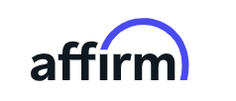

GARAUNTEED 0% INTEREST FOR 6 MONTHS!

You have the freedom to receive your favorite treatments – and Beauty Bar Academy Courses!

Don’t let financial concerns stop your self-improvement journey – we provide easy & accessible financing.

Beauty Bar Medical Clinic is delighted to present you with the opportunity to enjoy 0% interest financing for all our aesthetic/medical treatments and services!

Whether it’s Botox or Filler to rejuvenate your facial appearance or CoolSculpting to target stubborn fat – you can access these treatments without worrying about budget!

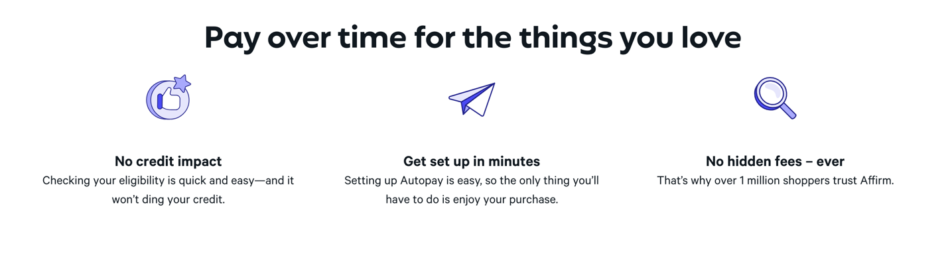

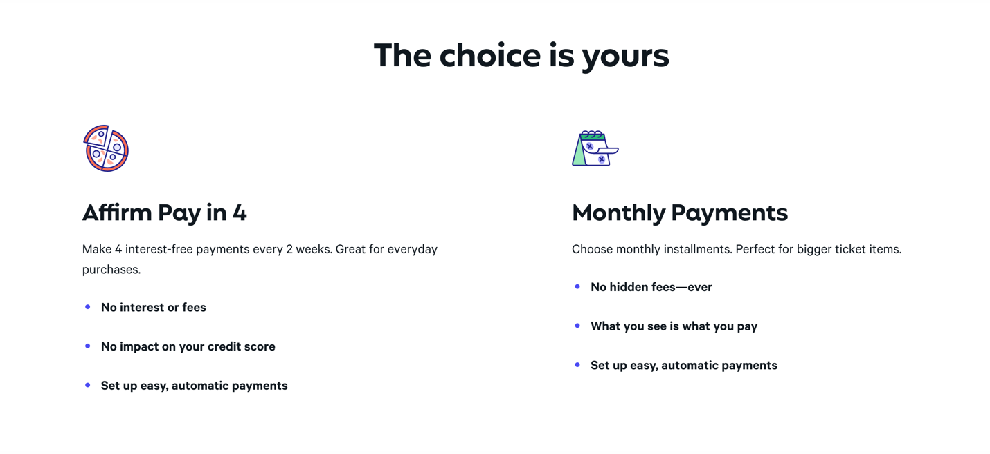

We will also be sending in a link for PRE APPROVAL and a QR Code that we will be adding to the page.

