Bello Corpo Med Spa - Secret Shopper Leads Test Report Summary
Overall Analysis: High Priority - Requires immediate attention
Spa Response time: Phone call: No Phone calls placed to the lead
Spa Response time: Text Message: No Text Messages placed to the lead
Spa Response time - No Email Messages sent to the lead
Problems with form/button: NONE
Follow up Phone call: NONE!
Follow up Phone Email: NONE!
Follow up Phone Text: None!
Staff’s Handling of Calls from Potential Leads Directly: Needs Improvement
On September 27th, 2019, at 9:39 AM EDT, a Secret Shopper lead test was performed on Bello Corpo Med Spa. This included filling out a lead form on the website and later calling the spa directly. That was done in order to test the lead form, the response of the spa to leads coming in and overall handling of callers.
Below are the results.
Lead sheet was filled out at using the Coolsculpting link. This is the confirmation link.
The following information was entered in the lead form:

Name - Wendy Cruz
Email - wendylinda_0123@mail.com
Phone # - (347) 480-9290
Message - Hi, my boyfriend and I are looking to have our stomachs coolsculpted. thanks

Proof of Lead:
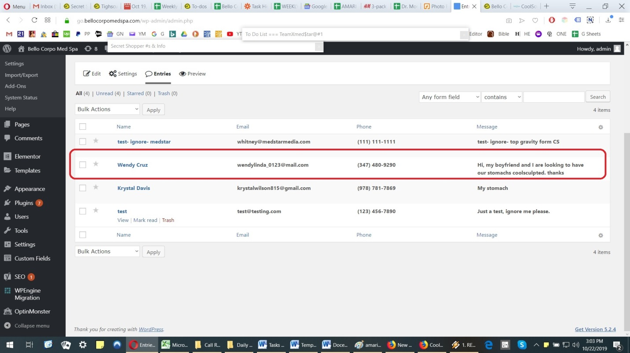

Bello Corpo Med Spa Staff did not respond or contacted the lead in any way, shape or form. That means there were no direct phone calls, no text messages, emails or any other type of method used contact the lead. More than 3 full weeks went by without any kind of contact to the lead by the Bello Corpo staff. Following this, the second phase of the Secret Shopper test went into effect where a phone call was placed to Bello Corpo Med Spa using the following tracking number - 781-214-3700.
Total number of calls: 1
Date: October 22, 2019
Time: 1:54 PM EDT
Call 1 -
The phone rang and an agent by the name of Renata answered. I informed her that I was calling in regards to Coolsculpting. I also told her that my girlfriend and I were interested in Coolsculpting and that she had filled out a form online. However, my girlfriend was never contacted by anyone at the spa at any time. The agent then apologized and asked me what I would like to know about Coolsculpting.
I then told her I had a few questions about Coolsculpting and the procedure. I asked the responding the agent the following questions:
1. How safe is the Coolsculpting Procedure? - The agent said it was an approved treatment and she then paused. After which, she told me that I should speak to the CS practitioner.
2. How many sessions will I need? - She responded by saying that I would have to book a consultation so that the technician could access me.
3. How much is the Coolsculpting consultation? - She said it was free.
4. What should I expect to pay for Coolsculpting? - Agent said it would depend on how many sessions I would need. But, she could not provide me with any prices over the phone.
5. How long before I see any results? - The agent stumbled on the answer and said she did not know.
Following our conversation I told her that I wanted to speak to the manager directly at a later time so she could answer some more questions.
---
Analysis on the website lead & phone call: The response to the lead by the Bello Corpo Med Spa staff requires immediate attention. That’s because they did not reach out to the potential lead obtained by their online forms being filled. The fact that not even an email was sent to the lead is also alarming. All of this happened even after more than three weeks went by.
On the call, agent Renata was courteous and tried to be helpful. However, she seemed unable to answer simple questions about Coolsculpting. In addition, the agent seemed to stumbled on some of the questions and even responded with a “I don’t know,” which is never recommended.
Areas that require attention and can be improved by the staff at Bello Corpo Med Spa:
- Within minutes of first contact by a potential lead, there should be – and should have been – a confirmation or welcoming email sent to them.
- A potential lead should be contacted via a direct phone call right away. Calls should generally be done within an hour at most. The staff not calling the lead at all needs to be addressed.
- A welcoming or acknowledgment text message should be sent out to the potential lead. This works in several ways, not just letting the lead know that their request has been received. It also helps create a personal line of communication between the Spa and the potential client.
- Responding agent should have been more assertive in asking lead to give her the information used to contact them. Often, telling leads that they need the information for their records works very well.
- Agent Renata did not mention any promotions or discounts on Coolsculpting. She also did not mention that the Coolsculpting consultation was free until the lead asked her about it. Generally, agents who mention discounts or promotions tend to set up a higher amount of appointments or consultations set up than those who do not.
- When the lead asked the agent how safe the Coolsculpting procedure was she stumbled on the answer, only saying that it was approved - not even using FDA - in her answer.
- When the lead asked agent how long should I expect to see any results she was unable to answer the question and said "She did not know" the answer. Using such words to any potential lead is never recommended and should be avoided.
- We recommend preparing responding agents with an FAQ’s answer sheet; not just for the Coolsculpting procedure, but other services as well.

