Bloom Health - CallRail Audit & Secret Shopper Results – July 25 to Sept 27
CallRail Audit Date range covering 51 calls from July 25th to September 27th, 2019
Secret Shopper Leads Test: Center’s Staff Needs Improvement
Observations & Assessments on Calls & Secret Shopper Leads Test:
- High Priority: Discovered a pattern where more than 36 callers hung up the phone right after the “Thank you for choosing Bloom Health” automated message began to play. It appears that the message confuses callers into thinking the call has gone to the Spa’s Voice Mail answering system. Or there might be something wrong with the phone system. Automation needs adjustment. See sample of call here
- Bloom Health had an extremely high number of "dropped," or calls that were hanged up by callers. About 36 of the 51 calls the spa received resulted in the callers hanging up before the line actually rang. That’s almost 70% of all calls being lost due to the automation system or some other problem.
- The staff for Bloom Health spa needs to improve on how they handle incoming leads from our secret shopper department. During our leads tests using the Spa’s online form to submit a lead, the response time from the staff was
- Secret Shopper leads test results: Requires attention. (See report below following CallRail audit)

To listen, first login here: https://app.callrail.com/
User: info@bloom.health – old account, now disabled. New one created.
Pass: CJBloom@248*$

Calls for Review:
Call 1) - Listen to Call Here
Notes on call – Caller wanted to schedule a consultation for Coolsculpting. She went on to schedule an appointment.
Extra analysis on call – During this call, the person calling wanted to set up an appointment for Coolsculpting. Overall, the responding agent handled the call very well. The only adjustment may be in the lack of mention on current promotions or Coolsculpting discounts the spa may be running. Appointment good, promotions adjust.
-----------
Call 2) - Listen to Call Here
Notes on call – Caller hung up the phone before the automation system reached the receptionist.
Extra analysis on call – One of 36 calls where the person calling chose to hang up the phone within 11 seconds of the call. All of the callers did not wait for the automated message to continue. That leads to the conclusion that callers may believe the phone went to the answering system. Automation adjust.
-----------
===================================================================================
Bloom Health - Secret Shopper Leads Test Results
On October 3rd, 2019, at 9:55 AM EDT, a Secret Shopper lead test was performed on Bloom Health. This included filling out a lead form on the website and later calling the spa directly. That was done in order to test the lead form, the response of the spa to leads coming in and overall handling of callers.
Below are the results.
Lead sheet was filled out at using the Coolsculpting link. This is the confirmation link.
The following information was entered in the lead form:

Name – Julio Rivera
Email - Mrp.990123@gmail.com
Phone # - (347) 480-9290
Message - Having problems with belly fat surrounding my waist.

Bloom Health’s response to the secret shopper lead test requires attention. That’s because no one from the spa had any contact with the prospective lead. There were no phone calls, text messages, emails or voice mails left to the lead. This was quite odd since the spa performed very well during their last Secret shopper leads test.
Following this, the second phase of the Secret Shopper test went into effect where a direct phone call was placed to Bloom Health using the following tracking number - 248-292-3647.
Total number of calls: 1
Date: October 8th, 2019
Time: 9:49 AM EDT
Call 1 -
The phone rang and the automated messaging system began to play. At that point someone picked up the phone whom I later found out was Dr. Nicholas Crawford. I proceeded to inform the Doctor of my reason for calling. I told the Dr. that I had filled out a form online a few days earlier regarding a Coolsculpting consultation but that no one had ever bothered to call me back. The doctor expressed concern and was surprised about this since he said the spa generally contacts leads back right away.
Once the secret shopper found out that it was the doctor himself answering the call, he proceeded to inform Dr. Crawford that it was a secret shopper leads test call taking place. He then informed the dr. that a test of the forms would be done to ensure all leads were being properly submitted.
--
Analysis on the website lead & phone call: Following Doctor Crawford’s statement that Bloom Health had received no lead notification, Chris Zelig himself began to check on the issue. Chris filled out a test form and checked the Wordpress site to make sure everything was working properly. Our staff also checked out Zappier forms, OptinMonster forms and other issues. All forms are properly set up and leads are being recorded properly. It turns out we are properly sending leads to Bloom Health and forms are recording them. The problem seems to be on Bloom Health’s end. *See screenshot attached.
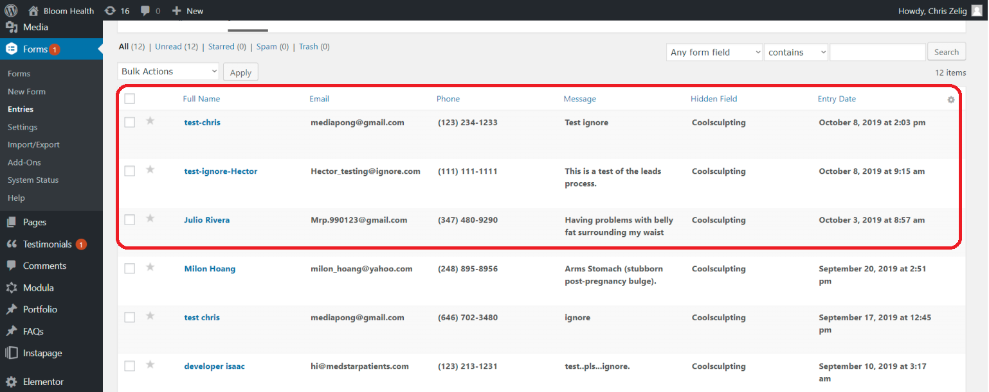

Areas that require attention and can be improved by the staff at Bloom Health:
- Problem with leads being properly routed or followed up on by Bloom Health’s system needs to be rectified as soon as possible.

