Body Morph MD Emsculpt Treatment Page Update.KA
Contour your physique with Emsculpt. This revolutionary body-shaping treatment is the first of its kind. It uses advanced electromagnetic energy to burn fat and build up muscle. Improve your performance and transform your physique with a tighter core, sculpted abs, a firmer buttock, and stronger arms and legs. Top rated Emsculpt provider in the Harrison, NY. area.

BENEFITS OF EMSCULPT BODY SCULPTING
- Build, strengthen, and tone muscles
- Reduce fat
- Safe and FDA cleared
- Scientifically proven
- Natural-looking results
- Improve athletic performance
- 30-minute treatments
- No downtime + painless

REAL RESULTS | EMSCULPT BEFORE AND AFTER*
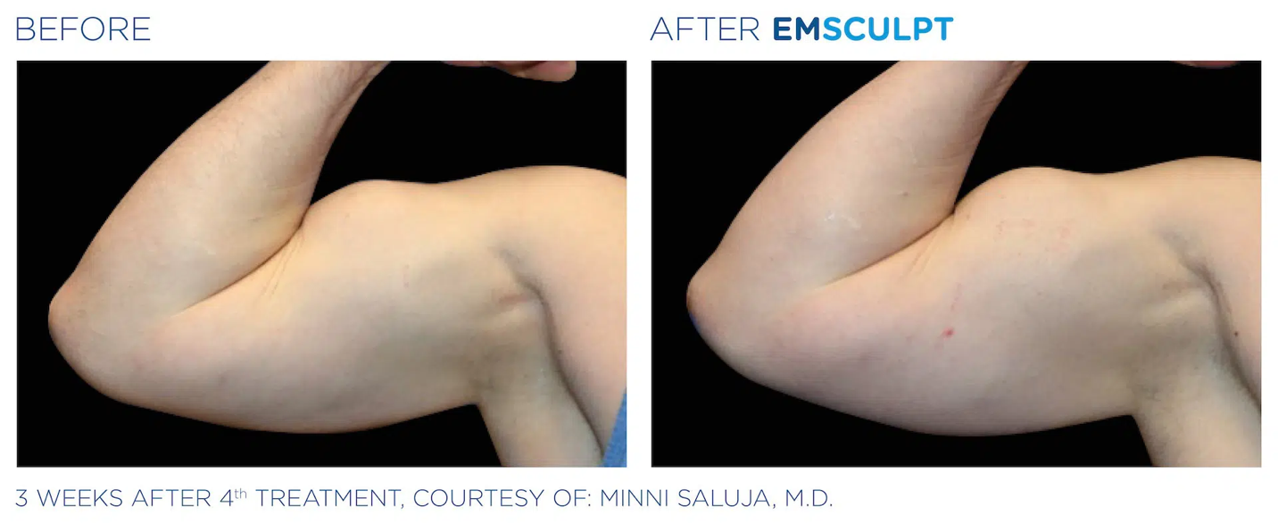
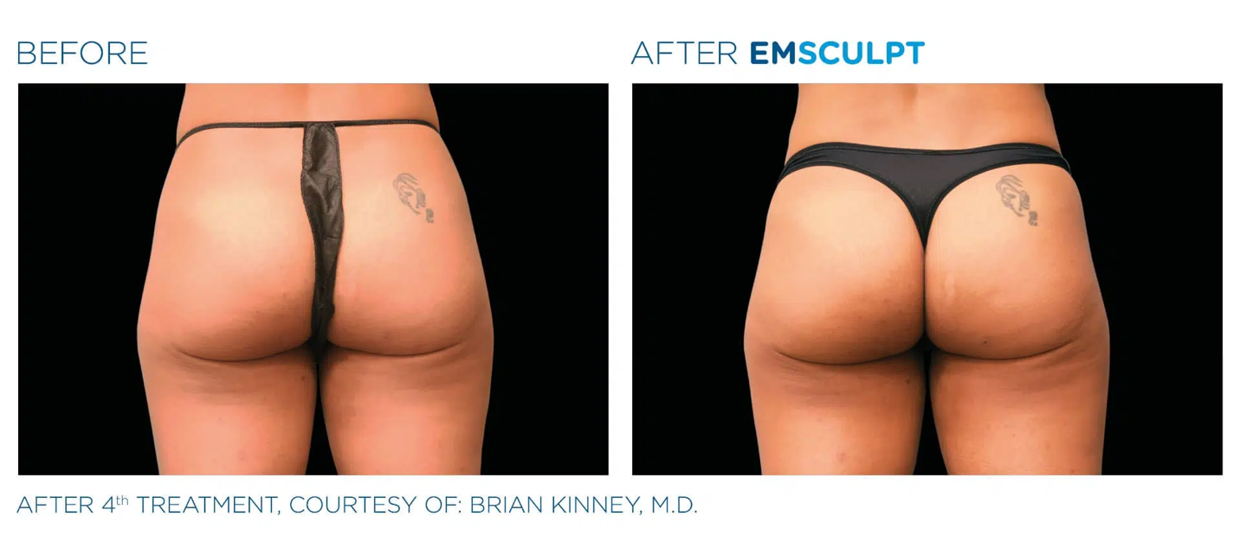
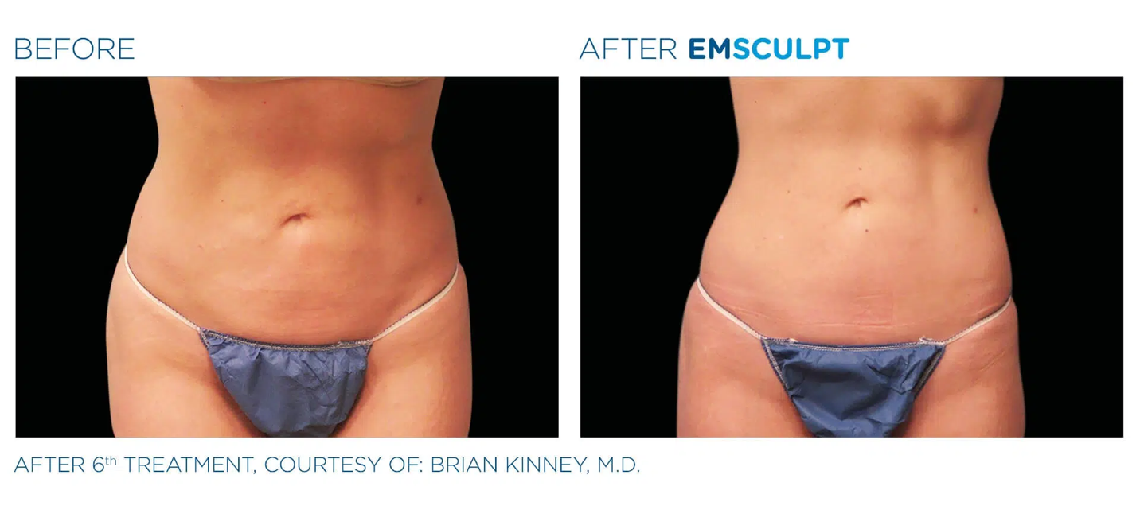
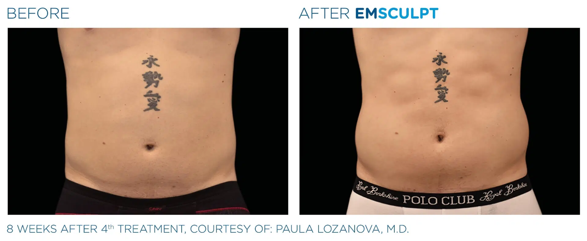
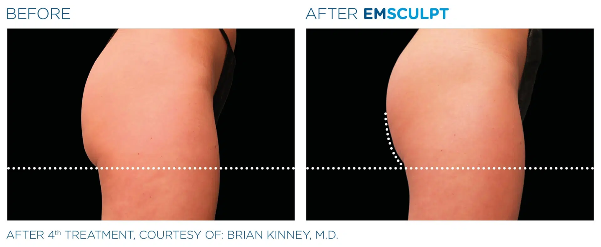
These pictures showcase actual patients and demonstrate real Emsculpt before and after results. As with any body-contouring option, individuals experiences may vary. *

HOW EMSCULPT WORKS
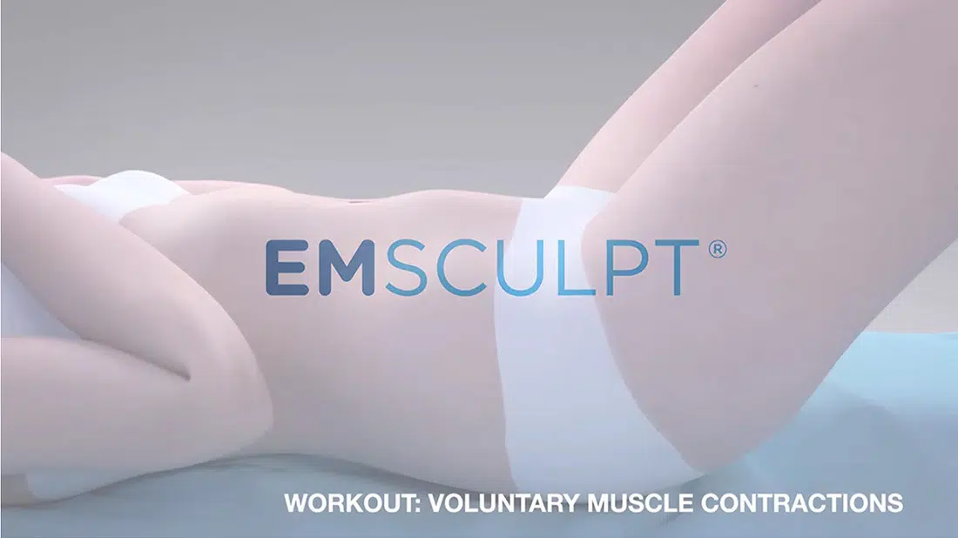
Play Video
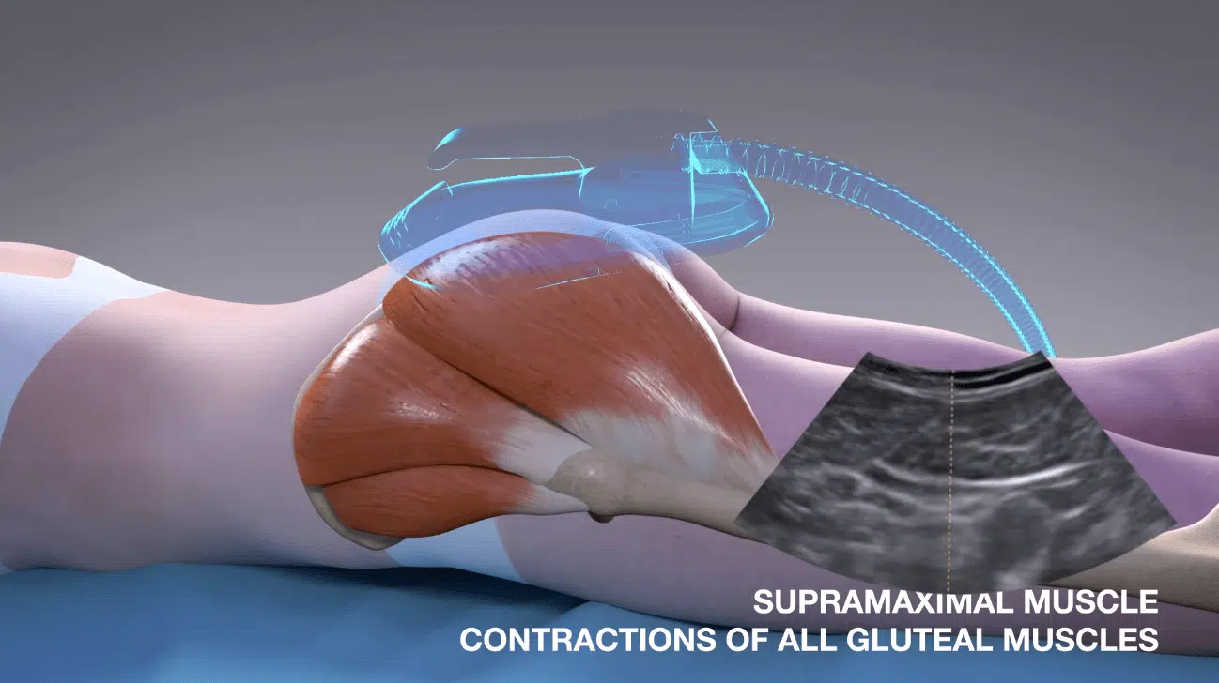
Play Video
Emsculpt, also known as M Sculpt, induces powerful contractions by stimulating muscle tissue with Highly Focused Intense Electromagnetic (HIFEM) energy. Known as supramaximal contractions, these contractions are faster and more intense than anything a person could initiate voluntarily with strength-building exercises.
A single, 30-minute treatment produces 20,000 supramaximal contractions. This is the equivalent of performing 20,000 reps of a muscle-building exercise, such as sit-ups or squats.
The body responds to these super-powerful contractions in two essential ways. First, it draws upon nearby fat cells to fuel the intense contractions. This reduces fat in the treatment area. Secondly, the body adapts to the powerful muscle workout by remodeling tissue. Muscle fibers become bigger, stronger, and more developed.
This all results in a stronger body and a slimmer, more sculpted physique.

EMSCULPT FOR HIGH-PERFORMANCE ATHLETES​
At Body Morph MD, we specialize in helping high-performance athletes become the best versions of themselves.
Emsculpt is an excellent resource for the competitive athlete. Electromagnetic muscle stimulation (EMS) is commonly used among elite athletes to strengthen their bodies and improve their performance. There are many reasons why EMS with Emsculpt can be a game-changer.
- The procedure works the muscles beyond what is humanly possible through voluntary effort. It takes most people a year in the gym to replicate the muscle-building contractions of a single Emsculpt treatment.
- Emsculpt induces muscle hypertrophy—tissue building—and promotes muscle tone. This makes the athlete stronger.
- A popular treatment application for athletes is the abdomen to strengthen the core. A tight, strong core is essential for division 1 athletes, especially swimmers who must engage their entire body for efficient stroke technique.
- Emsculpt reduces fat, helping athletes achieve their ideal body composition.
Emsculpt Reviews in Scientific Literature
Emsculpt is one of the newer advancements in non-invasive body sculpting technology. It has a significant amount of scientific evidence behind it to support its safety and efficacy. Several studies clinically evaluate Emsculpt using a spectrum of scientific methods, including Ultrasound, MRIs, and CT scans. The findings include: ¹²
- Muscle mass increased by 16% within 1 month after treatment*
- The increase in muscle mass improved to 18% within 6 months after treatment
- Fat was reduced by 19% within 1 month after treatment*
- The reduction in fat improved to 23% within 6 months after treatment
- 500% increase in fat metabolism (apoptotic index increased from 19% to 92% after treatment)
- 80% patients demonstrated visible lifting effect of buttocks
- Waist circumference decreased by 4.4 cm (nearly 2 inches.)*
- No adverse side effects were seen in any of the studies
*Results will vary per person.

MAJOR MUSCLE GROUPS
Emsculpt targets four major muscle groups. These include:
- The abdomen: strengthen the core and sculpt six-pack abs
- The upper legs: Firm your quads and hamstrings and tone your thighs
- The upper arms: Sculpt your triceps and biceps
- The buttocks: Adds subtle lift and firms the buttocks to provide a non-surgical alternative to a butt lift.

TREATMENT AND EMSCULPT RESULTS
To achieve optimal results, most patients undergo four treatments, spaced 2 or 3 days apart. After each procedure, the targeted muscle group may feel sore for a day or two. This soreness is like the muscle fatigue one feels after an intense strength training session at the gym. Individual experiences may vary, but most patients see improved muscle tone within 2 to 4 weeks after their treatment. *

EMSCULPT AT BODY MORPH MD
Emsculpt, like all body-contouring treatments, is technique sensitive. Therefore, the experience and proficiency of the person performing the treatment affect your results. Many providers of Emsculpt in the New York area delegate this skill-dependent procedure to their estheticians. Lacking medical experience, these providers may compromise a patient’s safety and outcome.
In comparison, Emsculpt treatments from Body Morph MD are performed by Dr. Teresa Lantin, MD. Using his 25 years of experience in the medical field, Dr. Lantin provides patients with the highest standard of care and most optimal results possible,

EMSCULPT BODY SCULPTING IN NEW YORK
If you want to improve your performance or transform your physique, get started with Emsculpt today by scheduling a consultation with Body Morph MD. Conveniently located in Harrison, Body Morph MD is the leading provider of Emsculpt in the Harrison, New York area and is proud to serve the communities of Westchester and Greenwich. Call Body Morph MD today at (914) 953-2955 or reach out online via the form below.
EMSCULPT FAQS

H2: How much does Emsculpt cost?*

Emsculpt’s powerful muscle building treatment can be entirely customized to fit each patient’s individual goals. Therefore, the answer to “How much is Emsculpt?” varies depending on the specific needs of the patient.* Pricing is extensively covered during your consultation with Body Morph MD. We will also discuss financing options and ways to save on Emsculpt cost.
As the premier provider on non-invasive body contouring, Body Morph MD offers new clients 25% off Emsculpt cost when they sign up for a consultation.
H2: How long do Emsculpt results last?*

Emsculpt’s results on the muscle typically last around six months or longer. It is often recommended that patients receive a series of 4 to 8 treatments to see the full results. You may also need to come in for maintenance treatments as needed. As always, results vary per person.*

H2: Does Emsculpt flatten the stomach?

Emsculpt is a unique body sculpting treatment. It can not only melt away fat, but it also tones the muscles at the same time. This results in the flattening out of the belly and a more firm, strong core and midsection.

H2: Who should not use Emsculpt?

Emsculpt is a body sculpting treatment capable of treating almost anyone. However, it is recommended that patients with an implanted electronic device, such as a pacemaker or an artificial joint in the treatment zone, avoid this type of treatment. It is best to speak with your doctor before the treatment to ensure you are the best candidate for body sculpting with Emsculpt.

H2: What are the negative effects of Emsculpt?

Aside from mild muscle soreness, there are no notable side effects of the Emsculpt treatment.

H2: Do celebrities use Emsculpt?

Emsculpt and Emsculpt NEO are known for being very popular in Hollywood with celebrities like Drew Barrymore, The Kardashians, and more. This is because Emsculpt improves the body shape with any downtime so you can continue your regular schedule without missing a beat.

H2: Is Emsculpt better than CoolSculpting?

If you want to spot-reduce fat, CoolSculpting is a good treatment for you. However, if you want to strengthen and define your muscles, Emsculpt is the best treatment. Emsculpt provides better muscle definition in the abs, arms, legs, and buttocks.

