500 word update to Botox.Service Page.Body Morph MD.KA

Link to page: https://bodymorphmd.com/botox/

*THIS CONTENT WILL REPLACE THE CONTENT ON THE PAGE: THE SLUG STAYS THE SAME*

NEW Meta Title: Botox Harrison + Yonkers, New York | Treat Wrinkles at the Source

*slug stays the same*

NEW Meta Description: Body Morph MD in Harrison & Yonkers, NY, rejuvenates your appearance with anti-aging injectables including BOTOX, Dysport, Daxxify, and Xeomin.

NEW H1 Botox Treatments
NEW H2 Harrison and Yonkers. New York

BOTOX |S THE SAFEST, MOST EFFECTIVE ANTI-AGING TREATMENT
Botox is the #1 non-invasive cosmetic treatment. It helps countless people around the world look younger and more rejuvenated. The popular procedure safely and successfully reduces the signs of aging without invasive operations or downtime. Botox is also the perfect alternative to surgical procedures like facelifts or brow lifts. This cosmetic injectable smooths out fine lines and wrinkles around the forehead, brows, and eyes. When a reputable professional administers Botox, the results look natural and relaxed, never frozen.

Ensure you receive the best Botox results with Body Morph MD. We proudly serve clients living in Yonkers and Harrison and the surrounding areas of the Upper West Side, Westchester, and Greenwich areas. Call us at 914-391-1274 to schedule a consultation to learn more about Botox and how it can rejuvenate your skin and help you appear more youthful.

BENEFITS OF BOTOX
- #1 cosmetic treatment
- Reduces the signs of aging
- Safe and clinical proven in over 400+ studies
- Natural-looking results
- Ideal for everyone aged 20 and up
- Master injectors provide superior results

H2 Popular Botox Treatment Areas
Botox cosmetic injections are approved to treat the following areas and concerns:

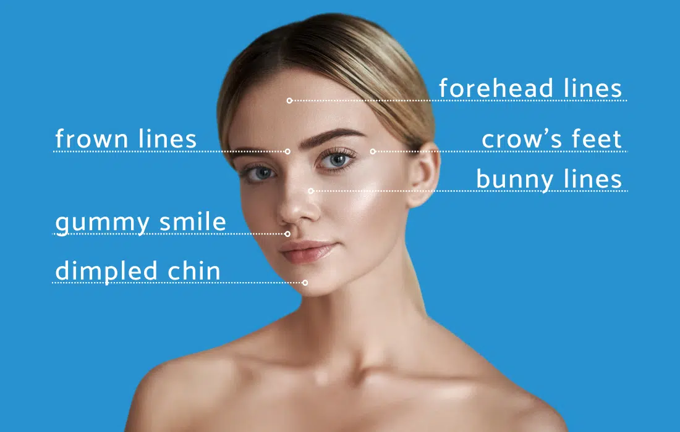

- Forehead Lines (Glabellar Lines): Lines above the eyebrows that run horizontally. They are often caused by facial expressions we commonly make when we are happy or sad like scowling, frowning, or laughing.
- Frown Lines: Vertical lines between your eyes. Often caused by repeated action of the underlying muscles, including frowning.
- Crow’s Feet: Lines in the outer corners of our eyes.
- Bunny Lines (Transverse Nasal): Horizontal lines at the top of the nose.
- Gummy Smile (Non-surgical Lip Augmentation): Botox is used during a Lip Flip where injections are strategically placed to make the top lip unfurl, appearing fuller.
- Dimpled Chin (Chin Dents): Dents in the chin due to underlying muscles.
- Perioral Lines (Smoker’s Lines): Fine vertical lines around the mouth.
- Marionette Lines: Commonly corrected with dermal fillers, Botox can smooth marionette lines.
- Brow Lift: The muscles in the forehead can be relaxed, resulting in a more lifted forehead and brow area.
- Vertical Platysma: Botox improves overactive platysmal bands in the neck that create vertical bands.

h2 botox cosmetics WHAT IS BOTOX?
Botox is an anti-aging treatment that is entirely non-invasive. It leaves patients looking dramatically younger and more rejuvenated. Botox and similar neuromodulators consist of a natural, purified protein known as Botulinum Toxin. Botox injections target the dynamic wrinkles commonly found around the brows, known as Glabellar lines, the forehead wrinkles, and fine lines around the eyes, also known as crow’s feet.

h2 understanding how botox injectables work HOW DOES BOTOX WORK?
To understand Botox, it helps to understand dynamic wrinkles. These wrinkles are known as expression lines. They appear after years of repetitive muscle contractions. When you smile, frown, squint, or laugh, your expression muscles contract and relax. This action pulls, folds, and releases the skin above the muscle. As you get older, collagen and elastin (structural proteins allowing your skin to spring back into place) start to break down. The repetitive muscle contractions begin to take a toll on your skin, leaving a permanent crease, known as an expression line or dynamic wrinkle. Dynamic wrinkling is found around the most expressive areas of the face: the eyes and the brows.
Botox treatments smooth out and soften dynamic wrinkles by temporarily relaxing the underlying muscles responsible for expression lines. Your master injector at Body Morph MD injects a small amount of Botox directly into the muscle below the wrinkles or fine lines. The neuromodulator temporarily blocks the signals telling the muscles to contract. This action allows the muscle to relax and lengthen, releasing the skin, thus effectively smoothing out the overlying wrinkles.

BOTOX BEFORE AND AFTER*
The Botox before and after pictures show actual patient results and how Botox alters the appearance. Individual experiences may vary. However, the people in the Botox before and after images received their injections from a reputable professional. The more experience the injector has, the better the anti-aging results.
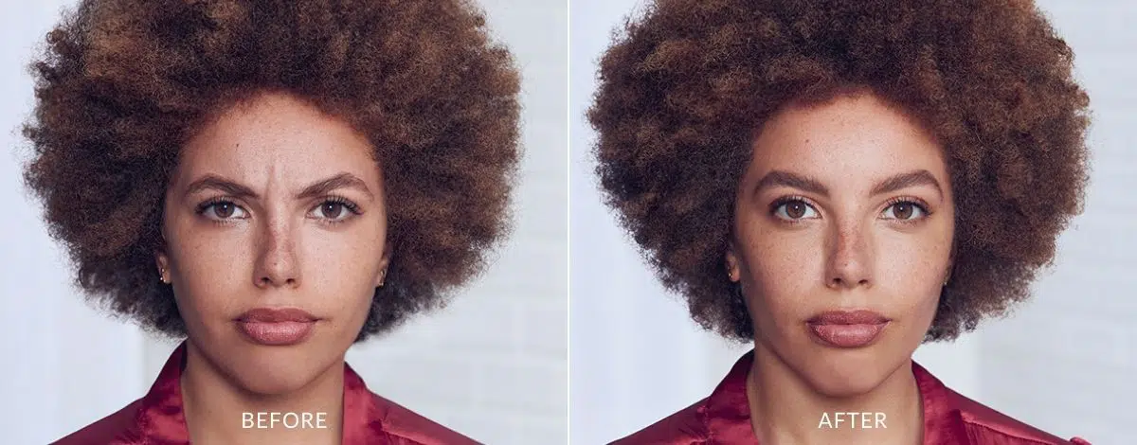
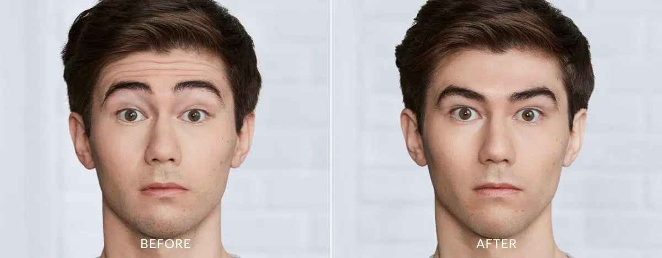
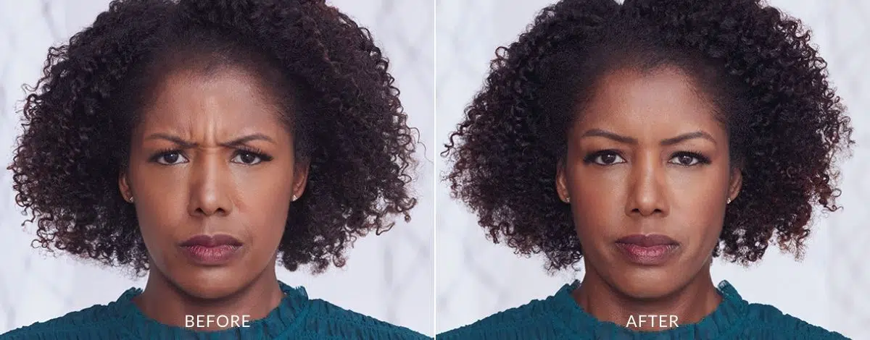
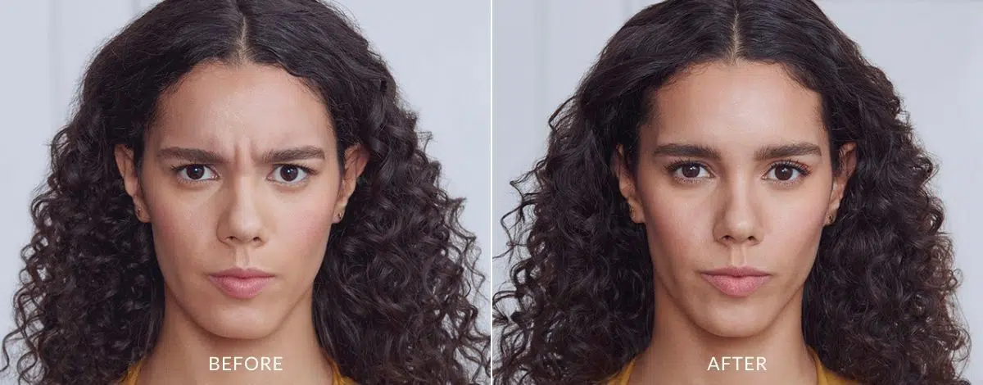
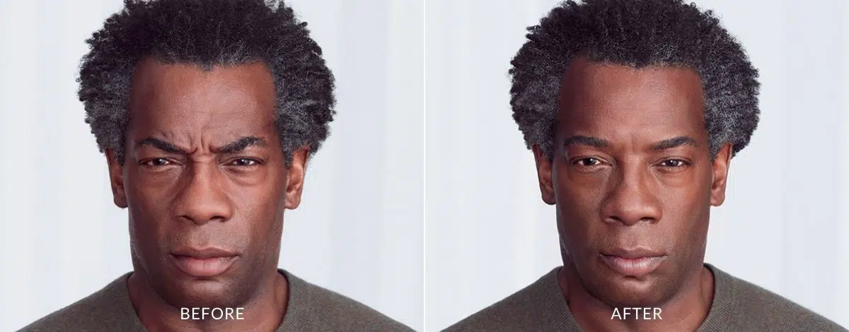
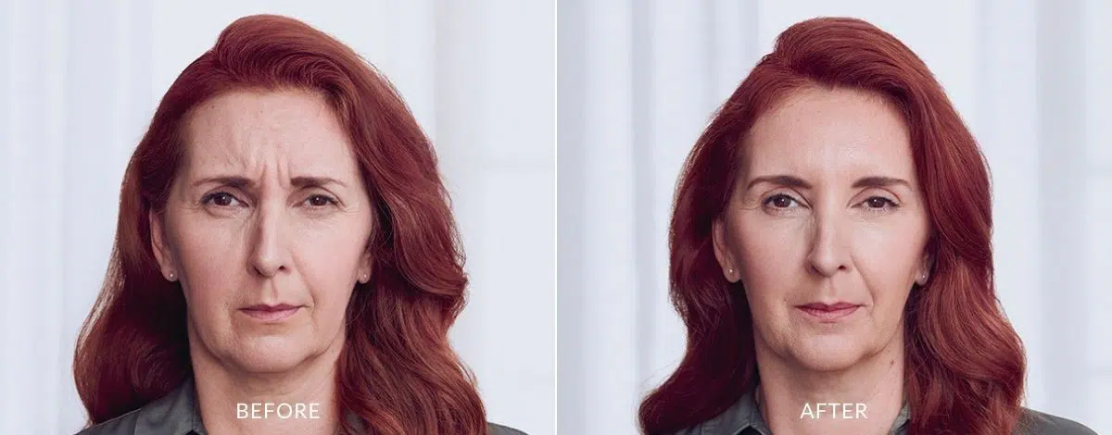

h2 botox results*
As with any cosmetic procedure, individual experiences vary. However, most patients see results within 24 to 72 hours after their injection. These people also enjoy the anti-aging benefits of Botox for 3 to 5 months afterward. In addition to managing fine lines and wrinkles, recent studies support Botox’s ability to prevent expression lines from every forming when done as a routine preventative treatment. When adults in their 20s and 30s get Botox regularly, they are likely to prolong their youthful appearance well into the 40s and 50s. As always, Botox results will vary per perso.*

IS BOTOX SAFE?
Botox is cleared by the FDA and scientifically proven to be safe and effective. There are nearly 500 clinical studies published on the neuromodulator, making Botox one of the most extensively studied and most understood treatments of all time. However, the rate of Botox risks also depends on the experience and competency of the professional you select. Therefore, finding the best provider in AREA is critical to secure a safe Botox experience.

H2 Additional Botox Treatment Applications
Botox injectables are used mostly for facial rejuvenation. However, this popular formula has a wide variety of treatment uses, including:
- Treating Migraines: Botox injections have been approved by the FDA to treat chronic migraines. Chronic migraines are a headache on 15 or more days a month. This treatment involves specific injection placement around pain fibers involved in a headache. This application helped countless of men and women overcome severe and often debilitating migraines.
- Treating excessive sweating: Now, Botox is FDA-approved to treat excessive sweating. Also known as hyperhidrosis. When injections are given under the skin, the formula selectively turns off sweat glands. This allows normal sweating with a reduction in noticeable wetness.
- Improving plantar fasciitis and foot pain: Botox for the feet is becoming a new and widely used treatment. Injections in the feet mitigate foot pain associated with specific medical foot concerns like plantar fasciitis.

H2 Preventative Botox Treatments
When people consider Botox, it is often as a reactionary process. However, Preventative Botox is becoming more popular with time. This type of treatment involves beginning Botox regularly as early as 20 years old to prevent the formation of dynamic wrinkles or static wrinkles. It does this by targeting expression muscles early in adulthood before the repetitive contractions lead to permanent creases and lines in the overlying skin.

H2 Introducing New Anti-Aging Injectables to Body Morph MD

Body Moroh MD is proud to offer three new anti-aging injectables: Dysport, Daxxify, and Xeomin.

H3 Dysport

Dysport is another popular anti-aging injectable. Like Botox, it is also made from Botulinum Toxin Type A. Dysport rejuvenates the face, enhances facial features, restores facial symmetry, and transforms appearance. It is FDA-cleared and provides natural-looking, fast-acting results. Dysport was specifically made to target and treat moderate to severe frown lines without changing the movement of the face. It delivers incredible results in as fast as 2 to 3 days.
H3 Daxxify*
Daxxify is known as the new toxin in town. It is the newest FDA-approved neurotoxin for smoothing moderate to severe frown lines between the brows. Daxxify uses Botulinum Toxin Type A for relaxing facial muscles that cause wrinkles. It reduces the appearance of frown lines that often cause you to look angry or even old. Daxxify injections are also known as the only long-lasting frown line with a peptide formula. In addition, on average, this revolutionary injection lasts 6 to 9 months for some people. As always, individual experiences vary.*
H3 Xeomin
Like Botox, Dysport, and Daxxify, Xeomin is made from the same Botulinum Toxin Type A. It is a prescription medication for a cosmetic injectable injected into the muscles of the face for temporary muscle relaxation. Xeomin is known for improving the appearance of moderate to severe frown lines or glabellar lines in adults. In addition, Xeomin treats forehead creases or crow’s feet around the eyes. It is praised for being the most purified neurotoxin available.

BOTOX SIDE EFFECTS AND BOTOX RISKS
As long as you take time and consider your professional Botox provider, the side effects and risks are rare. During a consultation at Body Morph MD, your specialist discusses Botox side effects in detail and answers all questions regarding any risks.

HOW MUCH DOES BOTOX COST?
Botox is an affordable treatment. However, specific Botox cost varies from person to person. During your consultation, Botox prices are talked about in detail, and a treatment plan is created to match your desired outcome and fit within your financial budget.

HOW LONG DO BOTOX RESULTS LAST?
As with any cosmetic procedure, individual experiences vary. However, most patients see results within 24 to 72 hours after their injection. These people also enjoy the anti-aging benefits of Botox for 3 to 5 months afterward. In addition to managing fine lines and wrinkles, recent studies support Botox’s ability to prevent expression lines from every forming when done as a routine preventative treatment. When adults in their 20s and 30s get Botox regularly, they are likely to prolong their youthful appearance well into the 40s and 50s. As always, Botox results will vary per perso.*

h2 experience the best anti-aging injectables in new york BOTOX NEAR ME
Reclaim your youthful appearance and avoid dynamic wrinkles with Botox. Now, you can also treat wrinkles and common signs of aging with Dysport, Daxxify, or Xeomin. Body Morph MD is proud to offer so many anti-aging injectable opinions to our amazing clients in New York. Learn more about the most popular anti-aging treatment and discover if Botox is right for you. Call Body Morph MD at 914-391-1274 and schedule your consultation today.
H2 BOTOX FAQs

H3 Is Botox safe?

Botox is cleared by the FDA and scientifically proven to be safe and effective. There are nearly 500 clinical studies published on the neuromodulator, making Botox one of the most extensively studied and most understood treatments of all time. However, the rate of Botox risks also depends on the experience and competency of the professional you select. Therefore, finding the best provider in AREA is critical to secure a safe Botox experience.

H3 How much does Botox cost in New York?

Botox is an affordable treatment. However, specific Botox cost varies from person to person. During your consultation, Botox prices are talked about in detail, and a treatment plan is created to match your desired outcome and fit within your financial budget. When you select Body Morph MD with two convenient locations in New York, Harrison and Yonkers, you receive the best anti-aging injectables at the best price.

H3 Are there risks or side effects with Botox injections?

As long as you take time and consider your professional Botox provider, the side effects and risks are rare. During a consultation at Body Morph MD, your specialist discusses Botox side effects in detail and answers all questions regarding any risks.

