DYSPORT®
Dysport is a natural-looking, fast-acting, long-lasting prescription injection proven to help smooth moderate to severe frown lines between the eyebrows—without changing the look or movement of the rest of your face.
- Injections are quick (10 to 20 minutes) and have practically no downtime.
- For some people, Dysport may kick in faster than other injectable neurotoxins.
- Dysport may create a more natural look than other neuromodulators.
- Many people report that it lasts longer than other neuromodulators.

ONE INJECTION. FIVE POINTS.

Dysport temporarily treats moderate to severe frown lines between the eyebrows by reducing specific muscle activity. Wrinkles are caused by repeated movements and muscle contractions. One injection into each of the 5 points between and above the eyebrows temporarily prevents muscle contractions that cause frown lines.
In other words, natural-looking results that look and feel like you.

DYSPORT® FAQS
Find quick and simple answers about Dysport for treatment of frown lines between the eyebrows.

WHAT IS DYSPORT USED FOR?
Dysport is a prescription injection administered by a licensed healthcare professional to treat moderate to severe frown lines (those wrinkles between the eyebrows). Medically, it’s a botulinum neurotoxin (abobotulinumtoxinA), an acetylcholine release inhibitor and a neuromuscular blocking agent. It temporarily prevents specific muscle movements that cause frown lines.

WHAT ARE DYSPORT INJECTIONS?

HOW LONG DOES IT TAKE TO ADMINISTER?

HOW LONG DOES IT TAKE DYSPORT TO WORK?

HOW LONG DOES DYSPORT LAST?

IS DYSPORT DIFFERENT FROM BOTOX® COSMETIC?

RESULTS WHEN YOU NEED THEM.
You’ve got better things to do than think about what your frown lines look like. The majority of users see improvement in just 2-3 days after treatment. In just one 10- to 20-minute treatment, Dysport may help improve the look of your frown lines between the eyebrows for up to 5 months. Results of repeat treatments may be comparable to your first use. Another plus? There is minimal downtime after your treatment, which means you can get back to your day faster.
Dysport users were satisfied with their results–and with only two treatments per year.

DYSPORT® BEFORE AND AFTER*
It’s not a facial transformation—far from it. Dysport® treatment temporarily improves the look of your moderate to severe frown lines between the eyebrows in a way that suits your style. And no one will know—unless you tell them. Check out our gallery below and see for yourself.
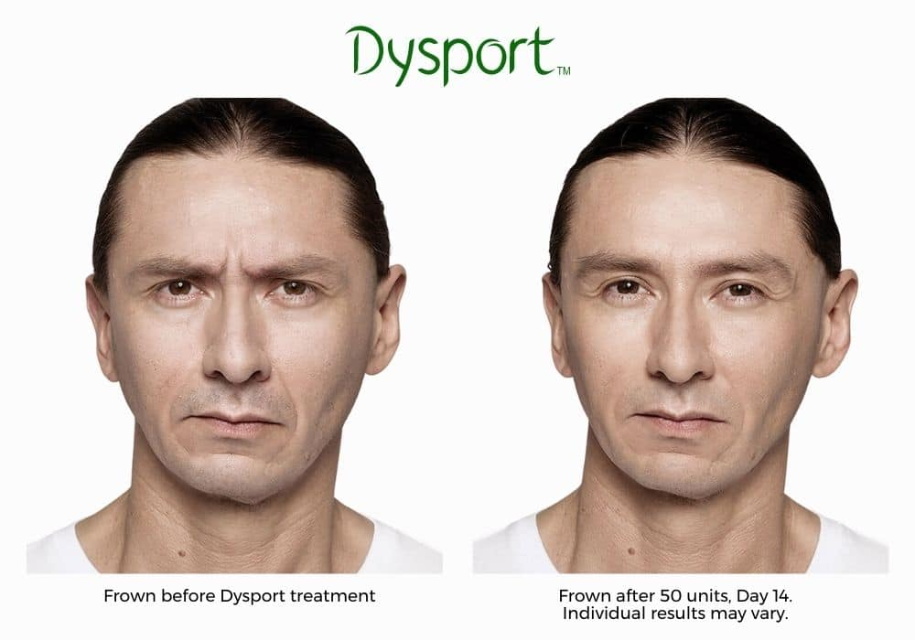
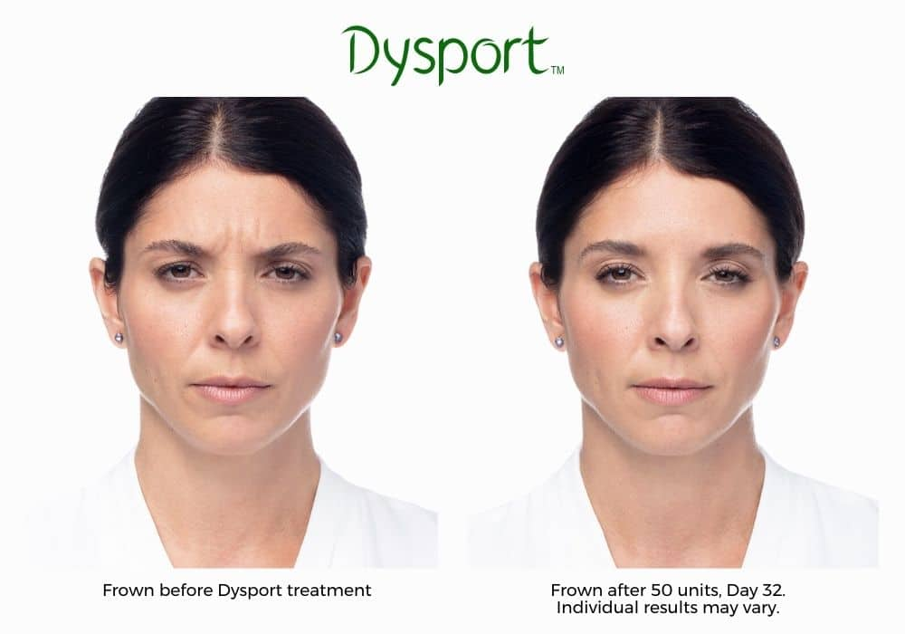
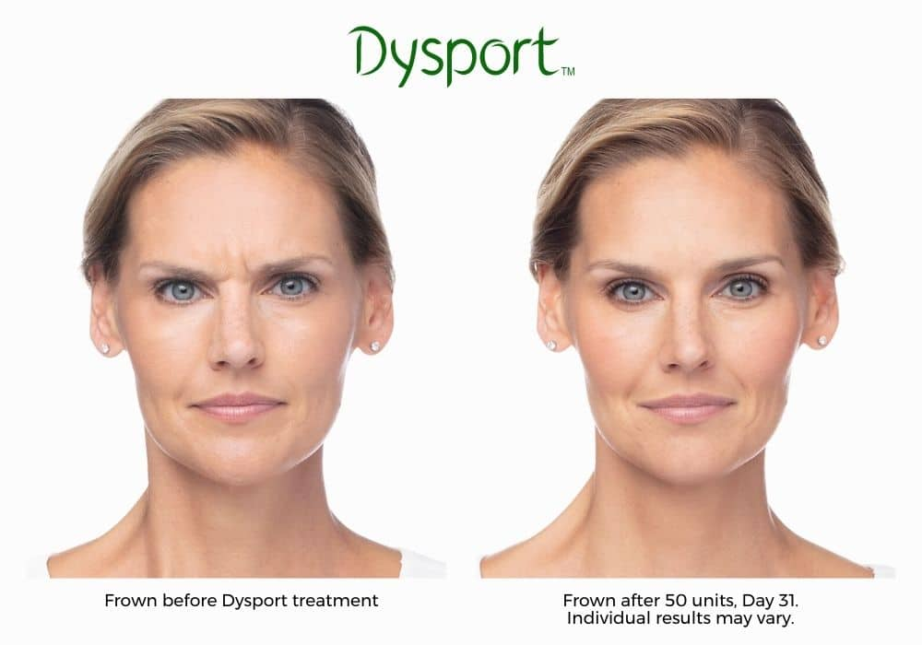
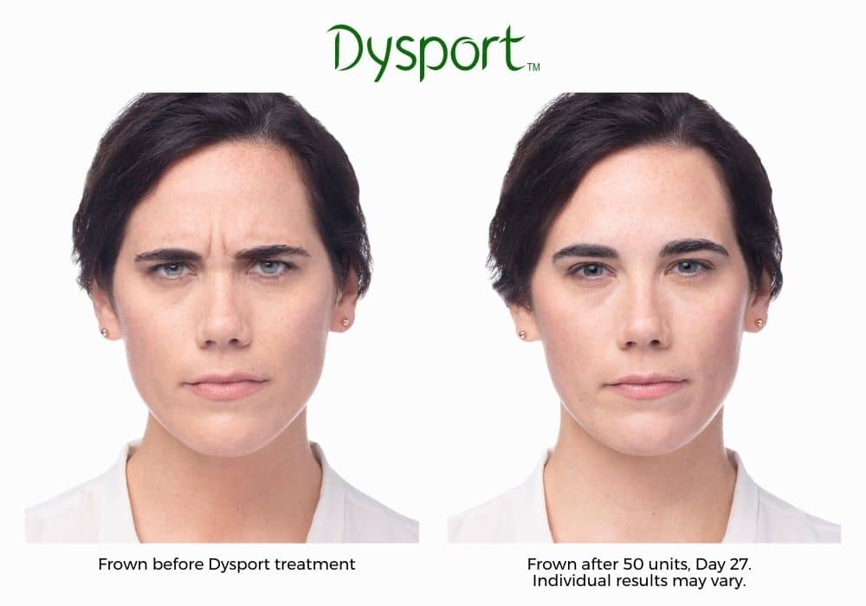
*results may vary

