JEUVEAU
You know those pesky little wrinkles between your eyebrows that won’t go away? Well, they’re called glabellar lines, or “frown lines.” Jeuveau® is an injectable treatment that works to temporarily improve the appearance of moderate to severe frown lines in adults. Jeuveau™ is similar to the popular Botox® treatment but formulated specifically for cosmetic use.
Jeuveau® is a prescription medicine that is injected into muscles and used in adults for a short period of time (temporary) to improve the look of moderate to severe frown lines between the eyebrows (glabellar lines).


BENEFITS OF JEUVEAU
- Soften wrinkles and fine lines
- Smooth Frown Lines
- Look and feel more rejuvenated
- FDA cleared as safe and effective
- Quick, 10-minute treatment
- Natural Looking

JEUVEAU BEFORE AND AFTER*
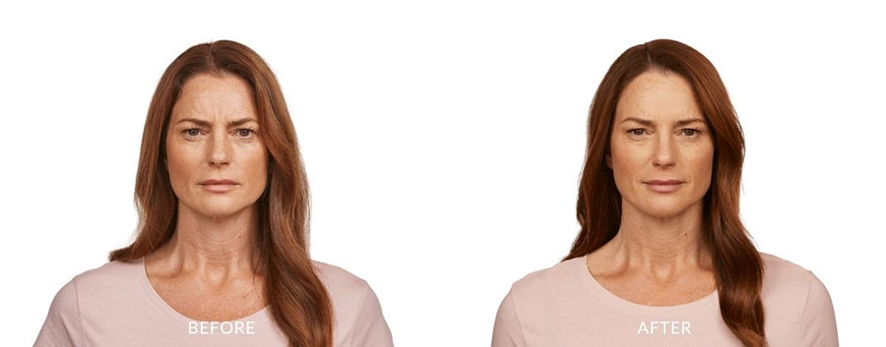
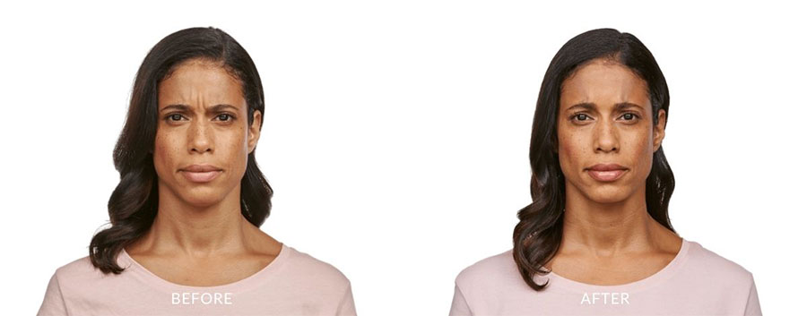
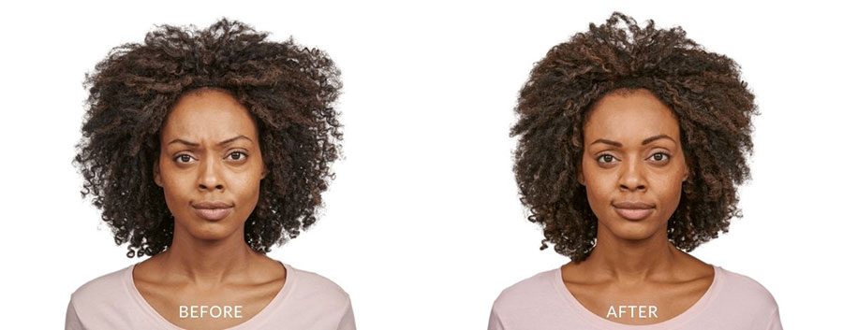
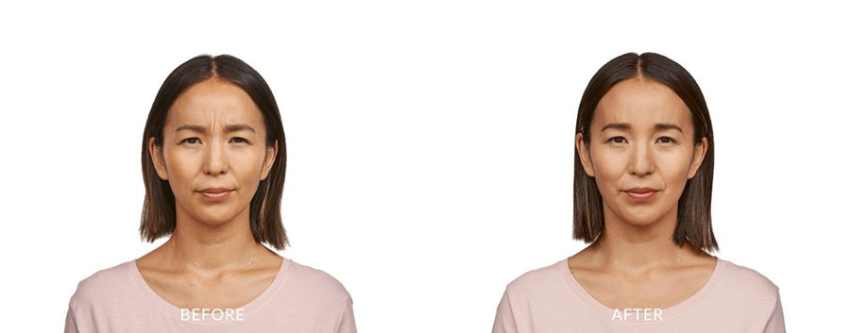
*results may vary

HOW DOES JEUVEAU WORK?
When injected, Jeuveau® temporarily prevents your nerves from telling your facial muscles to flex. The result? In clinical trials, Jeuveau® was shown to temporarily improve the appearance of moderate to severe frown lines.
In clinical trials, Jeuveau® was shown to temporarily improve the appearance of moderate to severe frown lines. In US studies, 68% and 70% of Jeuveau® patients had a 2-grade or better physician and patient-rated improvement in frown lines at Day 30. But that’s not all. In a study conducted in Europe and Canada, 54% of patients had visible results as early as 2 days after treatment.* And at 5 months after treatment, 38% of patients had visible results with Jeuveau® **
* 54% of patients had a >1-grade improvement in frown lines at Day 2 based on physician assessment compared to 12% for placebo (secondary endpoint). In US studies, 46% and 56% had a >1-grade improvement in frown lines at Day 2 based on physician-assessment compared to 8% and 17% for placebo (exploratory endpoint). Results based on a 1-grade improvement may not be considered clinically meaningful.
** 38% of patients had a >1-grade improvement in frown lines at 5 months based on physician assessment compared to 8% for placebo (secondary endpoint). In US studies, almost 5% of patients had a >2-grade improvement in frown lines at 5 months based on both patient and physician assessments compared to 0% for placebo (secondary endpoint). Results based on a 1-grade improvement may not be considered. What are the results with Jeuveau®? Clinically meaningful.

WHAT’S IT LIKE BEFORE & AFTER TREATMENT?
If it’s your first time getting a treatment, you may be a little nervous and that’s okay! Localized pain, infection, inflammation, tenderness, swelling, erythema, and/or bleeding/bruising may be associated with the injection.
For specific instructions on what to do before and after your injection, please follow the instructions given to you by your doctor or healthcare provider.

JEUVEAU® NEAR ME
Reverse signs of aging with Jeuveau. If you are interested in Jeuveau anti-aging treatment, Schedule your free consultation with Jeuveau to discuss your concerns and all of your treatment options to ensure that Jeuveau is right for you.

