IV Nutritional Therapy

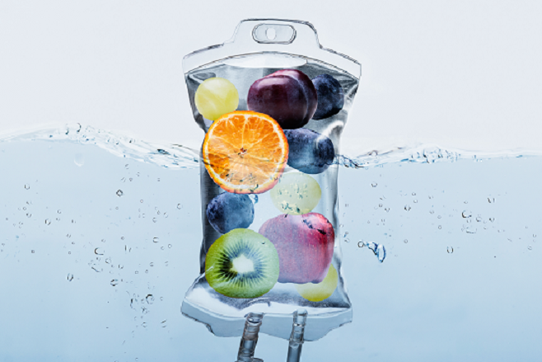

Calista Skin and Laser Center is excited to now offer Intravenous (IV) Nutritional Therapy at our Wellness Clinic. IV nutritional therapy is a method of delivering vitamins, minerals and other vital nutrients to the body directly into the bloodstream. A small intravenous catheter is placed into a vein and these nutrients and saline solution are infused. In less than an hour, you’ll feel hydrated, refreshed and energized. Many people rely on these treatments to recover from hangovers, jet lag, illness and more. However, when IV therapy is used as part of a wellness routine it can help combat aging, boost brainpower, control stress, and/or reduce symptoms of various medical conditions. Let’s slow down the progression of aging and improve overall health.

Myer’s Cocktail
Reduce seasonal allergies, fatigue, and inflammation, and restore natural balance.
Learn More:

Recovery & Performance Drip
Decrease recovery time and enhance your athletic performance by combating fatigue from dehydration.
Learn More:

Immunity IV Drip
Strengthen your immune system and feel better faster.
Learn More:

Inner Beauty Drip
Reduce appearance of wrinkles and fortify hair, skin and nails.
Learn More:

Glutathione Drip
Do you know that glutathione is a powerful antioxidant that’s found naturally in the body? But stress, medications, aging, and bad health can deplete glutathione levels. Antioxidants combat free radicals that can damage healthy cells.
Learn More:

Tri-Immune Boost Injection
Is a triple defense immunity formula that consists of potent antioxidants and an essential mineral that assists in supporting the body’s immune response.
Learn More:

Benefits of IV therapy:
- Hydration
- Anti-Aging
- Detoxification
- Increased Immunity
- Increased Energy
- Improved Skin Appearance
- Increased Collagen Production
- Promote Healthy Hair & Growth
- Reduction in Headaches
- Improved Well-Being

Common Questions:
Why do IV therapy? It’s a great addition for people that are health and fitness minded or people that want to replenish their body of essential vitamins, amino acids and minerals. These nutrients work to help prevent illness and increase energy levels.
What should I expect? Before your first treatment a complete medical history must be completed by the nurse practitioner. The history will provide risk assessment of the patient which includes a list of current medications as well as any active diseases. It is important to begin hydrating 24 hours prior to your appointment for easier access to your veins.
Can anyone do IV therapy? It’s very safe and most people will enjoy the benefits. However, you’re not a good candidate for IV therapy if you have kidney disease, active liver disease, congestive heart failure, diabetes or hypertension.
Are there side effects? Most people feel very good after IV therapies. However, some people will temporarily feel worse; symptoms include headache, general uncomfortable feeling, diarrhea or constipation, flu-like symptoms or body aches. These negative-like symptoms may arise from certain ingredients causing a strong detox effect and the organs are being overworked.
How long does it take? Most IV’s given at Calista only take 30-45 minutes. Feel free to bring any internet device to keep up with your work, reading or listen to music.
Is there an alternative to IV therapy? Yes, we offer several injections that will help to replenish vital nutrients. These are a great alternative to IV therapies and can be done in the office in less than 5 minutes. You’ll love the Tri-Immune Boost injection.

