Hello Hello Calista Laser Team,

How are you?

We wanted to give you an update on the progress of your SEO campaign. Our team implemented numerous initiatives to improve your SEO ranking. We’ve also added your site to several SEO Marketing sites. We used their tools and ours - combined with our expertise - to review, audit, manage & boost your online presence and SEO score. We have outlined your improvement & progress in more detail below.

It would be easiest for us to jump on a call and discuss how to look at these reports, but we provide some content below.

In order to improve your rankings on our end, we focus on creating relevant content, building links, improving your onsite SEO and updating and adding your business to local directories.

Content Creation & Blog Posts December
https://calistalaser.com/coolsculpting-arms/
https://calistalaser.com/coolsculpting-chin

Content Creation & Blog Posts November
https://calistalaser.com/diy-coolsculpting/
https://calistalaser.com/fat-freezing/

Content Creation & Blog Posts Views, Clicks – From 07/01/21 to 12/31/21 *
https://calistalaser.com/ | (clicks) 637 | (Impressions) 22,125
https://calistalaser.com/morpheus8/ | 256 | 10,568
https://calistalaser.com/specials/ | 153 | 9,379
https://calistalaser.com/treating-acanthosis-nigricans/ | 53 | 1,275
https://calistalaser.com/our-technology/ | 43 | 1,279
https://calistalaser.com/gainswave/ | 43 | 13,298

Top Queries – From 07/01/21 to 12/31/21 *
calista skin and laser
calista skin and laser center
calista
morpheus8 grid marks
calista colleyville
calysta laser
calista skin & laser center
calista laser
grid marks after morpheus8
calista med spa
* See full stats on attached Excel sheet report.

Online link building
Press releases we published for you were picked up by 100+ outlets. Although Google doesn't count these links multiple times, it still benefits you.

We also had some bloggers which own sites with substantial domain authority link to your CoolSculpting page. This produces what is called “Link Juice” which Google and other search engines love.

Landing page - https://calistalaser.com/coolsculpting/
Keyword targeted: Coolsculpting near me
Post title - Common Reasons Why You Aren’t Losing Weight
Post link - https://productreviewcafe.com/common-reasons-why-you-arent-losing-weight/

Google My Business SEO Work
Added and updated information on Google My Business profile and shared posts. Also responded to reviews left by clients to help with engagement & for SEO purposes. Tweaked settings, followed up on insights, managed profile.

Your Onsite SEO Score
You are currently scored at 98 out of a 100 which is excellent. We made many adjustments to your site, pages & other properties to help you obtain this score. The report is attached.
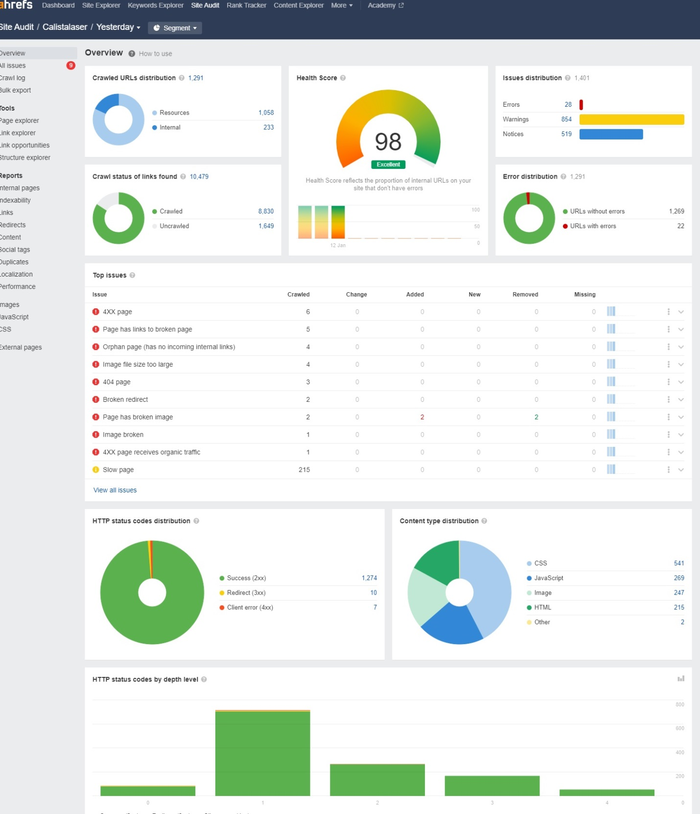

* See full stats on attached PDF report.

Reputation Management:
- Average Star rating: 4.18
- Number of Reviews: 207

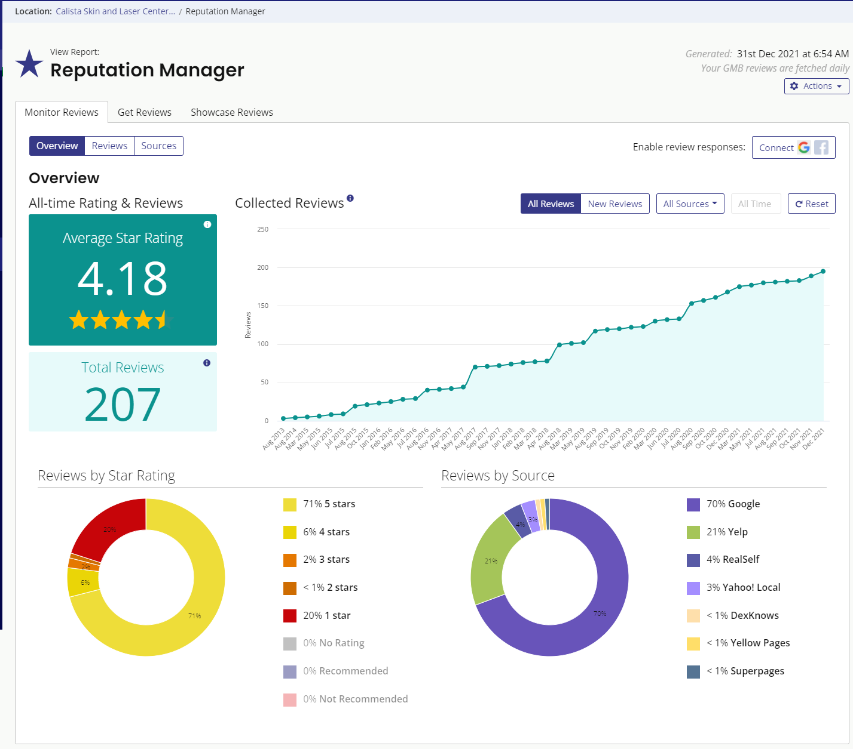

Your Citation Tracker, Builder reports (Bright Local)
Your site is added to over 25 of the most popular and powerful directories on the web. Automated distribution to local data aggregators. This helps boost your local rankings. Some of these are:

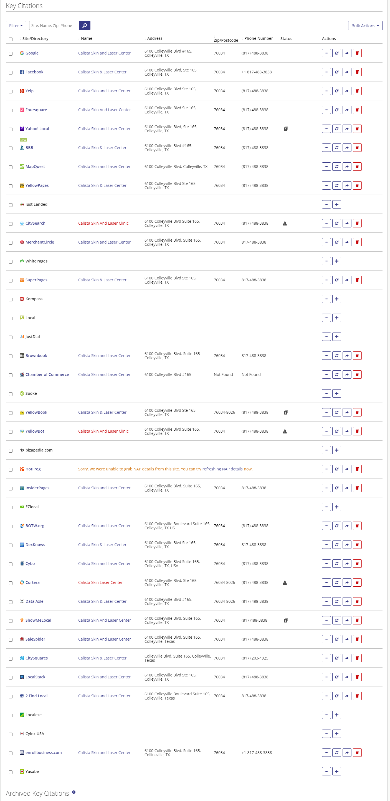

Your Keyword ranking reports (Bright Local)
Your current keyword report shows your ranking positions as well as the rankings table. You can see which pages and keywords you are presently ranking in first place for.
Keyword: Coolsculpting Cost – Rank - – local , - - organic
Keyword: Coolsculpting Near Me – Rank 6 – Local, 5 - organic
Keyword: Coolsculpting Texas – Rank – Organic – 8,
Keyword: Cool Sculpting Near Me – Rank – Organic – #1, B local
Keyword: Coolsculpting reviews – Rank – - local, 9 organic

* See full stats on attached PDF report.

Please let us know if you have any questions about your SEO report. We are also attaching it in Word format for your convenience.

