COOLSCULPTING DALLAS-FORT WORTH | FAT FREEZING
CoolSculpting is an innovative body contouring treatment that reduces fat without the need for invasive surgery. This popular cosmetic treatment uses an advanced cooling technology known as Cryolipolysis to combat fat bulges in problem areas like the belly and flanks. It is most useful for men and women who struggle with diet and exercise-resistant fat. It is FDA-cleared as safe and effective with countless scientific journals to back its safety profile. CoolSculpting cycles take around 35-minutes with minimal discomfort for most patients. Considering all the benefits CoolSculpting provides, it is no wonder why millions of people worldwide turn to this treatment to help them achieve the body of their dreams. Learn more about the #1 non-invasive fat reduction method and determine if it is right for you by scheduling a free consultation with Calista Skin & Laser Center. Call us at 817-663-8260 to start your CoolSculpting journey.

BENEFITS OF COOLSCULPTING
- Safe and effective
- FDA-cleared
- Reduces stubborn fat deposits
- Target love handles, thighs, belly, double chins, and more
- Non-surgical alternative to liposuction
- All-natural looking results
- Long lasting fat reduction
- Sculpt attractive curves

COOLSCULPTING BEFORE AND AFTER PICTURES*
CoolSculpting before and after pictures illustrate how this fat reduction treatment helps countless patients achieve optimal results. Results may vary per patient, but the people in the CoolSculpting before and after images show authentic fat freezing results.*
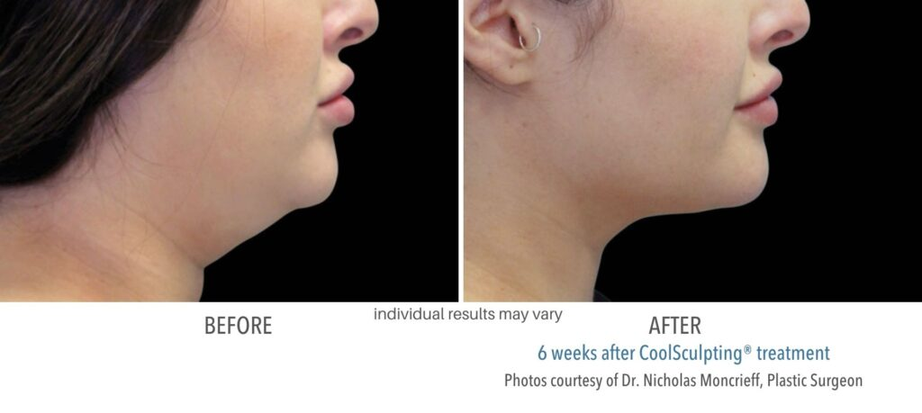
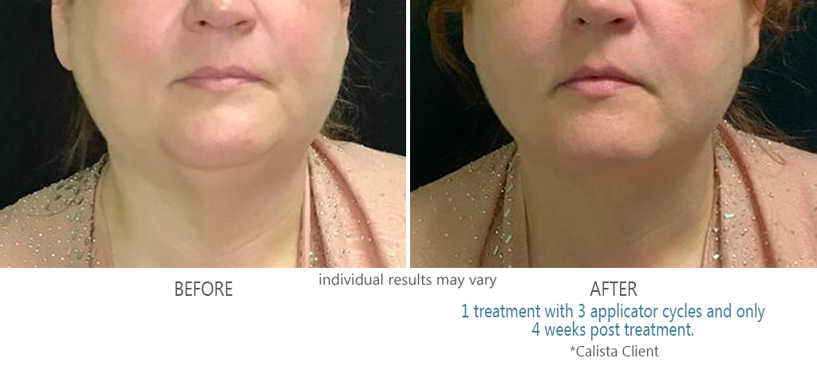
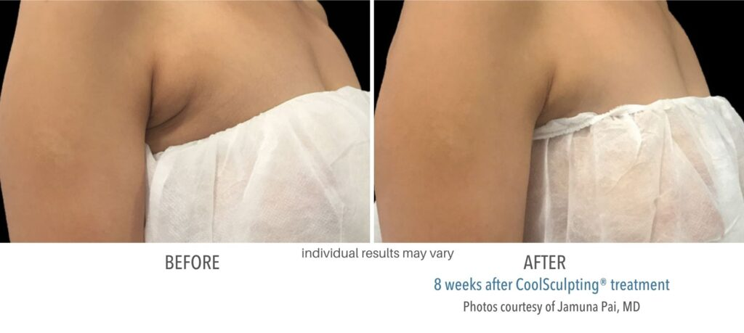
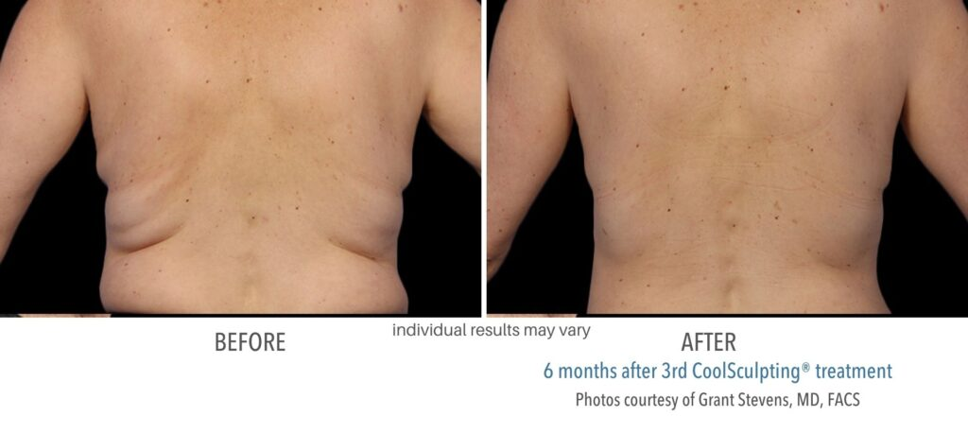
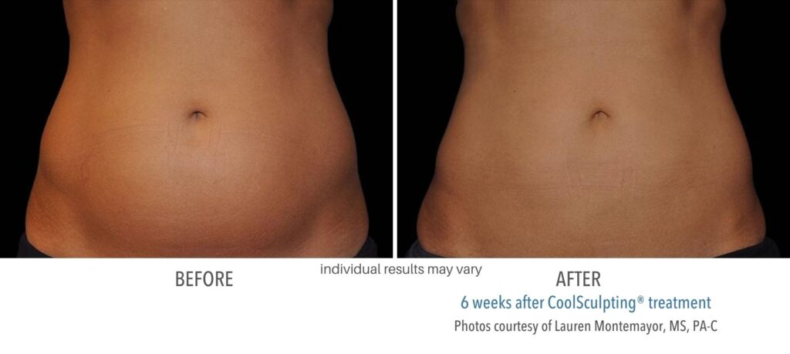
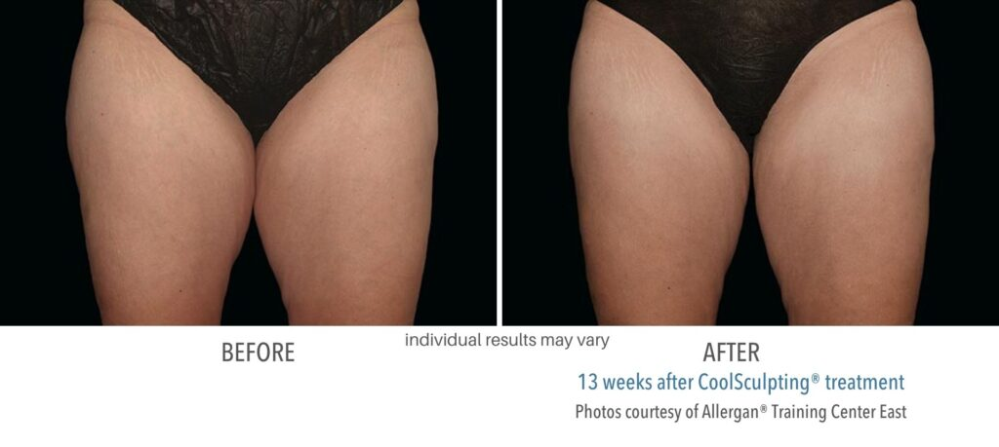

HOW COOLSCULPTING WORKS
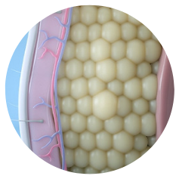
CoolSculpting eliminates fat cells by applying Cryolipolysis, a scientifically proven process. The extreme cooling targets fat cells without harming the skin or surrounding tissue.
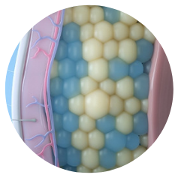
CoolSculpting freezes a percentage of the underlying fat cells, known as adipocytes. When they freeze, the cell’s membrane ruptures. The cell can no longer store fat and is useless.
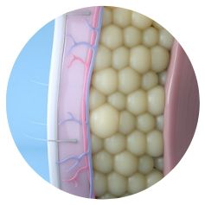
This triggers apoptosis (cell death and removal.) Weeks after the CoolSculpting treatment, the body naturally collects the dead cells. It removes them from the body as a form of waste.

H2: Customize Your Contour

CoolSculpting treatments at Calista Skin & Laser Center let you customize your contour with FDA clearance to treat multiple areas of the body including visible fat bulges in the following areas:
- Abdomen
- Flanks or love handles
- Back
- Armpits or bra bulges
- Inner and outer thighs
- Submental or under the chin
- Submandibular or under the jaw
- Area below the buttocks known as the “banana roll”
- Chest (for men with “moobs” or “man boobs”)
- Upper arms

COOLSCULPTING RESULTS
CoolSculpting provides patients with long-lasting fat reduction. Unlike regular weight loss programs that shrink fat cells, Cryolipolysis metabolizes fat cells and eliminates them from the body. Once those fat cells are removed, they cannot grow back or re-expand. However, CoolSculpting results can be obscured if the patient gains an excessive weight after the procedure. To continue enjoying the fat reduction results, the patient should follow a healthy diet and exercise lifestyle.
The longevity of CoolSculpting results is substantiated by research³ published in the Journal of Cosmetic Dermatology. Examiners tracked patients for nine years after receiving a single CoolSculpting treatment. For those nine years, results persisted, remaining visible, even when the patients gained weight. The study concluded, “Local reductions in fat [after a single CoolSculpting treatment] have significant longevity.”

COOLSCULPTING COST AT CALISTA LASER
The exact cost per CoolSculpting treatment varies. To determine your specific cost, schedule a complimentary consultation with Calista Skin & Laser Center. CoolSculpting treatments cost an estimate of $800 to $1350 depending on the unique parameters of your plan. During your consultation, your specialist will cover the different factors that affect CoolSculpting prices and create the perfect personalized treatment plan.

COOLSCULPTING RISKS AND SIDE EFFECTS
CoolSculpting is FDA-cleared as safe and effective for millions of men and women. This treatment receives the highest safety profile and is backed by countless scientific studies. The study “Safety, Tolerance, And Patient Satisfaction with Noninvasive Cryolipolysis”² revealed, “cryolipolysis is a safe, well-tolerated, and effective treatment method for reduction of… fat.” Another clinical study¹ echoed that conclusion, noting, “Cryolipolysis is considered to be both safe and efficient with a high patient satisfaction rate.”
CoolSculpting side effects are infrequent. It is, however, not unusual to experience symptoms associated with a typical immune response after treatment. This response is when the body begins to process the dead fat cells out of the body. A fraction of patients experiences tenderness, redness, numbness, or bruising at the treatment site. The symptoms, if present, are mild and will only last a few days.

COOLSCULPTING TREATMENTS NEAR ME
If you want to achieve optimal results in a luxury establishment, contact Calista Laser. We are a premier provider of fat-freezing treatments in Colleyville, TX. Our knowledgeable, skilled treatment specialists can help you achieve your dream body. To learn more about CoolSculpting, call us at 817-663-8260 to schedule your consultation or reach out to us online.

COOLSCULPTING FAQS

H2: Is CoolSculpting right for me?

Contrary to what many believe, CoolSculpting is not meant for everyone. Instead, this fat-freezing treatment is ideal for a specific pool of candidates. The perfect CoolSculpting patient lives a healthy, active lifestyle but still struggles with stubborn fat. During a consultation with Calista Skin & Laser Center, our specialists can help determine if you are the right candidate for CoolSculpting.

H2: When will I see CoolSculpting results?*

After the CoolSculpting treatment, the lymphatic system processes the frozen fat cells. Then, it excretes them from the body as a form of waste. Individual experience will vary, but most patients see a noticeable reduction in fat in as little as four weeks. The full results take 8 to 12 weeks for most patients to manifest.

We are committed to offering the best CoolSculpting in the Colleyville, TX, area by providing the latest CoolSculpting equipment and technology. We also have an expert staff dedicated to helping each patient achieve the most transformative results.

H2: How long does CoolSculpting last?

Your CoolSculpting results should last indefinitely. That is because once the fat cells are destroyed and removed from the body, they cannot return or regrow. However, it is important to note that your results can be obscured if you gain weight in surrounding areas. Follow a healthy diet plan and exercise routine to continue enjoying your fat reduction.

H2: What is the downside of CoolSculpting?*

CoolSculpting patients often report mild bruising in the area and swelling and redness at the treatment site. These are all common symptoms of the natural immune response during treatment. These symptoms will be mild and go away on their own. However, as with all treatments, results will vary.* If you are concerned about side effects, speak with your professional CoolSculpting provider during your consultation.

H2: How much weight does CoolSculpting remove?

CoolSculpting is a fat-reduction treatment. Your body loses fat cells, not pounds. Through the CoolSculpting fat-freezing process, you can expect to see a reduction in fat cells in the target area by 20 to 25%.

H2: Is CoolSculpting better than lipo?

CoolSculpting is the better treatment if you are targeting a specific area. Liposuction may be the better choice if you have several areas and are very overweight. If you question whether or not CoolSculpting is the best treatment for you, contact Calista Skin & Laser for a complete evaluation.

H2: Does skin tighten after CoolSculpting?

If you receive CoolSculpting treatments in the submental region, you may also experience significant skin tightening as a result. The FDA cleared CoolSculpting for tightening skin in the submental area, including double chins and neck fat.

H2: Where does fat go after CoolSculpting?

The frozen fat cells become a waste product and are processed out of the body via the lymphatic system. This eliminates the fat cells entirely. The body will not regenerate those fat cells. They are gone for good.

