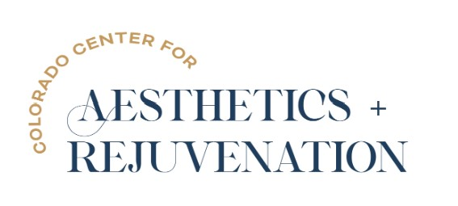

Alithia Ruiz

We would like to give a WARM WELCOME to Alithia Ruiz who has joined CO-CAR as our Master CoolSculpting Specialist & Master Clinical Esthetician.

Alithia holds her Master CoolSculpting Elite Certification and has been performing both CoolSculpting & CoolSculpting Elite since 2011. Alithia has performed over 4,000 treatments since 2011 and is an expert at her craft with an aesthetic eye for detail.

Additionally, Alithia has over 14 years of experience in clinical aesthetics holds her Master Clinical Esthetician Certification. She proficient in multiple advanced skincare modalities including Chemical Peels, Dermaplaning, SkinPen Microneedling, Microdermabrasion and has her Advanced Cosmetic Laser Certification. Some of Alithia’s favorite treatments include treating ethnic skin types, acne treatment protocols, laser aesthetics and she especially loves helping clients with their anti-aging goals.

On top of all that … Alithia enjoyes educating clients on skin care best-practices and holds her Ambassador Certification with SkinCeuticals one of our practices favorite medical grade skin care lines.

We are thrilled to have Alithia as part of our CO-CAR family, I guess you could say she sets the bar high and provides the Gold Standard for BOTH CoolSculpting & Clinical Esthetics!

