500 Word Update for CoolSculpting Elite Service Page.Concierge Medspa.KA

Link to page: https://www.conciergemedspa.com/coolsculpting/

NEW META TITLE: CoolSculpting Elite Chicago | Top-rated Body Contouring

*SLUG STAYS THE SAME*

NEW META DESCRIPTION: Coolsculpting Elite in Chicago is FDA-Cleared, non-surgical way to reduce fat cells in trouble spots such as the abdomen, flanks or under the chin.

H1 COOLSCULPTING ELITE IN CHICAGO: CONTOUR A SLEEK, ATTRACTIVE PHYSIQUE

CoolSculpting Elite is the world’s most popular, non-invasive fat reduction treatment. It has revolutionized the body contouring industry by utilizing advanced cooling technology to reduce unwanted fat safely, painlessly, and effectively. This FDA-cleared treatment offers a surprisingly affordable solution for healthy adults who struggle with stubborn bulges that resist diet and exercise. Fat freezing is perfect for targeting love handles, belly fat, upper arm fat, bra bulge, thigh fat, double chins, and other visible bulges. And with treatments that take as little as 35 minutes and require no downtime, it’s no wonder millions of men and women have chosen CoolSculpting Elite as a non-surgical alternative to liposuction.
If you want to learn more about CoolSculpting Elite and how this new body contouring treatment reduces twice the amount of fat cells in less time, contact Concierge Aesthetics & Plastic Surgery now! We are proud to be the top-rated CoolSculpting Elite body contouring provider in Chicago, IL. Call us now at 312-255-1495 or reach out to us online to schedule your consultation. Discover if this body contouring and fat reduction method suits your goals.
Clinical findings on the effectiveness of CoolSculpting Elite were published in the Journal of Cosmetic Dermatology, reporting “Caliper measurements demonstrated 23% reduction in fat layer thickness at 3 months.” Investigator assessments of CoolSculpting Elite before and after pictures concluded “86% of subjects” showed improvement at the treatment area, and patient surveys revealed “82% of patients would recommend the procedure to a friend.”

BENEFITS OF COOLSCULPTING ELITE
- #1 Non-invasive fat reduction treatment in the world
- Safe and effective
- Reduce stubborn fat deposits
- Non-surgical alternative for liposuction
- Long-lasting results
- Target bulges that resist diet & exercise
- FDA cleared and clinically proven
- Look better & feel more confident
- Easy, 35-minute treatments
- Millions of treatments performed worldwide

H2 HOW COOLSCULPTING ELITE WORKS
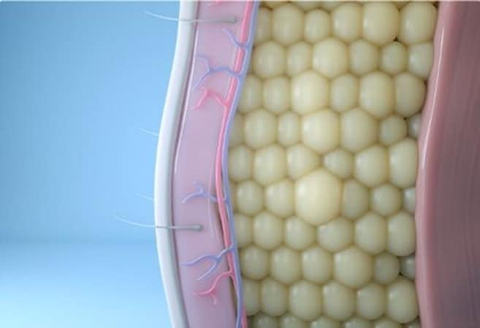
Many of us have stubborn fat despite diet and exercise.
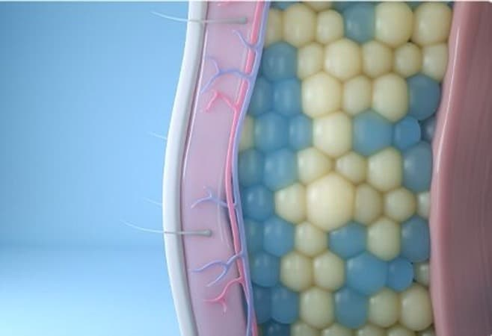
CoolSculpting Elite effectively target fat cells underneath the skin without damage to the skin or surrounding tissues. Treated fat cells are frozen and then die.
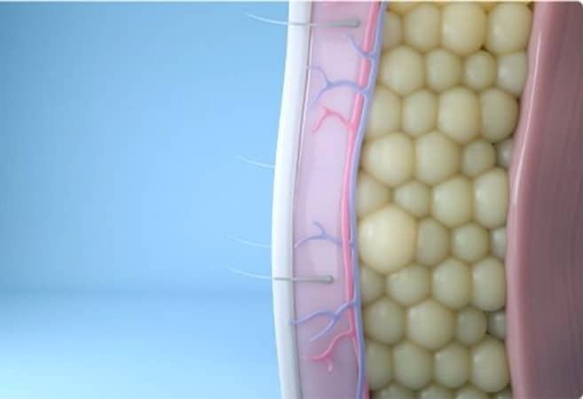
In the weeks that follow, the body naturally processes and eliminates these dead fat cells. Treated fat cells are gone for good!*

This revolutionary fat freezing treatment uses the science of cryolipolysis to reduce stubborn fat bulges. Broken down, cryolipolysis means the reduction of fat cells through exposure to controlled cooling; cryo meaning cold, lipo meaning fat, lysis meaning cell destruction. Cryolipolysis has been scientifically proven to effectively reduce stubborn bulges that are especially resistant to diet and exercise. In addition, this treatment is virtually painless, safe, and effective.
Treatments are virtually painless and take about 35 minutes to complete. As CoolSculpting is non-invasive and requires no anesthesia, many patients choose to multitask during their treatment time by reading, conversing, or even sleeping. Many can resume daily activity immediately. As with any cosmetic treatment, individual experiences will vary.

H2 AREAS COOLSCULPTING ELITE CAN TREAT
The CoolSculpting Elite machine is equipped with several applicators of various sizes and shapes. The versatility in applicators allows Concierge Aesthetics & Plastic Surgery to freeze stubborn fat, starting with a double chin, ending with fat above the knees, and all notorious bulges in between. Popular treatment areas for freezing fat include:
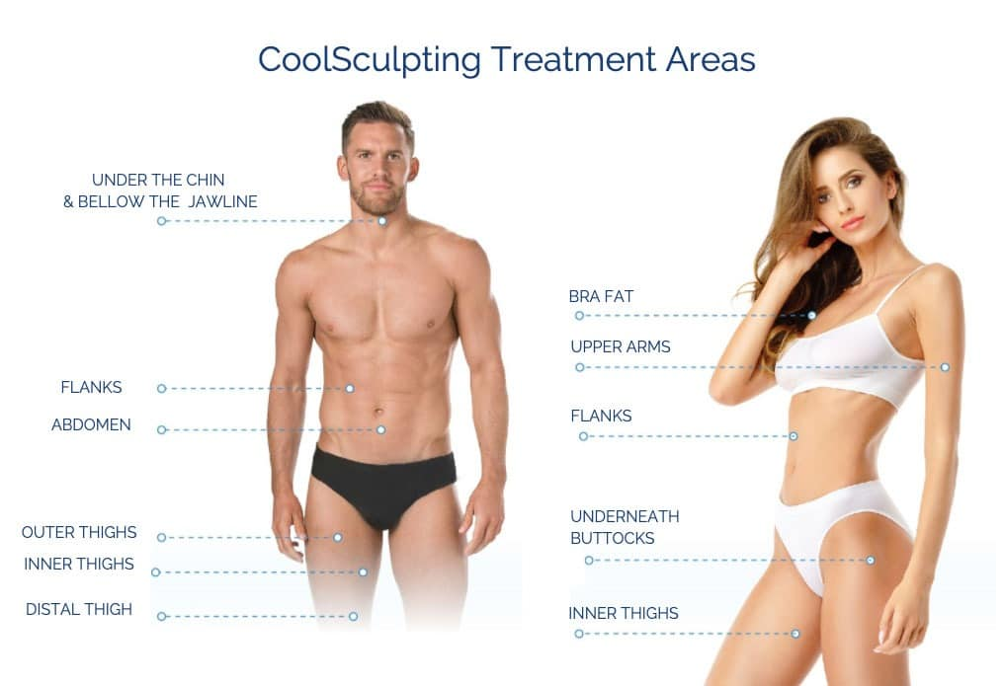
- The abdomen (targeting belly fat)
- The flanks (targeting love handles)
- Legs (targeting inner and outer thigh fat)
- The back
- The upper arms
- The submental region (targeting double chins and neck fat)
- The chest (ideal for men wanting to reduce moobs or man boobs)
- The armpit (targeting “bra bulge”)

H2 SEE THE COOLSCULPTING ELITE BEFORE AND AFTERS*
CoolSculpting Elite before and after images attest to how well fat freezing works. As with any body contouring treatment, results may vary. However, the men and women depicted in these CoolSculpting Elite before and after pictures are actual patients and demonstrate the amazing transformation that can result when a skilled and experienced professional performs your treatment.
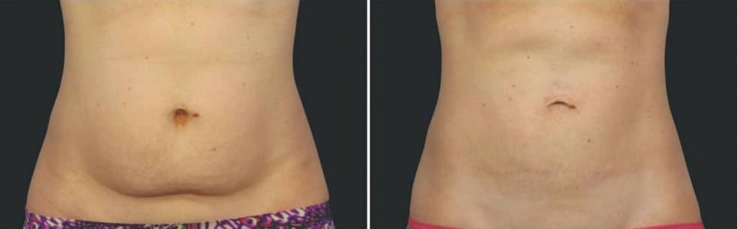
individual results may vary
BEFORE
16 WEEKS AFTER
Second CoolSculpting® Session
Photos courtesy of Grant Stevens, MD, FACS
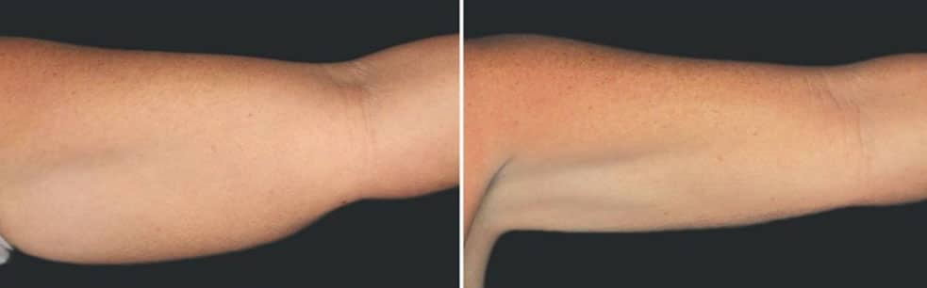
individual results may vary
BEFORE
10 WEEKS AFTER
CoolSculpting® Session
Photos courtesy of Jeffrey C. Dawes MD, FRCSC
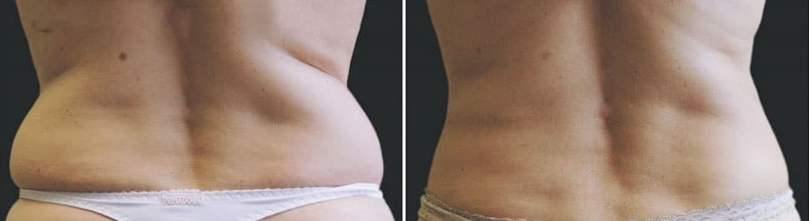
individual results may vary
BEFORE
16 WEEKS AFTER
CoolSculpting® Session
Photos courtesy of John B. Fasano, MD
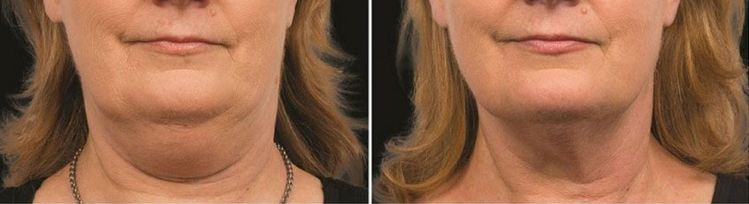
individual results may vary
BEFORE
12 WEEKS AFTER
Second CoolSculpting® Session
Photos courtesy of A. Jay Burns, MD
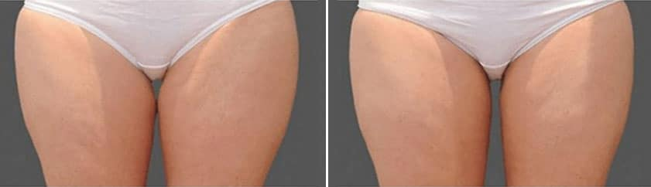
individual results may vary
BEFORE
5 WEEKS AFTER
CoolSculpting® Session
Photos courtesy of Dr. Tracy Mountford
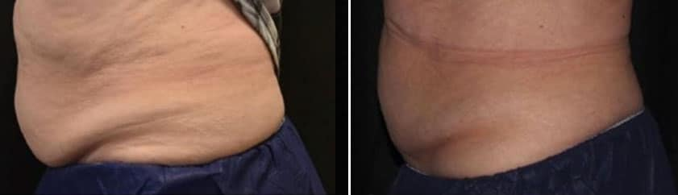
individual results may vary
BEFORE
4 WEEKS AFTER
CoolSculpting® Session
Photos courtesy of Kyle Farr, DNP, NP-C

H2 COOLSCULPTING ELITE RESULTS*
CoolSculpting Elite works differently than weight loss programs and liposuction. CoolSculpting Elite results last. Both weight loss programs and liposuction seek to shrink fat cells. Through cryolipolysis, fat cells crystallize and rupture. These cells are no longer functional, and the body processes them out as waste via the lymphatic system. Once these fat cells are gone, they are gone for good and cannot grow back. However, excessive weight gain may obscure CoolSculpting Elite results. So it is recommended to follow a healthy lifestyle after treatments to maintain optimal results and a sculpted physique.
H2 COOLSCULPTING ELITE SAFETY
CoolSculpting Elite is both scientifically proven¹ and FDA cleared as safe and effective. Because fat freezing eliminates fat cells in a non-invasive manner, Cool Sculpting side effects are rare. Nevertheless, the best way to ensure a safe treatment (as well as optimal results) is to choose a reputable Cool Sculpting Chicago provider who is highly experienced in the fat freezing procedure.
While long-term Cool Sculpting side effects and adverse events are rare, it is not uncommon for patients to experience symptoms associated with an immune response following their treatment. This may include redness, tenderness, bruising, or numbing. These symptoms are typically mild, isolated to the treatment area, and resolve themselves within a few days.*
H2 COOLSCULPTING ELITE REVIEWS
CoolSculpting Elite reviews are raving. Moreover, they are not just coming from patients. The medical community is impressed by how well fat freezing works, as demonstrated by the numerous clinical studies and papers published in academic literature. One of the most well-known studies evaluated more than 500 Cool Sculpting patients and found that “89% of respondents report[ed] a positive perception of treatment duration and 96% report[ed] minimal to tolerable discomfort…” The study concluded, “Cryolipolysis is a safe, well-tolerated, and effective treatment method for reduction of subcutaneous fat.”²
Another Cool Sculpting review published in scientific literature measured how much fat can actually be reduced from a single Cool Sculpting treatment. The study found “cryolipolysis was shown to reduce subcutaneous fat at the treatment site by up to 25% after one treatment.”²
H2 COOLSCULPTING VS LIPOSUCTION
Before introducing nonsurgical and non-invasive procedures, people had to undergo surgical procedures like liposuction to reduce unwanted fat. Liposuction is indeed an effective fat-reduction treatment. However, it is a surgical procedure involving incisions, anesthesia, a complicated recovery, and sometimes scars.
Now, people struggling with fat bulges can use CoolSculpting Elite as a no-surgery-required way to reduce fat cells. CoolSculpting Elite targets common trouble zones like the stomach, thighs, and back fat. Best of all, treatments are entirely nonsurgical and non-invasive. Patients can enjoy their CoolSculpting Elite treatment and continue their usual daily routine. There is minimal downtime and no surgical risks like liposuction.
However, some people are not eligible for CoolSculpting Elite. For example, if someone is significantly overweight, they may not be able to have cooling cycles. Instead, they would have to trust liposuction to reduce their fat bulges. It is important to know that CoolSculpting Elite is a body contouring treatment for healthy and active adults close to their ideal weight and body size but still struggling with fat cells in problem areas.
Concierge Aesthetics & Plastic Surgery offers both CoolSculpting Elite and liposuction. Schedule a consultation if you are struggling with excess fat cells and want to achieve a slimmer, leaner physique. We will evaluate your body during your visit and listen to your aesthetic goals. We can help you determine which fat reduction method is best for your body and goals.
H2 COOLSCULPTING COST IN CHICAGO
CoolSculpting Elite cost differs for each patient, depending on the unique parameters of the individual’s customized treatment plan. Factors that affect CoolSculpting cost include the size of applicator, the number of cooling cycles needed to achieve the desired results, and the number of treatment areas. One of the best ways to save on fat freezing is to purchase a treatment package of multiple cooling cycles.
During your free consultation with Concierge Aesthetics, we will discuss Cool Sculpting prices in detail. If fat freezing is right for you, we will help create a customized treatment plan that is tailored to your body, your goals, and your budget.
As the premier Cool Sculpting Chicago provider, Concierge Aesthetics & Plastic Surgery is offering new clients who schedule a complimentary consultation 25% off the cost of CoolSculpting.

WHEN WILL I SEE MY COOLSCULPTING RESULTS?
After a CoolSculpting Elite treatment, the lymphatic continues to process out frozen fat cells over several weeks. Individual results will vary, but some patients are able to see visible results in as little as 4 weeks. For most patients, however, CoolSculpting Elite results take about 8 – 12 weeks to be fully manifest. Although some patients with CoolSculpting Elite results were immediate, many appreciate the pace of natural weight loss that occurs with CoolSculpting Elite.

COOLSCULPTING ELITE COST
Many factors determine the exact cost of CoolSculpting Elite. These factors include; treatment area, your desired outcome and the amount of treatments needed to achieve those results, the size of the applicator, and more. During your complimentary consultation with Concierge Aesthetics, a specialist will cover the CoolSculpting Elite prices and payment options with you. A great way to save on CoolSculpting Elite is to purchase treatment packages that include multiple cooling cycles. As a premier provider of CoolSculpting Elite in Chicago, Concierge Aesthetics and Plastic Surgery offer new clients that schedule a complimentary consultation $1000 off CoolSculpting Elite.
H2 COOLSCULPTING ELITE FAQS

H3 WHEN WILL I SEE MY COOLSCULPTING RESULTS?*
After a CoolSculpting Elite treatment, the lymphatic continues to process out frozen fat cells over several weeks. Individual results will vary, but some patients are able to see visible results in as little as 4 weeks. For most patients, however, CoolSculpting Elite results take about 8 – 12 weeks to be fully manifest. Although some patients with CoolSculpting Elite results were immediate, many appreciate the pace of natural weight loss that occurs with CoolSculpting Elite. As always, individual experiences will be different.*

h3 AM I A GOOD CANDIDATE FOR COOLSCULPTING ELITE?
CoolSculpting Elite is intended for those who live a healthy and active lifestyle yet struggle to reduce stubborn bulges. However, fat freezing is not for everyone. The best way to discover if CoolSculpting Elite is for you is to speak with experts during a complimentary consultation with Concierge Aesthetics and Plastic Surgery. During this meeting, a CoolSculpting Elite specialist will analyze whether fat freezing can help you reduce fat and achieve your aesthetic goals. If it is decided that CoolSculpting Elite is a good option for you, a personalized treatment will be created for you that suits your budget and body goals.

HOW MUCH DOES IT COST?
CoolSculpting Elite cost differs for each patient, depending on the unique parameters of the individual’s customized treatment plan. Factors that affect CoolSculpting cost include the size of applicator, the number of cooling cycles needed to achieve the desired results, and the number of treatment areas. One of the best ways to save on fat freezing is to purchase a treatment package of multiple cooling cycles.
During your free consultation with Concierge Aesthetics, we will discuss Cool Sculpting prices in detail. If fat freezing is right for you, we will help create a customized treatment plan that is tailored to your body, your goals, and your budget.
As the premier Cool Sculpting Chicago provider, Concierge Aesthetics & Plastic Surgery is offering new clients who schedule a complimentary consultation 25% off the cost of CoolSculpting.
IS THE COOLSCULPTING ELITE TREATMENT SAFE?
CoolSculpting Elite is both scientifically proven¹ and FDA cleared as safe and effective. Because fat freezing eliminates fat cells in a non-invasive manner, Cool Sculpting side effects are rare. Nevertheless, the best way to ensure a safe treatment (as well as optimal results) is to choose a reputable Cool Sculpting Chicago provider who is highly experienced in the fat freezing procedure.
While long-term Cool Sculpting side effects and adverse events are rare, it is not uncommon for patients to experience symptoms associated with an immune response following their treatment. This may include redness, tenderness, bruising, or numbing. These symptoms are typically mild, isolated to the treatment area, and resolve themselves within a few days.*
WHAT TO EXPECT DURING THE FAT FREEZING PROCEDURE
Because CoolSculpting stimulates the body to naturally eliminate the frozen fat cells, Cool Sculpting results appear gradually over the course of several weeks. Some patients begin to see reductions in fat in as little as 4 weeks. However, the most dramatic results are typically seen within 12 to 16 weeks. Individual experiences may vary.* Depending on your body and treatment area, we may schedule additional cooling sessions in order to meet your goals.
Most importantly, Cool Sculpting results are long lasting. According to a longitudinal study that followed patients over the span of 9 years to measure the longevity of fat freezing results, “local reductions in fat [after a single CoolSculpting cycle] have significant longevity…and suggest that results from Cryolipolysis may be very long-lasting.”³
HOW DOES COOLSCULPTING ELITE REDUCE FAT?
CoolSculpting is the only FDA cleared body contouring treatment to reduce fat using controlled cooling. Simply put, CoolSculpting eliminates fat cells by freezing them to death. Cool Sculpting works because the fat cells freeze at higher temperatures than skin cells, permitting the procedure to induce a process called Cryolipolysis (Cryo = cold + lipo = fat + lysis = cell death.) To begin the treatment, an applicator is placed over a stubborn bulge. A gentle vacuum mechanism secures the applicator in place and draws fat cells up towards the surface. The applicator then exposes the bulge to temperatures cold enough to freeze fat cells, but not cold enough to harm the skin or surrounding tissue.
The frozen fat cells below the skin’s surface crystalize and rupture, permanently disabling the cell from storing fat. Destroying the fat cells triggers the body’s natural immune response. Over the duration of several weeks, the frozen fat cells are collected and processed out of the body. Destroyed fat cells that are excreted from the body cannot grow back. Those fat cells are gone for good, leading to long lasting results. However, not all fat cells are removed from the treatment area, so patients are advised to maintain a healthy diet and regular exercise routine to avoid gaining new weight that may obscure their Cool Sculpting results.
WHAT AREAS CAN COOLSCULPTING ELITE TREAT?
The CoolSculpting machine is equipped with several applicators of various sizes and shapes. The versatility in applicators allows Concierge Aesthetics to freeze stubborn fat, starting with a double chin, ending with fat above the knees, and all notorious bulges in between. Popular treatment areas for freezing fat include:
- The abdomen (targeting belly fat)
- The flanks (targeting love handles)
- Legs (targeting inner and outer thigh fat)
- The back
- The upper arms
- The submental region (targeting double chins and neck fat)
- The chest (ideal for men wanting to reduce moobs or man boobs)
- The armpit (targeting “bra bulge”)
WHY CHOOSE COOLSCULPTING ELITE FROM CONCIERGE AESTHETICS?
- Reduce fat without surgery or downtime
- #1 non-invasive body contouring treatment
- 35 minute, comfortable treatments
- Safe and FDA cleared
- Scientifically proven
- Long term results
- Sculpt attractive contours
- Eliminate fat cells that resist diet and exercise
- Treatments performed by the #1 Chicago CoolSculpting provider

WHAT ABOUT COOLSCULPTING ELITE REVIEWS?
CoolSculpting Elite reviews are raving. Moreover, they are not just coming from patients. The medical community is impressed by how well fat freezing works, as demonstrated by the numerous clinical studies and papers published in academic literature. One of the most well-known studies evaluated more than 500 Cool Sculpting patients and found that “89% of respondents report[ed] a positive perception of treatment duration and 96% report[ed] minimal to tolerable discomfort…” The study concluded, “Cryolipolysis is a safe, well-tolerated, and effective treatment method for reduction of subcutaneous fat.”²
Another Cool Sculpting review published in scientific literature measured how much fat can actually be reduced from a single Cool Sculpting treatment. The study found “cryolipolysis was shown to reduce subcutaneous fat at the treatment site by up to 25% after one treatment.”²
H2 EXPERIENCE THE BEST COOLSCULPTING ELITE TREATMENTS IN CHICAGO
If you have tried countless diets and exercise routines but still struggle with fat bulges that refuse to budge, CoolSculpting can help! Reduce fat cells, contour attractive curves, and achieve the fat reduction you have wanted so badly without countless hours in the gym or invasive surgery.

Contact Concierge Aesthetics & Plastic Surgery today! We are proud to be the leading provider of non-surgical body contouring treatments, including CoolSculpting Elite in Chicago. We proudly offer top-rated treatments in Chicago’s Gold Coast, Naperville, Barrington, and Geneva. Call us at 312-255-1495 to schedule your appointment and experience the best body contouring in Illinois.

