CoolSculpting Results.chalik.article.tomo
/ CoolSculpting Results
KW CoolSculpting Results

Meta: Learn more about the CoolSculpting results most patients experience, how long fat-reduction lasts, and find out what you can do to get good results.
CoolSculpting Results: Is Fat Freezing Really Worth It?
CoolSculpting results demonstrate the dramatic reduction in stubborn bulges that is possible by freezing fat. Maybe you are wondering what these results actually look like before you make the investment yourself? You’re in luck! There are many resources for those who want to learn more about CoolSculpting results, such as reviews and before and after images from and of real fat freezing patients. There are also published scientific studies that validate the long-term results of CoolSculpting.
As with all cosmetic procedures, fat freezing results vary. Many factors affect fat freezing results. Learn more about these factors and find out why CoolSculpting is the most popular non-invasive fat reduction treatment in the world.
Real CoolSculpting Patient Reviews
Reading reviews from actual patients is a fast and easy way to learn more about fat freezing or a particular provider’s experience and customer service. Many patients of Dr. Natalya Chalik of Emerson Medical have happily published reviews about their experience with this provider who specializes in weight loss and fat reduction.

Gail Kogan
1 review
2 months ago-
The doctor is very professional, she takes her time, listens carefully and makes the proper assessment after analysis. She is our family doctor for many years and we are very satisfied with her!
Like
1

Guy Greco
1 review
a month ago
Very professional and knowledgeable. Takes the time to listen to you and go over your options never rushed.
Like

Dorina Rexha
1 review
2 months ago
Dr Chalik Is the most courteous and professional doctor I’ve ever been to.

[Hey J, just try to make these reviews as nice looking as possible. If they look crappy, here is a screen shot that you can crop and add to article if needed.

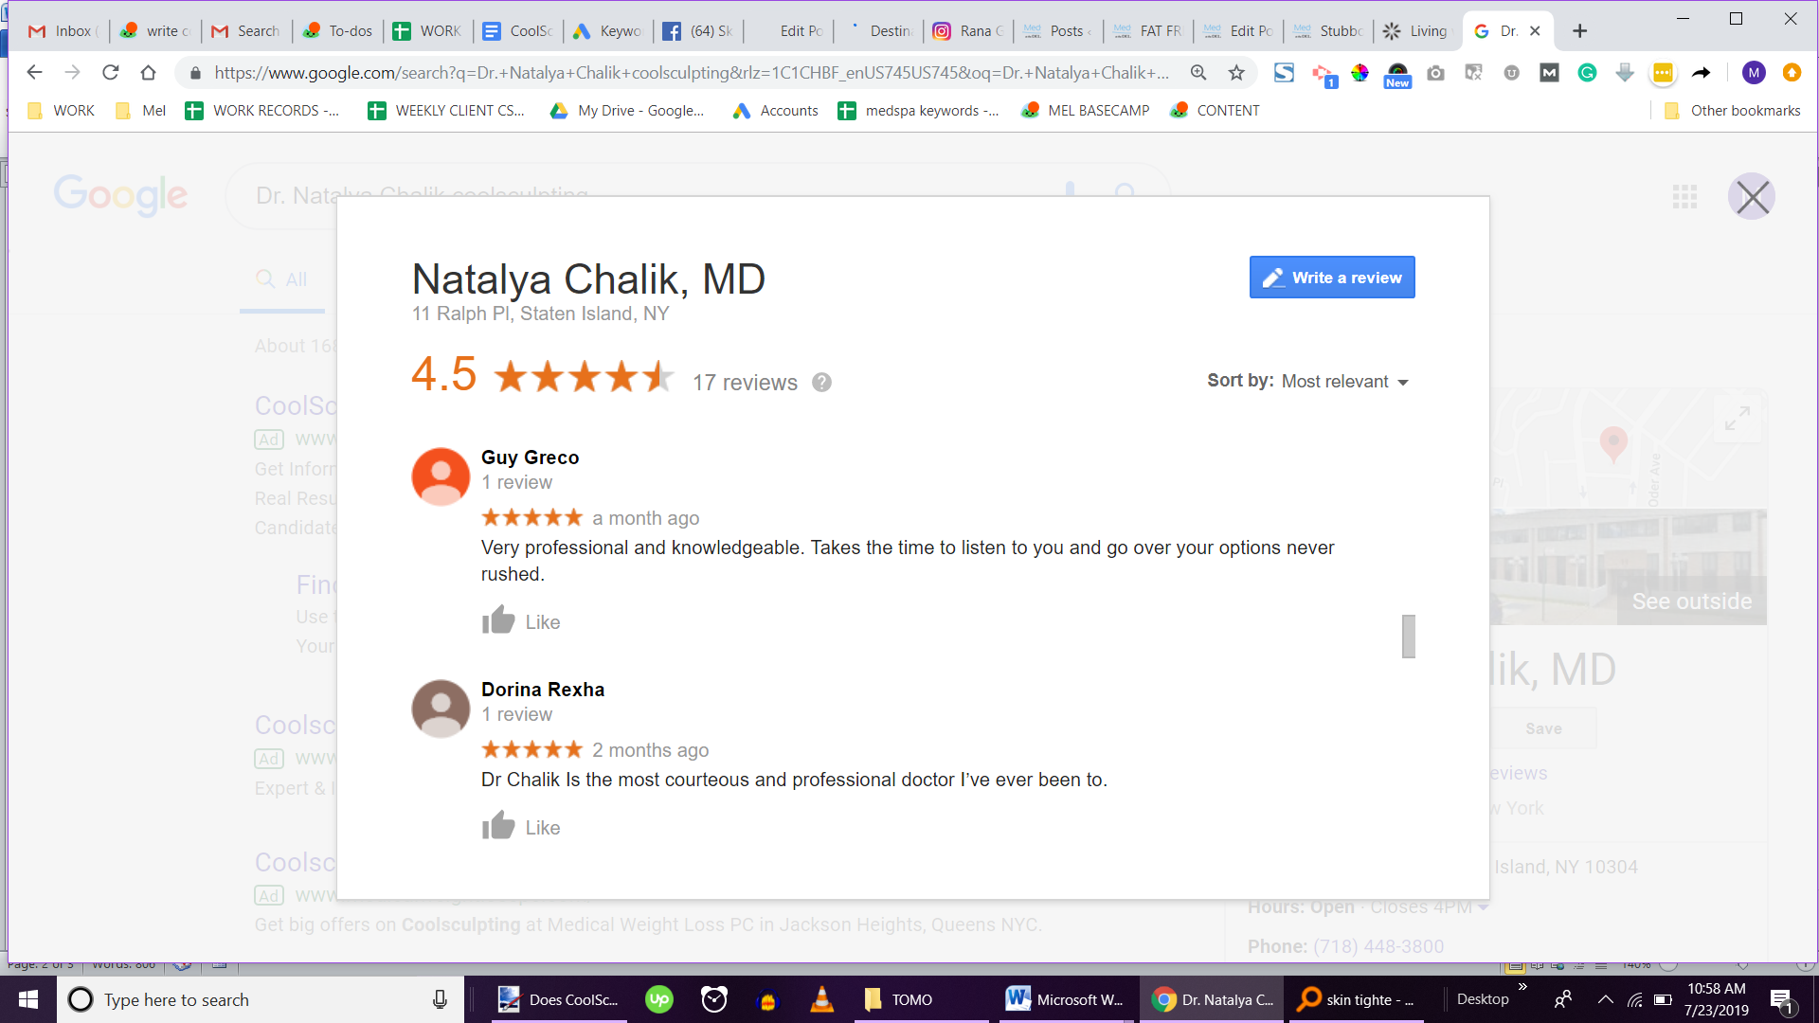
Before and After Pictures of CoolSculpting Results
Patient reviews can provide an excellent first-hand experience of fat freezing. However, actual CoolSculpting before and after photos of real patients will show you the results. Always keep in mind that individual results vary, as with any cosmetic treatment.
[INSERT BEFORE AND AFTER PIC]
Scientific Research on CoolSculpting Results
There have been a number of published studies on fat freezing that show empirical evidence of CoolSculpting results. One study, “Longitudinal evaluation of cryolipolysis efficacy”, was published in The Journal of Cosmetic Dermatology. The study found that in patients evaluated nine years after the initial fat freezing treatment there were “local reductions in fat [after a single CoolSculpting cycle] have significant longevity in these subjects and suggest that results from Cryolipolysis may be very long-lasting.”
A similar study titled “Cryolipolysis for noninvasive body contouring: clinical efficacy and patient satisfaction”, from The Journal of Clinical, Cosmetic and Investigational Dermatology. The study found that “[fat freezing] was shown to reduce subcutaneous fat at the treatment site by up to 25% after one treatment.”
Tips to Find the Best CoolSculpting Provider
When researching to find the best CoolSculpting in Staten Island, there are a few important things to keep in mind. The most important thing is the reputation and experience of the fat freezing clinic you choose. This technique-sensitive procedure requires the use of a specialist so be sure to ask questions about the training and experience of a clinic’s technology and specialists.
It can be tempting to look for a provider based on the lowest price available. If you want to achieve the best possible CoolSculpting results, expand your research to find a skilled, trustworthy provider.
Related Article: How much does CoolSculpting cost? >>
Another factor to consider is whether you are a good candidate for the CoolSculpting procedure. This procedure is not meant for everyone. It is intended for the treatment of isolated fatty areas that are diet and exercise resistant in healthy adults.
The best CoolSculpting providers know that fat freezing is not for everyone and will help people figure out if they are a good candidate with a complimentary consultation. Select a provider that will value patient experience and well-being rather than profit.
Get the Best CoolSculpting Results in Staten Island
If you are interested in fat freezing and want to learn more, consider Dr. Natalya Chalik of Emerson Medical. As a premier CoolSculpting provider in Staten Island, Dr. Chalik is committed to delivering the best patient experience and most optimal results possible. Contact Dr. Chalik today online or at (718) 448-3800 to set up a free consultation!

