Emtone cost.article.body morph.mz
/ Emtone cost
Kw: Emtone cost
META: Find out Emtone cost. Learn which factors influence Emtone prices and discover the best ways to save on the cost of this new cellulite reduction treatment.
How Much Does Emtone Cost? How to Save on Emtone Prices
Emtone cost ranges from $750 to $800. However, prices depend on several factors, like treatment area and discounts from package pricing. Read on to learn more about what price points affect Emtone cost and what you can do to save money on this revolutionary cellulite reduction treatment.
How Does Emtone Work?
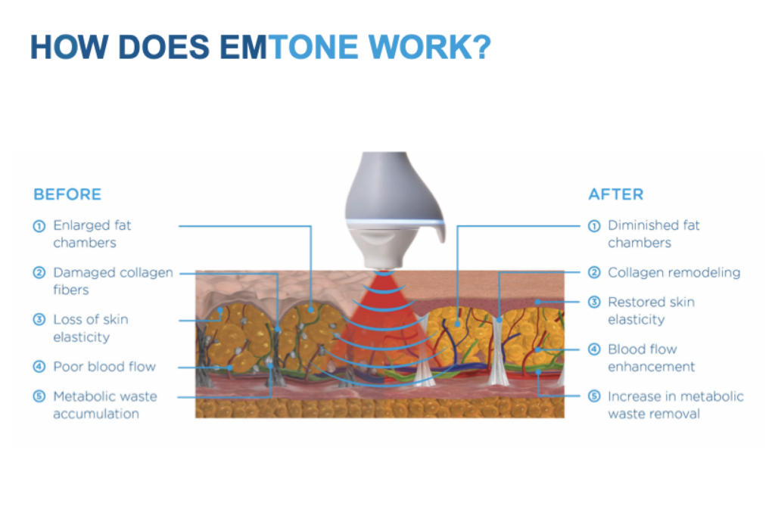
To better understand what determines Emtone cost, it is helpful to know how the cellulite treatment works.
Emtone gets rid of the main factors that cause cellulite. These factors include:
- the enlargement of fat cells
- damage to collagen and elastin
- decreased skin elasticity
- impaired circulation
- fluid retention
- metabolic waste buildup
Emtone targets these factors using a hand device that emits dual energies: mechanical pressure waves using acoustic energy and radiofrequency (RF). During the treatment, your Emtone specialist massages the hand device over the treatment area, focusing on the areas with the most cellulite buildup. The handpiece emits the dual energies, stimulating a cascade of therapeutic benefits. These include:
- Tightening and remodeling the connective fibers of collagen and elastin
- Disrupting enlarged fat cells
- Stimulating skin rejuvenation
- Improving skin elasticity
- Improving circulation to clear out metabolic waste and other debris.
See Real Emtone Results >>
Factors that Determine Emtone Cost
When pricing the Emtone procedure, the cost is determined by several factors. They include:
Treatment area. Emtone can target nearly any area suffering from cellulite. Popular treatment areas include the abdomen, the flanks (love handles or hips), the buttocks, the upper arms, and the various areas on the thighs (inner thighs, outer thighs, and the back of the thighs.) Bigger treatment areas (such as the abdomen) cost more than smaller treatment areas (like the inner thighs.)
Package Pricing: While many patients see improvement after a single Emtone treatment, most patients opt for the recommended protocol of four treatments, spaced one to two weeks apart. This series of four treatments garners the best results and ensures the highest patient satisfaction possible.
When determining Emtone cost, most providers will give patients a discount if they purchase an Emtone package of four treatments. Further savings are possible when adding additional treatment areas.
Emtone Specials: Some providers, like Body Morph MD offer new client specials. Call Body Morph MD to learn about current promotions.
Finding the best Emtone provider Near You
Remember, cost is only one factor to consider when shopping for a provider in your area. Emtone is a technique sensitive procedure. This means the experience and expertise of the person performing your treatment greatly impacts your results. The best way to get the most bang for your buck is shopping by quality, not pricing. However, if you are lucky, like the patients of Body Morph MD, you will find a reputable provider that ensures unparalleled experience at unbeatable prices. Find out if Emtone is right for you and additional ways to save on Emtone cost by scheduling a FREE consultation with Body Morph MD . Reach out online or call (914) 499 0675 today.

