CoolSculpting FAQ.article.CLIENT.mz
/COOLSCULPTING FAQ MARKETING
KW: CoolSculpting FAQ
META: If you are a CoolSculpting provider, a CoolSculpting FAQ page can improve online visibility, inform your readers, and promote consumer trust. CoolSculpting Marketing from Medstar Media

CoolSculpting Marketing:

CoolSculpting FAQ Page for More Leads

A CoolSculpting FAQ page is a great digital marketing strategy. FAQ pages answer frequently asked questions. If you are a CoolSculpting provider and marketing your practice online, discover why a CoolSculpting FAQ page is a great asset to your website.

HOW FAQ PAGES IMPROVE COOLSCULPTING LEADS

CoolSculpting FAQ pages provide two distinct advantages to your practice. First, your FAQ page provides a great resource for website visitors. Many prospective clients have questions about the CoolSculpting procedure. By providing answers, you inform your readers, distinguish yourself as an authority on the topic, and build consumer confidence.
Secondly, FAQ pages are a wonderful way to improve your online visibility, bulk up your website, and help SEO.

FEATURED SNIPPETS

The format of FAQ pages makes them ideal sources for Google to draw a featured snippet from. Featured snippets display a brief excerpt from a webpage. Featured snippets provide quick and convenient answers to a user’s query. If users wish to learn more, they click on the featured snippet’s link. That link leads to the source of the information (your FAQ page.)
Google places featured snippets in a few places:
- at the top of the results page (the most coveted real estate in online marketing)
- Below the paid ads, above organic results
- within the “people also ask” section
- within the knowledge panel
These snippets are often placed at the very top of the search engine results page (SERP), above the ads and organic results. Thus, featured snippets are a terrific way to secure free online visibility.
In addition to having an answer displayed as a featured snippet, the FAQ format makes your content ideal for voice searches. According to the latest stats from Google, voice searches account for 27% of all online searches.
Insert featured snippet image
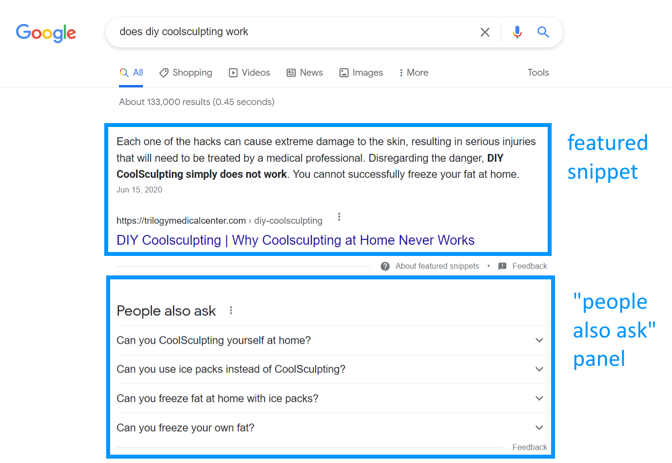

TIPS FOR MAKING YOUR COOLSCULPTING FAQ PAGE

To create a great CoolSculpting FAQ page or an FAQ page for any of your aesthetic services, follow these tips:

Determine which questions to answer

Find out what questions people are asking. Start with your own practice. What questions are you commonly asked when someone calls about CoolSculpting, asks during a consultation, or asks while undergoing the treatment?
Once you have your list, expand it by performing some online research. Look at the “people also ask” section for a list of popular long-tail search queries.
As of 2022, the top search queries for CoolSculpting are:
KEYWORD | MO. SEARCH VOLUME IN USA | COMPETITION
What is the cost of CoolSculpting? | 60,500 | high
Does CoolSculpting work? | 14,800 | medium
What is CoolSculpting? | 12,100 | medium
Is CoolSculpting safe? | 2400 | medium
What is body sculpting? | 5,400 | medium
Does CoolSculpting hurt? | 1,600 | low
Does CoolSculpting last? /  Is CoolSculpting permanent? | 1,600 | medium
Is CoolSculpting worth it? | 1,300 | medium

Will you put this into a table when formatting

Keep answers short

Most featured snippets range between 40 and 50 words (between 270 and 370 characters.) Keep your answers within this length range.

Answer the Question

Make your answers straight to the point. Use the inverted pyramid model employed by a journalist. Start by providing the answer first (what the user wants most) and then add supporting details.

Continually build your FAQ page

You don’t need to answer all your questions at once. Continually bulk up your FAQ page by providing a few new answers every month. This will help your SEO and will eventually give your website a robust FAQ page.

Write your own answers

It’s easy to copy and paste content from other websites, but Google won’t reward your site for plagiarized content. In fact, your website may be penalized for taking content from other websites. So, make sure you write your own answers.

COOLSCULPTING FAQ PAGE EXAMPLE

Check out this FAQ example to get a feel for writing answers for CoolSculpting’s most frequently asked questions.

What is CoolSculpting?
CoolSculpting, also known as fat freezing or cryolipolysis, is a non-invasive fat reduction treatment. It eliminates stubborn fat cells that resist diet and exercise by freezing the fat cells to death. People choose CoolSculpting to reduce fat without surgery or a lengthy downtime.

What is Cool Sculpting?
Cool Sculpting is the world’s most popular non-surgical fat reduction treatment. It reduces stubborn bulges by freezing fat cells to death. Studies show that one Cool Sculpting treatment can reduce fat by 25%.

What is fat freezing?
Fat freezing - also known as Cryolipolysis – refers to the body contouring procedure known as CoolSculpting. CoolSculpting literally freezes fat cells to death using precisely controlled cooling. CoolSculpting is the only FDA-cleared treatment that uses cooling to reduce unwanted fat.

What is Cryolipolysis?
Cryolipolysis is a scientifically proven procedure that uses controlled cooling to freeze unwanted fat cells to death. CoolSculpting is the only FDA-cleared body contouring treatment that uses cryolipolysis to reduce unwanted fat.

How much does CoolSculpting cost?
CoolSculpting prices depend on the area treated and the number of sessions required. A CoolSculpting session typically starts at $600 to $750. However, most patients require more than one session. Larger treatment areas (the abdomen) cost more than smaller treatment areas (the chin.) On average people spend $1,500 to $4,000 on CoolSculpting treatments.

What is the cost of CoolSculpting?
CoolSculpting cost varies per patient. Sessions typically start at $600. Most people need several CoolSculpting sessions for optimal results. On average, people spend $1,500 altogether on the CoolSculpting procedure.

Is CoolSculpting permanent? How long does CoolSculpting last?
CoolSculpting is scientifically proven to be very long-lasting. Once fat cells are eliminated, they cannot grow back. This results in long-lasting fat reduction results. Patients should maintain healthy lifestyles to avoid gaining weight in regions surrounding the treatment area, obscuring CoolSculpting results.

Does CoolSculpting work? How does CoolSculpting work? Does CoolSculpting really work? Is CoolSculpting effective?
Yes, CoolSculpting works. It is FDA cleared and scientifically proven to be safe and effective. One study found that a single CoolSculpting treatment can reduce fat by 25% at the treatment site. However, optimal results depend on appropriate patient selection.

Does CoolSculpting hurt?
CoolSculpting is considered a relatively tolerable treatment. During the first few minutes of the treatment, patients may experience a tugging sensation and a feeling of intense cold at the treatment site. However, the area quickly becomes numb. After the treatment, the technician massages the treated area for two minutes. Some patients find this uncomfortable.

Is CoolSculpting painful?
Most patients find the CoolSculpting treatment tolerable. The treatment is cold, but the only thing that will freeze is your fat cells. Some patients complain about the two-minute message that follows a CoolSculpting treatment. Afterward, the treatment area may be tender for the next several days.
CoolSculpting does not hurt, but it is cold. The cold feeling eases once the treatment area becomes numb, which typically takes 5 minutes. After treatment, the area is massaged, which some patients may find uncomfortable as the feeling comes back to the treatment site.

Can you freeze your fat at home? / Does CoolSculpting at Home work? Does CoolSculpting at home really work?
No, you can not freeze your fat at home. DIY CoolSculpting or CoolSculpting at home is dangerous and ineffective. Ice packs cannot reduce belly fat or other fat bulges. Placing ice packs on your skin will not freeze fat bulges, but it can freeze your skin leading to thermal injury.

Can ice packs reduce belly fat?
No, icepacks do not reduce belly fat or any area of fat. DIY fat freezing or CoolSculpting at home is ineffective and can lead to severe injury. The only way to successfully freeze your fat is with a legitimate CoolSculpting treatment from an authorized provider.

Which is better, CoolSculpting or Liposuction?
Liposuction removes more fat than CoolSculpting, but Liposuction is invasive. It requires surgery, general anesthesia, and a lengthy recovery time. CoolSculpting is non-invasive. It is better for spot-reducing isolated bulges of fat. It is ideal for people who want to reduce fat without surgery or lengthy downtime.

Is CoolSculpting right for me?
CoolSculpting is not a suitable option for everybody. It is intended for healthy men and women who diet and exercise but still struggle with stubborn bulges of isolated fat. CoolSculpting is not a weight loss treatment or a cure for obesity.

Who is a good candidate for CoolSculpting?
Determine if CoolSculpting is right for you by scheduling a consultation with a CoolSculpting provider. The treatment works best on isolated bulges of pinchable fat. It is intended for healthy adults who struggle with stubborn fat deposits that resist diet and exercise.

How long does it take to start seeing results from CoolSculpting?
People typically begin to see their CoolSculpting results within 8 to 12 weeks after their treatment. Some patients see results even earlier. Fat reduction may continue for up to 6 months following treatment.

When will I see CoolSculpting results?
CoolSculpting results take several weeks to manifest. Most patients see results within 8 to 12 weeks and continue to see a fat reduction for up to six months following the fat freezing procedure.

Does CoolSculpting work on arms? Can CoolSculpting get rid of batwings?
Yes, CoolSculpting works on arms. The FDA recently cleared a CoolSculpting applicator specifically designed to reduce upper arm fat, also known as bat wings.

Do you actually lose weight with CoolSculpting? Will CoolSculpting help me lose weight?
CoolSculpting is not a weight loss treatment. It is a fat reduction treatment. Unlike weight loss treatments that shrink fat cells, CoolSculpting eliminates fat cells via a process known as cryolipolysis. This results in visible reductions in fat.

Is CoolSculpting dangerous?
CoolSculpting is FDA cleared and scientifically proven to be a safe and effective method for reducing fat. Adverse side effects are rare. The best way to ensure your safety is to choose a reputable medical spa with a certified and experienced CoolSculpting provider.

How Cold Does CoolSculpting Get?
The CoolSculpting machine is calibrated for the optimum temperature for freezing fat cells. The CoolSculpting applicator chills a bulge to 4 degrees Celsius (39 to 41 degrees Fahrenheit) just above freezing.

How Cold is CoolSculpting?
The CoolSculpting machine exposes bulges to temperatures just above freezing at 4 degrees Celsius (39 to 41 degrees Fahrenheit). This is the optimum temperature for freezing subcutaneous fat cells.
CoolSculpting treatments expose bulges to 39 to 41 degrees Fahrenheit (4 degrees Celsius). This temperature, just above freezing, is the ideal temperature for freezing fat cells. Any colder and the chilling may damage the skin. Any warmer and the temperature will not freeze fat cells.

Is CoolSculpting Worth It?
It depends on your expectations. CoolSculpting is not intended for weight loss or reducing a lot of fat. CoolSculpting is designed to reduce isolated fat bulges, like belly fat or love handles. When patients complete the prescribed treatment plan, satisfaction rates are high.

COOLSCULPTING MARKETING WITH MEDSTAR MEDIA

If you are running a CoolSculpting practice, you may not have time to write your own FAQ page. Fortunately, the SEO department at Medstar Media are pros at writing CoolSculpting content. Reach out to us to learn more. Fill out the contact form below, send us an email, or call us at (801) 877-1744.

