MENSTRUATION BLEEDING.SERVICEPAGE.EDELMAN.WMNE.MZ.PAGE1
KW: abnormal bleeding
/abnormal bleeding
META: Abnormal bleeding is more common than women think. Learn about your menstrual patterns & abnormal bleeding from gynecologist, Dr. Julia Edelman.
TITLE: MENSTRUAL BLEEDING : WHAT IS ABNORMAL BLEEDING AND WHAT DOES IT MEAN
For most women, menstruation is a significant aspect of their child-bearing years. However, periods affect women differently. Characteristics , like how long a period lasts, how often a women gets her period, and how heavy her flow is, can differ from one woman to the next. Some of these differences are normal. However, some of them are not and may warrant further examination.
Abnormal bleeding, which may include heavy bleeding, bleeding too often, bleeding in between periods, or certain deviations from your normal menstrual patterns, can be a message that something is not right. It is important not to ignore abnormal bleeding, even if abnormal bleeding is normal for you.
Continue reading to learn more about abnormal bleeding. You’ll learn about the signs and symptoms to watch out for regarding menstruation, how to understand and record your menstrual patterns, find out if the features of your period are normal or abnormal, determine if your situation warrants a visit to your doctor, what tests and treatments your doctor can offer, and what underlying causes may be behind your abnormal bleeding.
TYPES OF MENSTRUAL BLEEDING
It is important to know how to differentiate between normal bleeding and abnormal bleeding.
NORMAL BLEEDING (YOUR MENSTRUAL PATTERN)
Every woman menstruates differently. It’s important to know your own patterns. This often requires keeping track of your period.
ABNORMAL BLEEDING
Abnormal uterine bleeding is when you:
- bleed (or spot) in between your monthly periods
- have extremely heavy periods
- Have prolonged periods
- Skip more than three menstrual periods in a row
However, “abnormal bleeding” may also refer to any deviation from your usual menstrual pattern.
Even though abnormal bleeding is common it is still abnormal. Abnormal bleeding is a prevalent problem, affecting more than 10 million women in the US.
ABNORMAL BLEEDING CAN TAKE MANY FORMS:
- Heavy bleeding:
- Bleeding too frequently
- Prolonged Bleeding: (Bleeding for too long)
- Spotting
- Irregular Menses: Skipping your period
- Bleeding after sex
- Bleeding after menopause

MAINTAINING A MENSTRUATION HISTORY
The best way to recognize abnormal bleeding is establishing a baseline of your usual bleeding patterns.
Dr. Edelman encourages all her patients to keep track of their bleeding patterns. The more information you provide your doctor, the easier it will be to recognize any deviations from your normal patterns. “The key to identifying abnormal bleeding is keeping an accurate menstrual chart or calendar.”
MENSTRUAL CALENDAR, APP, OR CHART
There are several ways to record of your menstrual history. Some women make note on their calendars. Other women make a dedicated chart or page in their journal. Some women download apps that record inputted data. The best method is whichever one works best for you.
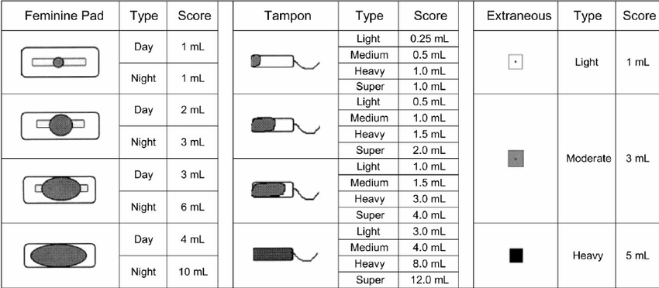
WHAT TO KEEP RECORD OF:
[DIJAH – Could I please enlist your awesome graphic design skills. I would like to make an image that explains the basics of keeping track of your period. Could you come up with icons for the following bolded characteristics. Reach out to me for more information. Thanks so much.]
When recording your menstrual cycle, keep track of the following:
[PLEASE TOGGLE THE FOLLOWING]
Menstrual Cycle length
The length of your menstrual cycle is calculated by the number of days between periods or “bleeding episodes.” The calculation starts on the first day of your period and goes to the first day of your next period.
When recording cycle length, it doesn’t matter when your period ends, just when it starts.
For example, if a woman started her period on June 1, bled for seven days, and then gets her next period on June 21, that would be a 21 day cycle. Whether she bleeds for 3 consecutive days or 7 days, her cycle length will still be 21 days.

Menstrual Period Length
The length of your menstrual period refers to how long your period lasts: from the day you start bleeding, to the day you stop.
Keep track of every day your bleed or spot during your period. Record any day(s) when you do not bleed while menstruating.

Flow: How much do you bleed?
How many days do you have a heavy flow or see clots? How many days do you have spotting or light flow?
How much are you really bleeding? It is very difficult to judge how much blood you are losing during a menstrual period. You may think you know how much blood you lose during menstruation. But, blood loss can be deceiving. Studies show that a woman’s assessment on how much blood she is losing is seldom accurate.
One of the more reliable ways to measure the flow of your period is by counting the pads or tampons you go through. Also record the absorbency capacity of the feminine product you use. Is it a light maxi pad or a super absorbent tampon, etc.?

The presence of blood clots
Large clots are often a sign of heavy bleeding.
If you notice clotting, record the size of the blood clot. Use coins as comparison. For example, was the blood clot the size of a dime? Or maybe it’s the size of a quarter.
Spotting (intermenstrual bleeding)
Take note of any spotting in between periods.
IS YOUR BLEEDING ABNORMAL?
There may be characteristics of your usual bleeding pattern that are in fact, not normal. Some features may be completely fine. Others warrant an assessment by your gynecologist.
Take the quiz:
[Jonamae – is there any way we can make this into a quiz – like CoolSculpting uses (is CoolSculpting right for you? Mel- Give J the URL. I think this would be a great thing for the service page and also something we could promote on Dr. Edelman’s social media.]
- Are your periods deviating from your normal bleeding patterns?

- Does the duration of your period or severity of your period stop you from pursuing your normal activities?

- Do you soak through a regular tampon or pad within one to two hours? Or do you soak through a super tampon or large maxi pad in 3 to 4 hours?

- Do you bleed through your clothes without warning? Do you bleed through your clothing and on to your bedding at night?

- Is your menstrual cycle less than 21 days? (Does your next period start less than 21 days since your previous period started?)

- Does your period last longer than 8 days (this includes any spotting before or after steady blood flow?

- Do you bleed (or spot) in between periods?

- Do you bleed after sex?
WHAT TO DO IF YOU HAVE ABNORMAL BLEEDING
If you answered “yes” to any of these questions, you should seek a medical evaluation. Talk to your doctor or a find a reputable gynecologist in your area.
When seeing your doctor, make sure to bring the data from your menstrual chart, app, or journal. Knowing your bleeding patterns is very helpful for determining if your abnormal bleeding warrants further investigation.
Your doctor will consider medical history, menstrual history, age (stage of menopause) and possibly a pelvic examination to determine which course of action is best for you.
GYNECOLOGIST NEAR ME
If you think you may experience abnormal bleeding, don’t ignore it. Schedule a consultation with Dr. Julia Edelman. She is renowned in the field of women’s health and can answer all your questions, diagnose your symptoms or problems, and offer non-invasive solutions using groundbreaking technology and the latest techniques in treating abnormal bleeding.
Reach out to Dr. Edelman at Women’s Health New England today by calling 508 947-0800 to schedule your consultation. You can also contact Dr. Edelman online by filling out the form below.
Sources:
Menopause Matters. Julia Edelman, MD, FACOG, NCMP LINK.

