Jessy Shirley was born and raised in Magnolia, Texas. She became a Licensed Cosmetologist in 2007. After a decade as a Cosmetologist, she continued her education by receiving her Associates Degree in Business in 2017. With a true passion for the beauty industry, she found the field of aesthetics and attended the Esthetician Program at The Aveda Institute. Jessy became a Licensed Aesthetician in 2018. She is now dual licensed. In Jessy’s two and a half years as a State Board Licensed Aesthetician she has had extensive training in numerous cosmetic procedures. She specializes in Coolsculpting. As an advanced Coolsculpting practitioner, she has performed thousands of procedures. She strives to customize treatment plans for her clients to make them feel more beautiful and confident. Jessy is excited to continue expanding her education and growing as apart of the team at Cypress Dermatology!!

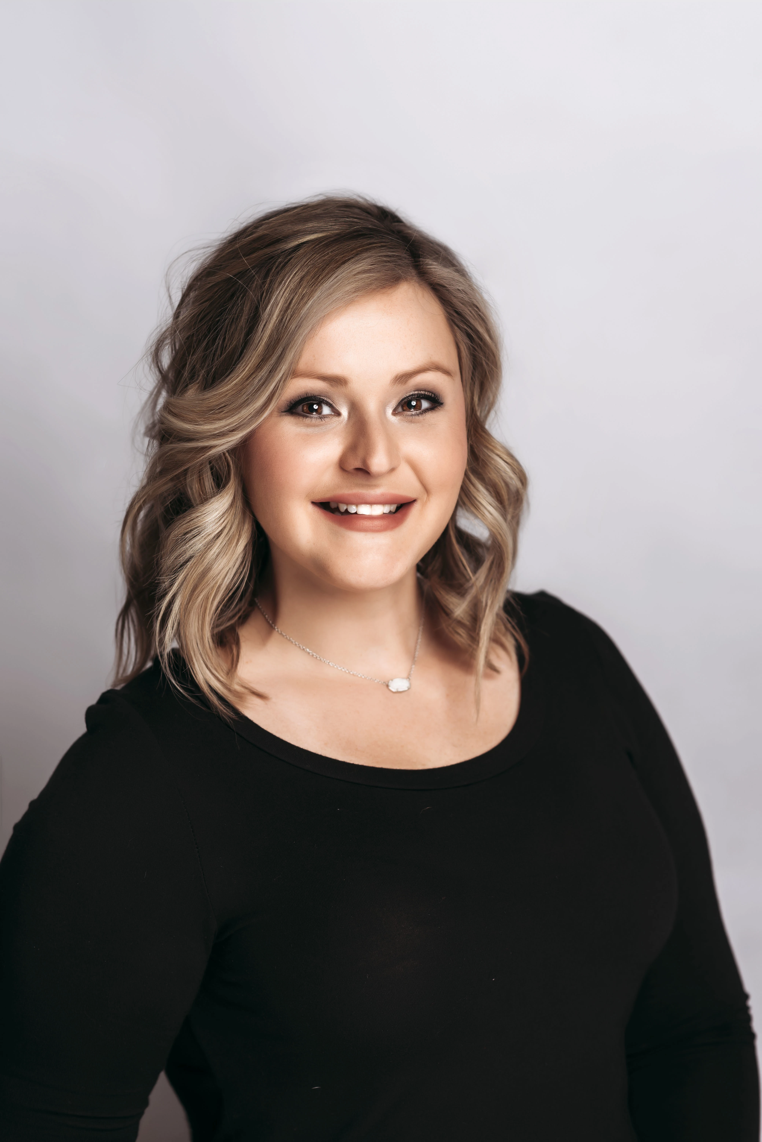

Cheyenne grew up here in cypress , tx . She always had a passion for skincare through middle school all the way through high school. Before beauty school, she was a competitive dancer for about 15 years and a gymnastics coach. But through all that her passion stuck for skin care so in 2018 she graduated from Aveda institute in the woodlands. Then she began her career in medical skin care treatments and knowledge. She specializes in acne treatments , chemical peels and microneedling. She is so excited to take you on are you skin care journey here at cypress dermatology. In her free time she enjoys Traveling and spending time with her boyfriend Christian and family

