FRONT DESK TRAINING
FOR
DELLO RUSSO LASER VISION

MEDSTAR MEDIA

Front desk training is a critical, yet often neglected, part of becoming a successful CoolSculpting provider. Enhancing your front desk practices is one of the most effective ways to book more consults, decrease no shows, and increase the number of potential customers who buy CoolSculpting treatments.

TABLE OF CONTENTS

FRONT DESK BEST PRACTICES ………………………………………………………………………2

LASIK CALL SCRIPT ……………………………………………………………………….6

ANSWERS TO FREQUENTLY ASKED QUESTIONS………………………………………………9

FRONT DESK BEST PRACTICES: TIPS

A caller’s initial interaction with the front desk staff has a profound impact on the person’s reception of Dello Russo Laser Vision and the Lasik procedure. An effective and efficient call with your front desk staff also sets up Dr. Dello Russo to conduct a successful consultation.

THE 3 OBJECTIVES WHEN ANSWERING A CALL ABOUT LASIK

- Answer questions / Share Information
- Develop elevator pitch explaining what Lasik is and why it is so popular. (See the FAQ section for examples.)
- Answer callers questions and provide information
- Try to use personal experience when answering questions. (See call script for examples.)
  - Avoid questions covered in the consultation (anything that would determine the treatment parameters or the caller’s candidacy for Lasik.)

- Share Excitement
- SHARE YOUR PASSION ABOUT LASIK: Use personal experience. Talk about why Lasik is so great.
- PRACTICE UNIQUENESS: Explain why Dello Russo is the best choice for Lasik.
  - (Develop an elevator pitch on practice uniqueness.)

- Book a Consultation
- Assume every caller is calling to schedule a consultation
- Use assumptive phrases

TIPS FOR EXCELLENT CUSTOMER SERVICE OVER THE PHONE

- When answering: Include “Dello Russo Laser Vision,” your name, and offer your assistance. Sound genuine and enthusiastic.

- All receptionists should know how to say “one moment please,” in spanish and any other language that is frequently requested by your callers.
- Use “verbal nods” like “Mhm” or “Ah yes, I understand”

- Use plain language. Avoid technical terms, jargon and acronyms. Be professional, concise and clear.

- Do not interrupt the customer.

- As soon as you receive a customer’s name, use it. Dale Carnegie said, “Remember that a person’s name is to that person the sweetest and most important sound in any language.”

- Try to validate questions: “That is a good question” “that is a common concern” etc.

- Avoid phrases such as “I don’t know,” “I can’t do that,” or “Just a second.” Specify how long completing a task will take, and state what you can do rather than what you cannot.
If caller asks a question you do not know…Reply with something like “That is a great question. I can ask Dr. Dello Russo or the financing specialist or whoever and get back to you with the answer by [give a specific time.”] Or “that is a good question. I can transfer you to [whatever department] who can give you a specific answer. Before I transfer you, may I get your name and phone number in case we get disconnected? Thank you.”

- Provide alternatives:
Insurance may not cover their Lasik, but you have available financing options.
They may not qualify for Lasik but they could qualify for other treatments.
The eye center may not be open on a specific day requested by the caller, but the center is open on these days, or the caller can visit another Dello Russo eye center.

- Share personal experience

- Avoid Yes or No questions.

- Assume all Lasik callers are calling to schedule a consultation. Use assumptive phrases and questions (See call script for examples.)

- The receptionist should NOT perform a consultation over the phone. Re-focus the caller to book a consult.

- Avoid the topic of cost if possible. However, if caller insists, follow the instructions given in the FAQ section.

- Ending the Conversation: As with most things, finishing a conversation on the right note can create lasting positivity and a satisfied customer. In order to achieve a great ending to a telephone call, make sure that the caller understands the information you passed along before you hang up. Ask the customer, “Is there anything else I can help you with?” Also, provide any information that the customer might need in the future. If he or she needs to call back, share optimal contact times and whom he or she should call.

USE PERSONAL EXPERIENCE TO FRAME YOUR RESPONSES

If the reception has received Lasik themselves, this is a fantastic advantage for developing trust and reporte with callers. Use your personal experience as much as possible. i.e. “When I got my Lasik…” or “I had the same concern before my lasik procedure…” etc. If the receptionist has not received Lasik, have him/her refer to their family member who has, or one of the patient’s they interacted with recently. i.e. “I brought my brothers into Dr. Dello Russo for their Lasik procedures and they said…” or “I just saw a patient who said…” or “That’s a common concern among our patients…” etc.

Being able to answer caller’s questions with personal experience makes the call sound more genuine, promotes the Lasik procedure, endorses Dr. Dello Russo , helps develop a connection with the caller, and allows the person answering the phone to express passion for the treatment.

4 THINGS THE RECEPTIONIST SHOULD KNOW BY HEART

- PRACTICE UNIQUENESS STATEMENT:

- LASIK ELEVATOR PITCH (brief statement on what Lasik is and why it is so popular.)

- Answers to frequently asked questions

- The Lasik call script and front desk best practices.

THE IMPORTANCE OF FAST RESPONSE TIMES

According to an MIT study, response times significantly affect conversion rates:

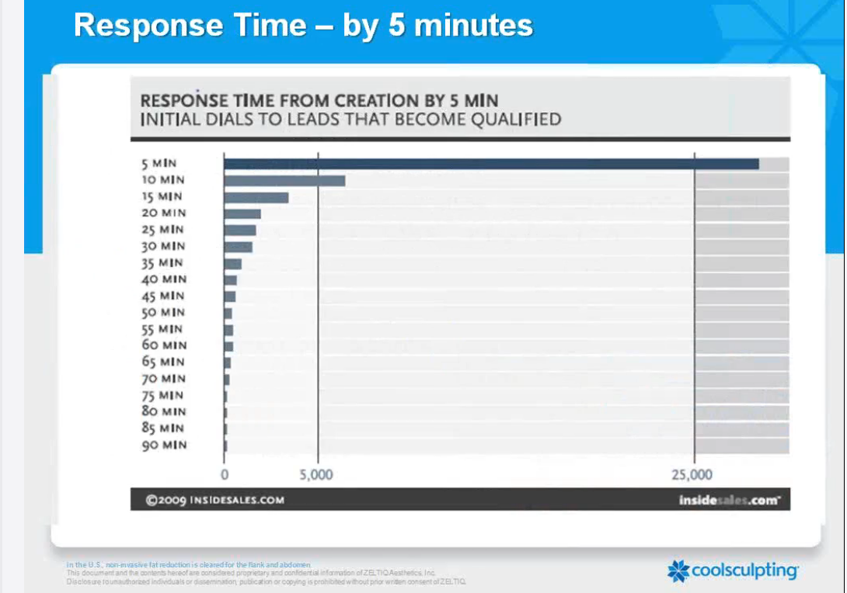

*4X less effective by waiting 10 minutes compared to responding within 5 minutes.

IF YOU HAVE TO PLACE A CALLER ON HOLD

Being placed on hold for too long, or put on hold instantly is one of the MAIN reasons callers hang up or decline to book a consultation.

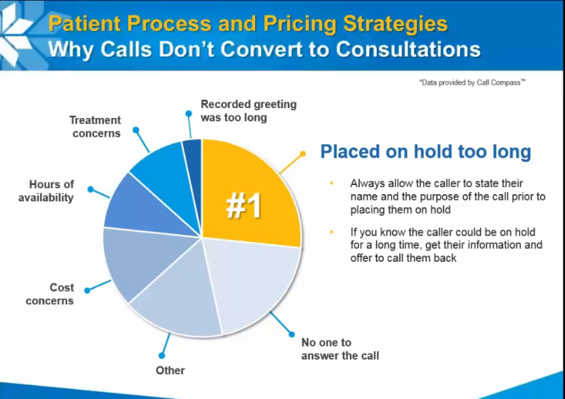

If you have to put someone on hold, make sure to get the caller’s name and purpose for calling before putting them on hold.

Receptionist: “Hello. Thank you for calling Dello Russo Laser Vision. My name is [Name.] May I ask with whom I am speaking?”

Caller: “My name is Melissa, I am calling about Lasik.”

Receptionist: “Hello Melissa. You’re interested in Lasik, that’s fantastic, you’ve called the right place! May I ask you to hold for a brief moment, I have another caller on the opposite line?

Caller: Yes

***Wait until the caller answers yes before placing them on hold.

***If the caller has to be on hold for a long time, get their information and call them back.

FRONT DESK CALL SCRIPT

SUGGESTED SCRIPT FOR A LASIK PATIENT CALL
RECEPTIONIST…….. | “Thank you for calling Dello Russo Laser Vision. This is [Name of Staff Member].  How may I help you?”
CALLER……………….. | “I was calling about Lasik…”
RECEPTIONIST…….. | “Fantastic. You have chosen the right place. We are a state-of-the-art eye center and our surgeons, Dr. Joseph Dello Russo and his son, Dr. Jeffrey Dello Russo are the most experienced eye surgeons on the East Coast. Together, they’ve performed more than 165,000 surgeries. You couldn’t be in better hands.  Be enthusiastic. Remember, passion is contagious.  Collect name and number on the Call Conversion Sheet  “I would love to answer any questions you may have but first, may I please have your name and phone number, just in case we get disconnected,?”  Once you receive their name, use it.
CALLER……………….. | Yes, my name is Melissa and my number is 888-888-8888.”
RECEPTIONIST…….. | “Great! Thank you, Melissa. ”  Next, ask the caller if they have any questions about the Lasik treatment. This will show the caller you are there to help them. It will also help you gauge where the caller is at, what concerns they have, and other insight that will help you customize the conversation to the caller’s needs and lead the caller to book a consultation over the phone.  “Are there any questions I can answer for you?  Refer to FAQ section for answers to caller’s questions.  If the caller does not articulate any specific questions, move on in the conversation by asking:  Lasik is a fantastic way to correct blurry vision. The procedure is safe and painless, recovery is quick and most patients walk away with better than 20/20 vision. [Insert personal endorsement] I got Lasik ten years ago, it was one of the best investments of my life. [End by reassuring the caller that Lasik is right for them] “I love my results. You’ll love your results, too!”  “What made you interested in Lasik?”  This is a great opportunity for the receptionist to validate the caller, connect with the caller, and learn more about the caller’s selling points. Whatever the caller’s concern is, validate it and then explain how Lasik from Dello Russo Laser Vision can address that concern.  I.E. A lot of Dr. Dello Russo’s patient’s come in for Lasik for the exact reason. Or, that’s why I choose to get Lasik from Dr. Dello Russo. Or, we just performed Lasik on a patient for that exact reason and they love their results,” etc.
RECEPTIONIST…….. | Do not ask if they want to book a consultation. Use ASSUMPTIVE PHRASES. (Assume every caller wants to book a consultation.) Just continue straight into the scheduling portion of the phone call. Remember; try to avoid yes and no questions when possible.  “During your complimentary consultation, you will actually meet with Dr. Dello Russo. We are one of the few Lasik Centers where your surgeon actually performs your eye exam. He can answer any questions you have about the procedure and will leave you with invaluable insight about the health of your eye and what treatment he thinks will be best for your situation.”  “We have new patient consults available on Tuesdays and Thursdays; Melissa, which day works better for you?”
CALLER……………….. | “Tuesdays.”
RECEPTIONIST…….. | “Do you prefer mornings or afternoons?”
CALLER……………….. | “Mornings”
RECEPTIONIST…….. | “Great! I have possibilities for you to come in for your consultation on this Tuesday afternoon at 9:00 am or 11:00 am. Which works better for you?”
 | 11:00 AM
AFTER you have scheduled the consult, you can ask them about their eye health history?
“Melissa, may I ask you if you have seen an eye doctor in the past for any eye conditions such as cataracts, or glaucoma?”
 | No I haven’t.
Okay, thank you Melissa.
The consultation typically takes 45 minutes in total. During your eye exam, Dr. Dello Russo will assess your eyes using state-of-the-art [device]. So we will not have to dialate your eyes, and the exam is completely painless. During your consultation, you will also meet with our counselor who will [insert benefit] and our fininacial counselor who will determine if there are any discounts you can take advantage of to save on your cost and customize a payment plan that works best for you.
Melissa, may I ask if you wear contacts or glasses?
If possible, Dr. Dello Russo requests that you wear your glasses in the 48 hours before your consulation because it allows for more precise measurements.
After your consultation, you are free to return to your normal activities. About a quarter of patients who undergo a consultation with Dr. Dello Russo opt to have the Lasik procedure immediately after. The Lasik procedure takes about 10 minutes to complete. If that is something you decide to do, just know you will not be able to drive for the next 24 hours. So you should arrange someone to take you home, or plan on an UBER or taxi.
Melissa, I would like to provide you with some additional helpful information about your Lasik consultation and the Lasik procedure. Is there an email address I can send this information to?
RECEPTIONIST…….. | Great, I will send that information your way. Do you have any other questions I may answer for you?
CALLER……………….. | No, I think I got it.
RECEPTIONIST…….. | Melissa, we are delighted that you have chosen Dello Russo Laser Vision We can’t wait to see you on [date and time.]”

ANSWERS TO FREQUENTLY ASKED QUESTIONS

- When answering questions, Do not say anything that would shut the caller down, for example, “no we do not accept insurance.”
- Validate questions.
- If you have personal experience (either receiving the Lasik procedure yourself or from your experience working at the office,) use that in your conversation. It will make the call more personal and intimate, which will improve the caller’s perception of Dello Russo Laser Vision.

Pain | “I was concerned that it might hurt as well But, when I got LASIK, it was completely painless.”  If caller inquires further: Dr. Dello Russo will administer local anesthetic eye drops to ensure you will not feel anything during the procedure and we can give you a mild sedative or other medication prior to surgery to help you relax, and ease any discomfort. Any irritation following the procedure dissipates in hours.”
Cost | “Cost varies per patient, depending on several factors, such as your eye prescription. During your complimentary consultation, Dr. Dello Russo will perform an eye exam to determine your prescription and can then provide an exact cost for your Lasik procedure. We understand that Lasik is an investment for our patients. That is why we offer some of the best payment plans on the market, including 0% financing. During your complimentary consultation, our financing specialist will discuss available discounts and work with you to design a payment plan to help you comfortably cover the cost of your procedure.”
If they ask about cost a second time
Insurance? | (Avoid saying you do not take insurance.)  “If your eye plan covers Lasik, we would be happy to work with your insurance. But in my experience, most insurance companies consider Lasik an elective procedure and refuse to cover it. However, during your complimentary consultation, our financing specialist can cover other discounts and payment programs you may qualify for.”
After surgery, how long before I can go back to using the computer at work, my smartphone, watch TV? | After your Lasik procedure, Dr. Dello Russo recommends avoiding screen time or reading for [hours.] This allows your eyes to rest and heal more quickly.
Do you guys do surgery on the same day? | Yes, absolutely. In fact, a good portion of our patients decide to undergo Lasik immediately after their consultation. If that is something you would like to do, just remember you wont be able to drive for 24 hours after your procedure, so you will need someone to drive you home or make preperations for an UBER. The surgery itself is completed in less than ten minutes, but I tell patients to plan on spending 11/2 to 2 hours tops at our office. Also, Dr. Dello Russo would like to see you again the following work day to ensure your eyes are healing optimally and answer any questions you may have.
When can I return to work/school? | “Most patients can resume work or school the following day after their LASIK eye surgery. However, you will also need to see your LASIK surgeon the following day for a follow-up eye examination.”
Result time | Begin with a positive: “Most patients recover from their Lasik procedure very quickly. (Share personal experience if possible.) Most patients experience noticeable improvements in vision within the first 24 hours. Your vision will get better and better with time as your eyes heal.”  Or  “It is normal to experience some blurry or hazy vision immediately after LASIK. However, expect to have a noticeably better vision the following day and as your eyes heal, the vision will get better and better with time.”
The Lasik Procedure | “Lasik is a relatively simple procedure. Using the latest technology in laser eye surgery, Dr. Dello Russo makes small alterations to the cornea to correct refraction errors. During your complimentary consultation, your eye surgeon will discuss the details of the Lasik procedure in detail.”
 | “You cannot drive immediately after a LASIK procedure so it’s a good idea to bring a friend or family member for a ride home.”
Callers who have received a consultation from another Lasik provider: | “Dr. Dello Russo customizes his treatment plans to each individual patient. Therefore he insists on performing his own evaluation before performing Lasik surgery on an individual.”

TEXT RESPONSES:

Lasik, or laser eye surgery is a safe, effective way to improve blurry vision.

