Procell Microchanneling Face $350 50min
Series of 3 $900

Procell Microchanneling Body $450 50min
Series of 3 $1150

Are you ready for a more sophisticated facial to help address skin concerns such as resurfacing & enlarged pores, aging skin, wrinkles, stretch marks, acne scarring, discoloration, or scarring? Then this facia is the solution for you.
ProCell Microchanneling Facial is the hottest and most innovative skin care modality on the market today!
This ProCell Microchanneling Facial is the closest alternative to Micro-needling. It is the most effective non-invasive & skin rejuvenating, with no downtime, and is one of the safest beauty devices on the market today. Many of the invasive treatments risk damage to the dermal layer with potential exposure to pain, infection, and toxic side effects.
If you want fast and effective results, this is the perfect facial to consider. It delivers nutrients into the skin encouraging the natural production of collagen and elastin.

The procedure makes uniform holes in the outermost layer of your skin, the same size & the same depth, without damaging or scratching your skin. These tiny holes, also called as channels, are the perfect way to get healing products into your skin, such as the ProCell Serum which has stem cell technology. This treatment is clinically proven to increase collagen & elastin production, which in turn increases the thickness of the skin while improving the appearance of the skin.

What are the benefits of ProCell Microchanneling therapy?
ProCell Microchanneling therapy helps reduce or even eliminate scars from the skin.
Apart from treating and correcting acne scars, this therapy can also reduce the appearance of stretch marks in the skin.
With this unique therapy, you can say goodbye to your fine lines and wrinkles
It can enhance your appearance without damaging your skin.
It can correct uneven skin tone and texture by promoting the regeneration of a newer, fresher layer of skin.
It leaves clients with healthy rejuvenated skin.

What conditions does ProCell Microchanneling treat?
Uneven skin tone & texture
Fine lines & wrinkles
Acne scars/surgical scars
Stretch marks
Enlarged pores
Hyperpigmentation
Rosacea
Dull-looking skin complexion
Lost elasticity

How long does ProCell Microchanneling last?
Well, ProCell Microchanneling can last anywhere from 2 to 10 years, depending on clients age and lifestyle!

How many treatments will I need?
For light anti-aging treatments, 1 to 2 treatments may be sufficient but for deeper wrinkles & scarring, you may require 4 to 6 treatments to achieve desired results. An interval of 3 to 4 weeks between treatments is typically recommended and you can see the results 2-3 weeks after your treatment.

Does ProCell Microchanneling hurt?
ProCell Microchanneling doesn’t hurt, but it does not feel good too. However, if you feel pain during the procedure, you can ask your specialist to apply a light topical numbing cream.

How long does it take to heal from ProCell Microchanneling therapy?
After the therapy, your skin will be pink or red in appearance for the first 24 to 48 hours. However, this can be covered with a quality mineral makeup within 90 minutes of treatment.

Who is a good candidate for ProCell Microchanneling?
You are an ideal candidate for Microchanneling if you have:
Fine lines or wrinkles,
Uneven skin texture
Moderate skin laxity
Stretch marks
Atrophic (depressed) acne scars
Sun damage
Traumatic scars

Who is not an ideal candidate for ProCell Microchanneling?
You are NOT a suitable candidate for micro-channeling if you have any of the conditions listed below.
you have certain skin diseases, such as eczema or psoriasis
you have cardiac abnormalities
you are pregnant or breastfeeding
you have infection of any type (bacterial, viral or fungal)
you have had radiation therapy recently
you have open wounds
you have Keloid scars
you are immunosuppressed or have an immune disorder
you have diabetes, hemophilia, bleeding disorders

How much does procell microchanneling cost?
The cost of your micro-channeling treatments will depend on what is being treated and the condition of your skin. Avg. price per session is $400 for face & neck, other treatment cost is based on consultation.

Is the ProCell Micro-Channeling treatment safe?
ProCell Microchanneling therapies are absolutely safe and side effects are uncommon when being performed by knowledgeable and trained skincare professionals.

What is the aftercare like?
Avoid washing your face for the first 6 hours. You can wash the treated area gently with a gentle cleanser and apply moisturizer thereafter.
After the therapy, nothing topical should be applied for at least 90 minutes.
Do not exfoliate at least for 7 days.
Avoid direct sunlight for at least 7 days.
Ensure you have proper sun protection whenever you are out in the sun
Avoid swimming or jogging in the rain for at least 72 hours.
Avoid vigorous exercise for first 72 hours.
Avoid anti-inflammatory medication pre and post treatment.
Avoid makeup for at least 6 hours after the procedure.

What is the difference between Microchanneling and Microneedling?
ProCell Micro-channeling therapy is the next generation of Microneedling.
The main difference between the two therapies is the type of device used to perform the treatment as well as the technique that is used.
Microneedling therapy involves using a handheld “roller” covered in tiny needles that is dragged over the skin which can actually tear the skin. Micro-needling pens use much larger steel needles that pierce through the epidermis to varying depths. This causes micro-injuries, which creates a wound-healing response to create new collagen. ProCell Microchanneling therapy, on the other hand, uses a disposable chip using a “stamping” technique, which creates micro vertical channels into the skin for better and deeper product penetration & less trauma to the skin. This helps to open up the stratum corneum and allows serum ingredients to be more effective. This stimulates cell repair and regeneration while helping your skin to become more luminous, hydrated, and plumped. It effectively targets the most sensitive areas, including the neck, under eyes, eyelids, and even lips

Endosphères Therapy® 45min - $250
$1,375 (6) *savings of $125
$2,700 (12) *savings of $300
$3,900 (18) *savings of $600
$5,000 (24) *Savings of $1,000

100% Non-invasive. Clinically Tested.
Outstanding Results.

Cellulite Reduction
Endosphères Therapy® is a technology that uses an innovative Compressive Microvibration™ system, a treatment that, through a roller device composed of 55 silicon spheres, generates low-frequency mechanical vibrations. The Endosphères Therapy® method has been enriched with the sensor system, a pressure-controlled mechanism, which allows it to accurately assess the amount of pressure applied in relation to the type of tissue and the number of sessions already completed.
The Endosphères treatment produces five synergistic actions; Lymphatic drainage, Pain relief, action of the vascular system, body contouring, and muscle toning. Endosphères therapy is effective on the whole body and allows you to target specific areas of your body that you wish to see improvement in. This treatment addresses everything from muscle toning, to reduction of cellulite, and rejuvenation.

Benefits:

Tones and Shapes Muscles

Effectively Reduces Cellulite
- Relieves minor muscle aches and pain
- Non-surgical technique that combats the appearance of cellulite
- Improves and reactivates local blood circulation
- Activates lymphatic system and enhances lymphatic drainage
- Aides in muscle recovery post workout
- Improves tone and texture

Contraindications & Considerations
Due to the safe and noninvasive nature of Endosphères therapy, there are very few conditions that are contraindicated for this service.

The conditions that are contraindicated for all treatments include:

- Pregnancy/Breastfeeding
- Deep Vein Thrombosis
- Phlebitis
- Severe Varicose veins
- Taking anticoagulant drugs
- Irremovable piercings in the treatment area
- Cancer treatments in the past five years (unless doctor’s clearance is received)
- Surgery in the past three months (unless doctor’s clearance is received)
- Active eczema or psoriasis in the treatment area
- Presence of an active skin and/or bacterial infection
- Open wounds or skin in the treatment area

If your client has a severe health condition not listed, we would always recommend they consult with their physician prior to treatment.

Please grab the video and put on the page -


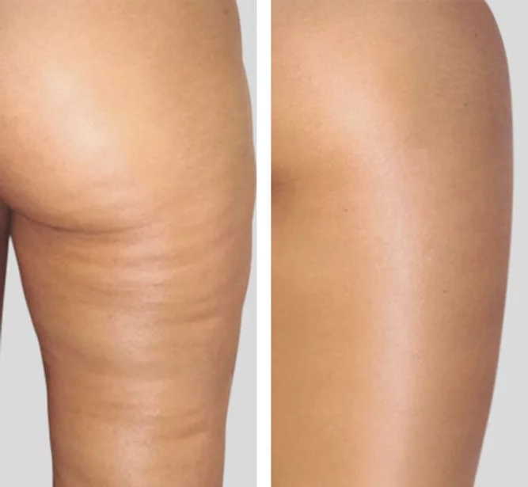
Results after 15 sessions

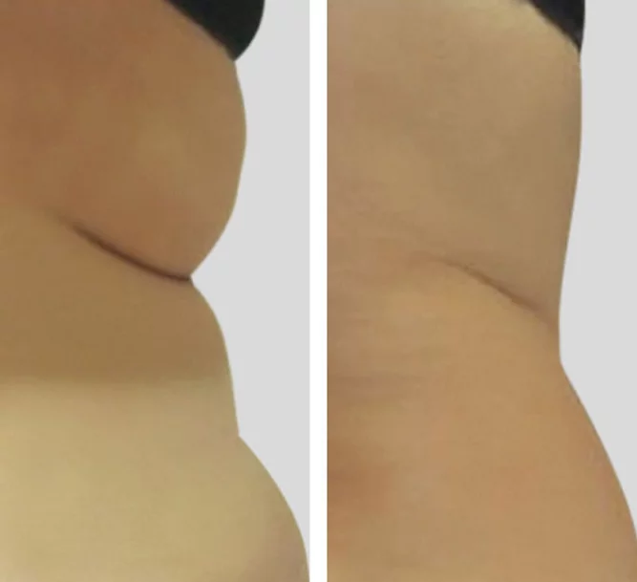
Results after 18 session

Cool Restore Cryo Therapy for Face and Body
50min Cryo Facial Treatment $150
50min Body Treatment $200 (per area)
CoolRestore Elegance is one of the latest advanced and unique Cryo Systems on the market

About Zemits CoolRestore Elegance
The all new and unique Zemits CoolRestore Elegance introduces cold or Cryo Therapy to targeted areas of the most concern with several positive effects:

Slimming:
The temperature range of +4 to -4 Degrees Celsius can dramatically impact the local fat deposits. This low range affects the local blood circulation and shrinks blood vessels. This leads to a “numbing” sensation during the treatment. Eventually this stressful freezing condition initiates the cascade of intracellular reactions and stimulates apoptosis - a natural death of fatty cells. As a result - reduced local fat deposits

Zemits CoolRestore Elegance performs an advanced treatment which involves exposing the targeted area to extremely low temperatures which shock the adipocytes and leads to a sped up and more effective adipocyte elimination process. Studies have shown that exposing the skin to freezing temperatures accelerates cell apoptosis which is a natural and controlled cell death. Cells will gradually eliminate within months after the treatment and be transferred out through the lymphatic system.

Facial Skin Tightening:

- Eye Lifting
- Face Rejuvenation
- Jawline Sculpting
- Double Chin Slimming
- Neck Firming

The extremely low cold temperatures in facial cryotherapy dramatically improve local skin metabolism that results in:
- Drastically increased blood and lymph circulation,
- Instant reduction of puffiness and visible face lifting
- Decreasing of pigmentation
- Effectively boosted of collagen and elastin production
CoolRestore Elegance Cryo Facial also helps to enhance exfoliation of dry dead cells on the skin surface and strengthen the skin improving its overall condition.
The low temperatures help tighten and smooth various facial areas with lack of elasticity or definition. Low temperature application on the skin helps to increase local blood and lymph microcirculation. That boosts skin oxygenation and helps to improve collagen and elastin production. enhance shedding of dead cells on the top skin layer, and bring arterial blood (full of oxygen to the skin from inside) to expose healthy and radiant skin beneath.
Zemits CoolRestore Elegance Facial treatments result in instantly tighter, firmer, and glowing skin.

What are the benefits of CoolRestore Elegance?
- Slimming
- Body contouring
- Anti-cellulite
- Local fat “freezing”
- Skin firming and lifting
- Boosting of the Collagen production
- Reduction of puffiness and lymphatic oedema
- Improving of skin tone and elasticity
- Healthy skin glow
- Reduction of inflammations
- Drastically improving healthy blood circulation

- What problems can it solve?
- Due to the Holistic nature of CoolRestore Elegance, virtually everyone is an excellent candidate for this treatment.

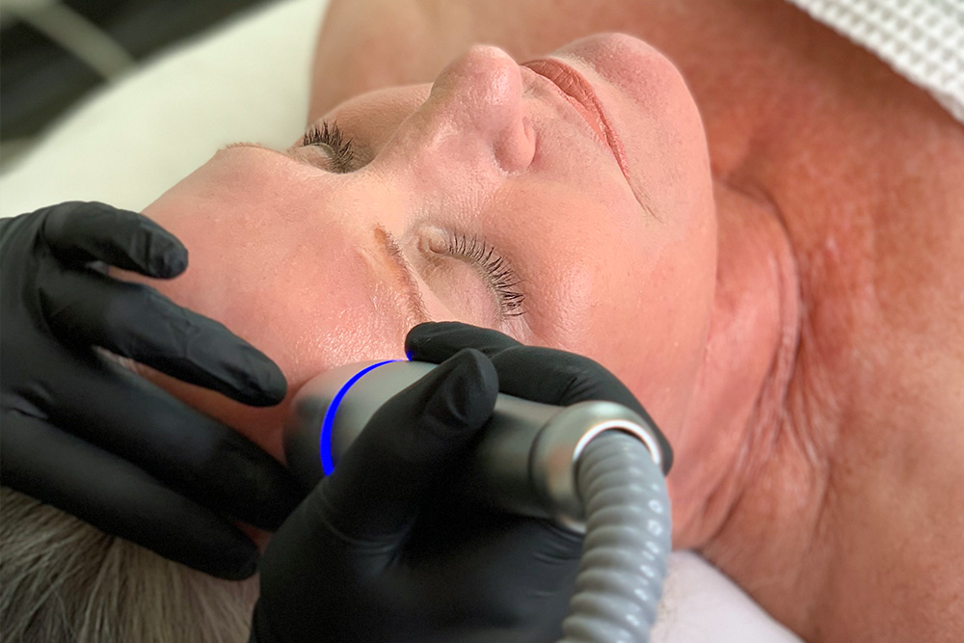
Face:
- Fine lines and wrinkles
- Sagging skin on neck and décolleté
- Decreased skin elasticity
- Post acne and aging pigmentation
- Dark circles and puffiness around eyes
- Hooded Brows
- Loose jaw line area

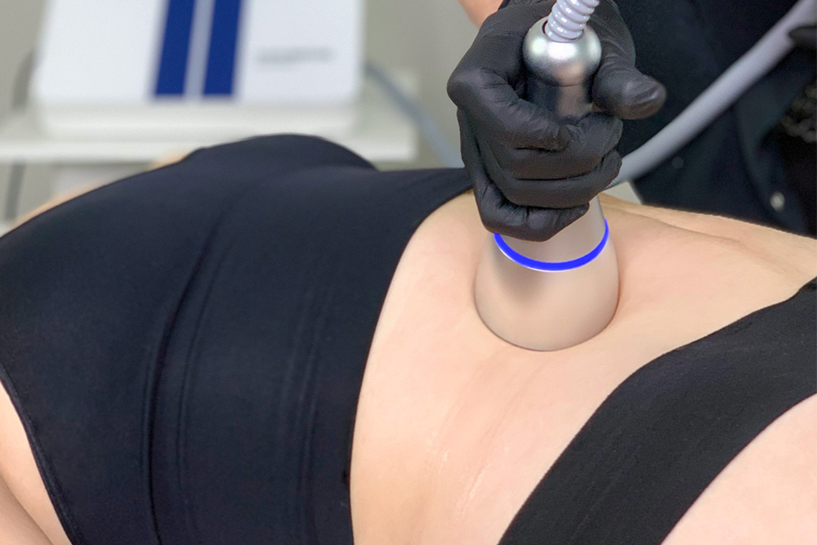
Body:
- Stubborn fat deposits
- Cellulite
- Loose skin
- Low skin tone
- Poor blood and lymphatic circulation
- Edema and puffiness
- Uneven fat deposits after surgical liposuction

The CoolRestore elegant Slimming Treatment consist of extremely low temperature which helps to stimulate fatty cells apoptosis, a naturally occurring sequence aided by the lymphatic system. During CoolRestore Elegance treatments clients experience deep cold and massage motion sensations. After the CoolRestore Elegance session, the treated fat cells will be eliminated from the body with the lymphatic flow within the following fifteen days. Clients usually notice an immediate “inch reduction”, which caused by lymph and blood decentralization, and a simply tension in the treated area. The target optimal long-lasting results will be achieved at the end of four to five session.
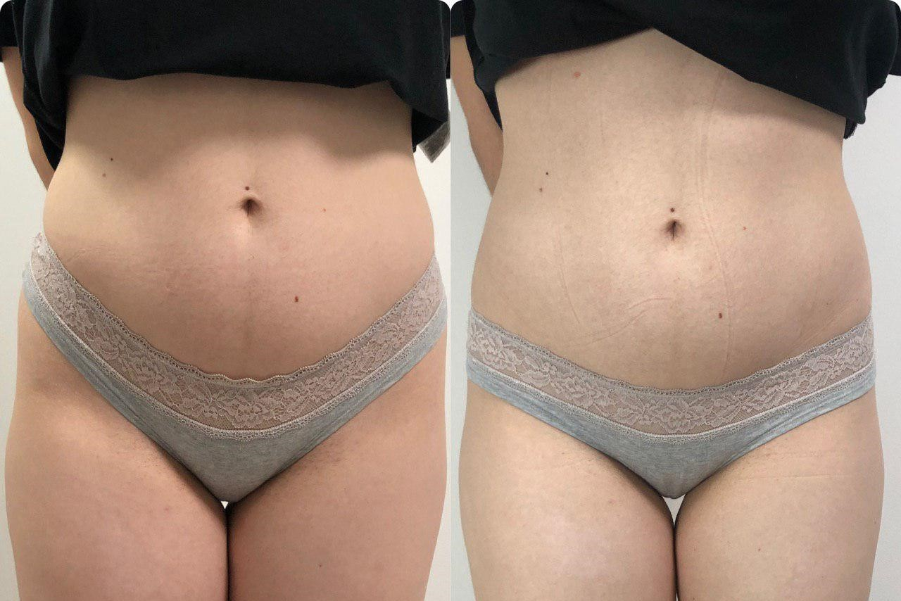

After 3 session

FQA:
How does it compare to Cavitation?
CoolRestore Elegance is a completely holistic therapy that uses doesn’t conduct any electrical current or ultrasound like other technologies. For most clients, cryo is a much more comfortable treatment experience overall.

Who is an ideal candidate?
- Individuals with loose skin, or skin lacking elasticity
- Individuals with signs of aging (fine lines, wrinkles, sagging, etc.)
- Individuals with uneven skin tone

How often is recommended to get Cool Restore?
- Facial skin toning sessions are recommended every week, 4-6 sessions for better results.
- Slimming treatment every 2 weeks for better results. The target optimal, long-lasting results will be achieved at the end of 4-8 sessions.

What are contraindications for Facial Toning?
- Botox injections in the past 30days
- Filler injections in the past 90days
- Severe Allergy to cold
- Implants in treatment area
- Progressive Diseases (MS, ALS, Parkinson’s)
- Irremovable Body Piercing(s) in treatment area

What is the contraindication for Body Slimming/ Toning Treatment?
- Active Cancer or individual taking post-cancer drugs
- HIV/AIDS
- Lymphatic Disorders or removed lymph nodes
- Uncontrolled diabetes or diabetes-related complications
- Pregnancy/Breastfeeding
- Severe Kidney or Liver Disease
- Severe Raynaud’s Syndrome
- Severe Allergy to Cold
- Progressive Diseases (MS, ALS, Parkinson’s)
- Irremovable body piercing(s) in treatment area
- Implants in treatment area

What is the recommendation pre-post care for CoolRestore Body Slimming treatment?
- Not to have carbs 2 hours before and 2 hours after the CoolRestore Elegant session
- Drink up to 2 liters of water on the day of session.
- Mandatory water consumptions:15-2 liters of water per day throughout the CoolRestore Elegance course.
- Minimal physical activity during the day: steady cardio training or 30min walk per day accelerates metabolism, helps reduce swelling, and provokes the quick excretion of cell dissolution products after CoolRestore.
- Combine CoolRestore Elegant treatments with workouts and another physical activity
- Lymphatic massage after session is recommended:
Lymph activation prevents sagging and eliminates toxins and tissue waste. Since this increase blood circulation, cell metabolism in cells is also sped up and the production of collagen and connective tissue improves.

Who is an ideal candidate for CoolRestore Body Slimming?
- Individual with a balanced diet and healthy lifestyle looking to lose the stubborn fat that does not improve with diet and exercise alone.
- Individuals under 35BMI

How long is the treatment?
One treatment session should only take between 15-30 minutes depending on the targeted treatment area(s).

