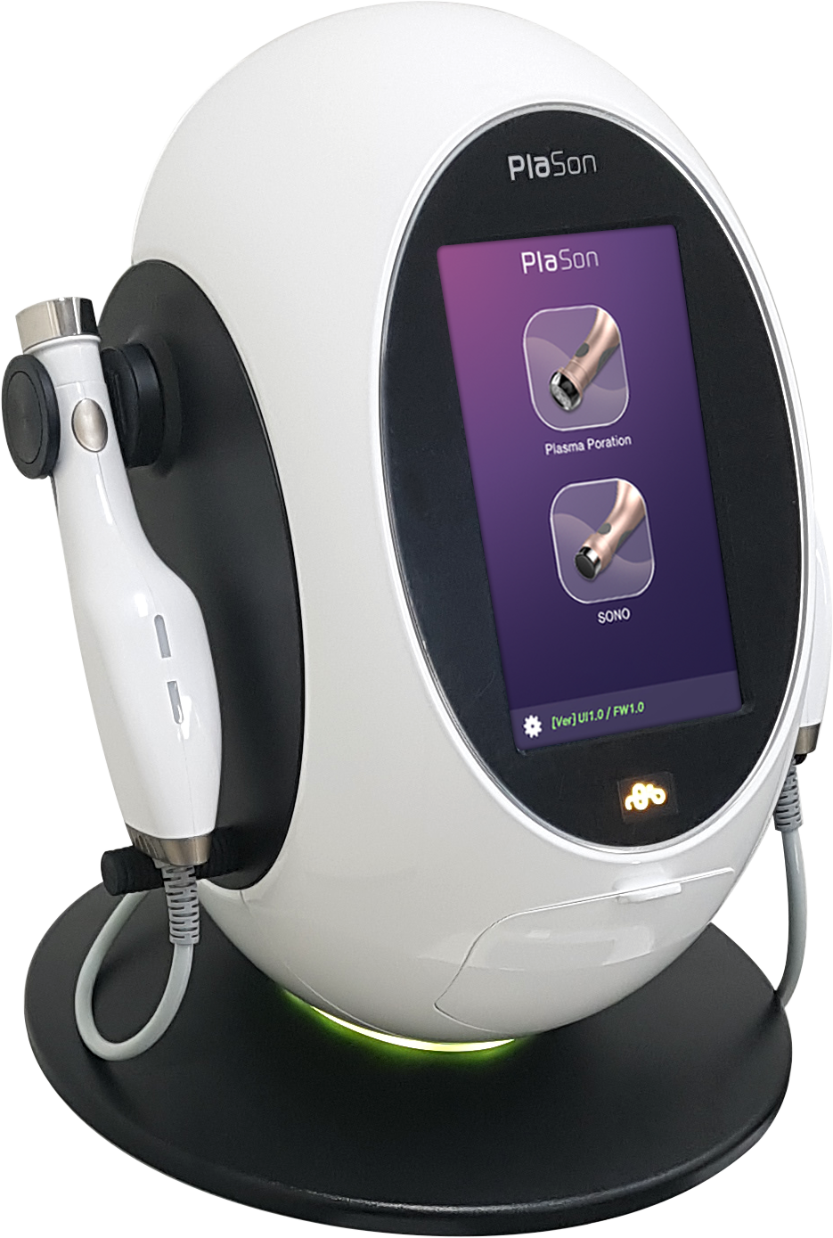
Plason Website Information

Introducing the latest technology for the treatment of acne, Plason!

Plason is FDA registered, non invasive and quick!.

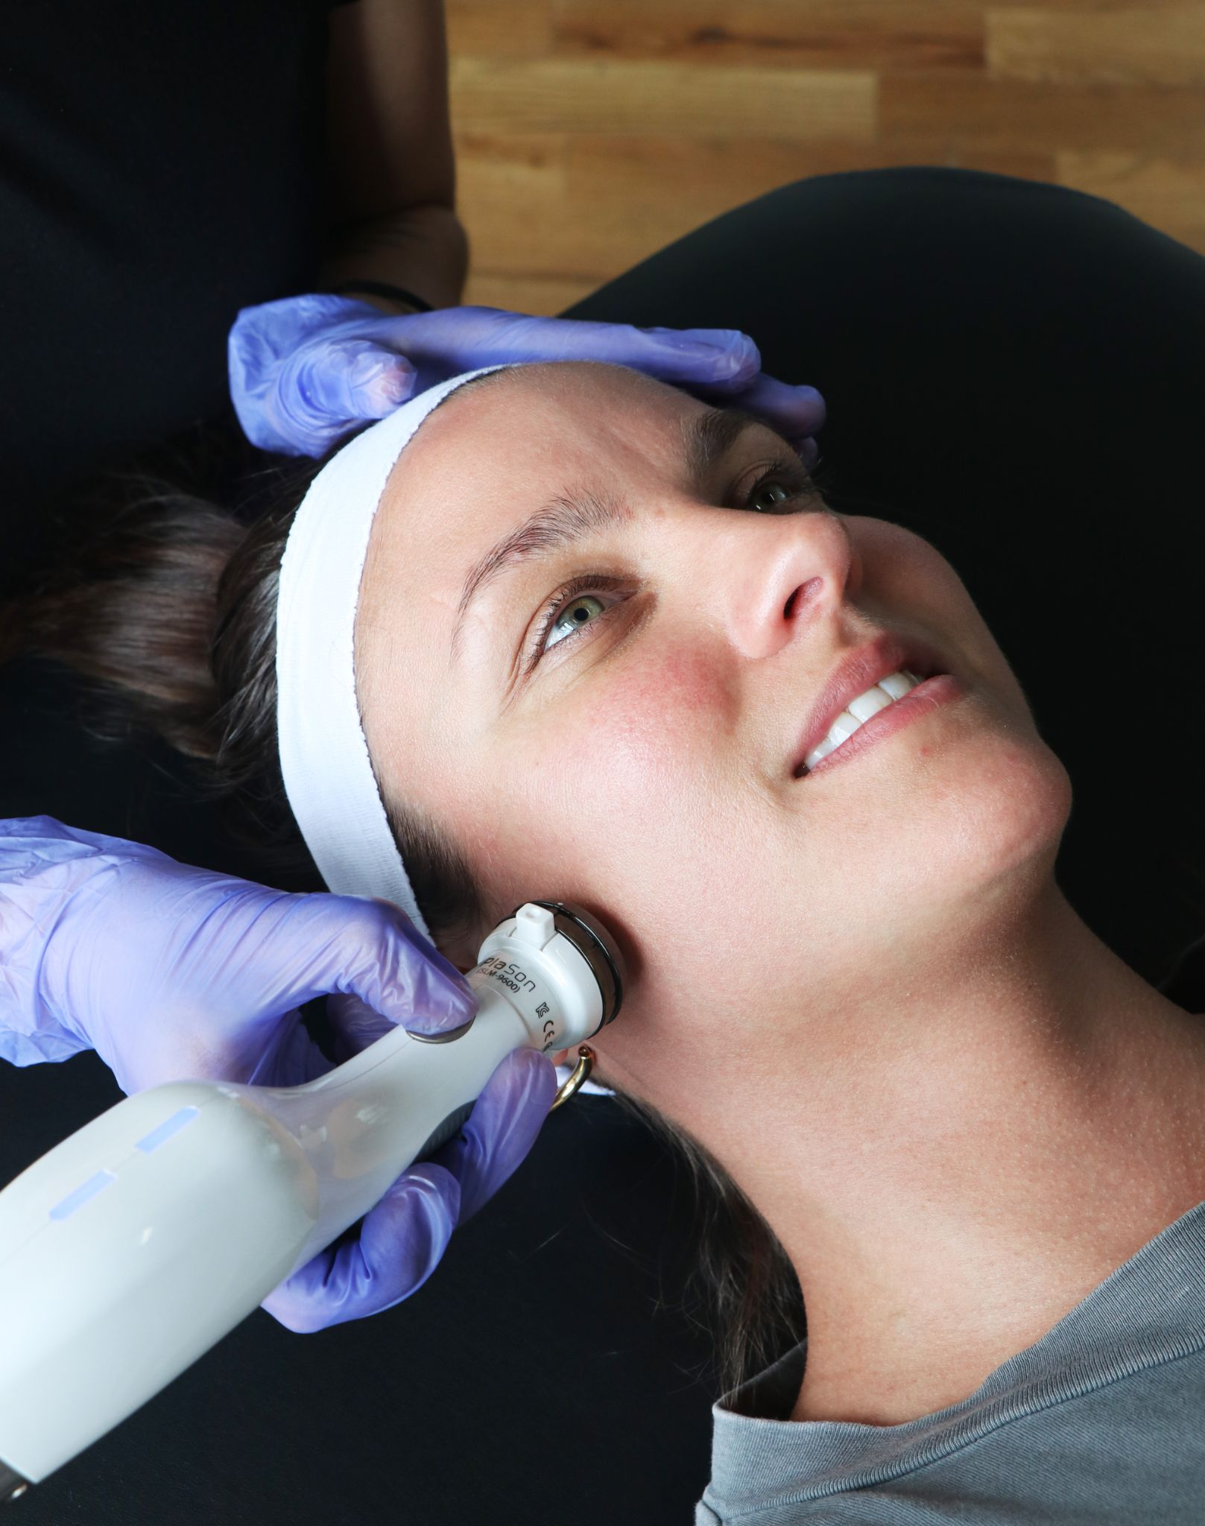
Plason uses an advanced plasma technology to treat acne by removing bacteria and aiding in transdermal absorption within the skin. It stimulates skin regeneration and boosts collagen for clearer, healthier, firmer skin.

Plason also reduces hyperpigmentation and wrinkles.

Plason is clinically proven and most people start to see results after just 1-2 sessions.

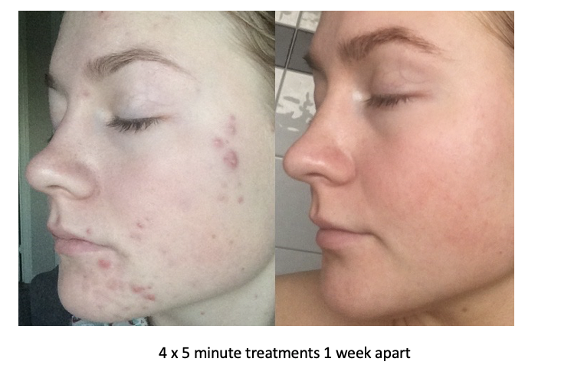
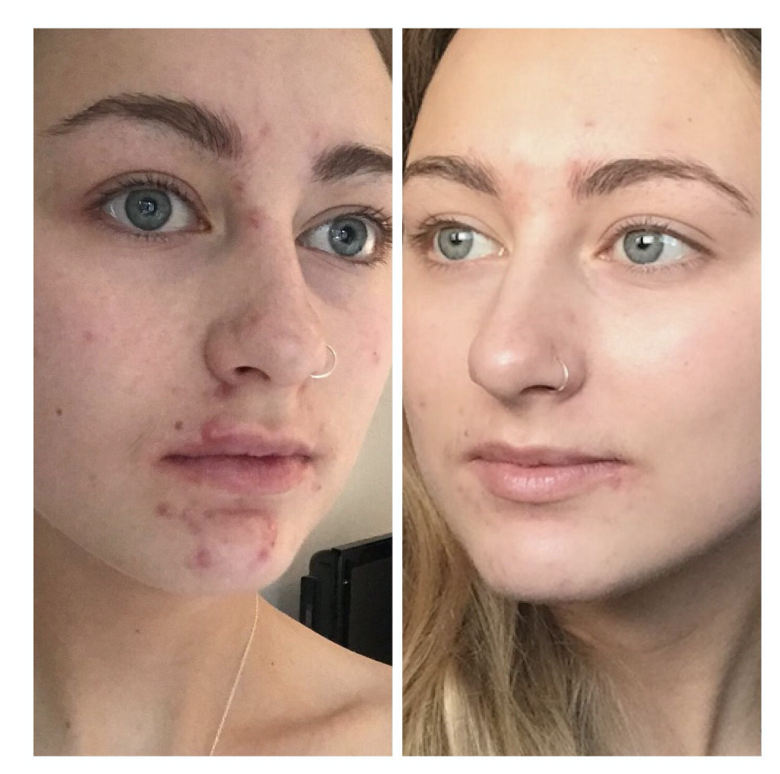

There are no side effects and no pain or downtime, as well as no age restriction.

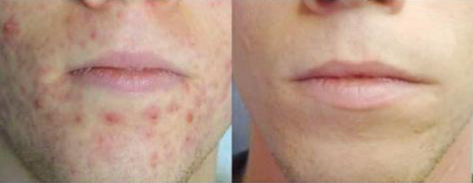
The treatment can be used on all skin types.

Give us a call today and speak with our technicians about Plason and how it is changing the lives of so many acne sufferers. It’s time for clearer and healthier skin!

FAQ’s
What is Plason?
Plason is an advanced plasma technology to remove bacteria, germs and aid transdermal absorption within the skin. Stimulating skin regeneration and boosting collagen for clearer, healthier, firmer skin.

How does Plason work?
Plason uses plasma, the fourth state of matter, closest to gas but it has been ionised by the high temperature and high electricity in our natural environment which has been reproduced by the Plason device. The Plasma poration handpiece releases ions, which have a positive effect on the skin cells and plasma radicals that are unstable, to stabilize they only attach to bacteria and germs on the skin. When attached, the radicals have a fatal effect on the bacteria, breaking down the molecular structure and sterilizing the skin.

Is Plason safe?
Plason is FDA registered and completely non ablative meaning it does not impact the skin or tissue. There are no side effects or downtime. In rare cases you will experience slight redness that normally disappears in less than 20 minutes.

What are the benefits of Plason?
Plason has been shown to be a solution for:
- Active Acne
- Skin Regeneration
- Collagen Remodelling
- Sebum Reduction
- Wrinkles
- Scarring
- Anti Pigmentation

What does the Plason treatment feel like?
The treatment is very relaxing, non invasive, quick and pain free, some people experience some very light warmth.

Who would benefit from Plason?
Everyone is a candidate for the Plason plasma-poration treatment, especially someone who suffers from Acne or dehydrated skin are perfect candidates.

How often can I have a treatment?
It is recommended to have at least 24 hours gap in between treatments.

Should anyone not have Plason?
- Pregnancy/Breastfeeding
- Under 18 years of age (Need parent or guardian approval)
- Pacemaker or internal defibrillator
- Permanent implants in that area such as metal or screws, silicone implants or an injected chemical substance
- Open skin/wounds in the treatment area
- Cancer or cancer treatments in the past five years (seek physician's approval)
- Surgery in the past three months (seek physician's approval)
- Poorly controlled endocrine disorders, such as diabetes or thyroid dysfunction
- Fillers (wait at least 2 days)
- Botox (Wait at least 2 weeks)

How quickly will I see results?
Results can be seen after just 1 treatment, to get your desired results we recommend consulting with your technician.

Are results permanent?
Results are not 100% permanent, but can be maintained with a course of maintenance treatments (recommended 1-2 per month).

Do I have to do anything in particular after the Plason treatment?
- Immediately after the treatment the skin may be slightly red, this is normal and will pass in the next 20 minutes
- Please do not place any products on the skin after the treatment for 4-6 hrs unless supplied by your practitioner
- Do not go to the Gym or endure exercise where there will be sweating for 4-6 hrs
- Try not to touch the treated area for 1 hour after treatment
- Do not shower or get your treated area wet for 4-6 hours
- Please take regular photographs of your progress/healing
- Please use mineral based make-up after 4-6 hrs to maximise results
- Please consult your practitioner regarding SPF
- Please consult your practitioner regarding moisturiser
- If in any doubt please contact your practitioner

