Hello Lori, Docere Med Spa Team,

How are you?

We wanted to give you an update on the progress of your SEO campaign. Our team implemented numerous initiatives to improve your SEO ranking. We’ve also added your site to several SEO Marketing sites. We used their tools and ours - combined with our expertise - to review, audit, manage & boost your online presence and SEO score. We have outlined your improvement & progress in more detail below.

It would be easiest for us to jump on a call and discuss how to look at these reports, but we provide some content below.

In order to improve your rankings on our end, we focus on creating relevant content, building links, improving your onsite SEO and updating and adding your business to local directories.

Content Creation & Blog Posts September

https://doceremedspa.com/freezing-fat-cells/
https://doceremedspa.com/coolsculpting-and-cooltone/
https://doceremedspa.com/cooltone-results/
https://doceremedspa.com/coolsculpting-for-men/

Content Creation & Blog Posts October

https://doceremedspa.com/body-contouring/
https://doceremedspa.com/coolsculpting-love-handles/

Content Creation & Blog Posts Views, Clicks – From 08/01/21 to 11/01/21 *
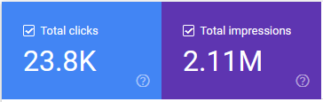

https://doceremedspa.com/cooltone-before-and-after/ | (clicks) 10,170 | (Impressions) 326,991
https://doceremedspa.com/cooltone-before-and-after/ | 3,625 | 629,203
https://doceremedspa.com/ | 3,132 | 178,266
https://doceremedspa.com/how-much-does cooltone-cost/ | 2,679 | 37,757
https://doceremedspa.com/diy-coolsculpting/ | 1,057 | 247,565
https://doceremedspa.com/about/ | 489 | 62,146
https://doceremedspa.com/coolsculpting-cost/ | 434 | 177,197

Top Queries – From 01/20/21 to 10/12/21 *
docere medical spa
coolsculpting before and after
cool tone
cooltone cost
coolsculpting results
cooltone
docere
cool sculpting results
* See full stats on attached Excel sheet report.

Online link building
Press releases we published for you were picked up by 100+ outlets. Although Google doesn't count these links multiple times, it still benefits you.

We also had some bloggers which own sites with substantial domain authority link to your CoolSculpting page. This produces what is called “Link Juice” which Google and other search engines love.

Landing page - https://doceremedspa.com/body-by-docere/coolsculpting-strongsville/
Post title - The Benefits of a High-Fiber Diet
Post link - http://www.averysweetblog.com/2021/11/the-benefits-of-high-fiber-diet.html

Google My Business SEO Work
Added and updated information on Google My Business profile and shared posts. Also responded to reviews left by clients to help with engagement & for SEO purposes. Tweaked settings, followed up on insights, managed profile.

Your Onsite SEO Score
You are currently scored at 100 out of a 100 which is perfect! We made many adjustments to your site, pages & other properties to help you obtain this score. The report is attached.

* See full stats on attached PDF report.

Reputation Management:
- Average Star rating: 4.66
- Number of Reviews: 230

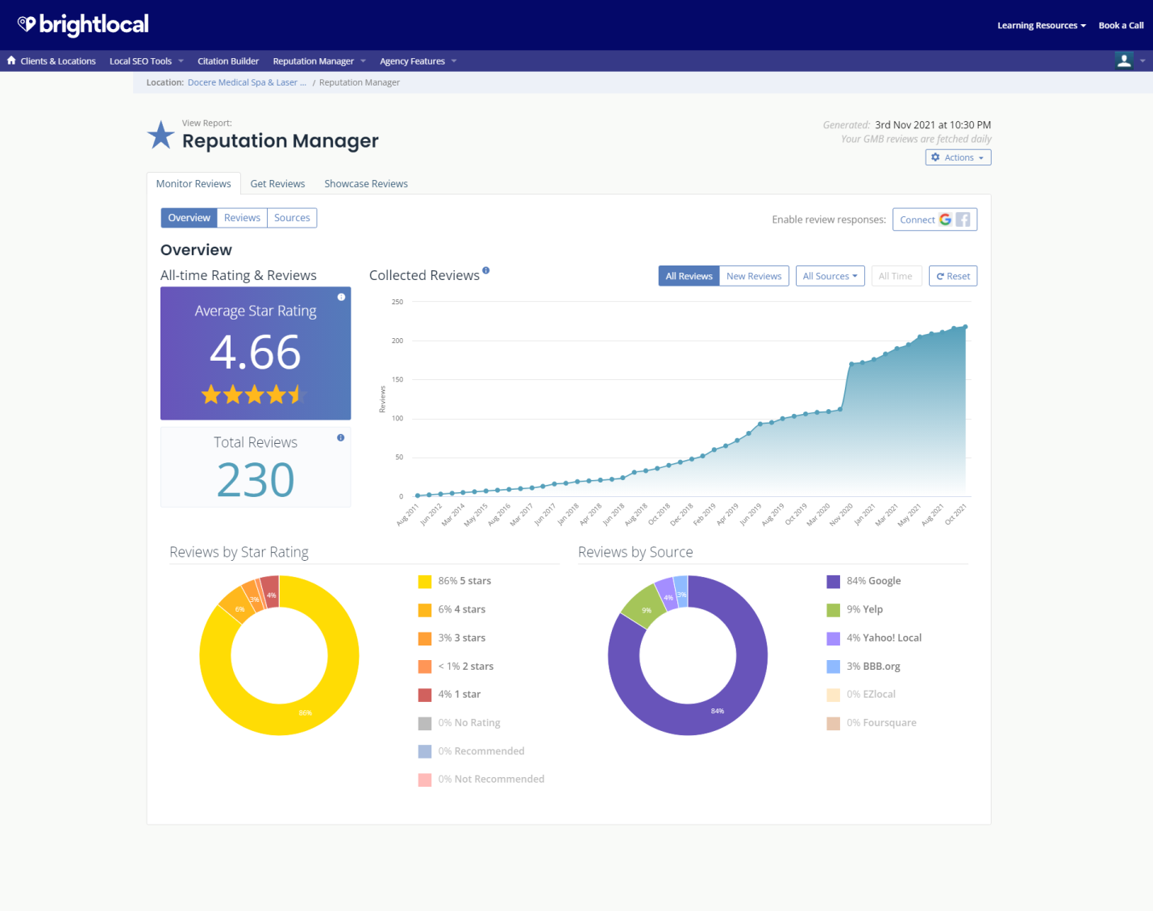

Your Citation Tracker, Builder reports (Bright Local)
Your site is being added to over 25 of the most popular and powerful directories on the web. Automated distribution to local data aggregators. This helps boost your local rankings.

Your Keyword ranking reports (Bright Local)
Your current keyword report shows your ranking positions as well as the rankings table. You can see which pages and keywords you are presently ranking in first place for.
Keyword: Cool Tone Cost – Rank (#1) Organic
Keyword: Signature treatments, – Rank – 2
Keyword: Cooltone Near Me – Rank – Organic – #1, 2
Keyword: Cooltone Strongsville – Rank - #1, 2
Keyword: Coolsculpting near me – Rank -#1, 2
Keyword: Cooltone OH – Rank – A
Keyword: Skin Medica Medical Peels, – Rank – Organic – B
Keyword: Ultherapy – Rank – Organic – B

* See full stats on attached PDF report.

Please let us know if you have any questions about your SEO report. We are also attaching it in Word format for your convenience.

