PatientFi Button Instructions
To add PatientFi buttons to your website please follow these steps below.

*Note: your website builder may look different, we’ve included examples from a Wordpress site. If you need assistance, please contact your web developer or place a request with your Practice Success Manager and we will implement the button for you!

Drag & Drop Website Builder

Follow these steps if you are using a drag and drop builder (Wordpress, Shopify, Wix, Squarespace):
- Add an image module to the section of your website where you want the button added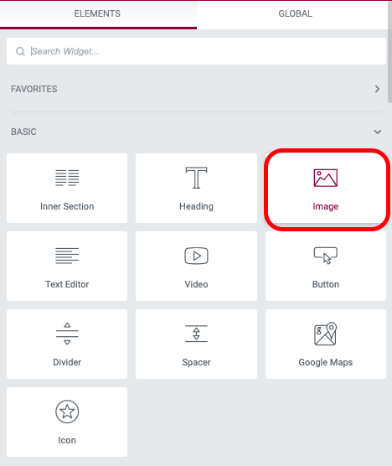
- Upload the button image provided by PatientFi by choosing the image file. You can adjust the size of the image to best fit your site.
- Link the button image to your unique application URL (Your practice success manager can provide this if you do not have it handy)
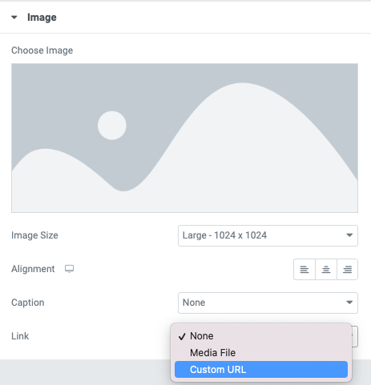

- Preview the changes before publishing and test link
- Publish changes to live website

HTML Instructions

Follow these steps if you want to add this button option in HTML code:


- Copy and paste the code snippet into the the HTML editor where you want the button image:
<html>
<head>
<title>PatientFi Button</title>
</head>
<body>
<a href="https://www.Your Custom App Link Here.com/">
<img src="https://patientfi.com/wp-content/uploads/2022/06/1-1.png"
width=150" height="50">
</a>
</body>
</html>
- Make sure to preview changes before publishing

Follow these steps if you want to add this button option in HTML code:


- Copy and paste the code snippet into the the HTML editor where you want the button image:
<html>
<head>
<title>PatientFi Button</title>
</head>
<body>
<a href="https://www.Your Custom App Link Here.com/">
<img src="https://patientfi.com/wp-content/uploads/2022/06/3-1.png"
width=150" height="50">
</a>
</body>
</html>
- Make sure to preview changes before publishing

