500 Word Coolsculpting Update.Dr. Fiorillo.KA

Link to page: https://www.drfiorillo.com/procedure/coolsculpting/

New Meta Title: CoolSculpting Pearl River MA | Freeze Your Fat

New Meta Description: CoolSculpting in Pearl River freezes your fat, safely and efficiently, for a noticeable reduction in fat and leaner, contoured curves. Learn more.

New H1 COOLSCULPTING IN PEARL RIVER, MA: CONTOUR SLEEK, ATTRACTIVE BODY CURVES

*NEW OPENING PARAGRAPH*
CoolSculpting uses advanced cooling technology to freeze away fat. This non-invasive body-contouring treatment targets stubborn bulges of fat that resist diet and exercise. Common treatment areas include freezing belly fat, love handles, thigh fat, back fat, double chins, upper arm fat, and more. Moreover, the 35-minute treatment is virtually painless, non-invasive, and requires minimal downtime — making it the #1 non-surgical alternative to Liposuction. Best of all, CoolSculpting works. Clinical studies report that fat freezing reduces fat by 20% – 25% after a single treatment.

Experience CoolSculpting for yourself. Call Dr. Fiorillo now to schedule a complimentary consultation to determine if this non-surgical fat reduction method suits your needs and goals. Dr. Fiorillo and his team of professionals at The Advanced Plastic Surgery Center are proud to be the primary provider of CoolSculpting treatments in Pearl River, MA. Call (845) 719-4781 now for your appointment.

H2 BENEFITS OF COOLSCULPTING
- Safely and effectively reduces stubborn fat
- Non-surgical alternative to Liposuction
- Quick and virtually painless treatment
- Little to no down time
- Sculpts natural looking physiques
- Long lasting results

H2 coolsculpting BEFORE AND AFTERS*
INSERT BAS
*Results may vary

h2 how coolsculpting’s fat freezing technology works
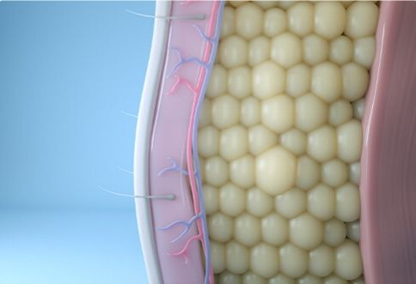
Harvard Scientists invented CoolSculpting utilizing Cryolipolysis. “Cryo” = cold + “lipo” = fat + “lysis” = cell death and removal.
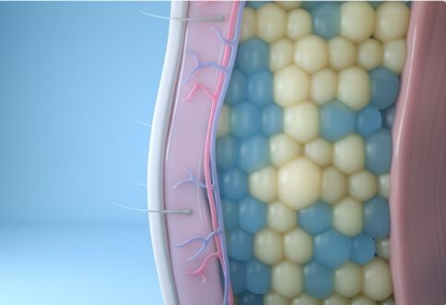
When fat cells are exposed to precise cooling, the cell membrane crystalizes and ruptures. The cell cannot store fat. This results in cell death.
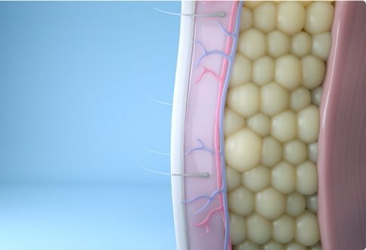
After a period of 8 to 12 weeks, these destroyed cells are excreted from the body as waste via the lymphatic system.
H2 COOLSCULPTING TREATMENT AREAS

With two CoolSculpting machines and the latest line of applicators, Dr. Fiorillo and his team can target bulges from nearly anywhere on the body. Commonly treated areas include:

- Belly Fat
- Submental fullness (neck fat and double chins)
- Love handles
- Thigh fit (inner and outer)
- Fat below the buttocks
- Upper arm fat
- Armpit fat (bra bulge)
- Back fat
- Chest fat (for men)

H2 COOLSCULPTING RISKS

CoolSculpting is recognized for its high safety profile and minimal risk, making it the optimal choice in non-surgical body shaping.

A clinical study measuring the “Safety, Tolerance, And Patient Satisfaction with Cryolipolysis” concluded “[CoolSculpting] is a safe, well-tolerated, and effective treatment method for reduction of subcutaneous fat”.

Another study published in the Journal of Dermatological Surgery confirmed these findings, saying “cryolipolysis is considered to be both safe and efficient with a high patient satisfaction rate.” Furthermore, “No significant side effects of adverse events were reported.”

In addition, patient surveys reveal the procedure is well-tolerated, with “89% of [patients] reporting a positive of treatment duration and 96% reporting minimal to tolerable discomfort.”

H2 COOLSCULPTING SIDE EFFECTS*

CoolSculpting side effects are rare. Most negative outcomes result from patients receiving treatment from unexperienced technicians using knock off fat freezing machines. This is why it is essential to choose a certified provider.
While side effects are rare after treatment, many patients experience mild symptoms associated with an immune response. The immune response indicates the lymphatic system is hard at work, gathering and disposing of the frozen fat cells. Some of these symptoms include:
- Tenderness
- Redness
- Swelling
- Bruising
However, symptoms are mild, isolated to treatment location, and resolves themselves within a week or so. As always, individual experiences will vary.*

H2 COOLSCULPTING AND SKIN TIGHTENING

Now, CoolSculpting is FDA-cleared to tighten the skin in the submental region. Known mainly as a double chin or turkey neck, submental fullness plagues millions of people. Despite healthy lifestyle choices like clean eating and exercising, submental fullness can affect anyone. This is because the fat in the chin and neck is affected by factors like genetics and gender. In addition, fat here often resists diet and exercise efforts, so no matter how much you try, you can still struggle with double chin and neck fat.

Thanks to the CoolMini applicator, people can target those annoying and embarrassing double chins. Clinical studies and CoolSculpting before and after pics show how this new applicator reduces fat under the chin. But that’s not all this nifty handheld device can do. The CoolMini is FDA-cleared to improve the appearance of lax or loose tissue in the neck and chin.

One study published in the Journal of Dermatologic Surgery noted “independent assessments by patients and investigators found consistent improvement in skin texture and laxity”⁶ after CoolSculpting treatments to reduce a double chin. This means the CoolMini applicator offers a dual solution for improving the appearance of a double chin by eliminating fat cells AND
tightening skin.

H2 COOLSCULPTING FAT LOSS VS. WEIGHT LOSS

It is important to understand the differences between fat loss and weight loss. CoolSculpting provides natural fat loss. In addition, it is a fat-reduction treatment. It is not a weight loss treatment.

With regular weight loss programs or medication, your fat cells shrink as you lose weight. But, unfortunately, this means they can re-expand in the future if you gain weight.

CoolSculpting, on the other hand, is a fat-reduction treatment. During cooling sessions, a portion of underlying fat cells is destroyed. Once those are removed from the body, they can never return. This leads to natural and permanent fat loss if you continue eating right and exercising.

Fat reduction with CoolSculpting reduces fat cells by 25% within a treatment area after a single cooling cycle. And since the body does not create new fat cells once you reach adulthood, CoolSculpting leads to lasting fat reduction.

H2 COOLSCULPTING VS. LIPOSUCTION

Liposuction is a popular weight loss surgery. It is invasive. A plastic surgeon often performs it in an operating room, requiring an anesthesiologist. Different treatment areas mean slightly different surgeries. However, the basic idea of liposuction involves several incisions made with a scalpel. Your surgeon inserts a cannula into those incisions into the fatty tissue. Next, they use a tube to break up the tissue and suction the fat out of the body.

Liposuction is a serious surgery. It involves pain, sutures, compression garments, pain medication, swelling, and a lengthy recovery. However, it also means dramatic fat loss in one single surgery.

CoolSculpting, on the other hand, is entirely noninvasive. Your technician uses the proprietary applicator to deliver advanced cooling to the target fat cells. Instead of dramatic results, CoolSculpting results appear gradually over a treatment plan and look like natural fat loss. In addition, it is virtually painless, has minimal risks or side effects, does not involve a lengthy recovery process, and has minimal downtime.

Dr. Fiorillo performs both Liposuction and CoolSculpting. He can help determine which method of fat reduction is best for your body and your aesthetic goals.

*NEW FAQ SECTION*

H2 COOLSCULPTING FAQS

H3 HOW MUCH DOES COOLSCULPTING COST IN PEARL RIVER?

CoolSculpting cost varies per individual. Many factors determine price, from the number of cycles, along with the size and shape of applicators.

As a distinguished provider of CoolSculpting, Dr. Fiorillo offers some of the best CoolSculpting prices in the Pearl River area. During your free appointment, we will discuss fat freezing costs, along with any discounts or specials. If CoolSculpting is right for you, we will customize your very own

H3 WHO IS THE PERFECT COOLSCULPTING CANDIDATE?

CoolSculpting is intended for healthy men and women who grapple with stubborn fat bulges that resist diet and exercise. CoolSculpting is not a weight loss program. Losing weight shrinks fat cells. It does not destroy fat cells. This permits the existing fat cells to expand again to accommodate weight gain in the future.
In contrast, Cold Sculpting your fat destroys and eliminates fat cells from the body. Frozen fat cells expelled from the body cannot re-expand. They do not grow back. They are gone for good.

H3 WHEN WILL I SEE RESULTS?*

Results appear gradually. Some patients notice reductions in fat within four weeks of their treatment. Most patients, however, require 6 to 12 weeks before results manifest. As with any treatment, individual experiences may vary.*

H3 ARE COOLSCULPTING RESULTS LONG-LASTING?*

CoolSculpting results are long-lasting. In a longitudinal study published in the Journal of Cosmetic Dermatology, researchers evaluated patients after 9 years following a single cryolipolysis treatment. Researchers found that fat reduction was still visible even after nearly a decade. The study concludes, “local reductions in fat [after one cycle of Cryolipolysis] have significant longevity.” This infers “results from Cryolipolysis may be very long lasting.” As always, experiences will vary.*

*NEW CLOSING PARAGRAPH *SHOULD BE OUTSIDE AND SEPARATE FROM FAQ SECTION*

H2 SAFELY CONTOUR YOUR CURVES AND REDUCE FAT WITH COOLSCULPTING IN PEARL RIVER

If you want to experience the revolutionary CoolSculpting technology for yourself, contact Dr. Fiorillo at The Advanced Plastic Surgery Center. We are proud to be the leading non surgical body contouring provider using CoolSculpting in Pearl River, MA. Call us now at (845) 719-4781 to schedule your consultation and discover how this innovative treatment can completely alter your physique without pain, surgery, or a long recovery.

COOLSCULPTING NEAR ME
Achieve naturally beautiful results in a state-of-the-art facility from highly experienced technicians. Schedule a FREE consultation with Dr. Fiorillo by calling (845) 719-4781 or filling out the online form below.

