Menorrhagia.edelman.page.mz
KW: menorrhagia
/ Menorrhagia-uterine-ablation
Menorrhagia Treatment for Heavy Periods – MARA Uterine Ablation
Women suffering from abnormally heavy periods (menorrhagia) find relief with the MARA uterine ablation system. MARA uses natural water vapor to gently seal blood vessels in the uterine lining (endometrium). Once the blood vessels in the lining of the uterus are sealed, there is less monthly bleeding. In some cases, monthly bleeding stops completely.
MARA is a brief, non-invasive, non-surgical treatment performed at Women's Health New England. Unlike many other endometrial ablation systems, MARA requires no general anesthesia. Many women choose to return to work after the MARA procedure. MARA is a non-surgical alternative to surgically removing the uterus (hysterectomy). MARA treatment uses no hormones, so it avoids the potential side effects of hormone therapy. MARA is safer than other endometrial ablation techniques that use radiofrequency, electrocautery, or hot water such as NovaSure, HTA/ hydrothermal ablation or a hot water balloon.
MARA treatment is not suitable for women who want to preserve their ability to become pregnant.
BENEFITS OF MARA ENDOMETRIAL ABLATION SYSTEM
- FDA approved + scientifically proven
- Reduces or stops heavy menstrual bleeding
- Reduces cramping
- Noninvasive
- Requires no general anesthesia)
- Short procedure lasts minutes
- Treatments performed in-office
- Many built-in safety checks
- Automated real-time safety monitoring
SCIENTIFIC REVIEWS OF MARA ENDOMETRIUM ABLATION SYSTEM
In a clinical study, MARA reduced bleeding by at least 50% in over 90% of the participants. 79% of participants reported significant reduction in bleeding or stoppage of menstrual bleeding altogether. These results were shown to last for years following the procedure.
In addition to reduced bleeding, studies showed:

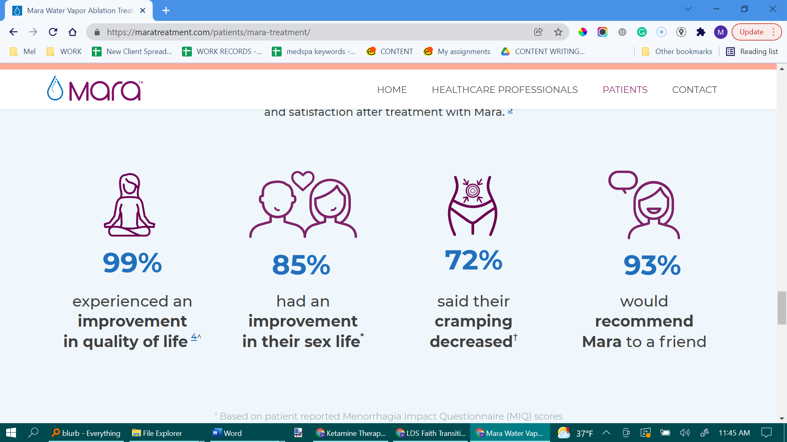
Take graphics from this website. You can use the same images for the icons

85% of women reported an improvement in their sex life
72% of women reported less cramping after the treatment
93% of women would recommend the treatment to a friend
99% of women experienced an improvement in quality of life

WHY CHOOSE DR. JULIA EDELMAN?
Insert pic of dr. Edelman to the left for desktop

Julia Edelman, MD, FACOG, NCMP is a Board-Certified Gynecologist and Certified Menopause Clinician. She has dedicated her career to caring for women. In addition to her successful medical practice, Dr. Edelman is renowned in her field as an accomplished speaker, author, and was an instructor at Harvard Medical School for twelve years.

Dr. Edelman's patients most appreciate her expertise and dedication to their personalized care. By staying at the forefront of established and emerging techniques and technologies, Dr. Edelman can educate, diagnose, and care for her patients with the best treatment for each patient.

Dr. Edelman's private practice, Women's Health New England, is located in Middleboro, Massachusetts (less than an hour of Boston, Newport, Providence, and Cape Cod.) Her comfortable, quiet, and well-equipped office features the latest equipment for minimally invasive diagnostic, surgical, and non-surgical procedures.

WHAT IS MENORRHAGIA?
Menorrhagia is the medical term for abnormally heavy periods or periods that last too long or occur too often. Many women are affected by prolonged or excessive menstrual bleeding. Menorrhagia may occur in adolescents and young adults. However, heavy bleeding is most likely to affect women in their 30s, 40’s and early 50’s. Over age 35 it is more common to find an underlying physical cause of the heavy uterine bleeding that is important to identify such as a polyp or fibroid or even a cancer or pre-cancer.
Menorrhagia may negatively affect a women's standard of living. Heavy periods can disrupt your social life, disturb your day-to-day activities, complicate your sex life, and interrupt sleep.
In addition, heavy periods may cause other medical concerns, such as anemia and iron deficiency. In addition, 86% of women with heavy periods also experience painful menstrual cramping.
DO I HAVE MENORRHAGIA?
The best way to determine if you are suffering from menorrhagia is by consulting with an experienced gynecologist, like Dr. Julia Edelman. Common menorrhagia symptoms include:
- Bleeding through your sanitary product every hour for several hours in a row.
- Bleeding for more than seven days
- Needing to double up your sanitary products
- Needing to wake up during the night to change your sanitary product
- Passing large blood clots (clots bigger than a quarter)
- Restricting your daily activities due to heavy bleeding
- Displaying symptoms of anemia, such as fatigue
- Painful menstruation or heavy cramping

IS ENDOMETRIAL ABLATION RIGHT FOR ME?
There are many causes of menorrhagia. Before treating your heavy bleeding, Dr. Edelman will rule out more serious causes of abnormal bleeding such as cancer, uterine pathology, or thyroid abnormalities.
Not long ago, a hysterectomy (removal of the uterus) was the only way to reduce heavy bleeding. Other invasive treatment options included surgical removal of fibroids. In some cases, a Mirena IUD or medication or hormonal treatments may also be helpful.
Uterine ablation is a minimally invasive option for heavy bleeding in ideal candidates. Uterine ablation may be right for you if:
- You have abnormally heavy or long-lasting periods
- You are premenopausal
- You are done having children
- Your bleeding has benign causes
HOW DOES THE MARA WATER VAPOR SYSTEM WORK?
Insert the 3 icon pics above each column

Dr. Edelman gently inserts the Mara Water Vapor Probe into the Uterus. Balloons inflate and seal off the Uterus, cervix, and top of the vagina.
The probe releases water vapor into the Uterus, which seals the blood vessels in the uterine lining. No general anesthesia or incisions required.
Having sealed the uterine lining, Dr. Edelman deflates the balloons and removes the probe. Treatments take a few minutes including safety checks.

HOW MUCH DOES UTERINE ABLATION COST?
Uterine ablation is one of the most affordable treatment options for heavy menstrual bleeding. Insurance typically covers the cost of the uterine ablation, but you may have a copay or deductible depending upon your insurance plan.
UTERINE ABLATION NEAR ME
If you suffer from heavy bleeding, Dr. Julia Edelman of Women's Health New England can help. Schedule a consultation to determine if endometrial ablation is right for you. Reach out to Dr. Edelman and call her office at (508) 947-0800 to schedule a consultation, gynecologic evaluation, or second opinion.
SOURCES:
The American College of Obstetricians and Gynecologists. F.A.Q. June 2016. https://www.acog.org/Patients/FAQs/Heavy-Menstrual-Bleeding?IsMobileSet=false.
Levie MD, Chudnoff SG. "A Prospective, Multicenter, Pivotal Trial to Evaluate the Safety and Effectiveness of the A.E.G.E.A. Vapor Endometrial Ablation System." Journal of Minimally Invasive Gynecology. May/June 2019; 26(4); 679-87. LINK.
Levie H, et al. Endometrial Ablation Using Water Vapor: 36-Month Follow-up. Journal of Minimally Invasive Gynecology 2018. LINK.
Johns DA, Garza-Leal JG. "Post-Ablation Cavity Evaluation: A Prospective Multicenter Observational Clinical Study to Evaluate Hysteroscopic Access to the Uterine Cavity 4 Years after Water Vapor Endometrial Ablation for the Treatment of Heavy Menstrual Bleeding." Journal of Minimally Invasive Gynecology. September 2019. LINK.
SE-3000 Pivotal Trial Patient Questionnaire, A.E.G.E.A. Medical.

