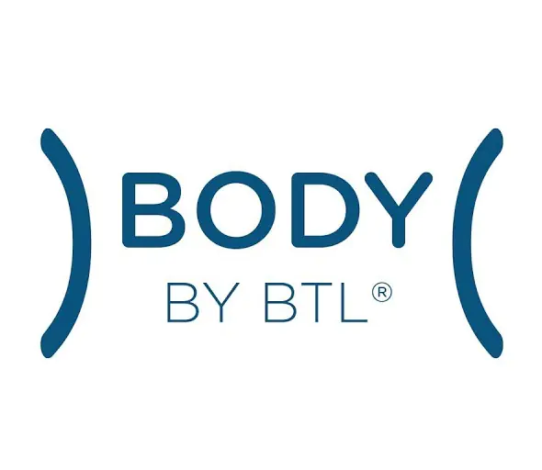
https://bodybybtl.com/

“Emface”
Keyword Research

Keyword | MSV | Difficulty
Emface btl | 60 | 2
Emface | 100 | 0
Btl | 4.8K | 56
What is radio frequency | 700 | 65
Rf exposure limits chart | 33 | 500
Radio frequency energy | 67 | 250
Facial sculpting near me | 200 | 3
Hifem side effects | 150 | 4
Hifem machine | 150 | 0
What is facial sculpting | 100 | 1
Radio frequency exposure limits | 80 | 44
Facial sculpting cost | 70 | 14
Face sculpting injections | 40 | 7
Face sculpting near me | 200 | 1
Hifem before and after | 80 | 1
Instant face lift | 1.1K | 1
Facelift without surgery | 900 | 16
How to get a facelift without surgery | 60 | 22

Supporting Secondary Keywords

Hifem face by btl
high intensity focused electromagnetic therapy
hifem reviews
hifem machine
non-invasive face sculpting
non-surgical face contouring near me
non-surgical face contouring cost
non-surgical face contouring before and after
non-invasive face sculpting reviews
non-invasive face sculpting procedures
non-invasive face sculpting side effects

Content Topics
- What is facial heat therapy?
- Is heat therapy good for the face?
- What is skin thermography?
- Does heat tighten skin?
- Is heat good for wrinkles?
- Are radio frequencies harmful?
- What is heat production in the body?
- What causes radio emission?
- How does muscle contraction produce heat?
- What are radio frequency skin tightening dangers?

Video Content Ideas
- Emface by btl
- Emface
- Instant face lift
- Facelift without surgery

Source URLs

https://www.dravaliani.com/cosmetic-treatments/emface/

https://www.spaandclinic.com.au/technology/meet-emface-btl-aesthetics-most-revolutionary-device-yet

https://practicaldermatology.com/news/btl-introduces-emface-technology

"EMFACE presents a paradigm shift in facial treatments," said Yael Halaas, MD. "EMFACE will do for the face what Emsculpt did for the body."

https://surgicaltimes.com/btl-emface-coming-2022/

