Changes in red.

Meta Title: CoolSculpting NYC | New York Fat Freezing

Meta Description: CoolSculpting NYC treatments provide a non-invasive and non-surgical way to reduce stubborn fat and contour your dream physique. Learn more about CoolSculpting here.

H1: CoolSculpting Elite in NYC
CoolSculpting is America’s #1 non-invasive fat reduction treatment that safely and effectively reduces unwanted body fat. Ideal for both men and women, CoolSculpting targets notorious problem areas such as belly fat, love handles, thigh fat, upper arm fat, double chins, and more. Hailed as the non-surgical alternative to liposuction, CoolSculpting uses advanced cooling technology to safely reduce unwanted fat painlessly* and requires no downtime. Treatments are quick, convenient, and surprisingly affordable, so you'll look and feel great from every angle.
Emerson Medical is excited to offer the most up-to-date fat-freezing technology on the market, featuring CoolSculpting Elite. CoolSculpting Elite is the newly updated CoolSculpting experience with dual applicators and redesigned C-series curved applicators. These new applicators can better conform to your body’s shape, boosting your treatment’s suction capability and leading to 18% more cooling coverage.
CoolSculpting Elite also features dual CoolSculpting applicators on each machine, meaning you can treat multiple areas in tandem. These tandem treatments cut down on the number of appointments you need to complete the recommended number of sessions suggested by your skilled CoolSculpting technician. Ultimately this flexibility gets you to your amazing final transformation in less time than with single-treatment CoolSculpting.
CoolSculpting Elite Near Me:
Ensure you get the best CoolSculpting Results possible by choosing only the best New York CoolSculpting providers in Staten Island. If you are ready to eliminate stubborn fat that keeps you from loving the way you look in the mirror, call Dr. Natalya Chalik now to schedule your free CoolSculpting consultation. New clients receive 25% off CoolSculpting cost.

H2 COOLSCULPTING FOR REAL RESULTS
Eliminating stubborn fat without surgery or downtime may sound too good to be true. This leads many people to wonder if CoolSculpting really works? But science, real CoolSculpting reviews, and fat freezing before and after pictures all answer with a resounding yes! This innovative body contouring treatment really works!
CoolSculpting is cleared by the FDA and is proven to work by scores of scientific research*. While results may vary, clinical studies show CoolSculpting reduces up to 25% of subcutaneous fat cells from the treatment area after a single treatment.¹* These results are noticeable and natural-looking,² contributing to an impressively high customer satisfaction rate, with “82% of patients” reporting they “would recommend the [Coolsculpting] procedure to a friend.²”
Now CoolSculpting Elite also features dual CoolSculpting applicators on each machine, meaning you can treat multiple areas in tandem. These tandem treatments cut down on the number of appointments you need to complete the recommended number of sessions suggested by your skilled CoolSculpting technician. Ultimately this flexibility gets you to your amazing final transformation in less time than with single-treatment CoolSculpting.

H2 WHY CHOOSE COOLSCULPTING ELITE*
- America’s #1 Non-Invasive Fat Reduction
- Non-surgical Alternative to Liposuction
- Target stubborn fat deposits
- FDA-cleared & scientifically proven*
- Safe, Painless, & No Downtime*
- Natural-looking, long-lasting results*
- Sculpt attractive contours & define musculature

H2 COOLSCULPTING BEFORE AND AFTER PICTURES*
CoolSculpting before and after pictures reveal impressive reductions in fat, with clients looking noticeably slimmer and more sculpted. While results may vary, these fat freezing before and after pictures are of real CoolSculpting patients in New York and depict typical real CoolSculpting results.* As seen in the results, the CoolSculpting procedure targets visible fat bulges and reduces the number of unwanted fat cells in the treatment area with ease.
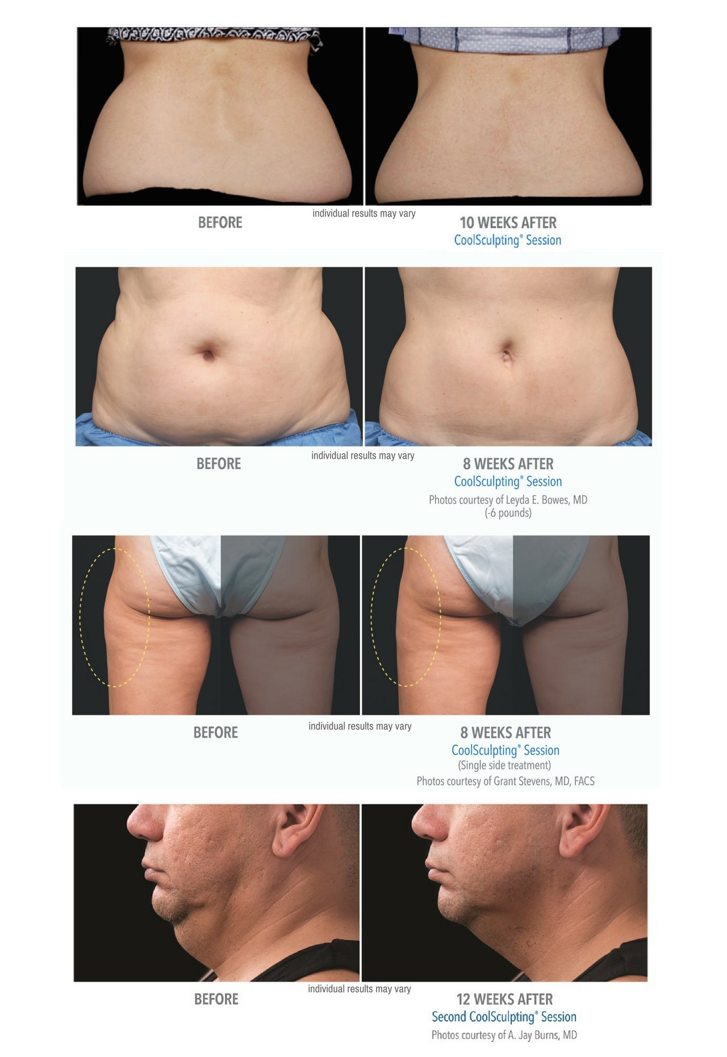

H2 CoolSculpting TREATMENT AREAS
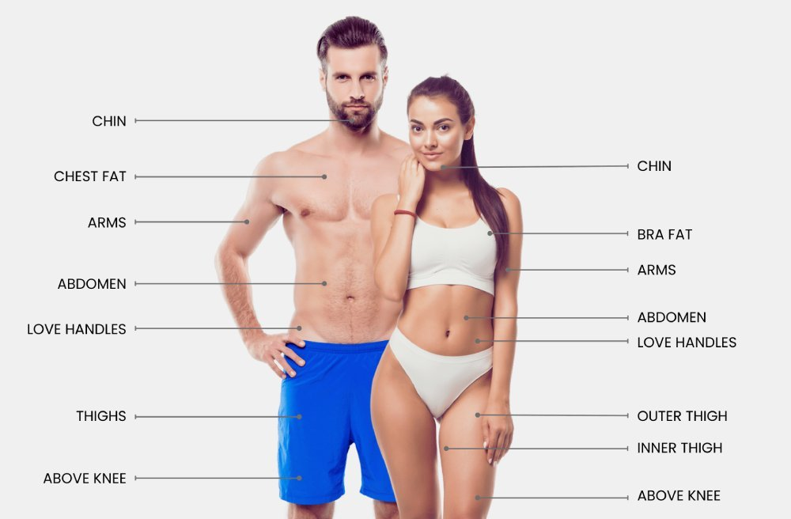

H2 HOW COOLSCULPTING WORKS
Fat cells are more vulnerable to colder temperatures than other types of cells in our bodies. This scientifically proven phenomenon is called Cryolipolysis, and it’s what makes CoolSculpting possible. During your CoolSculpting treatment in New York, targeted fat deposits are exposed to controlled cooling, essentially freezing a portion of the underlying fat cells without harming the skin or surrounding tissues.²
Fat freezing fat cells causes apoptosis or cellular death, triggering the body’s natural metabolic process for removing damaged cells. Over time, your body naturally processes destroyed unwanted fat cells and excretes them from the body as waste¹. This often results in natural-looking fat reduction, leaving you with a skinnier, more sculpted physique.¹*

AM I A GOOD CANDIDATE FOR COOLSCULPTING ELITE?
CoolSculpting is intended to help healthy men and women reduce stubborn fat* deposits that resist diet and exercise. The best way to determine if CoolSculpting is a good solution for reducing your unwanted body fat is to set up a free consultation with Dr. Chalik at Emerson Medical. If you are a good candidate for CoolSculpting Dr. Chalik will work hard to develop a customized CoolSculpting treatment plan that best addresses your problem areas. She can also discuss if additional CoolSculpting sessions may further enhance your results. Your individualized treatment plan will be tailored to your body, your goals, and your budget.

h2 the new york coolsculpting elite experience
During your CoolSculpting Elite treatment at Emerson Medical in New York, we make it easy to sit back and relax while you say goodbye to stubborn fat. After the area(s) to be treated are selected, Dr. Chalik carefully positions the CoolSculpting Elite applicator to the treatment area. This applicator contains cooling panels that will safely deliver controlled cooling to the subcutaneous fat. The CoolSculpting Elite machine is turned on and the controlled cooling begins.

H2 POSSIBLE coolsculpting TREATMENT AREAS
At Emerson Medical, Dr. Natalya Chalik, uses the latest fat freezing techniques, using the most modern technologies. These technologies include the latest line of CoolSculpting Elite applicators, known as the C-Series Collection. The new line of applicators is curved to increase cooling coverage by 18%.
Popular treatment applications include:
· CoolSculpting neck fat and double chins (submental fullness)
· CoolSculpting chest fat (ideal for men with moobs a.k.a “man boobs”)
· CoolSculpting Belly Fat (the abdomen or stomach)
· CoolSculpting hips and love handles (the flanks)
· CoolSculpting back fat
· CoolSculpting armpit fat (bra fat or “bra bulge”)
· CoolSculpting upper arm fat (bat wings)
· CoolSculpting banana rolls (fat below the buttocks)
· CoolSculpting thigh fat (inner thigh fat and outer thigh fat)
· CoolSculpting knee fat (small pockets of fat above the knees)

H2 COOLSCULPTING REVIEWS
CoolSculpting reviews from patients are positive and enthusiastic. However, consumers are not the only group raving about the fat freezing procedure. The academic community has contributed many positive CoolSculpting reviews to scientific journals. Here are some of the findings reported from the clinical data:
“Cryolipolysis for Noninvasive Body Contouring,” published in Clinical, Cosmetic and Investigational Dermatology¹ reported:
· “In clinical studies, Cryolipolysis was shown to reduce subcutaneous fat at the treatment site by up to 25% after one treatment”
· “improvements…seen in 86% of treated subjects.”
· “Cryolipolysis has been proven to be a very safe method for body contouring, and is accomplished with only minimal discomfort”
· “Cryolipolysis is considered to be both safe and efficient with a high patient satisfaction rate.”
"Safety, Tolerance, And Patient Satisfaction With Noninvasive Cryolipolysis" found in Dermatological Surgery2 reported:
· “89% of respondents reporting a positive perception of treatment duration.”
· “96% reporting minimal to tolerable discomfort.”
· “82% of patients would recommend the Cryolipolysis procedure to a friend.”
· “No significant side effects or adverse events were reported. “
· “The procedure was well-tolerated.”

H2 COOLSCULPTING ELITE VS. LIPOSUCTION
Cool Sculpting and liposuction are both fat reduction procedures. They decrease fat by removing stubborn fat cells from the body. Once treated fat cells are removed from the body, they do not grow back. Moreover, the body does not replace those targeted fat cells. This leads to long term results. The biggest difference between liposuction and Cool Sculpting is the method of removing the fat. cells.
Liposuction uses a sharp cannula (tube) to break up the fat cells and suction them through the tube out of the body. This is a surgical procedure. It results in surgical scarring. It requires a cosmetic surgeon, an operating room, anesthesia, and significant downtime to recover from surgery.
The CoolSculpting procedure removes fat cells via cryolipolysis. It destroys the fat cells by freezing them to death. The fat cells then exit the body gradually via natural metabolic processes. Once frozen, the cells are excreted from the body as urine, they are gone from the body for good.1 Unlike liposuction, Cool Sculpting is non-invasive. There are no stitches, scars, or invasive procedures. Moreover, freezing fat requires little to no downtime.

DOES COOLSCULPTING HURT?
While experiences may vary, most patients do not report pain during the CoolSculpting treatment. At first, you may feel a cold sensation at the treatment area. This is akin to having an ice pack placed on the skin. This sensation usually goes away within a few minutes and most clients read, check email, or even nap for the remainder of the treatment. The CoolSculpting fat freezing procedure is completely non-surgical, so you can return to work and normal activities immediately.* Dr. Chalik and her team in New York do everything to ensure ultimate patient comfortability during cooling sessions.

H2 COOLSCULPTING ELITE SIDE EFFECTS
While Cool Sculpting side effects are rare, it is not unusual to experience some mild redness, swelling, or tingling after Cool Sculpting treatments. These symptoms are typically minor and dissipate quickly. During your free consultation Dr. Chalik will discuss what to expect after your Cool Sculpting treatment and Cool Sculpting side effects in more detail and answer any questions you may have.

H2 coolsculpting RESULTS*
Over the course of several weeks your body steadily processes the fat cells that have been frozen and removes them from the body as waste. While every person’s body is different, typically, optimal CoolSculpting results are seen between 8 to 12 weeks following the treatment.¹*
You will love what you see in the following weeks and months after your treatment as your CoolSculpting results gradually appear for impressive, natural looking results. fat reduction.
H2: COOLSCULPTING RECOVERY*
One of the most notable differences between CoolSculpting procedures and other fat reduction methods like lipo is minimal downtime and almost no recovery time! Most patients return to their regular routine as usual, including work, school, gym, and other daily activities on the same day as their treatment. However, some patients may experience mild soreness or numbness from the treatment, which resolves on its own within a few weeks. As always, results are different for everyone.* If you are concerned about the recovery, speak with Dr. Chalik and her team.

ARE COOLSCULPTING RESULTS PERMANENT?
Cool Sculpting results last. One longitudinal study measured the durability of Cool Sculpting results on subjects who had their love handles treated. The study concluded that even with moderate fluctuations in weight, “local reductions in flank fat have significant longevity in these subjects and suggest that results from Cryolipolysis may be very long-lasting.”³

WILL COOLSCULPTING HELP ME LOSE WEIGHT?
No. Cool Sculpting is a fat reduction treatment. This is different than weight loss. With this body contouring treatment, once they fat cells are removed from the body, they cannot grow back. This is different from weight loss, wherein fat cells shrink but remain in the body, with the potential to expand again if a person gains weight.

H2 COOLSCULPTING COST
CoolSculpting prices vary by individual depending on the treatment area and how many cycles are needed to deliver real CoolSculpting results. During your free CoolSculpting consultation, Dr. Chalik will discuss how much CoolSculpting costs and the various factors that influence CoolSculpting prices.
If you are a good candidate for CoolSculpting and are ready to eliminate stubborn fat deposits, you and Dr. Chalik will customize a treatment plan that matches your desires and your budget. In addition, as the premier New York CoolSculpting physician, Dr. Chalik offers new clients 25% off CoolSculpting cost. Call 718-448-3800 for more details.

WHAT CAN I DO TO IMPROVE MY COOLSCULPTING RESULTS?
One of the best ways to ensure you get the most optimal CoolSculpting results possible is to select a reputable, experienced CoolSculpting provider with formal medical training.
Unlike other CoolSculpting providers that allow staff without formal medical training to perform these fat reduction procedures, all CoolSculpting treatments at Emerson Medical are performed by Dr. Natalya Chalik, MD, who has extensive expertise in fat reduction and weight loss. During your free consultation, you will meet with Dr. Chalik to determine if CoolSculpting is right for you, and if so, develop a customized treatment plan that is specifically designed to your body.

H2 CoolSculpting Treatment Plan
Studies show that the CoolSculpting procedure results in significant fat loss after a single treatment. However, for some patients, a series of treatments is prescribed for optimal results. So, yes, you may require more than one treatment.
The number of treatments needed depends on several factors. First and foremost, every person’s body is different. Some people respond well to their first CoolSculpting treatment. Others require more of a nudge with additional treatments.
Additionally, the treatment area may affect the number of cooling cycles required. Some areas of the body respond better than other treatment areas. For example, most patients freeze away their double chin to their desired aesthetic with only two treatments using the CoolMini applicator.
The best way to determine how many treatments you may need to achieve your desired results is to schedule a FREE consultation with Dr. Natalya Chalik of Emerson Medical. Dr. Chalik draws upon her decades of experience to assess your situation and determine if the fat freezing treatment is optimized to result in your expected outcome. If so, she can estimate how many treatments your aesthetic goals may require.

H2 coolsculpting for men
More and more men are turning to CoolSculpting. Reducing fat helps men feel more confident about their bodies. Moreover, many male professionals believe that sporting a slim, sculpted physique provides advantages in the workplace.
There are numerous reasons why men prefer the CoolSculpting procedure over Liposuction. First, CoolSculpting is non-surgical. This is helpful for men who feel a stigma around cosmetic surgeries. Furthermore, because fat freezing is non-invasive, it does not require men to take off work to recover after the treatment. This vastly differs from Liposuction, which can take weeks to heal from entirely. Not only does CoolSculpting require little to no downtime, but male patients can also return to their normal activities immediately after the 35-minute treatment. The minimal downtime and short treatment duration are why people are calling CoolSculpting “lunch hour lipo.”
Lastly, CoolSculpting results appear gradually over several weeks. This means that the fat reduction obtained after a CoolSculpting treatment appears natural, like the weight loss seen when someone successfully diets and exercises.
The most popular treatment areas for men include:
- The abdomen to reduce stubborn belly fat
- The flanks to tackle tenacious love handles
- The submental region to reduce neck fat and freeze away a double chin
- The chest area (the treatment area applies to men who are suffering from “moobs” or “man boobs.)

H2 COOLSCULPTING ELITE New York City
Emerson Medical is a certified New York CoolSculpting Provider in Staten Island, NY.
At Emerson Medical, all fat freezing treatments are performed by New York City Cool Sculpting physician, Dr. Natalya Chalik, MD. Dr. Chalik shares her extensive expertise in body contouring and weight loss to help patients transform their bodies.
Dr. Chalik and her staff are dedicated to providing New York patients with the highest standard of care to deliver the best results possible. This includes using the next generation of CoolSculpting machines and CoolSculpting applicators, featuring the newly released CoolSculpting Elite.

H2 GET STARTED WITH COOLSCULPTING in NEw york
Are you ready to love every view of you? The sooner you set up your consultation, the sooner you'll see results in the mirror—long-term results in those areas that have resisted all efforts through diet and exercise. Contact us today to find out if the CoolSculpting fat freezing procedure is right for you.

Get up to 50% OFF

COOLSCULPTING ELITE*

CoolSculpting FAQs

H2: Am I a good candidate for Coolsculpting Elite?

CoolSculpting is intended to help healthy men and women reduce stubborn fat* deposits that resist diet and exercise. The best way to determine if CoolSculpting is a good solution for reducing your unwanted body fat is to set up a free consultation with Dr. Chalik at Emerson Medical. If you are a good candidate for CoolSculpting Dr. Chalik will work hard to develop a customized CoolSculpting treatment plan that best addresses your problem areas. She can also discuss if additional CoolSculpting sessions may further enhance your results. Your individualized treatment plan will be tailored to your body, your goals, and your budget.

H2: What can I do to improve my Coolsculpting results?

One of the best ways to ensure you get the most optimal CoolSculpting results possible is to select a reputable, experienced CoolSculpting provider with formal medical training.

Unlike other CoolSculpting providers that allow staff without formal medical training to perform these fat reduction procedures, all CoolSculpting treatments at Emerson Medical are performed by Dr. Natalya Chalik, MD, who has extensive expertise in fat reduction and weight loss. During your free consultation, you will meet with Dr. Chalik to determine if CoolSculpting is right for you, and if so, develop a customized treatment plan that is specifically designed to your body.

H2 Does Coolsculpting hurt?

While experiences may vary, most patients do not report pain during the CoolSculpting treatment. At first, you may feel a cold sensation at the treatment area. This is akin to having an ice pack placed on the skin. This sensation usually goes away within a few minutes and most clients read, check email, or even nap for the remainder of the treatment. The CoolSculpting fat freezing procedure is completely non-surgical, so you can return to work and normal activities immediately.* Dr. Chalik and her team in New York do everything to ensure ultimate patient comfortability during cooling sessions.

H2 Will Coolsculpting help me lose weight?
No. Cool Sculpting is a fat reduction treatment. This is different than weight loss. With this body contouring treatment, once they fat cells are removed from the body, they cannot grow back. This is different from weight loss, wherein fat cells shrink but remain in the body, with the potential to expand again if a person gains weight.
H2: How much is CoolSculpting in New York?

CoolSculpting prices vary by individual depending on the treatment area and how many cycles are needed to deliver real CoolSculpting results. During your free CoolSculpting consultation, Dr. Chalik will discuss how much CoolSculpting costs and the various factors that influence CoolSculpting prices.

If you are a good candidate for CoolSculpting and are ready to eliminate stubborn fat deposits, you and Dr. Chalik will customize a treatment plan that matches your desires and your budget. In addition, as the premier New York CoolSculpting physician, Dr. Chalik offers new clients 25% off CoolSculpting cost. Call 718-448-3800 for more details.

H2: Are Coolsculpting results permanent?

Cool Sculpting results last. One longitudinal study measured the durability of Cool Sculpting results on subjects who had their love handles treated. The study concluded that even with moderate fluctuations in weight, “local reductions in flank fat have significant longevity in these subjects and suggest that results from Cryolipolysis may be very long-lasting.”³

H2: What is the success rate of CoolSculpting?
Cool Sculpting totes a high success rate. Treatments are entirely non-invasive and side effects are mild and disappear immediately. The treatment reduces stubborn fat by 25%.

