MICRODERMABRASION.PAGE.BOWEN.MZ

/microdermabrasion diamond glow
Kw: microdermabrasion
META: Microdermabrasion with the DiamondGlow facial repairs and rejuvenates the skin using gentle exfoliation and nourishing serums for healthy, glowing skin.
MICRODERMABRASION | DIAMOND GLOW FACIALS
Microdermabrasion using DiamondGlow is a popular, high-tech facial. It repairs and rejuvenates the skin using gentle exfoliation and nourishing serums. The 30-minute skin treatment improves fine lines and wrinkles, pigmentation, blackheads, light acne scarring or other scars, and other common skin issues.
Furthermore, this microdermabrasion treatment is safe, soothing, and requires no downtime. This is men and women, of all skin types, choose DiamondGlow for non-surgical skin rejuvenation.
GET STARTED WITH DIAMOND GLOW
Th DiamondGlow is a skill-sensitive treatment. You cannot get this skin treatment at a typical day spa or salon. Treatments must be performed under the direction of a qualified medical professional.
Dr. Robert Bowen is one of the exclusive providers of microdermabrasion using the DiamondGlow system. Learn more about this advanced skincare treatment by contacting Dr. Bowen’s office at (304) 264-9080.
WHY PEOPLE LOVE MICRODERMABRASION with DiamondGlow
- Rejuvenate the skin naturally
- No lasers or harsh chemicals
- FDA cleared + Clinically verified
- No pain or downtime
- Magnifies nourishing serum and skin creams
- Radiant, glowing skin
MICRODERMABRASION BEFORE AND AFTER*
The men and women in these images are actual patients. They demonstrate genuine microdermabrasion before and after results. As with any skin treatment, results may vary.* However, the optimal outcomes on display reveal the rejuvenating potential of this exfoliating treatment.
INSERT BAS OF DIAMOND GLOW
How does DiamondGlow work?
Unlike other microdermabrasion treatments, the DiamondGlow system combines non-invasive exfoliation in combination with deep delivery of patient-specific serums directly to the skin. The procedure delivers results without the use of sharp crystals or chemical exfoliants. The serums are selected to infuse hydration, pore-cleansing, antioxidant, and/or skin lightening/brightening ingredients.
With each pass of the handpiece, dead, dull, dry skin is thoroughly removed. This permits the extraction of dirt, debris, and bacteria.
This form of mechanical exfoliation benefits the skin in two main ways:
REJUVENATION AT THE SURFACE LEVEL: By exfoliating the top layer of skin, you slough away the dead skin cells that dull your complexion and clog your pores. With the top layer removed, a fresher, healthier layer of skin is revealed, rejuvenating your complexion.ⁱ
RENEWAL AT A CELLULAR LEVEL: Research indicates that microdermabrasion also stimulates the body’s rejuvenation mechanisms on a cellular level. Exfoliation triggers the production of new skin cells that add to the epidermis to make it thicker and stronger.ⁱⁱ This mechanism is called cellular turnover or cellular renewal. Data also demonstrates the microdermabrasion stimulates the production of collagen and elastin.ⁱ These structural proteins help your skin look taut, flexible, and plump.
By renewing the skin on a cellular level, microdermabrasion is shown to smooth skin texture, reduce the appearance of brown spots and other pigmentation irregularities, as well as soften the appearance of surface flaws such as acne scars and fine lines.ⁱⁱ
INFUSION
Exfoliation is only one part of the DiamondGlow system. This high-tech facial also provides an advanced delivery system of skincare products.
The patented 3-in-1 DiamondGlow technology encourages delivery of the serum at the moment of exfoliation, just before the skin’s protective process begins. This allows for deeper penetration of active ingredients and enhances absorption and retention—the result: increased plumpness, volume, hydration, tone, and texture.
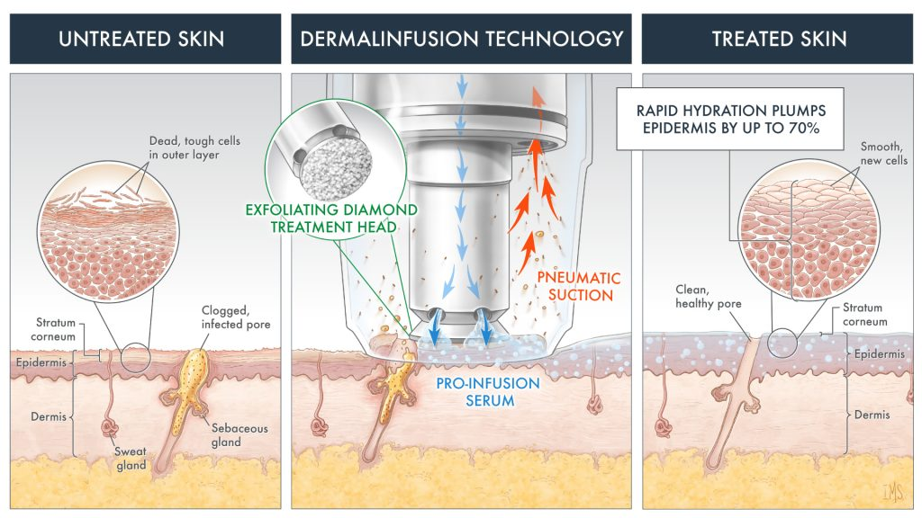
For more information on the benefits of DiamondGlow, please feel free to schedule a consultation, and we will gladly explain all the perks of this state-of-the-art treatment.
What Is the Treatment Like?
To begin your treatment, your provider cleanses your face and neck. He or she will then select the serum appropriate for your skin concerns. The provider guides the DiamondGlow handpiece over your skin. The diamond tip simultaneously exfoliates, extracts, and infuses the serum to optimal skin depths.
Does Microdermabrasion Hurt?
Microdermabrasion using the Diamond Glow system is safe and painless. Most patients describe a tingling sensation, but discomfort is usually non-existent. Patients immediately notice a smoother, more hydrated look and feel to their skin.
DiamondGlow is a 30-minute treatment; patients can return to activities immediately.
How Many Facial Treatments Will I Need?
Patients notice a difference right away after their first treatment. However, when patients receive treatment in a series for more dramatic outcomes.
Benefits of the DiamondGlow Treatment:
- Volumized Skin
- More radiant refreshed skin
- Visible reductions in the appearance of fine lines and wrinkles
- Improved pigmentation, congested pores, rough texture, and mild acne scarring
- A lasting youthful boost
- Stimulates healthy cell renewal
What are the side effects and risks?
There is no downtime after this procedure, but some patients notice a tingling sensation after treatment. A light pinkness to the skin is common and usually resolves within an hour.
Can this be combined with other treatments?
The DiamondGlow treatment may be combined with other treatments in our office, such as photorejuvenation (BBL), chemical peel, Halo Laser, and injectable fillers. Many patients choose to undergo combination treatments for maximum aesthetic results.
How Much Does Microdermabrasion Cost?
Microdermabrasion cost depends on different factors. These include the number of treatments conducted and whether you combine your DiamondGlow facial with other treatments, such as a chemical peel or laser skin resurfacing.
We will discuss if this treatment is right for you during your complimentary consultation and how much microdermabrasion costs.
MICRODERMABRASION NEAR ME
Rejuvenate your appearance with youthful, glowing skin. Get started by scheduling a free consultation with Dr. Robert Bowen. Conveniently located in Martinsburg, Dr. Bowen is the premier provider of high-tech skin treatments in West Virginia. Contact the office of Dr. Bowen by reaching out online or calling (304) 264-9080.

