Emana Medical.Homepage Update

Section should go here on the page. In between these two sections.
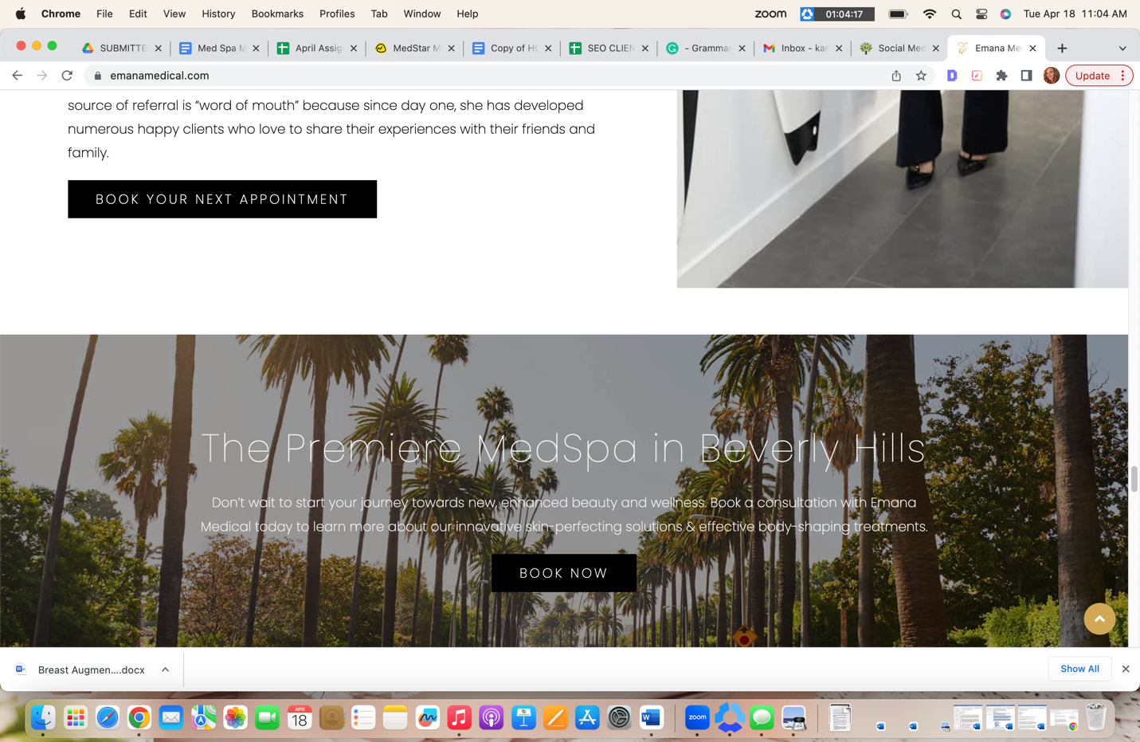

H2 Dr. Eman in the Press

Embed Video: link https://ktla.com/morning-news/tighten-lift-your-skin-with-non-invasive-device-emface/

Blurb will go underneath the video

Dr. Eman Abdallah of Emana Medical is proud to show the world how the revolutionary EMFace non-surgical facelift works. On KTLA’s Morning News, Dr. Eman shares her expert knowledge and demonstrates how the new needle-free and toxin-free facelift device works. EMface is the perfect surgical facelift alternative which people who want to avoid an operation, stitches, scars, and downtime. Watch this video to see how this innovative device works, and listen to Dr. Eman explain the science behind the treatment.

Read more here (link to video)

Link to article: https://www.instyle.com/dissolving-fillers-6753361

Blurb will go underneath the article image

Dr. Eman Abdallah at Emana Medical is an expert on dermal fillers. Dermal fillers can be a great way to restore volume and youthful contours, but there are various reasons why someone may want to dissolve fillers. This article discusses which fillers can be dissolved, why this procedure may be needed, potential side effects, and how the process works. Learn everything you need to know about getting fillers dissolved.

Read more here (link to article)

Link to article: https://www.elle.com/beauty/makeup-skin-care/g41927730/best-red-light-therapy-at-home/

Blurb will go underneath the article image

Red Light Therapy delivers impressive benefits to the skin. It can reduce lines & wrinkles, minimize the appearance of scars, stimulate collagen, and more. With so many devices available for purchase, finding the best one may take time and effort. This article discusses the top 10 at-home red light therapy devices professionals recommend. Find out which one Dr. Eman Abdallah from Emana Medical recommends and why.

Read more here (link to article)

