COOLSCULPTING CONTENT – SOMERSET

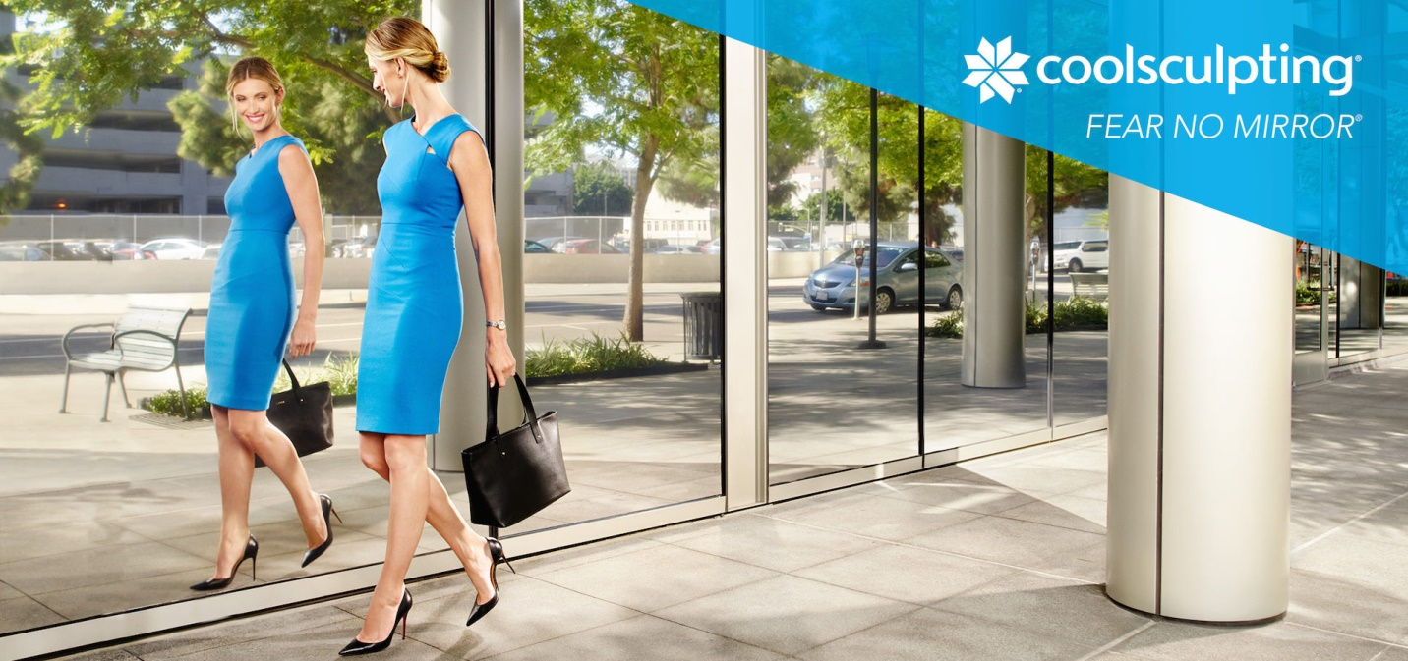

[H1]COOLSCULPTING SOMERSET – FAT FREEZING

Millions of women are reducing fat and sculpting attractive contours with CoolSculpting – the #1 non-invasive fat reduction treatment in the world. People love CoolSculpting because it safely and effectively reduces fat without surgery or downtime, offering a non-invasive alternative to liposuction. This revolutionary solution for stubborn bulges uses controlled cooling to eliminate fat deposits that resist diet and exercise. Fat freezing effectively targets belly fat, love handles, thigh fat, upper arm fat, submental fullness (commonly known as a double chin) and other problem areas. Fat reductions look natural and longitudinal studies conclude that CoolSculpting results are “very long lasting.”³

[h2] Benefits of CoolSculpting

- Eliminate stubborn fat deposits
- Contour attractive curves & define musculature
- Long lasting, natural looking results
- Non-invasive and no downtime
- FDA cleared & backed by scientific research¹
- Non-surgical alternative to liposuction

[h2]How Does CoolSculpting Work?

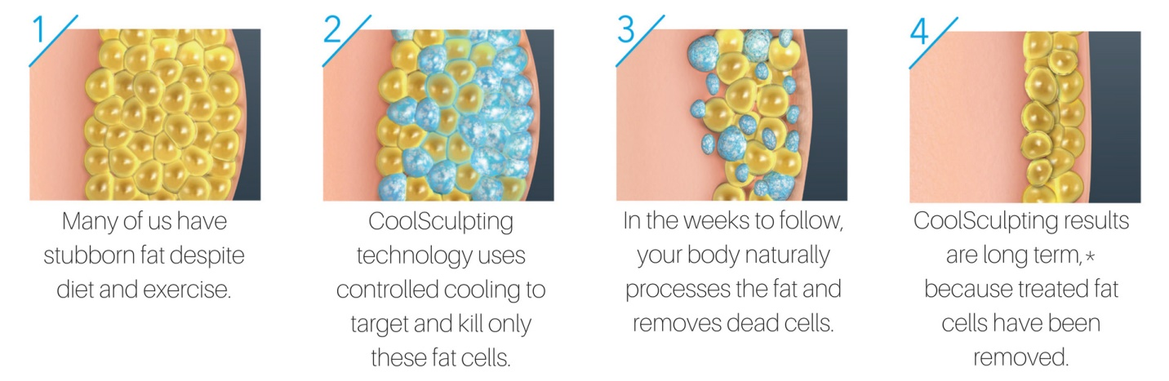

CoolSculpting eliminates stubborn bulges by freezing fat cells to death in a process known as Cryolipolysis (“Cryo” meaning cold, “lipo” meaning fat and “lysis” meaning cell death.) During a CoolSculpting procedure, a contoured applicator initiates cryolipolysis by exposing a problem area (such as the flank,) to near freezing temperatures. This precise application of controlled cooling chills the fat cells that create unwanted bulges (like love handles,) without harming the overlying skin or surrounding tissue. Once fat cells are frozen, they rupture, triggering apoptosis, or cell death. Over the span of several weeks, the lymphatic system collects and processes the destroyed fat cells out of the body. Once fat cells are excreted from the body, they are gone for good and cannot grow back.¹

[h2]CoolSculpting before and after*

CoolSculpting before and after pictures demonstrate impressive fat reduction and attractive body contouring. Although results may vary, these CoolSculpting before and after pictures depict actual CoolSculpting patients. While, before and after CoolSculpting pictures reveal amazing physical transformations, impressive CoolSculpting results are not the exception. Scientific research reveals that the vast majority of CoolSculpting patients experience visible results that leave them looking dramatically slimmer and more contoured.²

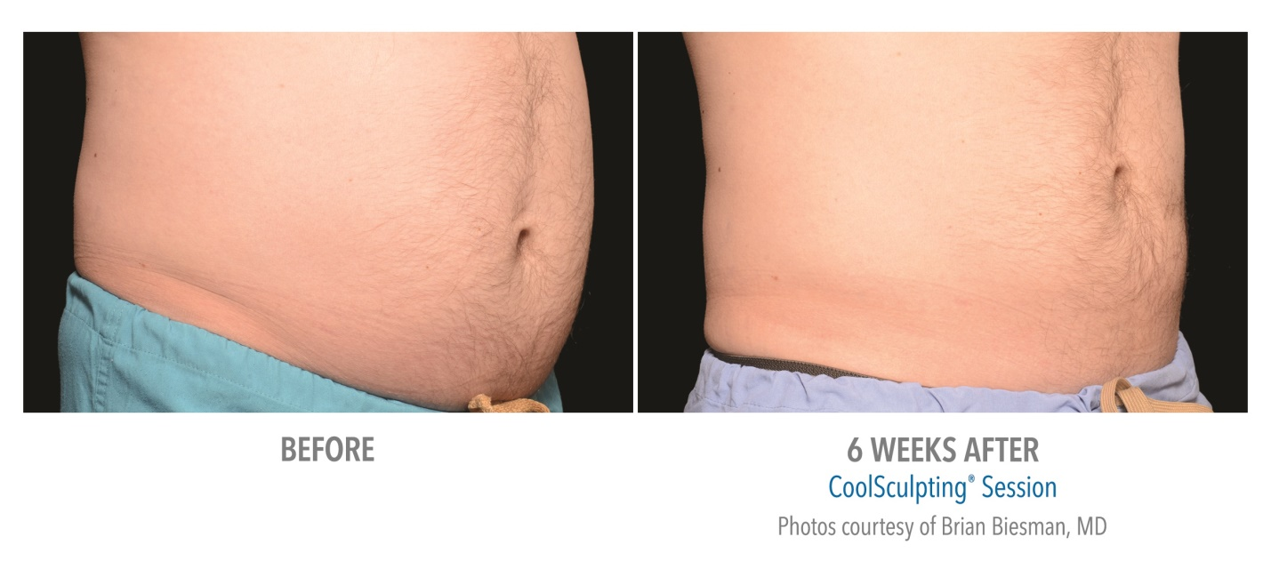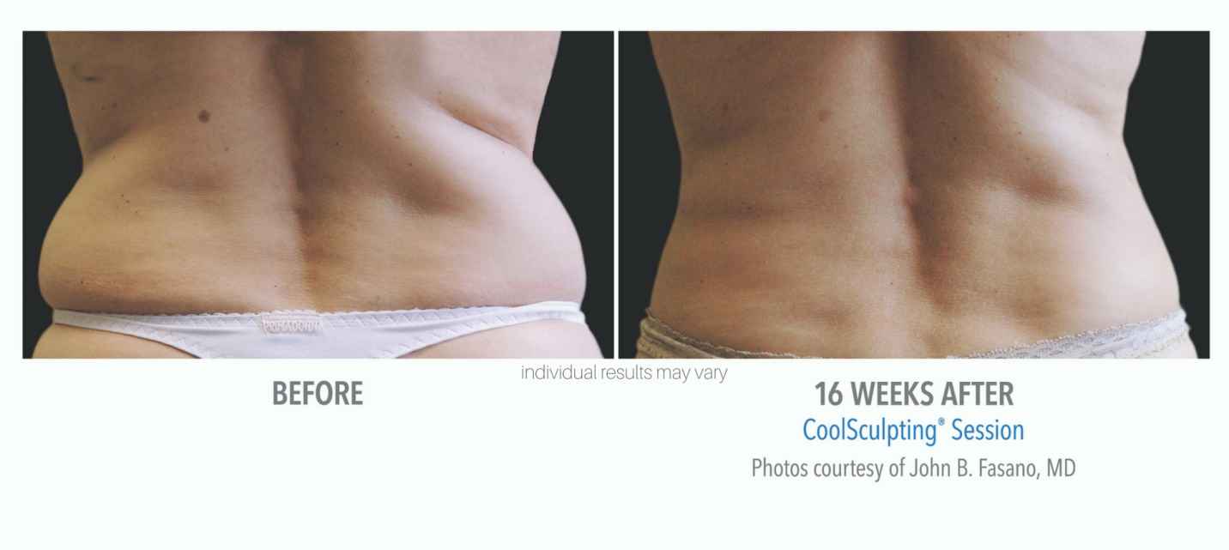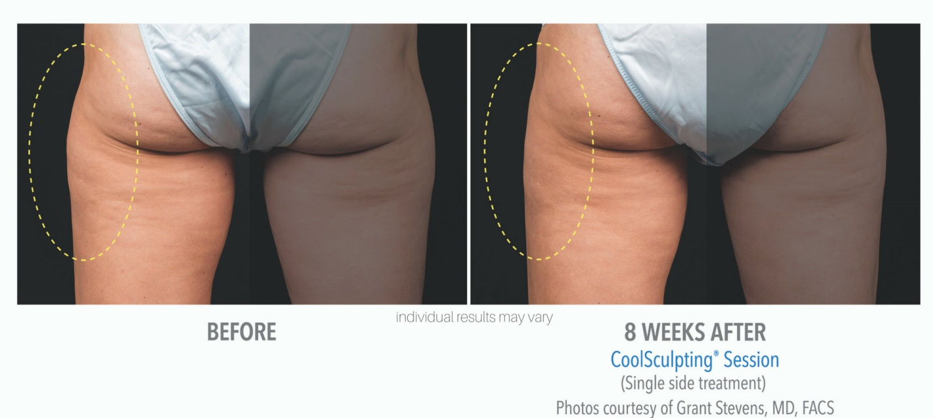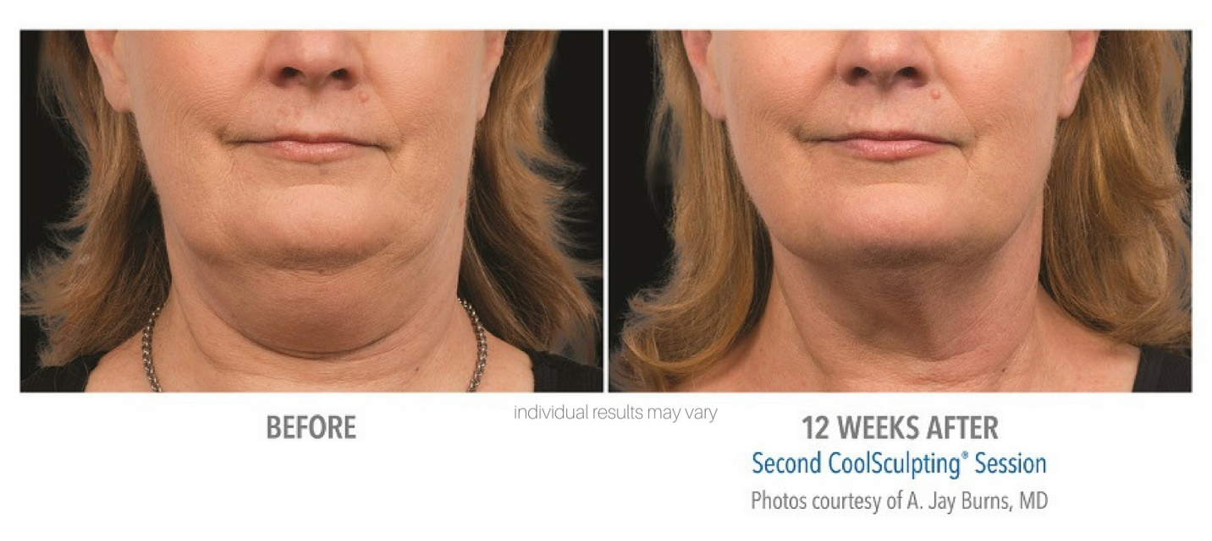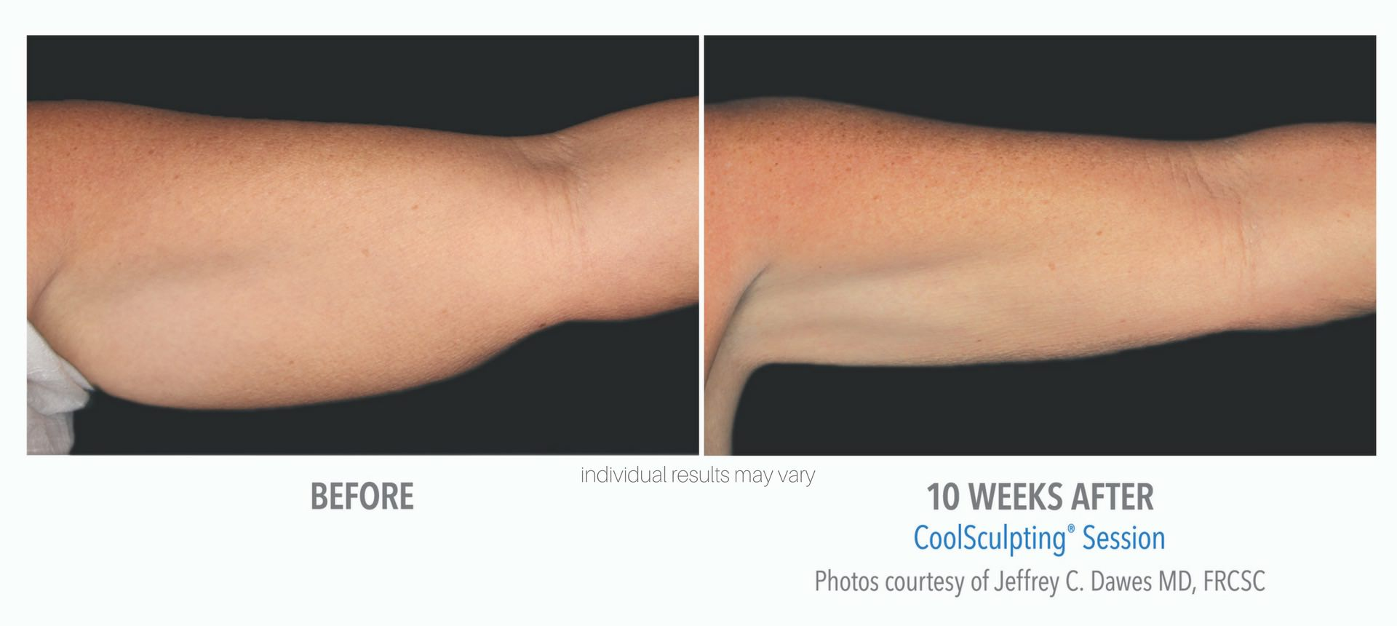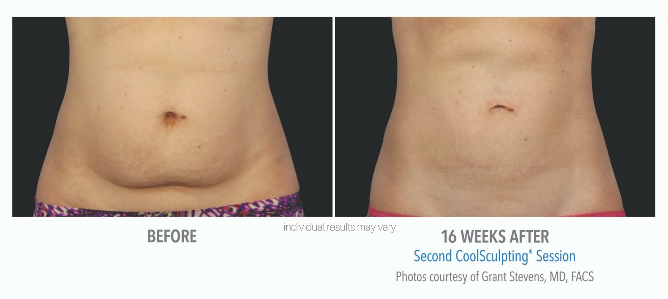

[h2] How much does CoolSculpting cost?

CoolSculpting cost is determined by numerous factors that differentiate between individual treatment plans. Factors that affect CoolSculpting prices include the treatment area and the number of cooling cycles needed to achieve optimal results. During your free consultation, your personal CoolSculpting specialist from Women’s Care of Somerset will discuss CoolSculpting prices in detail and customize a treatment plan that fits your budget.

As the premier CoolSculpting facility is Somerset, KY, Women’s Care of Somerset is dedicated to providing the best results at the best CoolSculpting prices. Call us today at 606-451-3151 for unbeatable savings on CoolSculpting cost.

[h2] Is Cool Sculpting right for me?

Cool Sculpting is ideal for individuals wanting a non-surgical alternative to liposuction that will deliver long-term fat reduction. The Cool Sculpting treatment works best for healthy men and women who struggle with stubborn fat deposits that are diet and exercise resistant. The best way to determine if you are a good candidate for Cool Sculpting is to schedule a free consultation with the medical professionals at Women’s Care of Somerset by signing up online or by calling 606-451-3151.
.
[h2]CoolSculpting side effects & CoolSculpting Risks

CoolSculpting is a safe, FDA cleared treatment that uses advanced cooling technology to reduce fat naturally. The non-invasive nature of this treatment also gives CoolSculpting a high safety profile with a very low rate of CoolSculpting risks and side effects.

While CoolSculpting side effects are rare, it is not uncommon to experience symptoms associated with the body's immune response as it goes to work collecting fat cells following a a fat freezing treatment. Post-treatment symptoms include redness, numbing, tenderness and bruising. However, these symptoms are usually mild and resolve quickly.*

During your free consultation, your specialist will discuss possible CoolSculpting side effects and CoolSculpting risks and what to expect during and post-treatment.

[h2]When will I see my Cool Sculpting results?

Once fat cells are frozen, cryolipolysis triggers the body natural metabolic processes to collect and eventually excrete the destroyed fat cells in the form of waste. The metabolic cycle takes several weeks to fully process the destroyed at cells. While some patients see visible results in as little as 4 weeks, most patients require 8 to 12 weeks to see the full effects of the Cool Sculpting results. However, Individual results may vary.*

[h2]Does Cool Sculpting hurt?

Most patients experience no Cool Sculpting pain during their treatment. However, some patients experience sensations of cold and tugging in the treatment area when the Cool Sculpting machine is first turned on. This discomfort typically goes away within the first 5 minutes of the cooling cycle, allowing patients to spend the remainder of their treatment relaxing, playing on their phone, or even taking a nap.*

[h2] CoolSculpting Providers in Somerset, KY
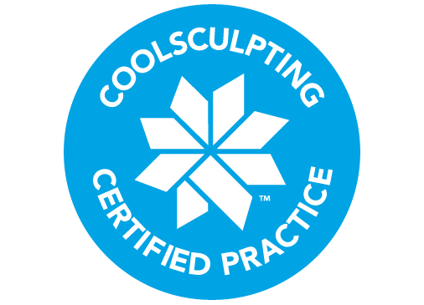
Women’s care of Somerset is the premier Cool Sculpting provider in Kentucky, happily serving the communities of Somerset, Lake Cumberland, Danville, Corbin, Bowling Green, Lexington, Corbin, and London.
Why Choose Women’s Care of Somerset as your preferred Cool Sculpting KY provider?
[TOGGLE ELEMENTS]
Extensively trained, experienced Cool Sculpting specialists:
As with any medical treatment, the person conducting the procedure matters. Our Cool Sculpting treatments are performed by medical professionals who are extensively trained and certified in the CoolSculpting procedure. That’s why discerning patients who want the best Cool Sculpting results possible chose the Women’s Care of Somerset to freeze their fat.
State-of-the-Art Medical Facility
Women’s Care of Somerset is a state-of-the-art medical facility equipped with the latest advancements in Cool Sculpting technologies. This includes Zeltiq’s recently released applicator, the CoolMini, specifically designed to reduce submental fullness (also known as a double chin.)
Indulge, while you freeze the bulge
We want you to love your experience, as much as you love your CoolSculpting results. Patients indulge in a luxurious spa setting and relax in one of our private patient rooms, equipped with comfortable chairs and plush blankets.
The best CoolSculpting Somerset Prices
We believe that everyone should enjoy the confidence of a skinny, sculpted bod. That is why Women’s Care of Somerset is committed to providing our patients with the best CoolSculpting prices in Somerset. We will beat or match any written quote from one of our competitors.
[h2]CoolSculpting Near Me:
If you live in the Somerset area and want to get started freezing away fat to reveal a skinny, sculpted physique, call us at 606-451-3151. If you can pinch it, we can freeze it. So say goodbye to those stubborn bulges and get started with CoolSculpting today!
[Insert Consult Form]
Sources
ⁱ Cryolipolysis For Noninvasive Body Contouring
ⁱⁱ Safety, Tolerance, And Patient Satisfaction With Noninvasive Cryolipolysis.
ⁱⁱⁱ Long-term efficacy follow-up on two cryolipolysis case studies: 6 and 9 years post-treatment
CoolSculpting Disclaimer
**Results may vary. Women’s Care of Somerset is reputable for complete customer satisfaction for completed treatments. Before and after images reflect real results from real patients, although individual results may vary. No treatment is promised to provide permanent results. A guarantee is neither provided nor implied. Statements estimating treatment duration and the amount of treatments required are based on the typical experience of patients of Women’s Care of Somerset however, duration and amount of treatments needed may vary per client.

