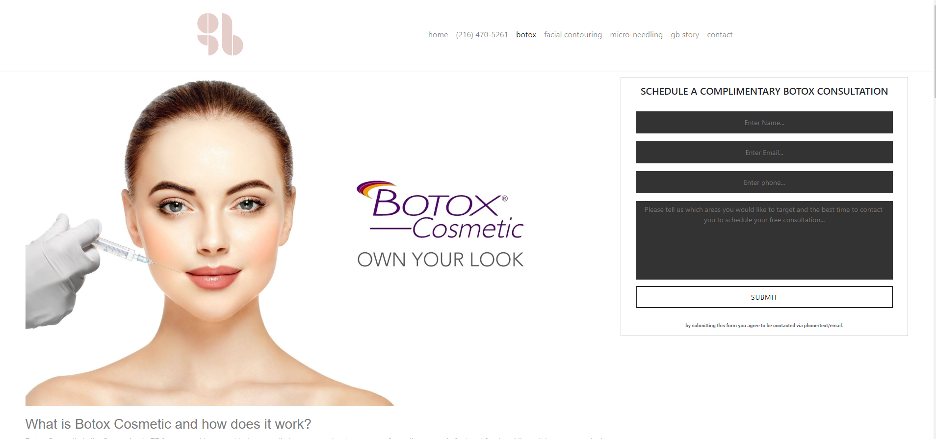
- Can we remove the phone number from the top bar? It looks out of place
- Can we change the consult box to white or pink? The black looks awkward
- Can you move the GB logo over or add our name next to it?? It looks out of place on the top tool bar (see below screen shot of our old website and the logo with our name on the top tool bar)
- Can you add the facebook and instagram hyperlinks on the top bar like we have on our current site?
- Can you add a spot to put the Book Here button at the top like we have on our current site?

Can you please add the following from our current website?
Pricing, FAQ, Skincare, Latisse, G+B Society tab (that has our specials) and all of additional services? I listed those below. These are just the screen shots from my computer.

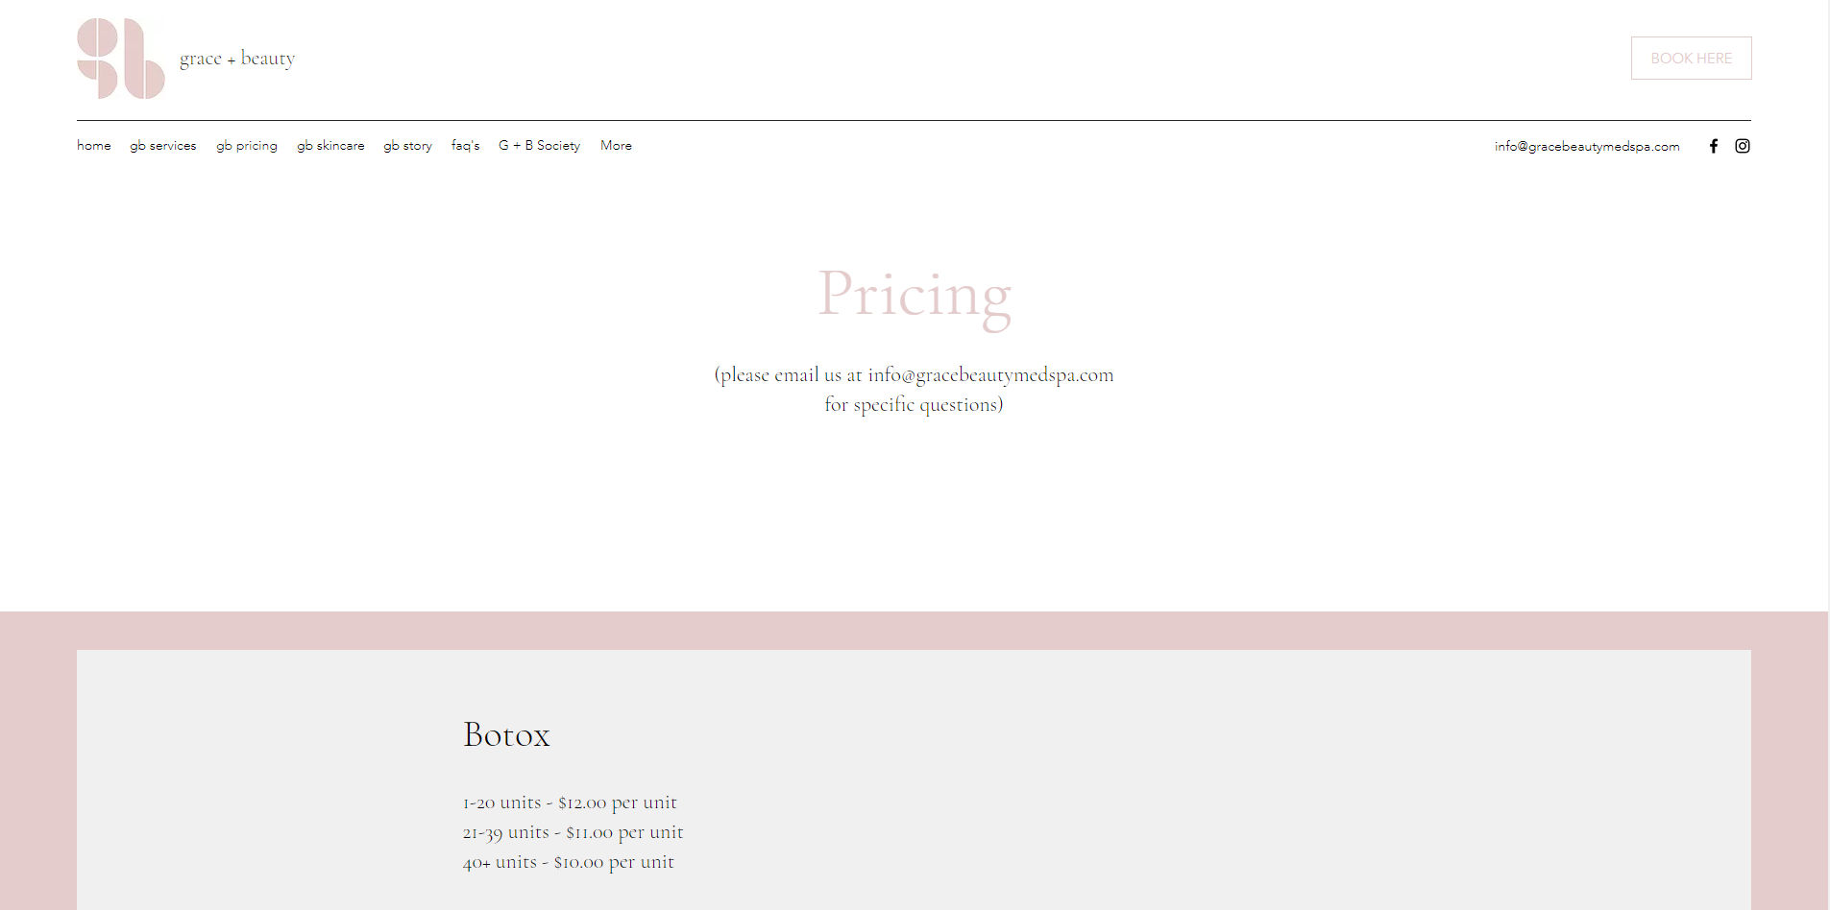
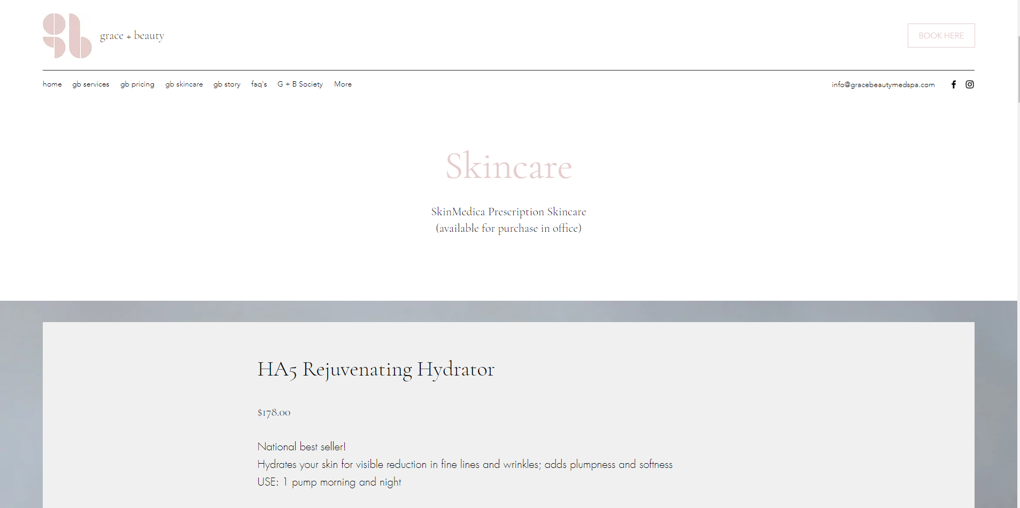

Additional services… Listed under GB service.. Missing skin Treatments, Kybella and follow up
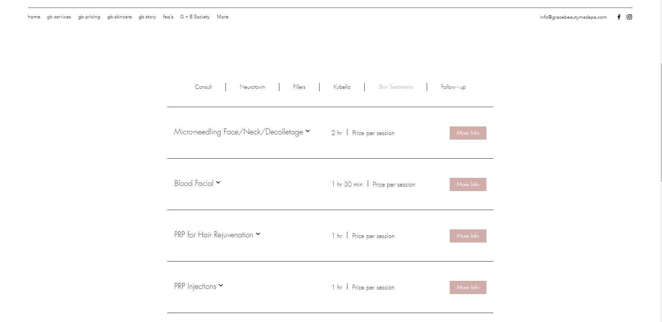

GB Society tab
