500 Word Semaglutide Service Page Update.Haus of Aesthetics.KA

Link to page: https://hausofaestheticsslc.com/semaglutide-wegovy-weight-loss/

NEW META TITLE: Semaglutide Weight Loss Salt Lake City | Wegovy | Ozempic

NEW META DESCRIPTION: Semaglutide in Salt Lake City, using Wegovy and Ozempic, improves metabolism, regulates appetite, decreases food intake, and encourages weight loss.

NEW H1 SEMAGLUTIDE WEIGHT LOSS IN SALT LAKE CITY: TREATMENTS WITH WEGOVY OR OZEMPIC
(NEW OPENING PARAGRAPH) One of the most effective ways to lose weight is the combination of a healthy diet, physical activity, and Semaglutide, also known as Wegovy, Ozempic, or Rybelsus (depending on your prescription). Semaglutide is a new long-term medication that helps your body burn fat more efficiently, reduces hunger cravings, suppresses appetite, and improves overall physical well-being.

If you have tried different diets and exercise routines but still struggle to lose weight, Semaglutide treatments may be the perfect solution. Now you can finally break free from those extra stubborn pounds, lose the weight, and keep it off with this revolutionary weight management treatment available in the SLC. Haus of Aesthetics is a top provider of Semaglutide treatments in Salt Lake City, UT. Call us at (801) 997-8199 to schedule an initial consultation and learn how to lose weight in Salt Lake City with Semaglutide.

HOW THE PROCESS WORKS
STEP ONE:
Schedule a free in-person or virtual consult with our medical provider
STEP TWO:
Get medication with a personalized plan and dosage. Inquire for pricing and take advantage of our $100 off the first month promo.
STEP THREE:
Start losing! Come in once a month to pick up your refill, we will pre-fill syringes for you to inject at home.
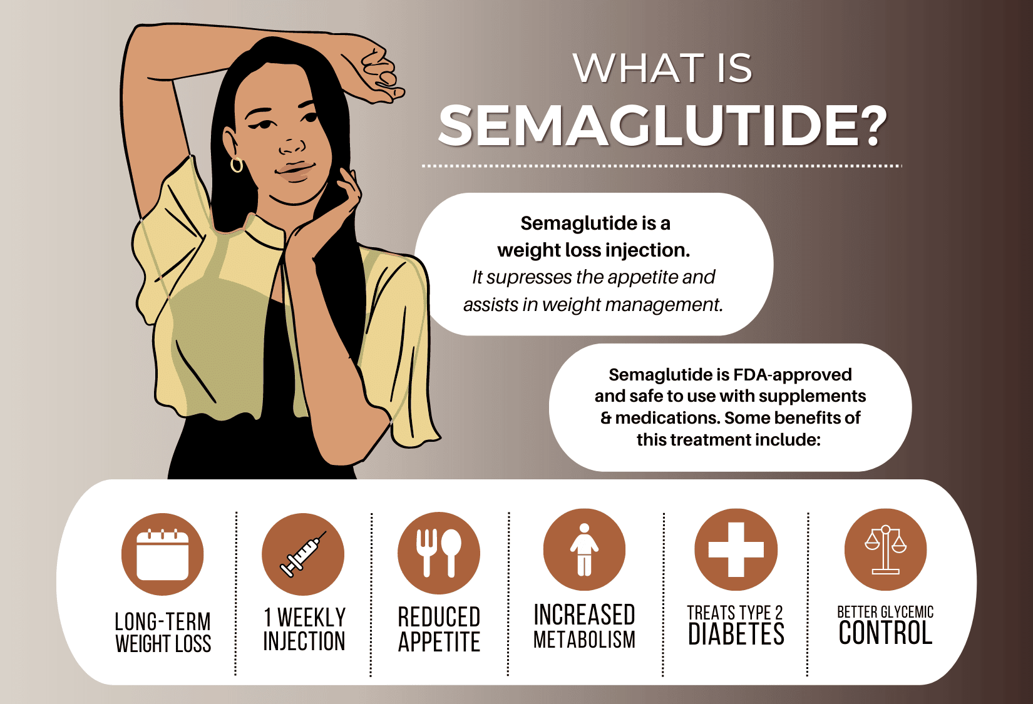

BENEFITS OF SEMAGLUTIDE FOR WEIGHT LOSS
It is common for people to weigh the pros and cons of phentermine and Semaglutide (also known as Wegovy and Ozempic) when deciding on a weight loss treatment plan. The reason for this is that phentermine is a popular diet pill and appetite suppressant. While phentermine is more affordable than Semaglutide, it is only approved for short-term use. So, people looking for long-term weight loss management opt for Semaglutide. Wegovy helps with chronic weight management, while Ozempic treats Type-2 diabetes and prevents heart problems.
Semaglutide is a promising new weight loss option: it is a once-a-week injection (Wegovy or Ozempic) or tablet (Rybelsus) that reduces appetite, increases metabolism, and helps you lose weight by reducing fat mass.
Other benefits of this new weight loss treatment include: If you are considering this weight loss solution, you may wonder, why do people turn to Semaglutide?
- It is FDA-approved for long-term use
- It does not alter your mood
- It decreases foot intake, reducing body fat
- It decreases appetite, reducing hunger cravings

SEMAGLUTIDE BEFORE AND AFTER*
Curious about what Semaglutide can do for you? You are not alone—patients come in asking us how to lose weight without feeling hungry all the time.
Below are some of our real patient before-and-after photos that show impressive transformations. As with any medical treatment, results vary per person.*
*LEAVE BAS THE SAME*
*results may vary

understanding how semaglutide worksHOW DOES SEMAGLUTIDE WORK?
Semaglutide, Wegovy or Ozempic, is an FDA-approved medication for adult weight management. It is the first drug of its kind approved for this purpose. Semaglutide mimics a hormone called glucagon-like peptide-1 (GLP-1), which regulates food intake and appetite.
Patients can expect their doctor to increase the medication dose gradually over 16-20 weeks. The average weight loss is 15% of one’s body weight. If you decide to go forward with Semaglutide, committing to at least 3 months of treatment is imperative to see results. You will get weekly injections under the skin, and the doctor will monitor your progress. Be prepared to make regular visits as part of your treatment plan.
Semaglutide also known as Wegovy or Ozempic is an FDA-approved medication for adult weight management. It is the first drug of its kind approved for this purpose. Semaglutide mimics a hormone called glucagon-like peptide-1 (GLP-1), which regulates food intake and appetite.
Patients can expect their doctor to increase the medication dose gradually over 16-20 weeks. The average weight loss is 15% of one’s body weight. If you decide to go forward with Semaglutide, it is imperative to commit to at least 3 months of treatment to see results. You will get weekly injections under the skin, and the doctor will monitor your progress during this time. Be prepared to make regular visits as part of your treatment plan.


h2 SEMAGLUTIDE RESULTS*
The Semaglutide injection treats obesity, a condition that causes one to be overweight. It subdues hunger, reduces one’s weight, and improves a person’s body mass index (BMI).

Consistency is key during your Semaglutide weight loss journey. It can take some time before the full results show. So, it is crucial to stick with your treatment plan. Semaglutide results vary per individual depending on circumstances like original weight and lifestyle habits.

The best way to get the most out of Semaglutide is by making sure you are eating nutritious foods and getting enough exercise each day as part of your overall lifestyle changes.¹ Finally, track your progress with before and after photos so that you stay motivated, and have a clear picture of how the treatment is working for you. As always, results will vary per person*

H2 SEMAGLUTIDE SIDE EFFECTS

Semaglutide Weight Loss medications have common side effects, including:
- Nausea
- Diarrhea
- Abdominal pain
- Vomiting
- Constipation
- Headache
- Fatigue
- Dizziness
- Low blood sugar
Most of the time, they are mild and subside on their own within a few weeks. Minimize these symptoms by following these helpful tips:
- Eat small portions, spaced throughout the day
- Avoid lying down after eating
- Avoid eating sweet or fried and greasy meals
- Do not eat within two hours of your bedtime
- Avoid big portions 1-2 days before your injection
- Eat slowly
- Drink clear or ice-cold beverages

H2 SEMAGLUTIDE (WEGOVY OR OZEMPIC) VS MOUNJARO (TRIZEPATIDE)

Another popular weight loss medication starting to make waves in the news is Mounjaro (Trizepatide). This weight loss treatment is similar to Semaglutide. It is in the same class as Wegovy, Ozempic, and Rybelsus. Mounjaro, like Semaglutide, is an incretin mimetic treatment. However, it is different. Mounjaro acts on GIP and GLP-1 receptors—Semaglutide only works on GLP-1.

Mounjaro is a dual-acting GIP and GLP-1. It lowers fasting and postprandial glucose concentrations. In addition, it decreases food intake, reduces body mass, and improves the health of patients with weight-related issues, including type-2 diabetes.

If you wonder which weight loss medication is best for you, speak to the professionals at Haus of Aesthetics. Gaining as much knowledge as possible about your weight loss treatment options is important. No matter which treatment you begin, you should never use these medicines with other GLP-1 or GIP receptor agonists.



H2 SEMAGLUTIDE WEIGHT LOSS FAQsFAQ
H3 HOW MUCH DOES SEMAGLUTIDE COST IN SALT LAKE CITY?

The Semaglutide weight loss treatment cost varies depending on where you get the injections and your provider’s expertise level. Your current weight also affects the price because it will add up if you need more treatments to achieve your desired weight.

Haus of Aesthetics currently offers a monthly early bird special of $500. This includes a once-a-week weight check and injections. In addition, you may renew your prescription every 30 days by meeting with your doctor or nurse practitioner. The best way to find out the actual cost of
Semaglutide is to contact a provider near you. After learning your goals and evaluating your current condition, a specialist will be able to provide an accurate quote.

H3 What does Semaglutide do to your body?

Semaglutide is an incretin mimetic. It helps the pancreas to release the correct amount of insulin when blood sugar levels are high. In addition, insulin helps move sugar from the blood into other body tissues, which are used as energy. This changes how the body metabolizes foods, reduces hunger cravings, and burns off fat more efficiently.

H3 Does Semaglutide get rid of belly fat?

Yes. Semaglutide improves body composition by reducing excess body fat, including belly fat.

H3 What foods should you avoid on Semaglutide?

Avoiding foods high in fat, sugar, and calories is a good idea. Instead, adopt a healthy diet in addition to the Semaglutide prescription to ensure optimal weight loss results and an overall improvement in health.

H3 Can I take Semaglutide if I am not diabetic?

Yes. Semaglutide, Wegovy, or Ozempic are now FDA-approved as weight-loss medication for people who are obese or overweight with severe health-related issues.

SEMAGLUTIDE (WEGOVY) INJECTION RESULTS
The Semaglutide injection treats obesity, a condition that causes one to be overweight. It subdues hunger, reduces one’s weight, and improves a person’s body mass index (BMI).

Consistency is key during your Semaglutide weight loss journey. It can take some time before the full results show. So, it is crucial to stick with your treatment plan. Semaglutide results vary per individual depending on circumstances like original weight and lifestyle habits.

The best way to get the most out of Wegovy is by making sure you are eating nutritious foods and getting enough exercise each day as part of your overall lifestyle changes.[1] Finally, track your progress with before and after photos so that you stay motivated, and have a clear picture of how the treatment is working for you.

H2 SEMAGLUTIDE INJECTION SIDE EFFECTS

Semaglutide Weight Loss Injection common side effects include:
- Nausea
- Diarrhea
- Abdominal pain
- Vomiting
- Constipation
- Headache
- Fatigue
- Dizziness
- Low blood sugar
Most of the time, they are mild and subside on their own within a few weeks. Minimize these symptoms by following these helpful tips:
- Eat small portions, spaced throughout the day
- Avoid lying down after eating
- Avoid eating sweet or fried and greasy meals
- Do not eat within two hours of your bedtime
- Avoid big portions 1-2 days before your injection
- Get fresh air outside
- Eat slowly
- Drink clear or ice-cold beverages

SEMAGLUTIDE (WEGOVY) INJECTIONS NEAR ME
Semaglutide Wegovy can be a viable option for people with Type-2 diabetes looking for an effective weight loss medication. It effectively suppresses appetite, thereby reducing hunger and cravings, and increasing satiety after eating. This means that individuals taking the drug will consume less food than before treatment began.

Residents of Salt Lake City, UT trust Haus of Aesthetics for the Wegovy injection. Our trained experts tailor Semaglutide treatments to each person's unique needs. Schedule a free consultation by calling (801) 997-8199 to start your weight loss journey with Wegovy.

H2 Lose weight and feel great with semaglutide in salt lake city
(NEW CLOSING PARAGRAPH * MAKE SURE THIS IS OUTSIDE AND SEPARATE FROM THE FAQ SECTION*)
Stop struggling with your weight and finally lose those extra pounds with Semaglutide. This new, FDA-approved long-term weight management medication provides a safe and effective way for people to take control of their weight once and for all. This means avoiding overeating and pesky hunger cravings. In addition, your body will burn fat more efficiently!
Learn everything you need to know from the SLC professionals! Haus of Aesthetics is proud to be the leading provider of Semaglutide in Salt Lake City, Utah. Learn more by calling (801) 997-8199 to schedule your appointment and begin your weight loss journey with Semaglutide.

