500 Word Addition to Botox Service Page.Hollywood Body Laser.KA

Link to page: https://hollywoodbodylaser.net/botox/

New Meta Title: Denver Botox | Restore Your Youth
New Meta Description: Denver Botox treatments make restoring your youth easy with this anti-aging treatment. Learn how Botox reduces fine lines and wrinkles with ease.

New H1: DEnver BOTOX® | ANTI-AGING TREATMENT
BOTOX® Cosmetic is the first and only treatment FDA-approved to temporarily make moderate to severe frown lines, crow’s feet, and forehead lines look better in adults. So you look like you, only with less noticeable facial lines.
Treatment requires minimal downtime. You can return to your daily routine immediately after you leave your specialist’s office. You may begin to notice results within 24 to 48 hours, with full results in 30 days, with results lasting up to 4 months for moderate to severe frown lines.
Learn why there’s only one BOTOX Cosmetic and find out how it works. Then get answers to your questions to see if it’s right for you and learn more about the history that has made BOTOX® Cosmetic the #1 selling treatment of its kind in the world.*

BENEFITS OF BOTOX® COSMETIC
- FDA-approved to treat crow’s feet, frown lines, and forehead lines
- Also used off-label to soften and smooth lip lines, “bunny lines” on the nose, chins, and neck bands
- Can also relax the muscles on the jaw
- When injected above the upper lip, it can also create a “lip flip”
- The treatments are quick and relatively painless
- Downtime is almost nonexistent
- Your face should still look natural, not frozen
- It delivers predictable, subtle results, so you look like you, only with less noticeable facial lines

BOTOX TREATMENT AREAS
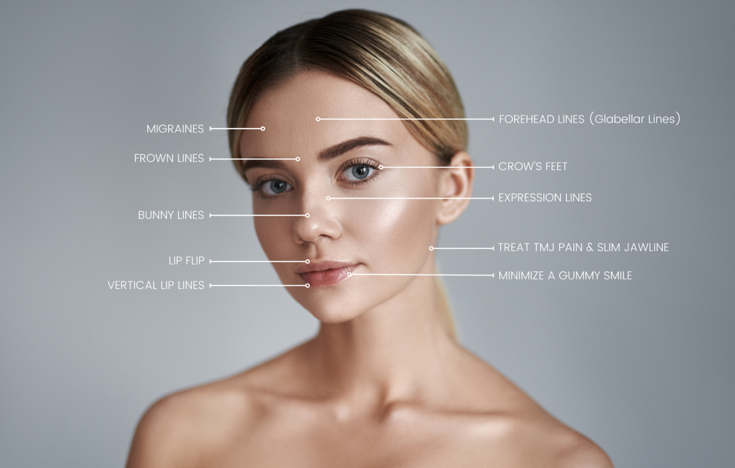

HOW BOTOX® COSMETIC WORKS
A combination of factors can cause facial lines. It’s not just about the cellular changes that may occur, or reduction of collagen, or damage caused by free radicals from the sun and the environment.
Repeated muscle contractions from frowning, squinting, or raising eyebrows cause skin to furrow and fold, gradually resulting in the formation of facial lines. BOTOX® Cosmetic works beneath the surface and temporarily reduces the underlying muscle activity that causes moderate to severe frown lines, crow’s feet and forehead lines in adults – to help them look better.

BOTOX BEFORE AND AFTER
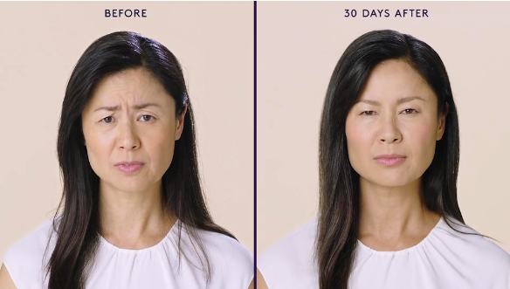
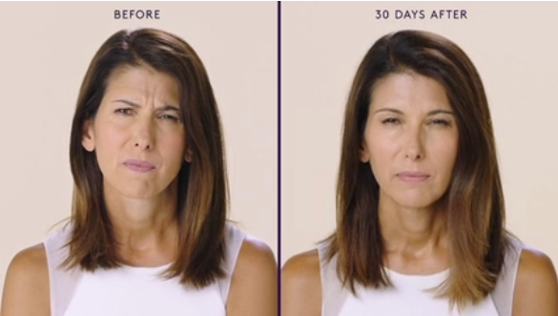
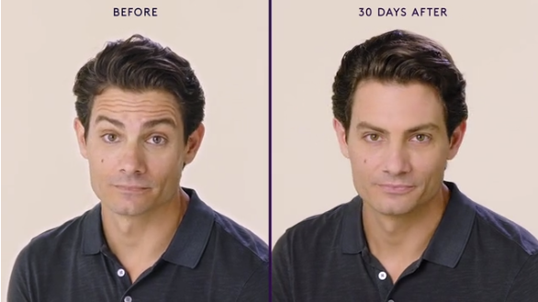
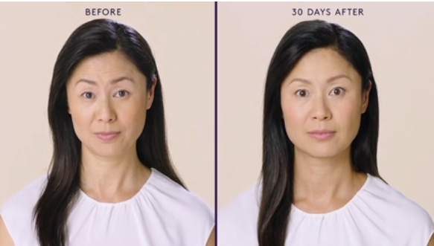
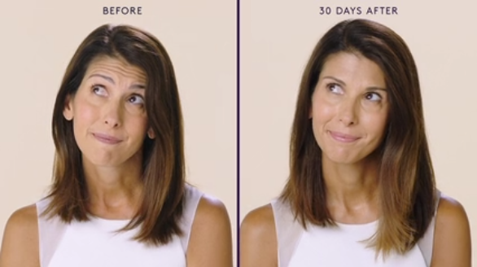
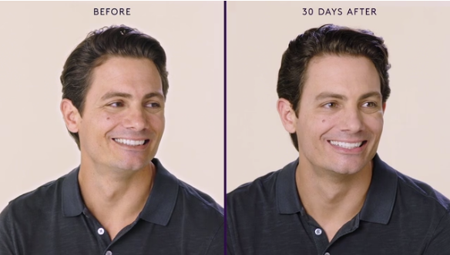

STILL YOU. WITH FEWER LINES.
Choose the brand medical providers and patients know and trust: BOTOX® Cosmetic. It’s the #1 selling treatment of its kind*:
- The first and only treatment FDA-approved to temporarily make moderate to severe frown lines, crow’s feet and forehead lines look better in adults
- Treatment requires minimal downtime. You can return to your daily routine immediately after you leave your specialist’s office
- You may begin to notice results within 24 to 48 hours for moderate to severe frown lines. Full results in 30 days
- It delivers predictable, subtle results, so you look like you, only with less noticeable facial lines
Ask for BOTOX® Cosmetic by name.
H2 Additional Botox Treatment Applications
Botox cosmetic is widely known for its anti-aging benefits, but it also has many other popular treatment applications:
H3 Botox for Migraines – Botox is now FDA-approved for treating migraines. Under the name of OnabotulinumtoxinA, Botox Cosmetic was FDA cleared in 2012 for the treatment of chronic migraines in adults. Clinical studies show that using Botox as a way to prevent migraines results in a “50% or more decrease in the frequency of headache days, in addition to a statistically significant reduction in headache frequency.” In another study, “70% of people showed a marked improvement in their migraines after five rounds of treatments.”
H3 Botox for TMJ – Another widespread use for Botox is relieving TMJ syndrome. This is because Botox injections can help relax the jaw muscles, decreasing pain and increasing mouth movements for three months following treatment. In a study, results showed patients found that their symptoms improved by 90%.
H3 Botox for Feet – Botox for feet is becoming a more common and popular type of cosmetic treatment. Botox injections can help alleviate the pain and improve your foot health if you struggle with foot pain, such as plantar fasciitis.
H3 Botox for Excessive Sweating – Also known as Hyperhidrosis, excessive sweating tends to occur in the armpits, hands, and even feet. Botox injections temporarily paralyze the sebaceous glands that produce sweat, decreasing excessive sweating and helping you feel fresh for longer.
H3 Botox for Lip Augmentation – The Botox Lip Flip is becoming a popular way to enhance and augment the lips without filler. This procedure involves a master injector injecting the Botox into specific areas of the lip, allowing the lip to unfurl, giving the appearance of a fuller and more prominent pout. The Lip Flip is also an excellent treatment for people who struggle with a “gummy smile.”
H2 Botox as a Preventative Treatment

When people first think of Botox injections, they think of them as a reactionary treatment for temporarily improving the appearance of wrinkles and lines for adults aged 40 or older. However, many physicians and Botox providers are seeing a massive surge in younger adults committing to preventative Botox injections.

Preventative Botox is quickly becoming one of the most popular cosmetic treatments for both men and women in their 20s and 30s who take a proactive approach to skincare. The idea is to stop the formation of dynamic wrinkles before they can begin.

According to viewpoints published in JAMA Dermatology, “Initiating regular treatment with a neuromodulator in an individual’s 20s or 30s will have a dramatic effect on the appearance of the face as seen in the person’s 40s or 50s. There will be few imprinted lines of facial expression present.”²

H2 Botox in Denver
When it comes to Botox injections, expertise matters. The best Denver Botox results come from the skilled medical professionals at Hollywood Body Laser. We are proud to be the primary provider of the most popular neuromodulator Botox in the Denver area, serving clients in Westminster, Colorado Springs, and the Metro Area. Get started with Botox today by calling us to schedule your consultation!
Denver (303) 800-1878 | Westminster (303) 872-7107 | Colorado Springs (719) 387-7150
LEAVE CURRENT FAQS AS THEY ARE ON THE PAGE

