Westminster Location Page.Hollywood Body Laser.KA

Note for dev: I would like for the location page to look similar to what we did for KTherapySLC: https://ktherapyslc.com/west-jordan/. If we can get a picture of each individual Hollywood Body Laser location for each page, as we are going to build up pages for each location, that would be amazing.

Meta Title: Top-rated Med Spa Westminster CO

/westminster/

Keywords:
- med spa colorado springs
- medspa colorado springs
- medical spa colorado springs

Meta description: Hollywood Body Laser is a premier medical spa in Westminster, CO, where we serve our clients with the highest-rated aesthetic services available on the market. Learn more about services here.

H1: Hollywood Body Laser: The Premier Med Spa in Westminster, CO

Hollywood Body Laser is proud to offer top-rated, quality aesthetic treatments in Westminster, CO. We offer a variety of laser treatments, anti-aging injectables, body contouring services, and more to help you enhance your natural beauty, age with grace, and feel comfortable in your own skin.

Our treatments range from the most popular body contouring treatments to the most effective injectables for reducing wrinkles and fine lines. Each service is administered by a top-rated specialist with the proper training to help you achieve the most optimal treatment results possible. When you select our Westminster Medspa, you are in the best hands, capable of ensuring your safety and satisfaction no matter what aesthetic service you choose.

*INCLUDE WESTMINSTER LOCATION DETAILS WITH MAP*
Example: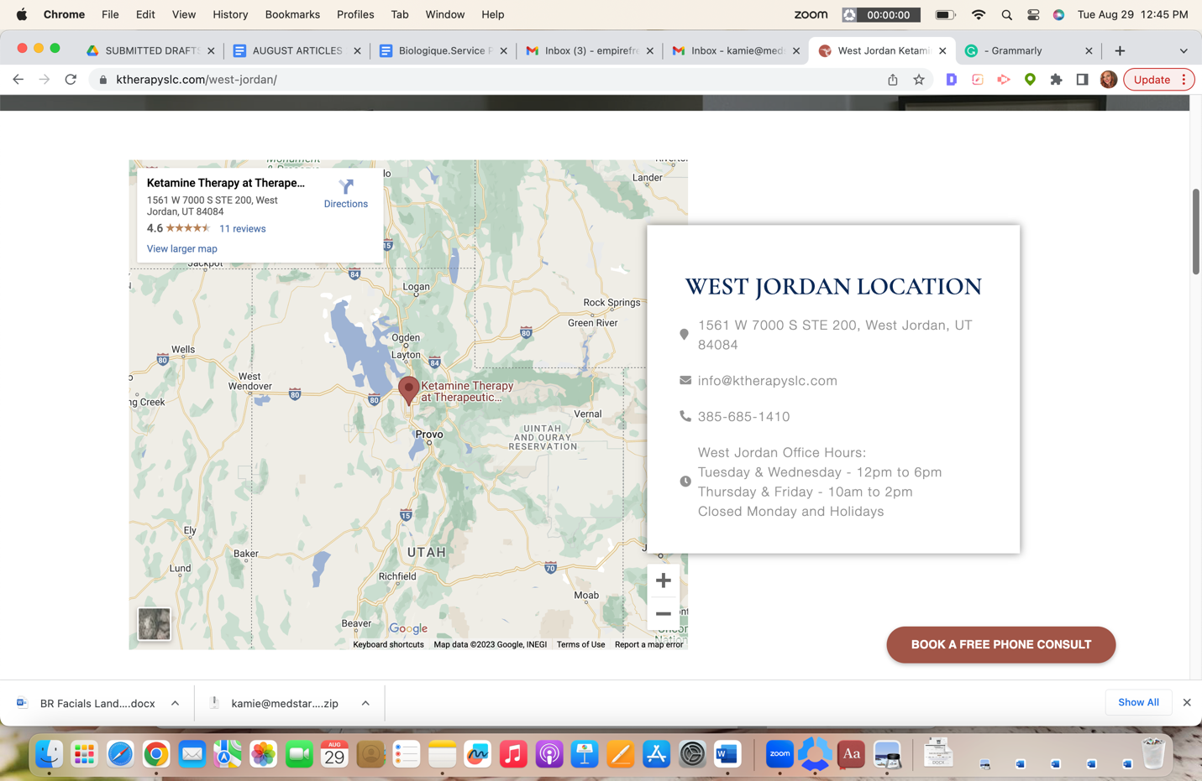

H2 Westminster Meds Spa Location

1001 W. 120th Avenue, Suite 130 Westminster,
CO 80234 United States
303-872-7107
H2 Services at this Location (please link all services to the corresponding service pages)

Example: 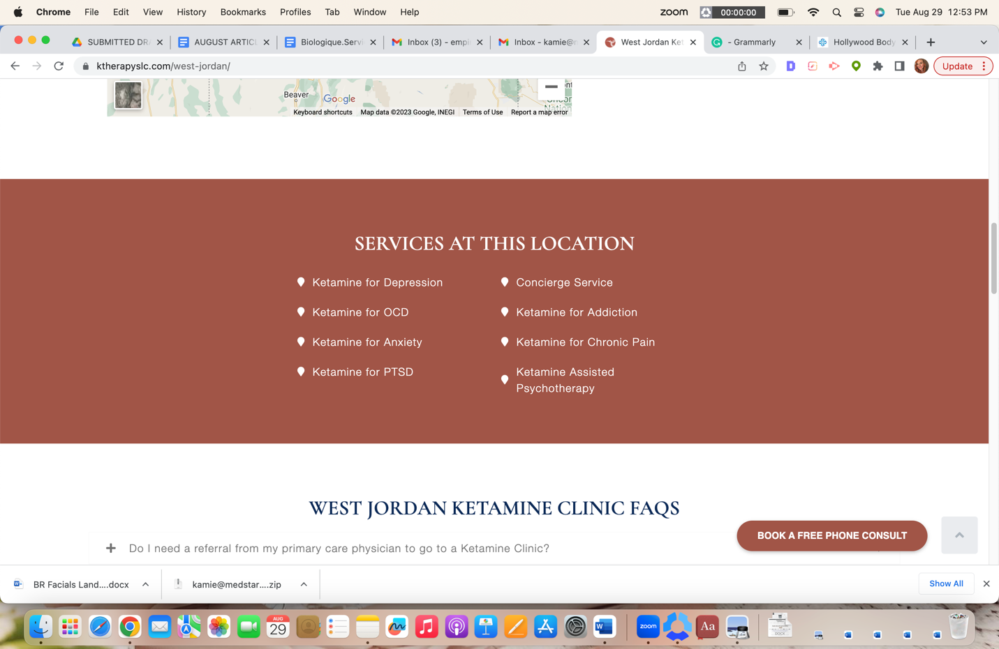

- CoolSculpting
- CoolTone
- Cellulite Reduction
- Zerona
- VelaShape
- Skin Tag Removal
- Weight Loss Injections
- Botox
- Dermal Fillers
- Lip Fillers
- Chemical Peels
- Co2 Laser Treatment
- IPL Photofacial
- Dermaplaning
- Hydrafacial
- Kybella
- Microdermabrasion
- Microneedling
- Non-surgical Facelift
- PDO Threads
- Jeuveau
- Skin Rejuvenation
- Sublative Rejuvenation
- Ultherapy

H2 Med Spa Westminster FAQs

H3 What does Med Spa stand for?

Medspa, or med spa and medi spa, all stand for the same thing, “medical spa.” A medspa combines medical procedures usually performed by a doctor with a day spa experience. Most medspa facilities emphasize anti-aging treatments and body contouring, like our Westminster, CO, medical spa, which offers all this and much more.

H3 What makes a med spa different?

A med spa is different from a traditional day spa. It offers a range of inner and outer beauty treatments for the face, skin, and body. A trained medical professional administers each treatment. In addition, the medical spa treatments are totally customizable to fit your needs in a safe, clean, and luxurious environment in which you can relax and enjoy your beauty treatments.

H3 Are med spa services expensive?

Our Westminster Med Spa services should be viewed as long-term investments. You are getting the best bang for your buck when you compare the cost of long-term treatments to the ever-rising prices of serums and creams that only provide temporary results. To learn more about services and the cost per treatment, contact a specialist today to discuss your cosmetic concerns, which services would be best for you, and how you can get the best long-term results.

H3 What are the most popular med spa services?

The most popular med spa services include Botox, dermal or facial fillers, chemical peels, fat reduction, cellulite reduction, laser treatments, microneedling, and more. Hollywood Body Laser’s Westminster medical spa is proud to offer all of these services and much more to accommodate each client, ensuring they receive the care they deserve in a luxury medical spa.

H3 Why do people go to med spas in Westminster, Colorado?

Most people visit a med spa in Westminster to receive treatments that improve their appearance, enhance their natural beauty, and help them feel comfortable in their skin. Hollywood Body Laser is a premier Westminster med spa thanks to our state-of-the-art facility's top-rated aesthetic services with the latest technology and treatments.

H3 Do medspas accept insurance as payment?

Most medical spas do not accept insurance as payment, as our services are primarily elective cosmetic treatments. If you want to learn more about our payment plans, speak with one of our knowledgeable specialists today.

*ADD TESTIMONIALS SECTION*

