Colorado Springs Location Page.Hollywood Body Laser.KA 750

Note for dev: I would like for the location page to look similar to what we did for KTherapySLC: https://ktherapyslc.com/west-jordan/. If we can get a picture of each individual Hollywood Body Laser location for each page, as we are going to build up pages for each location, that would be amazing.

Meta Title: Top-rated Med Spa Colorado Springs CO

/colorado-springs/

Keywords:
- med spa colorado springs
- medspa colorado springs
- medical spa colorado springs

Meta description: Hollywood Body Laser is a premier medical spa in Colorado Springs, CO. We make receiving quality medical spa services and aesthetic treatments simple and easy for our clients.

H1: Hollywood Body Laser: The Premier Med Spa in Colorado Springs, CO

Hollywood Body Laser is a premier med spa in Colorado Springs, CO. We proudly provide our incredible Colorado Springs clients with the most top-rated, luxury medispa treatments. From fat reduction with CoolSculpting body contouring to enhancing your natural beauty with popular facial fillers like Juvéderm, our med spa has the latest aesthetic services and technology to keep you looking your best all year long. We strive not to change how you look but to enhance your physical features and help boost your confidence so you can continue aging gracefully.

Our Colorado Springs medical spa treatments include the most effective injectables, chemical peels, fat-reduction, cellulite-reduction treatments, and more. Each of our popular aesthetic services is administered by licensed and trained individuals who know how to properly administer the treatment and help you achieve the most natural-looking but dramatic results possible. You are in the best hands when you select our Colorado Springs Medspa.

*INCLUDE COLORADO SPRINGS LOCATION DETAILS WITH MAP*
Example: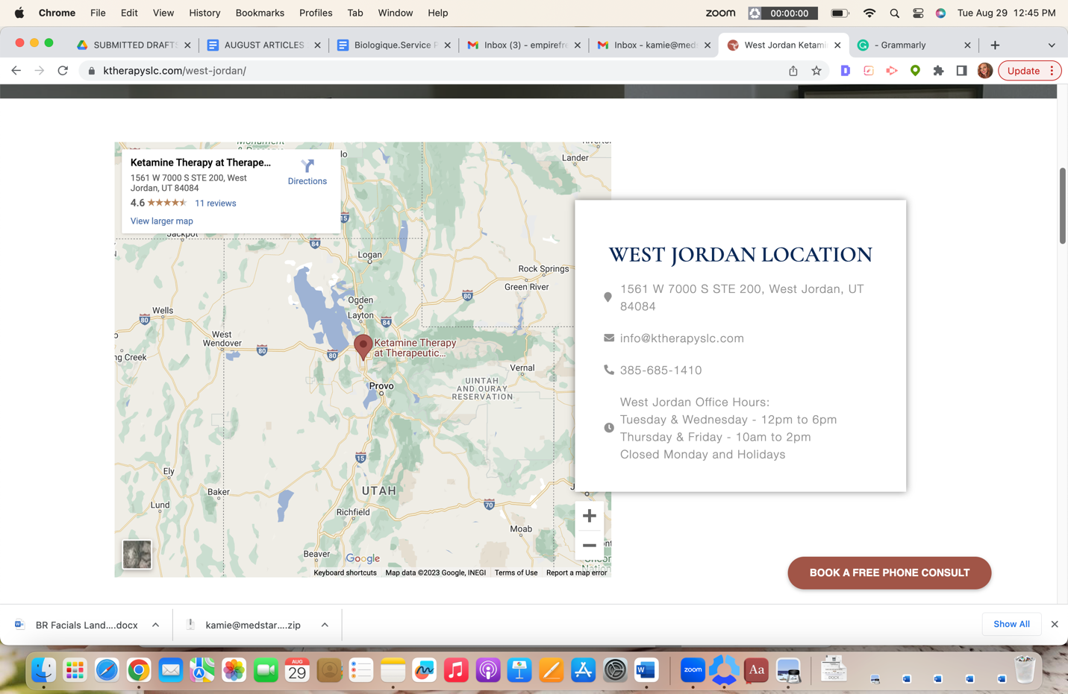

H2 Colorado Springs Med Spa Location

9205 N Union Blvd Suite 150, Colorado Springs, CO 80920
719-387-7150

H2 Services at this Colorado Springs Location (please link all services to the corresponding service pages)

Example: 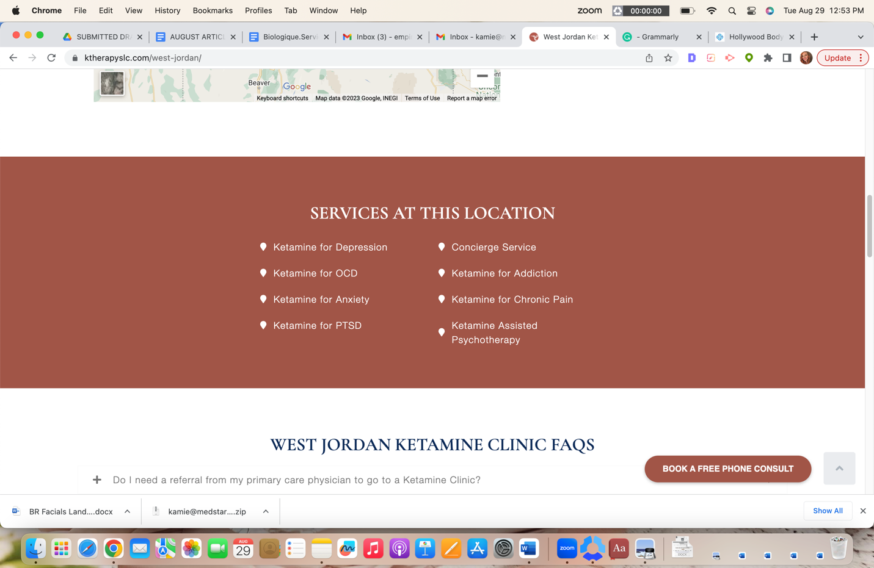

- CoolSculpting
- CoolTone
- Cellulite Reduction
- Zerona
- VelaShape
- Skin Tag Removal
- Weight Loss Injections
- Botox
- Dermal Fillers
- Lip Fillers
- Chemical Peels
- Co2 Laser Treatment
- IPL Photofacial
- Dermaplaning
- Hydrafacial
- Kybella
- Microdermabrasion
- Microneedling
- Non-surgical Facelift
- PDO Threads
- Jeuveau
- Skin Rejuvenation
- Sublative Rejuvenation
- Ultherapy

H2 Med Spa Colorado Springs FAQs

H3 What is the difference between a Colorado Springs day spa and a medical spa?

Most day spas in Colorado Springs focus more on massages, facials, pedicures, and manicures. A Medical Spa like Hollywood Body Laser is a facility where you get all the pampering under the supervision of our medical director and treatment experts capable of administering more medical-based services like fat-reduction, cellulite-reduction, lip fillers, facial fillers, Botox, and more.

H3 Is visiting a Colorado Springs med spa good for your health?

While most of our services focus on the outer appearance, some help improve your health. For example, CoolSculpting and CoolTone are both popular body contouring treatments that help rid your body of excess fat buildup, tighten your skin, and improve muscle tone. In return, you are physically more fit and, in a sense, healthier. Other services like Hydrafacial help improve your skin’s cellular health, providing healthy skin and an improved complexion. So, yes, some med spa services do help improve your health.

H3 Who should not use a med spa?

While typically anyone can receive services from a med spa, we advise women who are pregnant or nursing or anyone with heart disease and other severe health complications to steer clear of services like CoolSculpting, CoolTone, Velashape, etc. If you’re concerned about your health and whether or not you can receive treatment from our Colorado Springs med spa, contact our facility to speak with an expert.

H3 I want to go to a Colorado Springs Medspa, but how do I choose the best one?

The options can be overwhelming when selecting the best medical spa in Colorado Springs. However, there are simple guidelines to follow that will help you make the best choice:

Location and Offices: The best med spas in Colorado Springs offer multiple locations and access to a wide variety of medical spa services and licensed professionals. In addition, they should also provide the newest technology and latest aesthetic services.

Who: For the best results, the on-site supervising physician should be board-certified in cosmetic surgery, dermatology, or plastic surgery. In addition, your esthetician and the licensed professional performing the treatments should be experienced and have the proper qualifications to administer treatments.

H3 Do Colorado Springs medspas accept insurance as payment?

Most medical spas do not accept insurance as payment, as our services are primarily elective cosmetic treatments. If you want to learn more about our Colorado Springs med spa payment plans, speak with one of our knowledgeable specialists today.

*ADD TESTIMONIALS SECTION*

