STIMULATE. HAIR PAGE.ILEA.MZ
/hair loss treatment
KW: hair loss treatment
META: Hair loss treatments include RX medications like Propecia, the Capillus cap (a laser cap for hair growth), LOCKrx hair loss vitamins, and other natural hair growth treatments.
HAIR LOSS TREATMENTS | STIMULATE HAIR GROWTH
ILEA Hair Restoration offers several options to stimulate hair growth for men and women suffering from hair loss or hair thinning. If a hair transplant isn’t right for you, there are less invasive options scientifically proven to stop hair loss and stimulate hair growth and hair thickening. Read on to learn which natural hair growth treatment is right for you.
PRESCRIPTION HAIR LOSS MEDICATIONS
At ILEA Hair Restoration, Cesar Aristeiguieta, MD, offers curated medication regimes to halt hair loss and stimulate hair growth.
LOCKRX HAIR LOSS SYSTEM

LOCKrx provides a drug-free solution for balding or thinning hair. The revolutionary hair restoration system utilizes proven hair loss vitamins and supplements to stimulate natural hair growth.

The Healthy Inside System is specially formulated to address the nutritional factors that influence hair health. The system consists of oral supplements containing hair loss vitamins and hair loss supplements.

The Healthy Inside System stops hair loss and stimulates hair growth by:

- Defending against hair loss by reducing inflammation and improving nutrient absorption by boosting the immune system and balancing the microbiome.
- Blocking the factors that damage hair follicles.
- Guarding against hair loss by enhancing vitamins and other nutrients that support hair health.

The LOCKrx Healthy Outside Program reinforces hair growth by promoting healthy follicle cycles. The formula consists of purified growth factors of human origin. The growth factors are delivered to areas of the scalp suffering from hair loss or hair thinning via microchannels.

CapillusPro laser cap
[ get a picture of the cap here https://www.capillus.com/products/capillus-pro]

The Capillus cap is a laser cap for hair growth that is worn for six minutes each day. The FDA-cleared treatment is scientifically proven to prevent hair loss caused by male and female pattern balding (androgenic alopecia) and regrow thinning hair. The laser cap emits low-level light therapy (LLLT) to stimulate cellular regeneration within hair follicles. Scientific studies show that the laser cap for hair growth prevents hair loss and stimulates hair growth by:
Increase vascularization in the scalp for thicker, stronger, more flexible hair shafts
Stimulates the scalp’s natural oils (sebaceous glands) for silkier looking hair
Increases hair pigment (melanin) within hair follicles to darken graying hairs
According to clinical studies: “LLLT showed a significant effect on increasing hair density in patients with androgenetic alopecia. LLLT could be a safe and effective treatment for androgenetic alopecia in both sexes.”
Capillus Cap Before and After*
[find BAs here
https://www.capillus.com/pages/before-and-after ]
Low-level laser therapy is an effective treatment for stimulating hair growth. This is shown in Capillus cap before and after images. Like every cosmetic treatment, results may vary.*

THE SEPHYL PRFM SYSTEM

Growth factors found in blood have been used in numerous medical applications for decades. When utilized in hair restoration, these growth factors fortify existing hair follicles and revitalize your scalp to increase growth, hair density, hair count, and hair thickness.
This hair loss treatment is ideal for patients suffering from hair loss or hair thinning but are not ideal candidates for a hair transplant. The Sephyl PRFM rejuvenates hair growth naturally. It is ideal for patients wanting hair restoration without the surgery associated with a hair transplant.

Hair Loss Treatment Before and After
Before and after pictures of patients undergoing SEPHYL treatments demonstrate the amazing natural hair restoration that is possible with this hair loss solution. As with any cosmetic treatment, results may vary.*
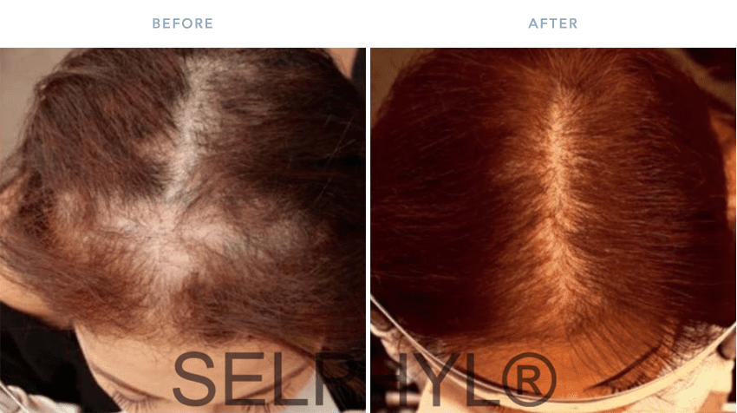
SOURCES:
Almohanna, Hind M et al. “The Role of Vitamins and Minerals in Hair Loss: A Review.” Dermatology and therapy vol. 9,1 (2019): 51-70. LINK.
”Efficacy of platelet-rich plasma in treatment of androgenic alopecia.” Asian journal of transfusion science. 2015. LINK.
Hamblin, Michael. MECHANISMS OF LOW LEVEL LIGHT THERAPY. Department of Dermatology, Harvard Medical School, BAR 414. Wellman Center for Photomedicine. LINK.
Jin, Huan et al. “Photobiomodulation therapy for hair regeneration: A synergetic activation of β-CATENIN in hair follicle stem cells by ROS and paracrine WNTs.” Stem cell reports vol. 16,6 (2021): 1568-1583. LINK.
“Platelet-Rich Plasma in Androgenic Alopecia.” Journal of cutaneous and aesthetic surgery. 2014. LINK.
Yoon, Jung Soo et al. “Low-level light therapy using a helmet-type device for the treatment of androgenetic alopecia: A 16-week, multicenter, randomized, double-blind, sham device-controlled trial.” Medicine vol. 99,29 (2020): LINK.

