
The font color is very light. I don’t like when there is just one word on a line like price.
Can you line up the prices then total and show the discounting.
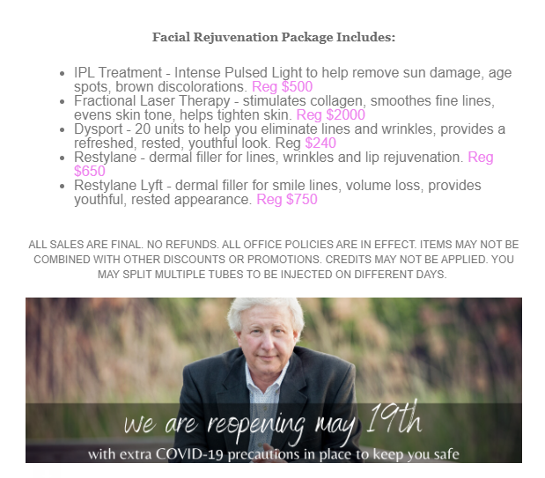
When I send a test this is what I see. It seems as if this is the whole ad. There is no information about the special. Nothing that says scroll down for more info
I would like my logo larger

