(below hero images)
LEARN MORE

What is ketamine infusion?
Ketamine infusion is an alternative therapeutic treatment for mental disorders resistant to traditional therapy and pharmaceutical prescriptions. Ketamine has demonstrated effective, promising results when treating depression, anxiety, PTSD, drug and alcohol addiction, and chronic pain. Ketamine targets the causes of mental illness, instead of only dulling the symptoms. It enables the mind to heal itself by rewiring malfunctioning neurons and creating new neural pathways in the brain.

(3 boxes under picture grid)

COST
We are committed to making affordable Ketamine therapy available to the Salt Lake City area and will create an effective treatment plan for any budget.

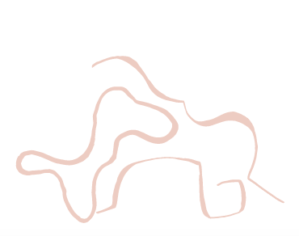

TREATMENT

Schedule your consultation today to meet with one of our therapists who will create a treatment plan that will begin your journey back to wellness.
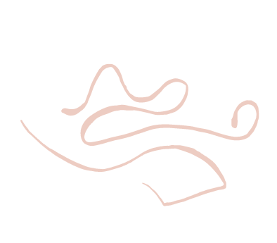

LOCATION
Therapeutic Alternatives’ Ketamine clinic resides within the beautiful healing space of the Theory & Method therapy center.

((blurb in the box with office location photo))

An Environment Designed for Healing
We are committed to creating a safe, comfortable setting where mind & body healing can happen. With this goal in mind, we have designed our private treatment rooms to foster an inviting home-like environment of peace and relaxation.
(lorem ipsum over the word “Contact”)

Make an Appointment
((Also make sure you change “Please tell us what areas you’d like to target…” to say “Comments”))
(lorem Ipsum over the word “Team” and below)

Meet Our Providers
Our partner Ketamine Infusion providers are both mental health experts and experienced medical providers.

(bio for Austin “Co-Owner”)

Austin
Austin is a board-certified Family Nurse Practitioner with additional degrees in Psychology and Sociology. He has been practicing in the Salt Lake Valley in primary care since 2013.

Hero Image 1:
Heading: Ketamine Therapy
Sub-Heading: Target the cause of depression, anxiety, trauma, and addiction.

Hero Image 2: Safe, effective ketamine treatments in a comfortable, relaxed setting

Hero Image 3: Therapeutic treatments that heal the mind instead of dulling symptoms

Box Blurbs-

Anxiety
Anxiety is the most common mental disorder in the United States, affecting 18% of adults. For patients with symptoms that have not responded well to medications or behavioral therapies, Ketamine is an ideal treatment.

Addiction
Ketamine helps to lessen the effects of post-acute withdrawal symptoms and aids in the detoxification process. It also assists patients to control their cravings, maintaining their sobriety from stimulants.

PTSD
Ketamine treatments offer a rapid reduction of PTSD symptoms for patients struggling with this disorder. Ketamine repairs the loss of synaptic connectivity caused by the stress experienced in PTSD, leading to long-term relief.

Chronic Pain
Ketamine enables the brain to repair neural pathways and malfunctions neurons, reducing signals responsible for inflammation. Inflammation is the leading cause of symptoms in chronic pain conditions.

Depression
Ketamine targets the physiological cause of depression by enabling the mind to heal itself. Unlike traditional anti-depressants that only numb the symptoms of depression, Ketamine creates new neural pathways.

OCD
Ketamine is one of the most innovative new treatments for Obsessive-Compulsive Disorder. Many patients have reported a loss of compulsion after just one session, with an improvement of symptoms lasting several weeks after treatment.

