West Jordan Location Page.Ketamine Therapy LA.KA

/west-jordan

Meta Title: West Jordan Ketamine Clinic | Ketamine Infusions UT

Meta Description: Ketamine Therapy at Therapeutic Alternative has a West Jordan Ketamine Clinic to better serve our Utah clients. Learn more about services here.

H1 west jordan ketamine clinic
Ketamine Therapy at Therapeutic Alternatives is proud to offer breakthrough Ketamine treatments at our West Jordan Ketamine clinic. Ketamine therapy is a safe, effective alternative treatment for mental illnesses, including depression, anxiety, PTSD, drug and alcohol addiction, and chronic pain.

This form of treatment enables the mind to essentially heal itself by rewiring malfunctioning neurons. Ketamine infusions help create new neural pathways in the brain so you can finally find the relief you deserve to live a life free of depression, anxiety, and other mental struggles.

*PLEASE MIMIC THE SAME SETUP WE DO FOR HEALTH FIRST AS SEEN BELOW*

INSERT A PICTURE OF THE WEST JORDAN LOCATION AND/OR STAFF

WEST JORDAN LOCATION

1561 W 7000 S STE 200,
West Jordan, UT 84084

info@ktherapyslc.com

385-685-1410

West Jordan Office Hours:
Tuesday & Wednesday - 12pm to 6pm
Thursday & Friday - 10am to 2pm
Closed Monday and Holidays

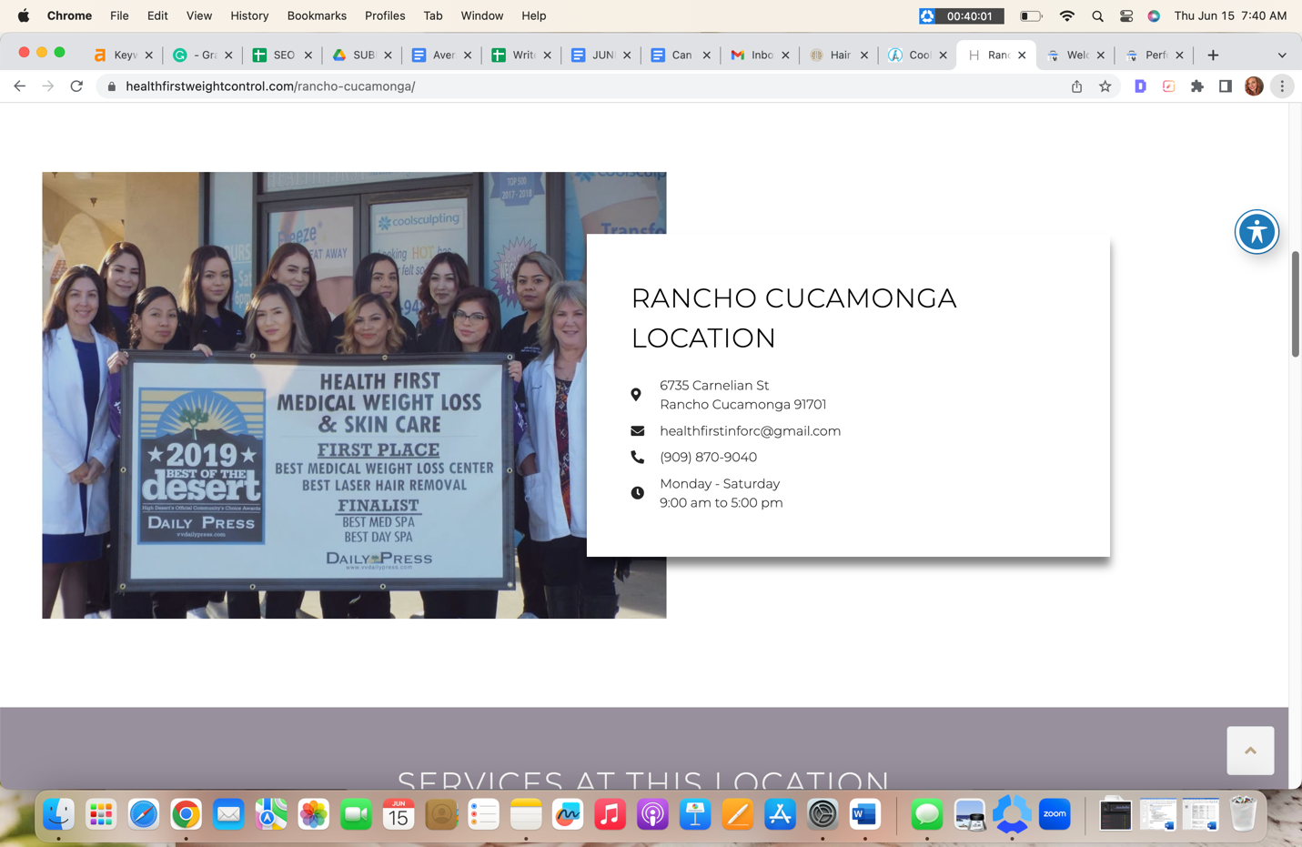

*PLEASE MIMIC THE SAME WAY WE LAID OUR TREATMENT SERVICES AT THIS LOCATION FOR HEALTH FIRST AS SEEN BELOW*

SERVICES AT THIS LOCATION

Ketamine for Depression
Ketamine for OCD
Ketamine for Anxiety
Ketamine for PTSD
Concierge Service
Ketamine for Addiction
Ketamine for Chronic Pain
Ketamine Assisted Psychotherapy

*PLEASE DIVIDE SERVICES SIDE BY SIDE AND LINK TO THEIR SERVICE PAGES*
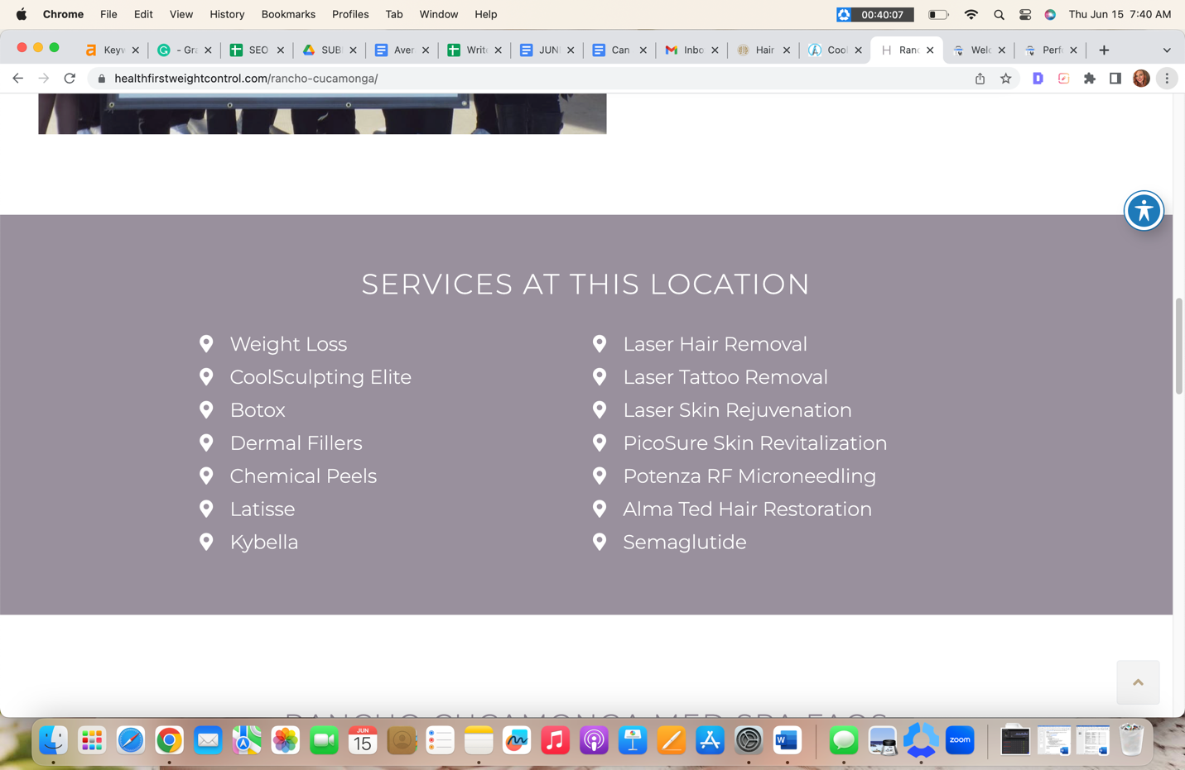
H2 WEST JORDAN KETAMINE CLINIC FAQs

H3 Do I need a referral from my primary care physician to go to a Ketamine Clinic?

No. You may receive care from a Ketamine clinic with a referral from any licensed mental health care professional or physician.

H3 Are there any specific medical conditions that would prevent me from receiving treatment?

Ketamine therapy is not for people who are diagnosed with psychosis. If you have high blood pressure, cardiac, and/or pulmonary issues, you may require thorough medical clearance from your primary care doctor before you can begin Ketamine infusions.

H3 Will I be treated as an outpatient?

Yes. Ketamine infusions in our Ketamine Clinic are outpatient procedures requiring no hospital stay or care.

H3 What can I expect during my visit to the West Jordan Ketamine Clinic?

When you visit Ketamine Therapy at Therapeutic Alternatives’ West Jordan Ketamine clinic, you can expect to receive exceptional care from our licensed, professional staff. We are dedicated to providing outstanding care for all of our clients. We know the value Ketamine infusions have on your quality of life, which is why we do our bests to ensure your safety and satisfaction during each therapy session.

H3 Does insurance cover my Ketamine clinic appointment?

Since Ketamine therapy is primarily used to improve mental health struggles, including depression, anxiety, OCD, etc., it is still viewed as experimental. This means insurance companies do not cover this form of medical treatment.

*ADD TESTIMONIALS*

*ADD CONTACT FORM*

