Changes to the FAQ Service Page for Ketamine Therapy LA

What is Ketamine Therapy?
Ketamine is a synthetic drug. In 1970 it gained FDA approval for use as a sedative. Now, after 20 years of research, scientists see the potential benefits Ketamine has on treating mental illnesses and certain physical ailments like Fibromyalgia and chronic pain.
What is a ketamine infusion?
Ketamine infusions works differently from traditional medicines. Traditional medicine requires regular intake to have any lasting effects on the body. In some instances, they have no affects at all. Ketamine infusions work faster and more efficiently.
What Does Ketamine Treat?
Ketamine improves a variety of different mental and physical conditions. Some of the conditions include:
- Anxiety Disorder
- Depression
- OCD or Obsessive Compulsive Disorder
- PTSD or Post-Traumatic Stress Disorder
- Chronic pain
- Bipolar disorder
- Addiction
- Suicidal Ideation
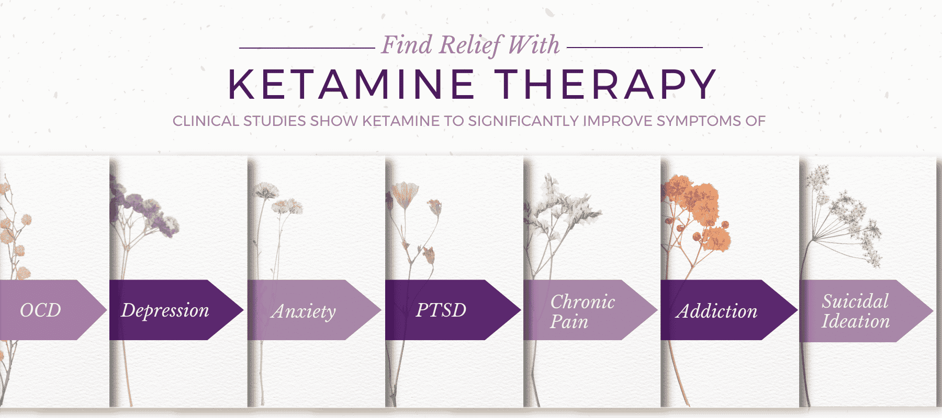
Learn about Ketamine for Anxiety>>
What are the benefits of ketamine?
- Relieves symptoms of depression
- Near instant results
- Targets psychological causes of depression
- Rewires the brain
- Reduce fatigue, feelings of sadness, and anxiety
- Improve overall mental wellness
How Long Do Ketamine Treatment Effects Last?*
The effects of a Ketamine treatment typically last for up to two weeks. After six treatments, some people can remain symptom-free for several months. As with any medical treatment, individual experiences will vary.* It is important to speak with a doctor about your expectations to develop a suitable treatment plan yielding optimal results.
How Many Ketamine Treatments Do I Need?
Most patients are prescribed a total of six infusions completed within a 3-week period. The 3-week window is to maximize the effects of the drug.
HOW MUCH DOES KETAMINE THERAPY COST?
The cost of Ketamine treatment varies per person. The price you pay depends on the unique parameters of your treatment plan, including the number of treatments needed for optimal results. If you want to learn more about Ketamine prices, contact Ketamine Therapy LA for a consultation to learn more about the specific details regarding Ketamine cost.
What does ketamine infusion feel like?
Ketamine is administered intravenously over a 45-minute treatment. You may not see any noticeable effects at the beginning of the infusion. However, as the infusion progresses, you may feel a “floating” or “weightless” sensation. In addition, patients experience a dissociative state but remain entirely conscious and able to speak. You are monitored closely for the duration of treatment. Finally, 15 minutes before the treatment is over, you regain your senses and thinking returns to normal.
What are the Ketamine treatment side effects?
The most common and frequent side effects of ketamine infusions are nausea and fatigue.
How does ketamine work in the brain?
Ketamine works by binding to specific receptors in the brain. This action promotes regrowth and connections between brain cells that help regulate a person’s mood. More prolonged Ketamine infusions show promise for “resetting” nerves and decreasing neuropathic pain for people struggling with chronic pain.
Learn about Ketamine Infusions in Los Angeles>>
How Does Ketamine Compare to SSRIs?
Traditional SSRIs like Prozac or Zoloft take weeks, sometimes months, to affect the brain and body. Occasionally, patients become resistant to the medication and see no valuable benefits. Ketamine is unlike SSRIs in that it provides instantaneous results. Ketamine is given through an IV port and delivered directly into the bloodstream, where it begins to work on the brain and body immediately.
Is ketamine legal?
Ketamine therapy is FDA-approved for use in the US as an anesthetic during surgical procedures. It is not approved for treating psychiatric conditions. Its use as a treatment for mental wellness is “off label.” This does not mean it is experimental, ineffective, or illegal.
Where Can I Receive Ketamine Infusions?
Ketamine treatment in Los Angeles is becoming an increasingly popular treatment in the mental health industry. It is important to select a reputable and skilled provider to administer this drug. Patients living in Los Angeles and West Hollywood select Ketamine Therapy LA for their Ketamine in Los Angeles.
At Ketamine Therapy LA, infusions are performed by Dr. Sirak, who has been administering this drug as an anesthesiologist since 2008. Dr. Sirak believes that “Ketamine treatment with therapeutic intention can have a profound healing experience” for his patients.
To learn more about Ketamine and discover if this revolutionary drug is right for your body and health concerns, contact Ketamine Therapy LA today for a consultation. Call us at (323) 650-9883 to schedule yours now.

