Hello KP Aesthetics Team,

How are you?

We wanted to give you an update on the progress of your SEO campaign. Our team implemented numerous initiatives to improve your SEO ranking. We’ve also added your site to several SEO Marketing sites. We used their tools and ours - combined with our expertise - to review, audit, manage & boost your online presence and SEO score. We have outlined your improvement & progress in more detail below.

It would be easiest for us to jump on a call and discuss how to look at these reports, but we provide some content below.

In order to improve your rankings on our end, we focus on creating relevant content, building links, improving your onsite SEO and updating and adding your business to local directories.

Content Creation & Blog Posts September
https://www.kpaesthetics.com/the-best-coolsculpting-newtown-square/
https://www.kpaesthetics.com/does-coolsculpting-last/

Content Creation & Blog Posts August
https://www.kpaesthetics.com/body-contouring-near-me/
https://www.kpaesthetics.com/does-coolsculpting-hurt/

Content Creation & Blog Posts Views, Clicks – From 01/20/21 to 10/12/21 *
https://www.kpaesthetics.com/ | (clicks) 7,086 | (Impressions) 173,547
https://www.kpaesthetics.com/lip-filler/ | 562 | 111,296
https://www.kpaesthetics.com/coolsculpting/ | 194 | 164,800
https://www.kpaesthetics.com/coolsculpting-risk/ | 186 | 67,668
https://www.kpaesthetics.com/iv-therapy/ | 172 | 35,079
https://www.kpaesthetics.com/coolsculpting-thighs/ | 170 | 104,902

Top Queries – From 01/20/21 to 10/12/21 *
KP Aesthetics
Hydrafacial near me
KP esthetics
Laser Hair removal near me
Lip Fillers near me
Lip Flip near me
Lip Injections near me

* See full stats on attached Excel sheet report.

Online link building
Press releases we published for you were picked up by 100+ outlets. Although Google doesn't count these links multiple times, it still benefits you. We also had some bloggers with sites with a decent domain authority link to your CoolSculpting page.

Your Onsite SEO Score
You are currently scored at 99 out of a 100 which is excellent. We made many adjustments to your site, pages & other properties to help you obtain this score. The report is attached.

* See full stats on attached PDF report.

Reputation Management:
- Average Star rating: 4.42
- Number of Reviews: 241

Your Citation Tracker, Builder reports (Bright Local)
Your site is added to over 25 of the most popular and powerful directories on the web. Automated distribution to local data aggregators. This helps boost your local rankings. Some of these are:
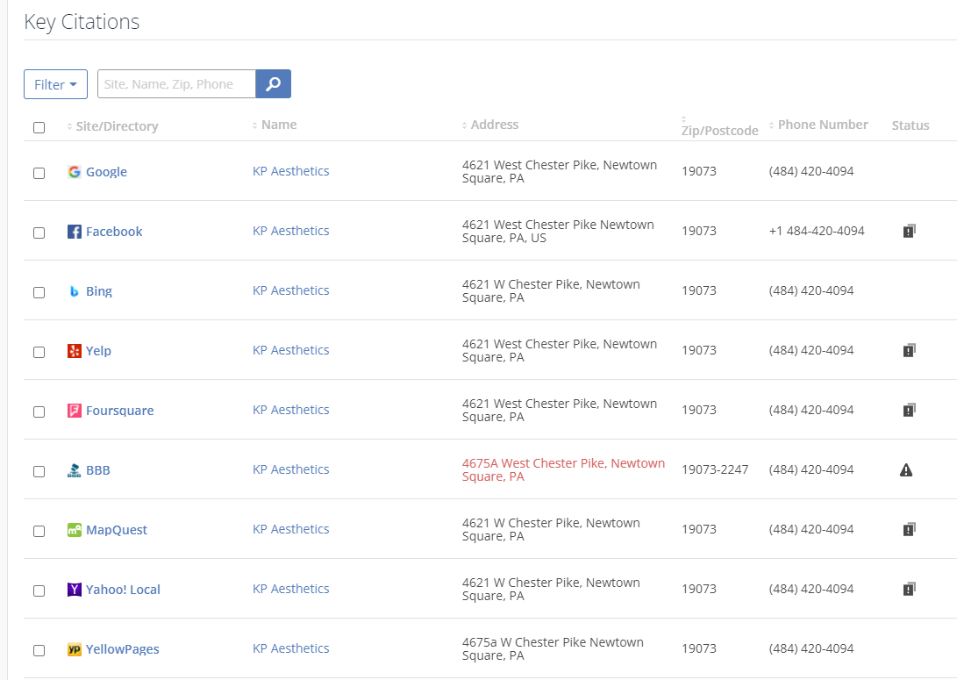

Your Keyword ranking reports (Bright Local)
Your current keyword report shows your ranking positions as well as the rankings table. You can see which pages and keywords you are presently ranking in first place for.
Keyword: Hydrafacial – Rank - #A
Keyword: Vivace Newtown Square, PA – Rank – 1
Keyword: Hydrafacial Near Me – Rank – Organic – A, #1
Keyword: Hydrafacial Newtown Square – Rank - – A, #1
Keyword: Cool sculpt Newtown Square, PA – Rank - – A, #1
Keyword: Laser Hair Removal Newtown Square – Rank – – A, #2
Keyword: Coolsculpting Near Me – Rank – Organic – B, #6

* See full stats on attached PDF report.

Please let us know if you have any questions about your SEO report.

