MDx Wellness Clinic website and mobile phone ready website changes - 09/07/21 - please reference https://sonaskin.com/ for some format and layout changes for the website - Derek Duke Noble
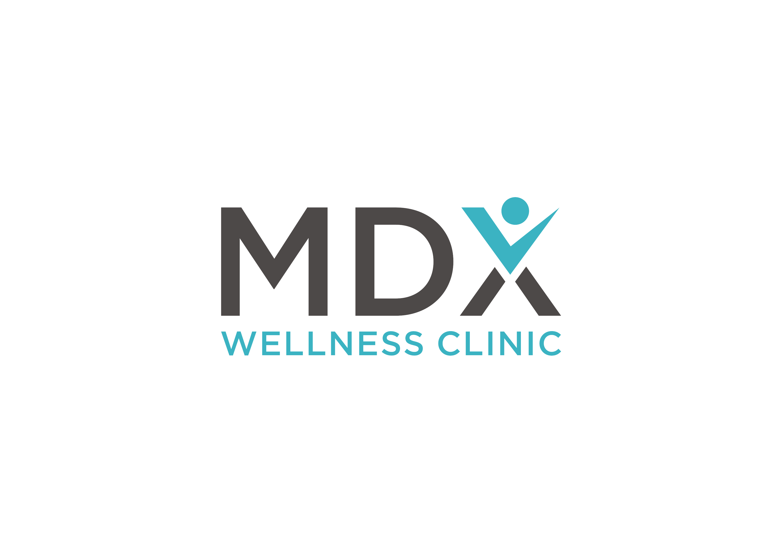
- Link to the url: www.mdxwellness.com link in medigenixx.com to site and link to www.mdxmd.com - we need to save www.mdxwellnessclinic.com
- Color palate for the site - White and our Teal Blue color with Black - see our MD logo - use lower case type face with no periods after service text.

3. Add new Mdx wellness clinic logo to top left side on home page
4. Change landing home page purple banner color to our branded blue teal color
5. Add our Mission Statement to - use the image with Photo with Face and graphic lines at bottom of home page at: www.mdxwellness.com - Combining - Latest Scientific Advances to Improve your Health, Beauty and
Well-Being
Add this Mission to Site - MDx wellness system philosophy - find a photo of man and woman looking and feeling healthy and well.
The human body is made up of trillions of cells. Holistic wellness is a state in which our cells act in harmony. It includes intricate protective systems such as hormonal, the immune system, nervous system and mind-body connections. These systems are inter-connected and work in concert.

Disease occurs when certain environmental toxins, micro-organisms, stress, injury or the aging process cause these these protective mechanisms to break down and lead to imbalances.

Most of the time you go to the doctor and the doctor makes a diagnosis and gives you a prescription. It may help but not for long. You end up going from doctor to doctor without relief. The ordinary treatment is just a “bandaid” and just covers up the actual cause. There is a better choice.

MDX wellness system was developed because it was recognized that treatment modalities that address Wellness at the cellular level help correct imbalances and enhance your bodies ability to heal itself giving better outcomes.

The first step in the MDX wellness system includes a complete history and physical exam and an analysis of your blood to find out the levels of toxins, hormones and other factors that may affect your health.

The second step in the MDX system is a customized program that addresses the results of the tests by prescribing vitamin supplements, bio identical hormones, and IV infusions to detox your system and enhance your immunity.

The MDX wellness Pain Management System uses specialized treatments for pain in the knee, the neck, back and other painful conditions such as Migraine headaches. Often a combination of therapies work more effectively when administered in sequence.

Once you are on your way to medical wellness, MDX Aesthetics can address how you can look and feel your best. Whether it’s the latest skin care, wrinkle removal or facial rejuvenation or body contouring and skin tightening our specialty trained physicians can advise you how to meet your personal transformation goals.

At MDX wellness we use customized medical treatments to meet your needs and get you results.

5 a. Add a Contact Us - in Message box have box with drop down menu item of treatment services - bio- identical hormone therapy pain management, ozone treatment and iv therapy, with p-shots, o-shot & p-shot enhancement, osteoarthritis, hair loss in men and woman, facial rejuvenation
6. Remove from page - coupon - Save 20% on Pre paid 5 treatment Package - there is no coupon to be printed? Let’s discuss the 5 treatment package
7. Change Reach out ….. ADD new content from Mdx wellness
philosophy - Move up box with Combining the latest scientific advances to improve your health and well-being……

8. Create new website menu list-
Home, Services, Meet our Doctors, add
Your Visit - will add this info - patient information - arrival time, patient forms, financing options, Billing Questions & Payment
Blog - Dr Singer will send you link later
Contact Us - Same as original but Saturday add - By Appointment Only
Use MDX LOGO - ADD Icons at bottom for Instagram, Facebook, Twitter, You Tube - we will send you links
9. Keep similar icon boxes but change order - Bio-Identical Hormone Therapy, Pain Management, Non-Surgical Facial Rejuventation, Non Surgical Hair Restoration, add new Icons for O-shots & P-shots, Weight Management
10. Add Featured Treatments Content with Photo’s - Use high Rez vibrant engaging photo’s and description of 4 top services with great photo images - Add Bio Identical Hormonal Therapy, Pain Management, Ozone Treatments & IV Therapy , O-shot & P-shot
11. Remove before and after images at bottom of the page - add to service menu - find better before and after photos for all of services
12. Remove face massage and add a PRP photo
13. - Clean up google location map and opening hours - find a better font to use and opening hours with tel: 833 777 7375
14. Add links to Instagram, Facebook, Twitter, Linked IN, You Tube links - add icons symbol
15. Improve sitemap make more modern— add career link - email us your resume and cover letter - have email - info@mdxwellness.com
16. Contact us - First - Last Name, Email and Telephone - Reason for Consultation list - add drop down box with list of treatments they can choose from our service menu
17. Meet our team of doctors - we will send updated doctor photand we will add video of doctors talking about their specialities at later date.
17 a, Add link under meet the doctors to meet Derek Duke Noble our General Manager & Medical Aesthetic Wellness Expert - Derek will send his bio and photo
18. Contact US - please complete the form below and we will contact you to schedule your medical appointment or cosmetic consultation. Call Us directly at: 833 777 7375

CAN YOU ADD OUR LEAD GENERATION FROM OUR WEBSITE INTO GO HIGH LEVEL - DO YOU HAVE AN ACCOUNT?

Copy needs to be added to the sections of our website: - change it over to this copy.

1. Bio Identical Hormone Therapy - Change photo - sub categories for Weight Management and Age Management - we will send you content and add some pics

2. Pain Management

3. Ozone Treatment & IV Therapy

4. Medical Aesthetic & Facial Rejuvenation

5. O-Shot & P-Shots

6. Osteoarthritis - Our specialty trained physicians provide advanced pain relief and customized therapeutic treatments for our OA patients

WEBSITE PAGES UPDATES 1 THRU 6

- Use same content for BIO IDENTICAL HORMONAL THERAPY - Change photo to:

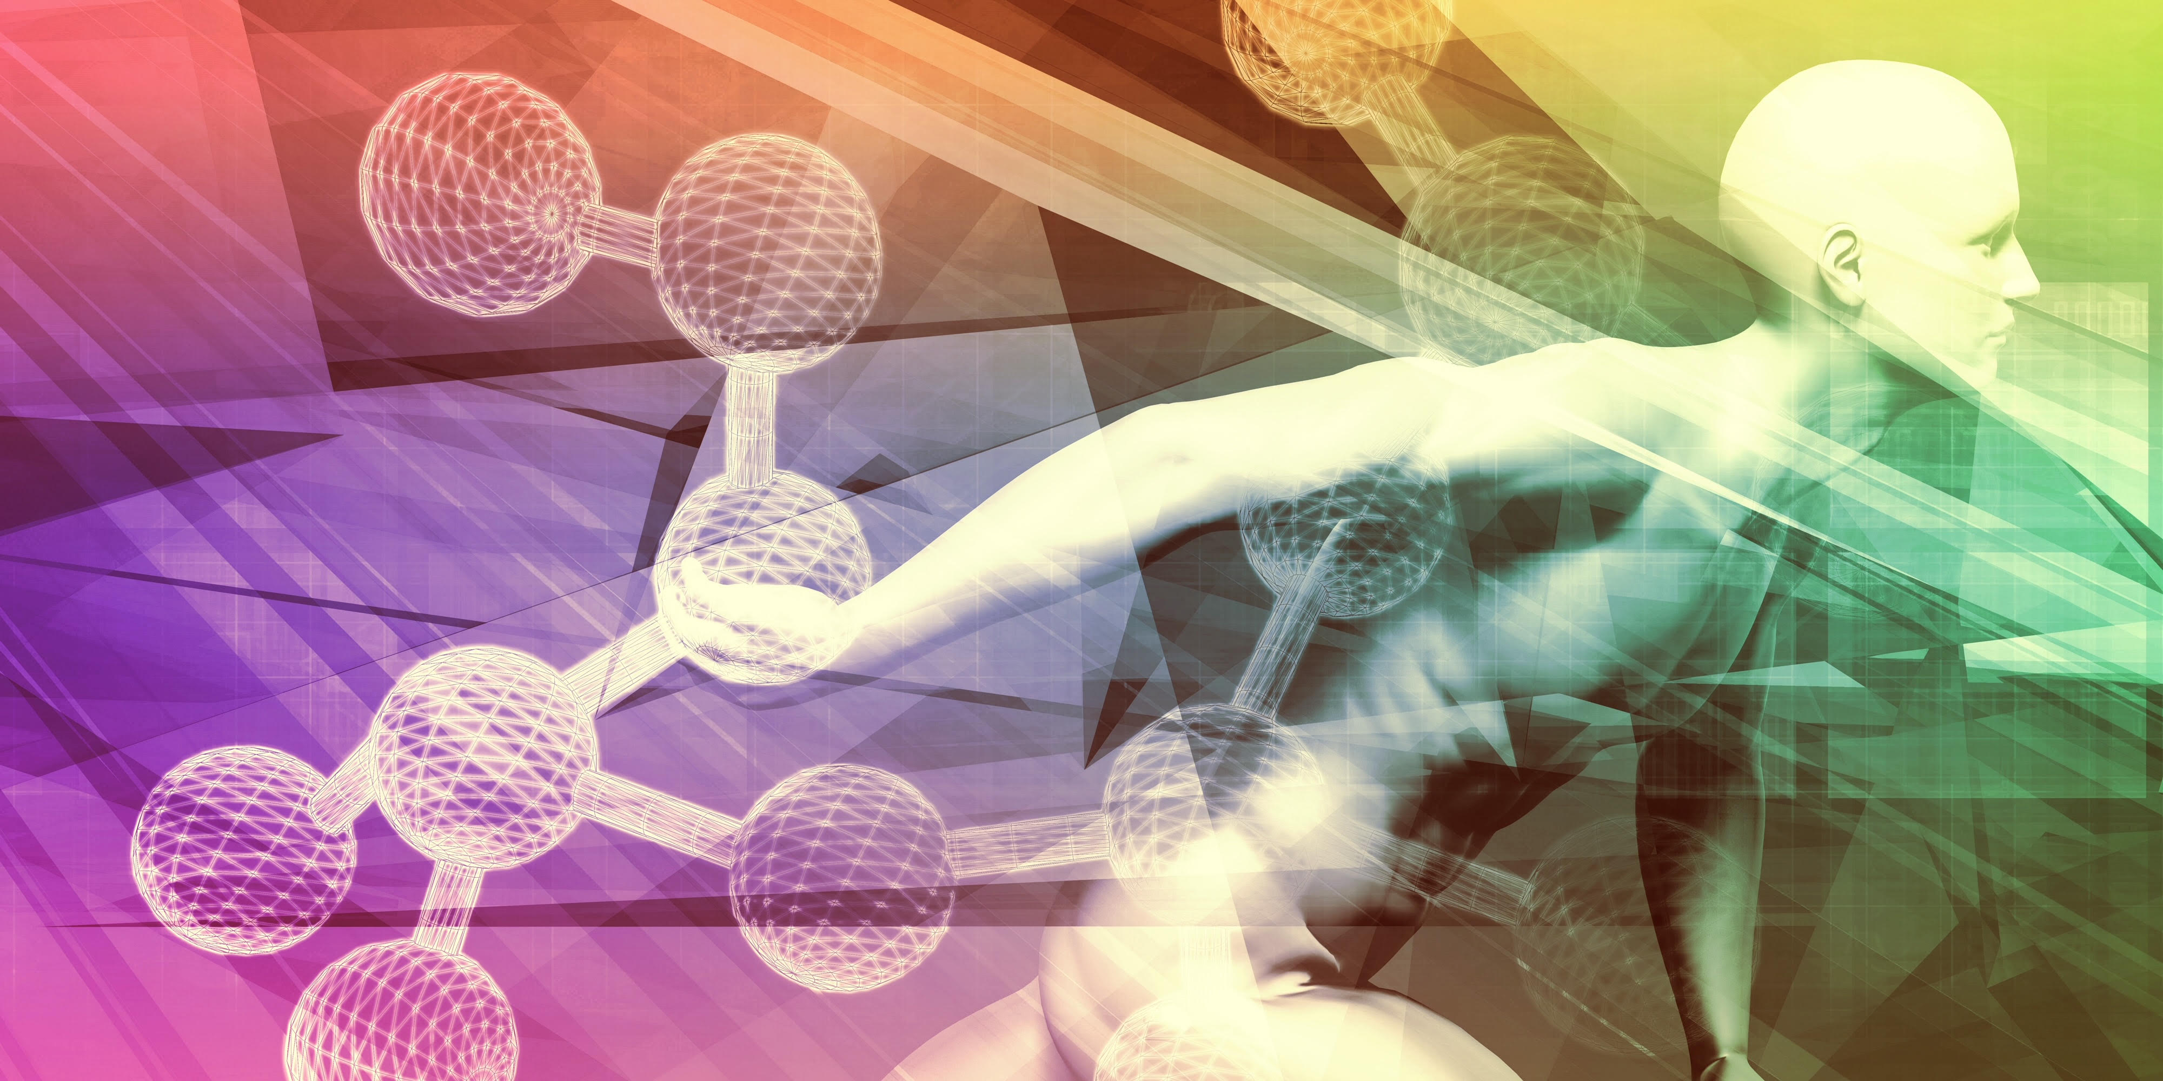

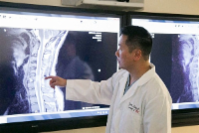

The MDX Wellness Pain Management System uses specialized medical treatments for back, knee, and neck pain as well as other painful conditions such as Migraine headaches. - you many want to find another high Rez photo.

Often a combination of medical therapies work more effectively when administered in sequence. At MDX wellness clinic we use customized treatments that heal and get you results - SEE PAIN CONTENT BELOW
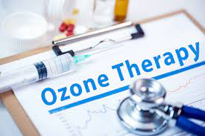
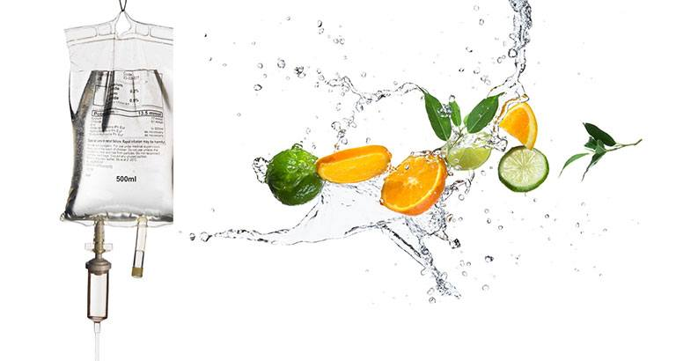

Ozone Treatment & IV Therapy - add content from Dr. Park Ave website -
https://www.parkaveregen.com/medical-ozone-therapy - use images like these
Medical Aesthetics & Facial Rejuvenation - Add photo’s
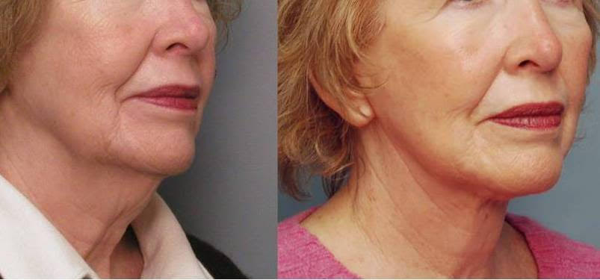

- see content at parkaveregen site.

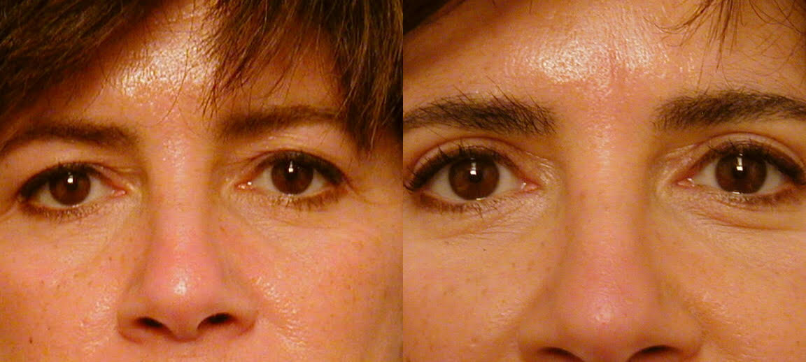
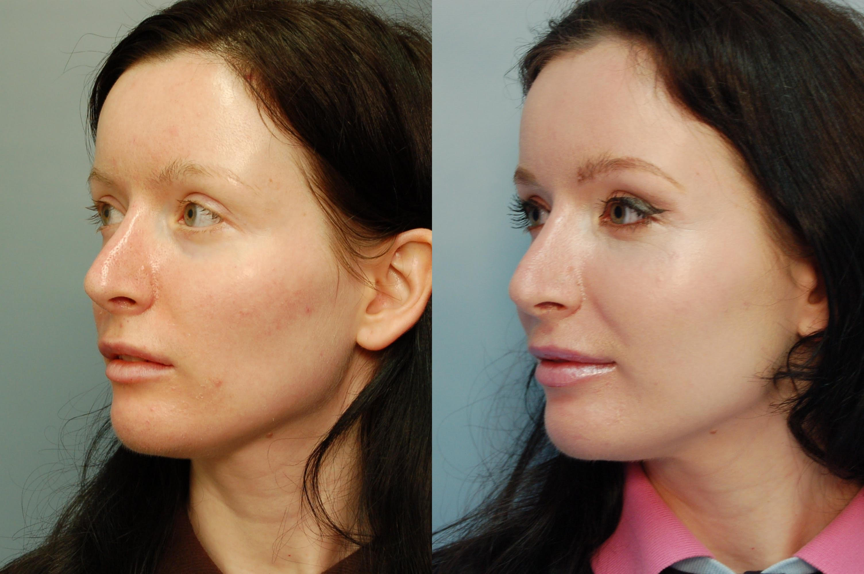


O-Shots & P-Shots - we like photo’s like this or find high rez couple photo

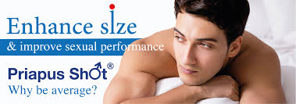
P-Shot

As we age sexual function decreases in both men and woman. We now have a sexual treatment program that reverses the aging process and improves performance. It’s called the O-Shot Injection on women and P-Shot Injection in men, and we have it here in New York City!.O-Spot and P-Spot enhancement is now available in New York City. With painless, non-surgical injections that require little or no recovery time, you could have a significantly improved sex life. The benefits of this treatment include increased natural lubrication, heightened sensation, and more frequent, intense orgasms.
O-SHOT ENHANCEMENT FOR WOMEN
A woman’s O-Shot is in the front of the vagina, about 2 inches in, and is known as the main area in the vagina in which orgasms are produced and stimulated. The O-Shot plays an essential role in sexual arousal. As a major erogenous zone, it plays a significant role in female sexual satisfaction. Enhancement of the O-Shot could result in greater sexual satisfaction for patients in New York.
During the O-Shot Enhancement procedure, filler or transfer of fat may be injected into your O-shot, creating more fullness. In addition, healing factors are also injected into the same area.
Vaginal areas that receive injections have increased blood flow, improved vascularization, and new healthy tissue growth. Though these enhancements may not permanent, repetition of this procedure could help maintain its benefits over long periods of time. With few downsides and several cosmetic and sensation benefits, this treatment could be the solution getting more out of your sex life.

P-SHOT ENHANCEMENT FOR MEN
In men there are similar arousal zones in the penis and in the prostate areas. These P-shots can also be enhanced by means of specialized injections of healing factors. P-shots play an essential role in sexual arousal as major erogenous zones in men.. Enhancement of the P-Shot could result in greater sexual satisfaction for patients in New York.
During the P-shot enhancement procedure, filler or transfer of fat is injected into the penis, and prostate areas creating more fullness. In addition, healing factors are also injected into the same area.
The P-Shot injection promotes cell restoration in the injection sites. Penile areas that receive injections have increased blood flow, improved vascularization, and new healthy tissue growth. Though these enhancements may not permanent, repetition of this procedure could help maintain its benefits. With few downsides and several cosmetic and sensation benefits, this treatment could be the solution getting more out of your sex life.
Combine these treatments with state-of -the-art Bio Identical Hormone Therapy at MDX wellness clinic and you see why we have excellent outcomes.

CALL NOW FOR A FREE CONSULTATION 833 777 7375 - create button link
EMAIL: info@MDXwellness.com

Osteoarthritis - we will send you content

MDX Wellness Clinic

Advanced MDx Wellness Pain Management treatments are available in midtown New York City at MDX Wellness Clinic. Our board certified pain relief physicians treat patients suffering with pain including severe and chronic conditions with special expertise and advanced techniques.

What makes MDX Wellness Pain Management System stand out from the rest is our commitment to providing you with the best possible outcomes.

Our immediate goal is to relieve your pain as soon as possible using the best methods available , but we go the extra mile using specialized procedures that can help restore function for long term results.

We evaluate your entire situation in order to provide the best treatment plan that may combine direct injections, trigger point injections, and X-ray or ultrasound guided treatments.

Ancillary procedures may include bio identical hormones, weight management and the use of alternative treatments such as IV Therapy, Acoustic Wave Treatments, Vibration Relaxation Therapy and Medical Ozone Therapy.

When your doctor says “Sorry you’re going to have to live with your pain” We say “let’s discuss your options” and there are many options available that go beyond traditional treatments.

You deserve to know what MDX Wellness Clinic is all about — why we are different and and why we can provide a standard of pain management care that’s recognized to be among the best anywhere.

We specialize in the advanced treatment of:

- Migraine Headaches
- Neck pain
- Shoulder pain
- Back pain
- Sciatica
- Hip pain
- Knee pain
- And much more

CALL NOW FOR A FREE CONSULTATION 833 777 7375 - link button
EMAIL: info@MDXwellness.com

Migraine Headaches

Migraine headaches are one of the most painful headaches you can get. Not only are they painful but migraines can be incapacitating to the point where you are unable to function.

Some people get a warning before the headache hits. But when it happens there is intense throbbing pain, often on only one side of your head with increased sensitivity to light, nausea and vomiting.

There are genetic and the environment factors that influence migraine headaches, and there are triggers that many people with migraines seem to have including:
- Female hormonal changes.
- Changes in sleep patterns.
- Stress
- Beverages. Caffeine or alcohol can lead to migraines. Wine can be an especially strong trigger.
- Activity. Excessive exercise
- Senses. Stimuli like loud sounds, bright lights and strong smells can act as triggers.
- Additives. Monosodium glutamate (MSG) or artificial sweeteners may be strong migraine triggers.
- Medication overuse.

If you are suffering from frequent Migraine Headaches and have tried everything without results you should consider the Migraine Headache specialists at MDX Wellness Pain Management Clinic. We offer a comprehensive approach to your condition that takes into consideration your general health as well as your specific symptoms

Diagnosis begins with a thorough medical history, physical exam and a series of blood tests . Imaging test are used to rule out underlying conditions.

Your Treatment Plan may include:

Blood pressure Medication

Biofeedback relaxation techniques

Specialized injections

Botox injections

Trans nasal Sphenoid blocks

Acoustic Wave Therapy

At MDX Wellness Clinic we combine specific migraine headache therapies with Bio Identical Hormone Therapy, Anti Inflammatory IV Infusions, Medical Ozone Therapy and many other ancillary therapies to achieve the best outcomes

CALL NOW FOR A FREE CONSULTATION 833 777 7375 - create link button
EMAIL: info@MDXwellness.com

Neck Pain
Neck pain can be excruciating. It can be acute or chronic. Complaints about neck pain are frequent and as many as five percent of those with neck pain may end up disabled or unable to work. This is why you need to seek treatment by the Team at MDx Wellness Clinic at the first signs of discomfort to prevent serious complications.

Your neck has to support your head and has to be flexible enough to allow proper motion.
Neck pain has many variations. The foundation of your neck is the cervical spine and relies on four different sets of muscles, ligaments, and tendons. Any associated discomfort may feel tender, dull, sharp and stabbing, or radiating to your shoulders or other body areas. Constant or chronic pain can be debilitating.

In addition to injuries, you can develop neck pain from a number of medical conditions. If left untreated it can develop into a chronic condition that requires more invasive treatment.

If you are suffering from neck pain and have tried everything without results you should consider the Neck pain relief specialists at MDx Wellness Clinic. We offer a comprehensive approach to your condition that takes into consideration your general health as well as your specific symptoms

The symptoms of neck injury are pain, stiffness and decreased range of motion.
- The type of pain you have — is it dull, aching, sharp or shooting?
- Exactly where your pain is located
- Whether it radiates to other areas
- When it started and how long it usually lasts
- What kind of movements most aggravate it
We recommend a medical exam and you may have to undergo some tests such as MRI, nerve conduction, X-Ray, or ultrasound in order to get a diagnosis. Once your doctor learns the source of your pain, then a decision to achieve relief as soon as possible

Your pain may be caused by:

Pinched nerve in your neck
Muscle spasm in the neck
Arthritis of facet joints
Herniated cervical disc
Spinal stenosis
Degenerative discs disease

Your Specific Treatment Plan may include:
- Nerve blocks and injections to relieve muscle spasm
- Trigger point injections
- Specialized injections with active ingredients that can relieve pain and inflammation
- Epidural Injection A steroid injection right at the source of your pain reduces inflammation as it masks the pain
- Facet Injection This neck pain treatment is appropriate if the cause is facet joint arthritis
- Biofeedback relaxation techniques
- Acoustic Wave Therapy

At MDX Wellness Clinic we combine specific pain management therapies with Bio Identical Hormone Therapy, Anti Inflammatory IV Infusions, Medical Ozone Therapy and many other ancillary therapies to achieve the best outcomes.

CALL NOW FOR A FREE CONSULTATION 833 777 7375 - link button
EMAIL: info@MDXwellness.com

