FRONT DESK TRAINING
FOR
COOLSCULPTING PROVIDERS

MEDSTAR MEDIA

Front desk training is a critical, yet often neglected, part of becoming a successful CoolSculpting provider. Enhancing your front desk practices is one of the most effective ways to book more consults, decrease no shows, and increase the number of potential customers who buy CoolSculpting treatments.

TABLE OF CONTENTS

FRONT DESK BEST PRACTICES ………………………………………………………………………2

COOLSCULPTING CALL SCRIPT ……………………………………………………………………….6

ANSWERS TO FREQUENTLY ASKED QUESTIONS………………………………………………9

FRONT DESK BEST PRACTICES: TIPS

A caller’s initial interaction with the front desk staff has a profound impact on the person’s reception of your practice and the CoolSculpting® procedure. An effective and efficient call with your front desk staff also sets up your CoolSculpting specialist to conduct a successful consultation.

THE 3 OBJECTIVES WHEN ANSWERING A CALL ABOUT COOLSCULPTING

- Answer questions / Share Information
- Develop elevator pitch explaining what CoolSculpting is and why it is so popular. (See the FAQ section for examples.)
- Try to use personal experience when answering questions. (See call script for examples.)
  - Avoid questions covered in the consultation (anything that would determine the treatment parameters or the caller’s candidacy for CoolSculpting.)

- Share Excitement
- Use personal experience. Talk about why CoolSculpting is great.
- Explain why your practice is the best choice for the CoolSculpting treatment. (Develop an elevator pitch on practice uniqueness.)

- Book a Consultation

TIPS FOR EXCELLENT CUSTOMER SERVICE OVER THE PHONE

- Use “verbal nods” like “Mhm” or “Ah yes, I understand”

- Use plain language. Avoid technical terms, jargon, and acronyms. Be professional, concise and clear.

- As soon as you receive a customer’s name, use it. Dale Carnegie said, “Remember that a person’s name is to that person the sweetest and most important sound in any language.”

- Try to validate questions: “That is a good question” “that is a common concern” etc.

- Be knowledgeable about the treatments callers may inquire about

- Share personal experience

- Avoid Yes or No questions.

- Use assumptive phrases and questions (See call script for examples.)

- The receptionist should NOT perform a consultation over the phone. Re-focus the caller to book a consult.

- Avoid the topic of cost

REQUIREMENTS FOR ANSWERING THE PHONE

Anyone answering the phone should be able to:

- Successfully field a CoolSculpting inquiry.

- Book a CoolSculpting consultation.

- Answer questions about the CoolSculpting treatment.
If a staff member does not know about CoolSculpting and does not know how to book a consultation, they should not answer the phone. This may require that all staff know the proper protocol for answering CoolSculpting inquiries.

AN INVESTMENT THAT MAKES A LOT OF DIFFERENCE

Anyone playing a role in your CoolSculpting sale’s funnel should undergo a CoolSculpting treatment. This is especially important for front desk receptionists who need to share excitement and experiences with callers inquiring about CoolSculpting.

Being able to answer caller’s questions with personal experience makes the call sound more genuine, endorses the CoolSculpting procedure, helps develop a connection with the caller, and allows the person answering the phone to express passion for the treatment.

4 THINGS THE RECEPTIONIST SHOULD KNOW BY HEART

- Uniqueness statement. Why is your spa unique? Why should a potential customer choose your facility over the competition? This statement should be one to two sentences or 15 seconds long.

- CoolSculpting elevator pitch (brief statement on what CoolSculpting is and why it is so popular.

- Answers to frequently asked questions

- The CoolSculpting call script and front desk best practices.

THE IMPORTANCE OF FAST RESPONSE TIMES

According to an MIT study, response times significantly affect conversion rates:

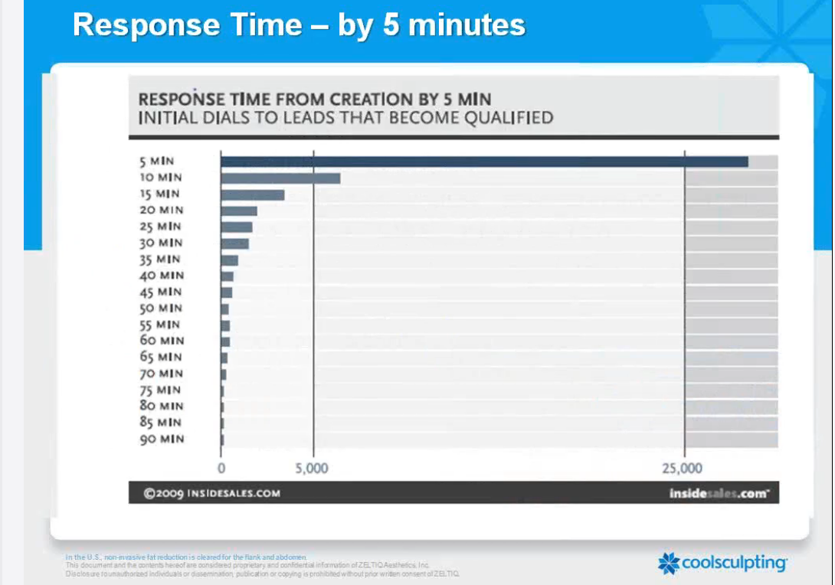

*4X less effective by waiting 10 minutes
IF YOU HAVE TO PLACE A CALLER ON HOLD

Being placed on hold for too long, or put on hold instantly is one of the MAIN reasons callers hang up or decline to book a consultation.

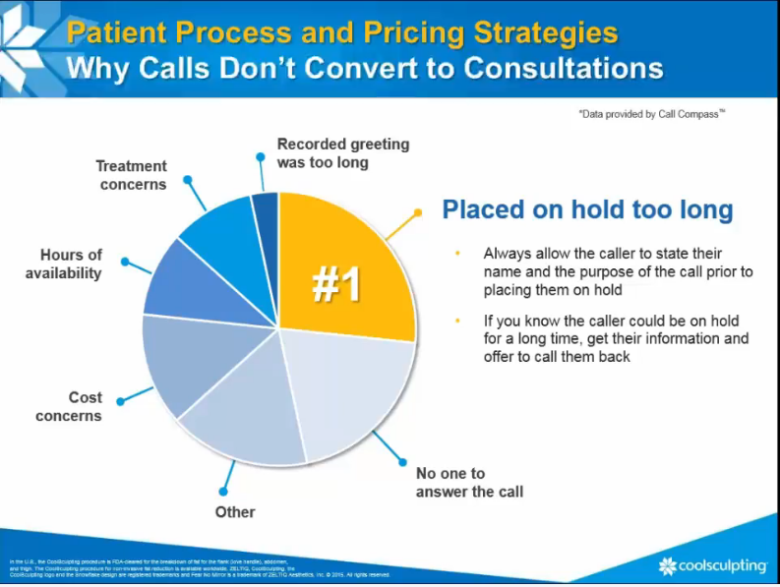

If you have to put someone on hold, make sure to get the caller’s name and purpose for calling before putting them on hold.

Receptionist: Hello. Thank you for calling [SPA.] My name is [Name.] May I ask with whom I am speaking?

Caller: My name is Melissa, I am calling about CoolSculpting

Receptionist: Hello Melissa. You’re interested in CoolSculpting, that’s fantastic. May I ask you to hold for a brief moment, I have another caller on the opposite line?

Caller: Yes

Wait until they answer yes before placing them on hold.

*If the caller has to be on hold for a long time, get their information and call them back.

FRONT DESK CALL SCRIPT

SUGGESTED SCRIPT FOR A COOLSCULPTING® PATIENT CALL

STAFF MEMBER “Thank you for calling [Name of Practice], this is [Name of Staff Member].
How may I help you?”
PROSPECTIVE PATIENT “I was calling about CoolSculpting…”
STAFF MEMBER Respond with a brief statement about why your spa is the best place to get CoolSculpting. (Uniqueness statement.) Be enthusiastic. Remember, passion is contagious.
“Great. You’ve called the right place! [SPA] is proud to be… [Distinguishing characteristic].
List your Spa’s experience (experience is an important factor for people choosing a CS provider.)
“We’ve performed hundreds of treatments.”

Collect name and number on the Call Conversion Sheet
“Just in case we get disconnected, may I please have your name and phone number?”
PROSPECTIVE PATIENT “Yes, my name is Melissa and my number is 888-888-8888.”
STAFF MEMBER “Great! Thank you, Melissa.”

CoolSculpting® 15-second Elevator Pitch
“CoolSculpting® is the world’s #1 non-invasive fat-reduction procedure*. It’s an innovative way to contour your body by freezing unwanted fat away with no surgery or little to no downtime.”

Receptionist’s Personal CoolSculpting experience
“I just had the CoolSculpting treatment performed on my abdomen three months ago and I love my results.
Next, ask the caller if they have any questions about the CS treatment. This will show the caller you are there to help them. It will also help you gauge where the caller is at, what concerns they have, and other insight that will help you customize the conversation to the caller’s needs and lead the caller to book a consultation over the phone.
STAFF MEMBER “Are there any questions I can answer for you?
PROSPECTIVE PATIENT [Patient question] “How long does it take to see the results?”
STAFF MEMBER After my treatment, I started seeing results about a month later. Most patients see their results between one and three months.”
If the caller does not articulate any specific questions, move on in the conversation by asking:
STAFF MEMBER “What made you interested in CoolSculpting?”
PROSPECTIVE PATIENT [Indicates reason] i.e. “I hate my thighs.”
STAFF MEMBER This is a great opportunity for the receptionist to validate the caller, connect with the caller, and learn more about the caller’s selling points. Whatever the caller’s concern is, validate it and then explain how CoolSculpting from your spa can address that concern.
“That is actually a really common area of concern. CoolSculpting works great on the thigh area. In fact, I just saw a patient who received CoolSculpting in that area a few months ago and she said her results look amazing.”
Or

“I had the same area of concern myself and CoolSculpting…”

PROSPECTIVE PATIENT “How much does it cost?”
STAFF MEMBER Remember, it’s best not to discuss the price over the phone.
“CoolSculpting® is a highly customized treatment. I would not be able to quote a price over the phone without our CoolSculpting® Specialist assessing you first.
Lead into the consultation

Our CoolSculpting® Specialist would love to meet with you privately to develop a custom treatment plan that meets your personal goals and matches your budget.

Mention a special, a deal, some financial incentive that has a time limit.

“We currently have a June special offering 25% off CoolSculpting on any treatment area. I’d love to get you in for your complimentary consultation with our CoolSculpting® Specialist, [Name of the specialist who will perform the consultation].”
Do not ask if they want to book a consultation. Use ASSUMPTIVE PHRASES. (Assume every caller wants to book a consultation.) Just continue straight into the scheduling portion of the phone call. Remember; try to avoid yes and no questions when possible.
“We have new patient consults available on Tuesdays and Thursdays; Melissa, which day works better for you?”
PROSPECTIVE PATIENT “Tuesdays.”
STAFF MEMBER “Do you prefer mornings or afternoons?”
PROSPECTIVE PATIENT “Mornings.”
STAFF MEMBER “Great! I have possibilities for you to come in for your consultation on this
Tuesday afternoon at 9:00 am or 11:00 am. Which works better for you?”
PROSPECTIVE PATIENT “9:00pm.”
STAFF MEMBER “Great, we look forward to seeing you [Day and time.] In the meantime, our CoolSculpting® Specialist, [name of specialist] would like to connect with you before you come in. Is (888) 888-8888 the best number for the CoolSculpting® Specialist to reach you within the next 48 hours?”
PROSPECTIVE PATIENT “Yes it is.”
STAFF MEMBER “Good, then please expect to hear from [name of specialist] within the next couple of days! When [specialist name] calls, she will be happy to answer any additional questions about CoolSculpting that you may have.”
“Melissa, we are delighted that you have chosen our practice for your CoolSculpting® treatment. We can’t wait to see you on [date and time.]”

ANSWERS TO FREQUENTLY ASKED QUESTIONS

 WHAT IS COOLSCULPTING®?

Rehearse a 15-second “elevator pitch”, such as:
 “CoolSculpting® is the world’s #1 non-invasive fat-reduction procedure*. It’s an innovative way to contour your body by freezing unwanted fat away with no surgery or little to no downtime.”

 IF A PATIENT ASKS ABOUT “HOW IT WORKS”:

Rehearse a 15-second “elevator pitch”, such as:
“CoolSculpting® is an amazing technology that uses controlled cooling to freeze your fat cells. Once treated fat cells are frozen, the body naturally processes the fat and eliminates these dead cells.”

 WHAT’S THE COST?

Cost is best discussed during the consultation process; avoid the conversation about the cost on the phone. If not, then explain:
- “CoolSculpting® is a highly customized procedure, and I would not be able to quote a price over the phone without our CoolSculpting® Specialist assessing you first.
- Some people call numerous practices to find the cheapest quote. Don’t lose a potential customer because you won’t quote them over the phone. If the caller asks more than once or says they are price shopping, give them a price for a single treatment, with a small applicator. Follow up the cost with a deal or special or some other kind of incentive. Do not give price ranges. People will only remember the higher price. Quote the least expensive treatment.

- “The initial cost of a single treatment is $xxxx, but there is a discount offered based upon the treatment package.”

 HOW MANY TREATMENTS DO I NEED?

Do not perform the consultation over the phone! Instead, re-focus the patient to discuss this question with the CoolSculpting® Specialist.
 “That’s a great question. The CoolSculpting® Specialist is the expert and is far better prepared to answer your questions.

WHEN DO I SEE RESULTS?

This is a great reason to ensure that the Front Desk Staff has experienced a CoolSculpting® treatment. They can confidently share their own experience and/or results, such as:
“I saw my results after about a month; most patients see results between one to three months.”

 IS THERE ANY PAIN OR DOWNTIME?

Again, another reason to make sure the receptionist has received the CoolSculpting treatment. If there is some luxury that distinguishes your CoolSculpting treatment, room or process, feel free to add that detail into the answer.

“I felt very comfortable during my treatment and the chairs are so relaxing that I slept through most of my
treatment…” Or “Great questions! When I had my treatment, the cold numbs the treatment area and you might feel
Some tingling. But as soon as the treatment started, I was able to watch TV and catch up on my favorite shows

– and –

“I was able to go back to work that same day.”

