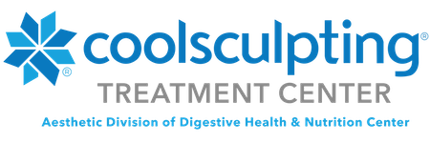
What is CoolSculpting
Freeze away your fat with CoolSculpting, the #1 non-invasive fat reduction treatment in the world! Millions of men and women choose CoolSculpting to eliminate stubborn bulges, such as belly fat, love handles, thigh fat, upper arm fat, and double chins. Numerous clinical studiesⁱ prove that CoolSculpting really works and results are natural looking and long lasting. The treatment is safe, FDA cleared, and requires no downtime, making CoolSculpting the perfect non-surgical alternative to liposuction.






IS THE COOLSCULPTING® TREATMENT RIGHT FOR ME?

Cool Sculpting is a highly customizable procedure, which means Cool Sculpting cost varies per patient depending on their individual treatment plans, how many areas receive treatment, and what applicators perform the cooling cycles. The best way to find out how much Cool Sculpting costs is to schedule a free consultation with Dr. Merlo. During your complimentary consultation, you and Dr. Merlo will discuss if Cool Sculpting is right for you, and if so, customize a treatment plan that addresses your problem areas while staying within your budget.

HOW MUCH DOES IT COST?
That all depends on what areas you treat and how many treatments you have. Many patients choose to do CoolSculpting® on multiple areas to reach their ideal end result. Typically, CoolSculpting® will cost anywhere between $2000-$4000 for a personalized treatment plan.
When you meet with a CoolSculpting® consultant, they will work with you to find a personalized treatment that fits your body and your budget. In fact, many CoolSculpting® providers offer flexible payment plans to help you get the results you want without having to pay the full cost up front.

CAN COOLSCULPTING® REDUCE FAT ON EVERY PART OF MY BODY?

CoolSculpting® is FDA-cleared for the treatment of visible fat bulges in the submental (under the chin) and submandibular (under the jawline) areas, thigh, abdomen and flank, along with bra fat, back fat, underneath the buttocks (also known as banana roll) and upper arm. It is also FDA-cleared to affect the appearance of lax tissue with submental area treatments.

Before and after photos
