Keyword | Cool sculpting
Keyword-Optimized Title | What is Coolsculpting and How It Works
Keyword-Optimized Meta Description | CoolSculpting is a cosmetic treatment procedure that freezes the fat cells in targeted regions of your body. Another name for this treatment is cryolipolysis, and just like liposuction, it helps remove difficult body fat.
Internal Links | No
External Links | Yes
Research Links | Yes
Images | Yes
Proofread | Yes
Copyscape Screenshot



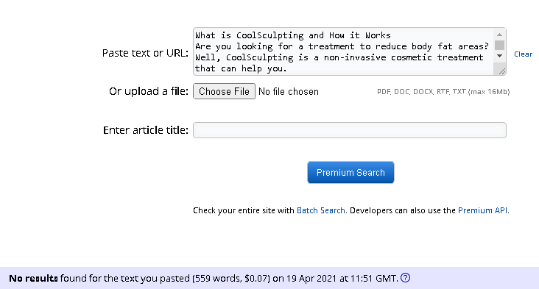

What is CoolSculpting and How it Works
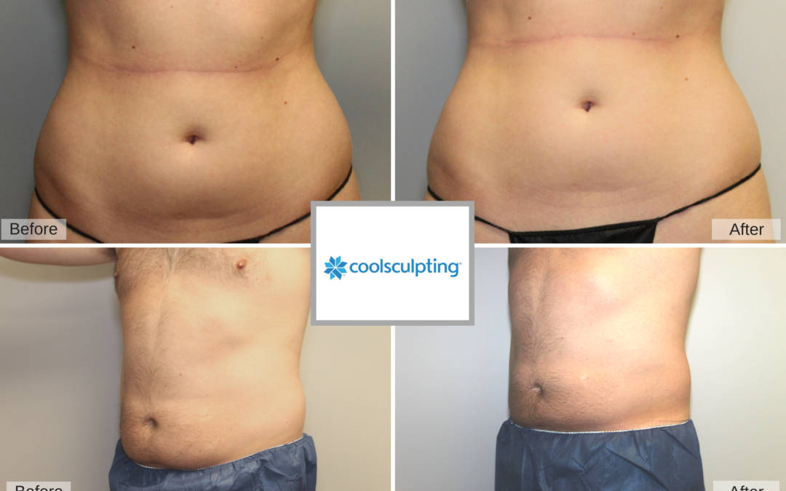
Image Source: Capizzimd
Are you looking for a treatment to reduce body fat areas? Well, CoolSculpting is a non-invasive cosmetic treatment that can help you.

What is Cool Sculpting
CoolSculpting is a cosmetic treatment procedure that freezes the fat cells in targeted regions of your body. Another name for this treatment is cryolipolysis, and just like liposuction, it helps remove difficult body fat.
This is a non-invasive procedure, meaning there are no anesthetic or cuts involved. There it is far less risky than liposuction. CoolSculpting is a safe and FDA-approved procedure. However, it would be best if you learned about how it works before opting for it.

How does it Work?
CoolSculpting uses freezing temperatures to break down stubborn body fat cells. The cold temperature does not damage any other cells like it does fat cells. Therefore, you will not have any side effects, such as damage to underlying tissues and skin.
During the treatment, the CoolSculpting practitioner will vacuum the fatty tissue area into an application to cool the fat cells. The freezing temperature will numb that particular skin area. Some people describe it as a cooling sensation; therefore, you will feel no pain.
The entire treatment may take up to an hour without any need for recovery time. You may feel soreness in the body area of treatment. This is similar to a temporary sensation you may feel in case of a minor muscle injury and/or intense workout.
It takes between 4 to 6 months after the CoolSculpting procedure for the fat cells to disappear. During this time, your fat area will decrease by 20 percent on average.

Not a Weight Loss Treatment
Remember, CoolSculpting is not a weight-loss treatment. It is more of a body shaping treatment. CoolSculpting will eliminate portions of fatty cells from the targeted body area. These eliminated cells cannot grow back. Therefore, CoolSculpting is long-lasting fat reduction treatment.

Does CoolSculpting Really Work
CoolSculpting has a promising success rate. The treatment is effective for removing body fat with fewer side effects. The effectiveness of the treatment also depends on your lifestyle and other factors. If a person continues to lead a sedentary lifestyle with an unhealthy diet intake, CoolSculpting might not be too effective.
According to research, people, on average, lose 14.6 to 28.5 of their body fat due to Coolsculpting treatment. Another study suggested fat reduction within two months of treatment.

Body Areas Where CoolSculpting is effective
You can treat the following skin regions on your body
- Upper arms
- Inner and outer thighs
- The back
- Double chins
- Neck fat
- Fat deposits above your knees
- The best (quite famous amongst men to get rid of man boobs)
- Armpits (bra bulge)
- Love handles and hips
- Belly fat
- The area under the buttocks

Are there any Side Effects
As CoolSculpting is a non-invasive procedure, there are not many side effects, and less than 1 percent of the people reported any complications. However, the side effects may include
- Bruising
- Localized pain
- Sensitivity
- Swelling
- Skin redness

Are you Interested?
Now that you know about CoolSculpting and feel that you are ready to get rid of that unwanted body fat, it is time to contact (Enter your SPA name). Call us today on (enter phone number) to schedule a complimentary consultation in (location).
Reference URLs
https://wb.md/2QdNktz
https://bit.ly/3eicEX8
https://coolscul.pt/3mXemBs
https://bit.ly/3x4S3hL
https://bit.ly/3glergO
https://bit.ly/32ppeP5
https://bit.ly/3n1FMWY
https://bit.ly/3ty9IMz

